**What is bootstrap**

Bootstrap is a popular framework for creating responsive and mobile-friendly websites with HTML, CSS, and JavaScript. It provides a set of ready-made components, layouts, and utilities that can speed up your front-end development process.

## **Benefits of Using Bootstrap in E-Gem**

* One of the main advantages of Bootstrap is that it saves you time and effort. You don't have to write a lot of code from scratch, as Bootstrap offers a variety of predefined elements, such as buttons, forms, cards, navbars, and more. You can also use Bootstrap's grid system to create flexible and responsive layouts that adapt to different screen sizes and devices. Bootstrap also has a large and active community of developers and designers, who contribute to its documentation, updates, and extensions. It is compatible on most of browsers like Chrome, Firefox, Internet Explorer, Safari and Opera etc.

**How to use Bootstrap in VCS**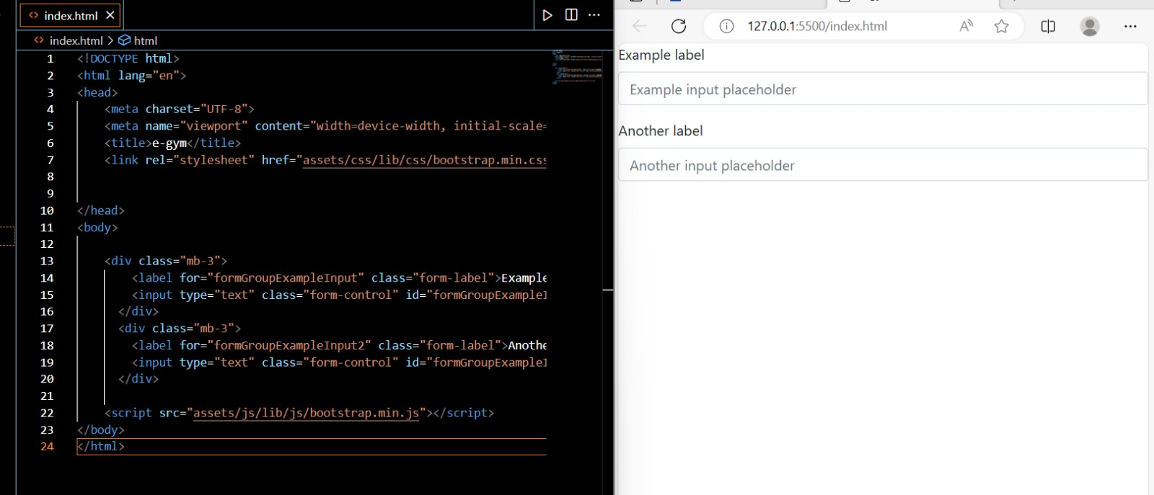

Download Bootstrap Source files  
Once you have downloaded the zip file, you need to extract its contents to access the individual files and folders within it. To set up the index.html file, follow these steps:

1. Locate the extracted folder and open the "css" directory.
2. Copy the bootstrap.min.css file and paste it into your project's "css" directory.
3. Open the "js" directory in the extracted folder and copy the bootstrap.min.js file.
4. Paste the bootstrap.min.js file into your project's "js" directory.

### What Bootstrap package contains

**Scaffolding:** Bootstrap provides a basic structure with Grid System, link styles, and background.

**CSS:** Bootstrap comes with the feature of global CSS settings, fundamental HTML elements style and an advanced grid system.

**Components:** Bootstrap contains a lot of reusable components built to provide iconography, dropdowns, navigation, alerts, pop-overs, and much more.

**JavaScript Plugins:** Bootstrap also contains a lot of custom jQuery plugins. You can easily include them all, or one by one.

**Customize:** Bootstrap components are customizable and you can customize Bootstrap's components, LESS variables, and jQuery plugins to get your own style.

## Is Bootstrap Framework Easy to Use?

It depends.

First, it depends on your background.

Those who already understand HTML5, CSS, and JavaScript should find the majority of Bootstrap a breeze. Bootstrap doesn’t do anything too complex. It’s more-or-less a library. If you go through the Bootstrap files, you will see exactly what it’s doing — controlling, refining, and customizing page elements.

Second, it depends on what you want to do with it.

It’s fairly easy to get a website up and running with Bootstrap in as little as an evening. If you just want to create a basic site with Bootstrap, you can hit the ground running and get it done ASAP.

But if you want to customize it, it could take a lot longer. Bootstrap makes a lot of things possible, but to edit some more complex things (like animated loading screens), you’ll have to dig deep.