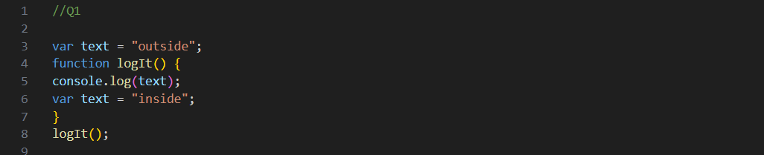

the output is undefined,

because the console.log(text) statement is executed before the

text variable inside the logIt() function is assigned the value "inside". This is due to variable

hoisting, where variable declarations are moved to the top of their respective scopes.

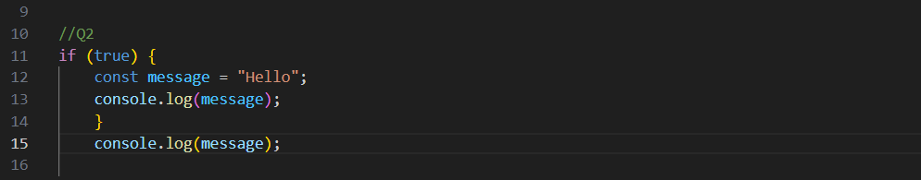

the first console.log(message) statement successfully prints "Hello" because it is within the same

block scope as the message variable. but the second console.log(message) statement throws a

ReferenceError because the message variable is not accessible outside the if block due to its block

scope. since the message variable is declared using the const.

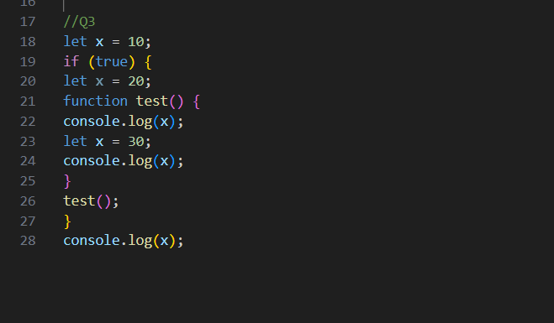

the first console.log(x) statement throws a ReferenceError because the x variable is not

accessible before its declaration within the test() function. The second console.log(x)

statement successfully prints 30 because it is within the block scope of the test() function.

Finally, the last console.log(x) statement successfully prints 10 because it is in the global

scope.