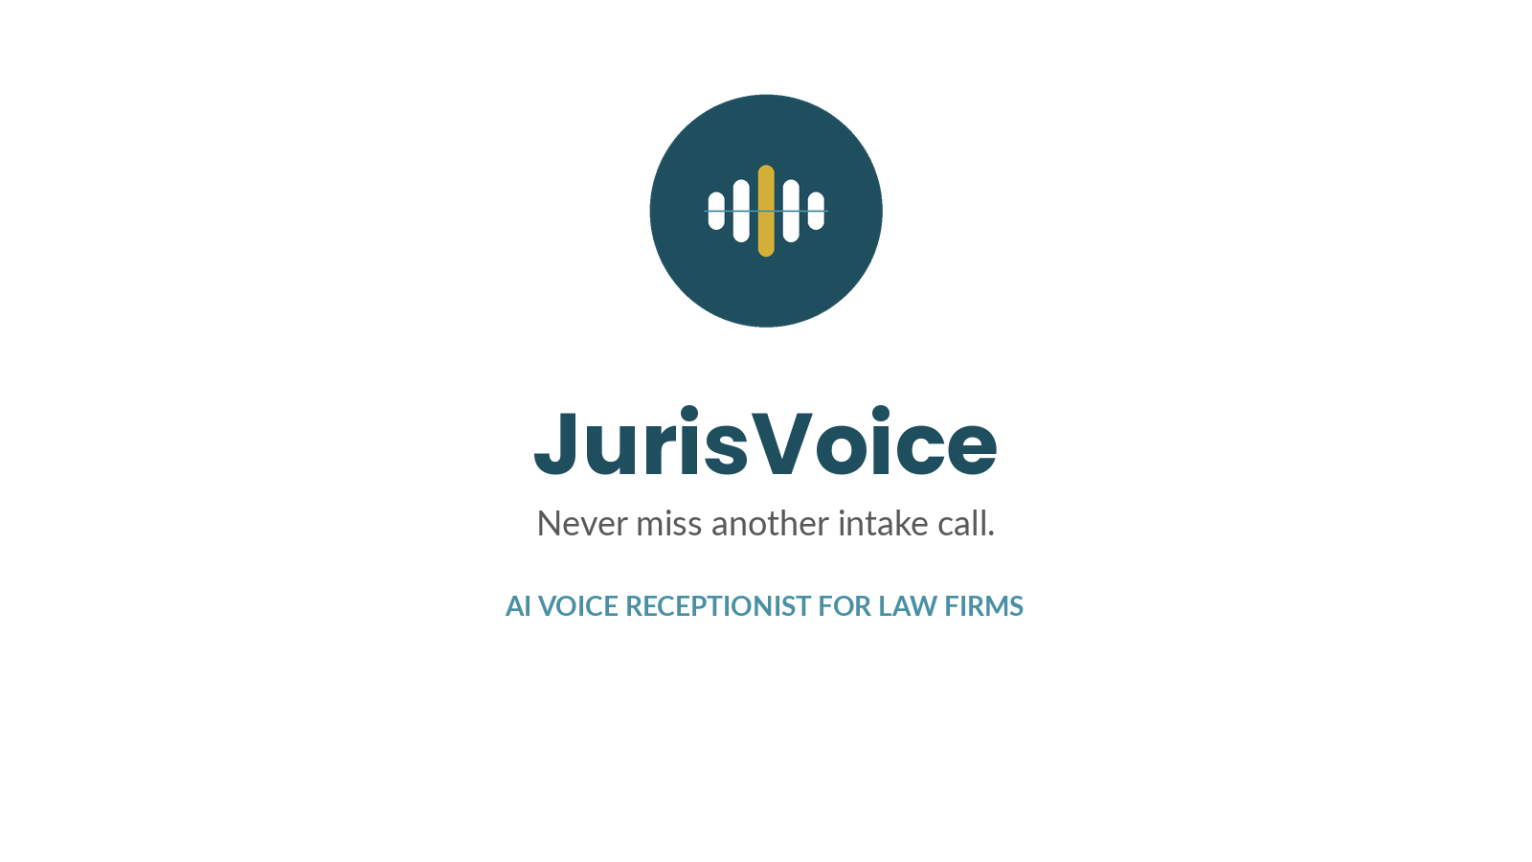

Brand Name
JurisVoice - AI voice receptionist for law firms. "Juris" signals the legal market; "Voice" signals the AI calling product. Easy to say, easy to spell, and reads as professional rather than gimmicky.

Logo & Icon
Primary mark: the soundwave/balance icon paired with the JurisVoice wordmark (shown above). The icon alone (below) works for favicons, app icons, and social profile photos.

- The gold center bar represents the firm's call being prioritized - the "balance" tying back to scales of justice.
- Minimum clear space: leave padding around the icon equal to roughly 20% of its width.
- Do not recolor the icon outside the approved palette below.

Color Palette
Color | Hex | Use | Preview
Deep Teal (Primary) | #1F4E5F | Logo, headings, primary buttons
Slate Blue (Secondary) | #4A90A4 | Subheadings, accents, links
Gold (Highlight) | #D4AF37 | Call-to-action highlight, key accent only
Charcoal (Text) | #262626 | Body text
Gray (Muted text) | #595959 | Taglines, captions

Typography
- Headings / wordmark: Poppins Bold (or Arial Bold as a system-font fallback).
- Body copy: Lato or Arial.

Tagline & Slogans
Primary tagline:
- Never miss another intake call.
Alternate slogans:
- Your firm's voice, working 24/7.
- Every call answered. Every lead captured.
- More cases. Less overhead.
- The answering service that never sleeps - and costs less.
- First to answer, first to win the case.

One-Line Pitch
JurisVoice replaces your $300/mo answering service with an AI receptionist that answers every call, screens by case type, flags urgent matters instantly, and sends your team a ready-to-use summary - for less than you're paying now.

Voice & Tone
- Professional, calm, and trustworthy - this is a tool used in a legal setting.
- Plain language over jargon when talking to firm owners.
- Lead with cost-substitution and missed-call value, not "AI" hype.

