Optimization Methods for Polynomial Regression
Retail Demand Forecasting Case Study
Optimization for Data Science - Final Project
SS 2026

1. Application and data
The application is daily retail demand forecasting. I used the Kaggle Store Item Demand Forecasting data and focused on one clean time series: store 1, item 1. The full training file has 913000 rows. After selecting the store-item pair and dropping rows needed for lag features, the experiment used 1454 training observations from 2013-2016 and 365 test observations from 2017. The target is daily sales.
The engineered features were: t, day_of_week, month, day_of_year, weekend, lag_1, lag_7, and rolling_mean_7. These features were standardized using training-set statistics only. The target was also standardized during optimization, and RMSE/MAE were converted back to sales units for reporting. Polynomial features were generated from all monomials up to degree p; the main comparison used p=3, giving 165 parameters including the intercept.

2. Polynomial regression objectives
For design matrix X with n samples and d features, and target y, the prediction is y_hat = Xw. I compared four objective structures.
Objective | Formula | Structure
MSE | J(w) = (1/(2n)) ||Xw - y||_2^2 | smooth convex
Ridge / L2 | J(w) = (1/(2n)) ||Xw - y||_2^2 + (lambda/2) ||w_1:||_2^2 | smooth strongly convex for lambda > 0
Lasso / L1 | J(w) = (1/(2n)) ||Xw - y||_2^2 + lambda ||w_1:||_1 | convex non-smooth
Smooth L0-like | J(w) = (1/(2n)) ||Xw - y||_2^2 + lambda sum_j>0 (1 - exp(-w_j^2/(2 tau^2))) | smooth non-convex
The intercept w0 was not regularized. Smooth objectives used gradients implemented directly in NumPy. The L1 objective used the proximal operator (soft-thresholding), so ISTA/FISTA can handle the non-smooth term.

3. Optimization algorithms
The implemented algorithms were Gradient Descent, Nesterov acceleration, Heavy Ball, SGD, SAGA, Adagrad, Adam, ISTA and FISTA. Gradient Descent and Nesterov used a step based on the Lipschitz estimate L = ||X||_2^2/n + lambda. SGD, Adagrad and Adam used mini-batches of 32 samples. SAGA used a stored table of individual gradients. Adam and Adagrad were included as adaptive stochastic methods beyond the basic deterministic methods.
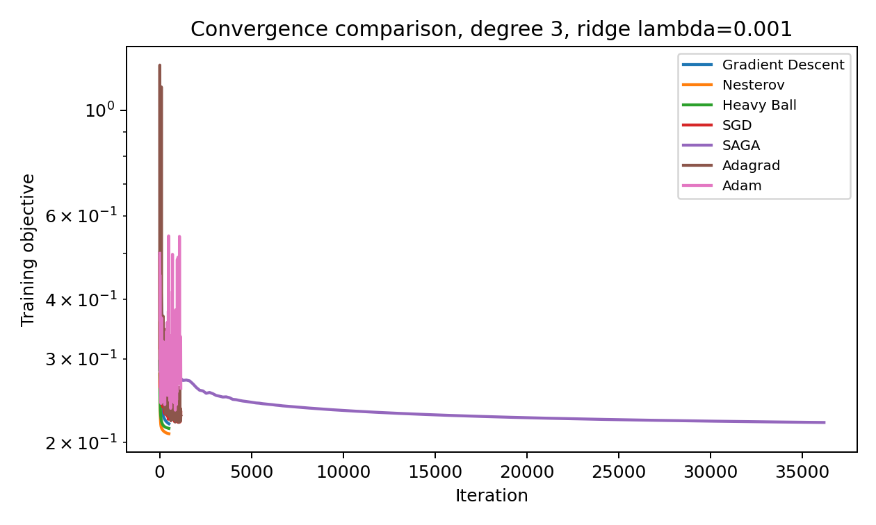 | 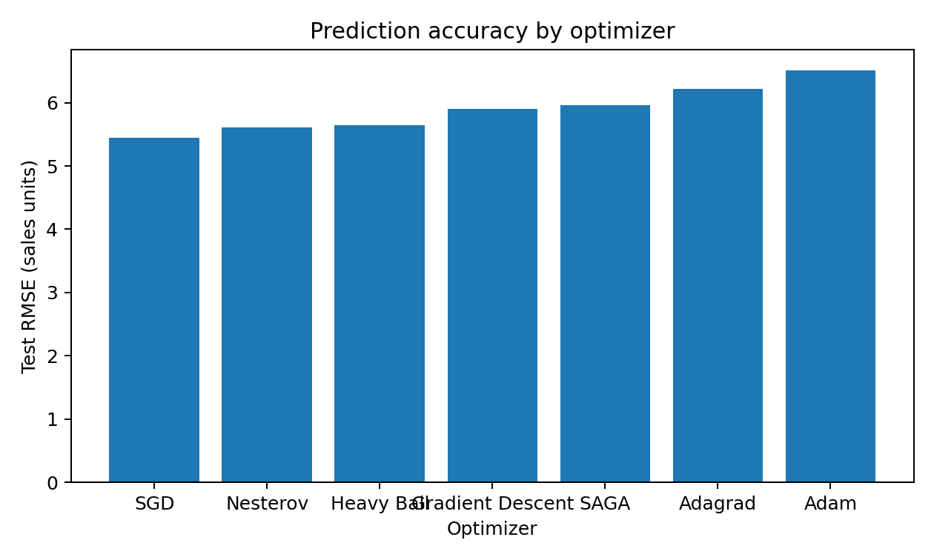
Figure 1. Optimizer comparison for ridge polynomial regression with degree 3 and lambda = 1e-3.
Table 1. Main optimizer comparison. Lower test RMSE is better.
Method | Train RMSE | Test RMSE | Test MAE
SGD | 4.47 | 5.45 | 4.31
Nesterov | 4.23 | 5.61 | 4.42
Heavy Ball | 4.29 | 5.64 | 4.47
Gradient Descent | 4.34 | 5.91 | 4.70
SAGA | 4.36 | 5.97 | 4.74
Adagrad | 4.43 | 6.22 | 4.97
Adam | 4.73 | 6.51 | 5.00

4. Experimental results
The best test RMSE in the main optimizer comparison was obtained by SGD with RMSE 5.45 and MAE 4.31 sales units. Deterministic accelerated methods reached lower training objective faster than plain Gradient Descent, while the stochastic method gave the best validation accuracy in this finite-run experiment.
Table 2. Objective-structure comparison.
Objective | Method | Test RMSE | Final scaled MSE
MSE | GD | 5.91 | 0.219
MSE + L2 | Nesterov | 5.61 | 0.208
MSE + L1 | FISTA | 5.46 | 0.212
MSE + smooth L0-like | GD | 5.84 | 0.219
For polynomial degree, performance improved from degree 1 to degree 2 and then overfitted for higher degrees. This is expected because the number of parameters grows quickly relative to the single store-item time series. The best degree by test RMSE was degree 2. For L2 regularization, the best tested value was lambda = 0.01.
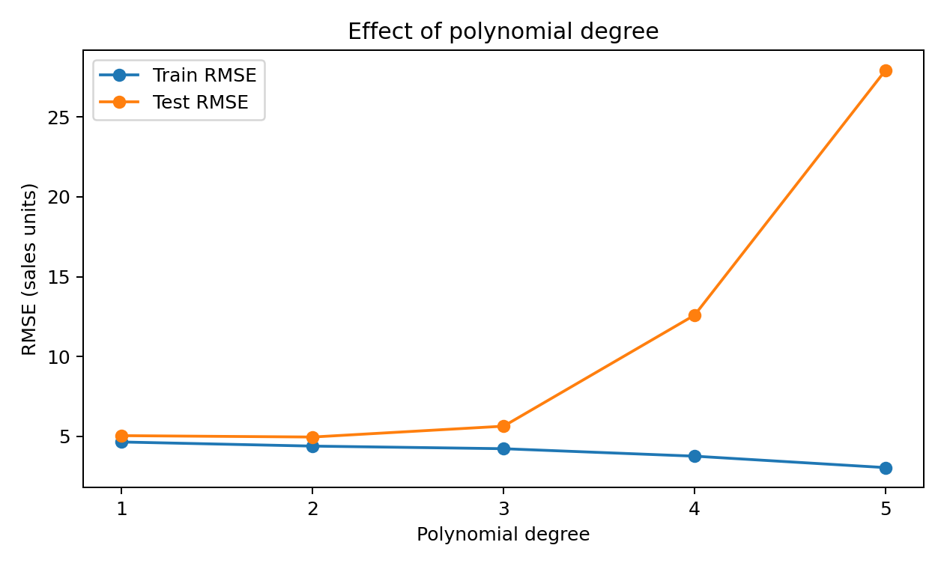 | 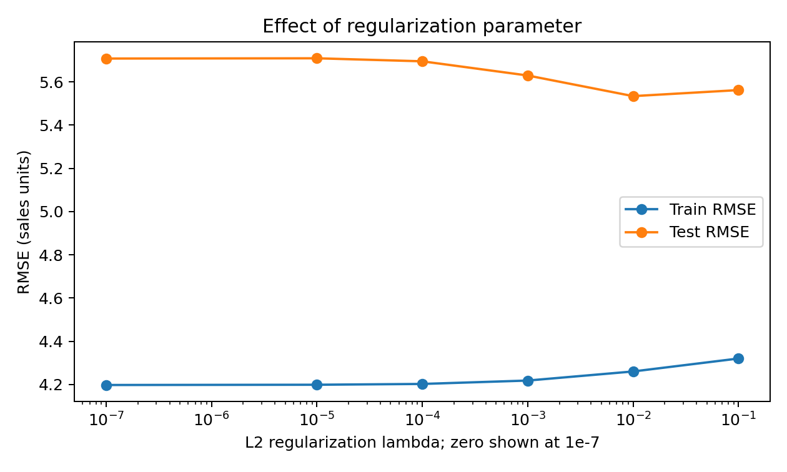
Figure 2. Hyperparameter effects required by the task: polynomial degree and regularization.
Table 3. Polynomial degree effect using ridge reference solutions.
Degree | Parameters | Train RMSE | Test RMSE
1 | 9 | 4.64 | 5.04
2 | 45 | 4.38 | 4.95
3 | 165 | 4.22 | 5.63
4 | 495 | 3.75 | 12.59
5 | 1287 | 3.03 | 27.94
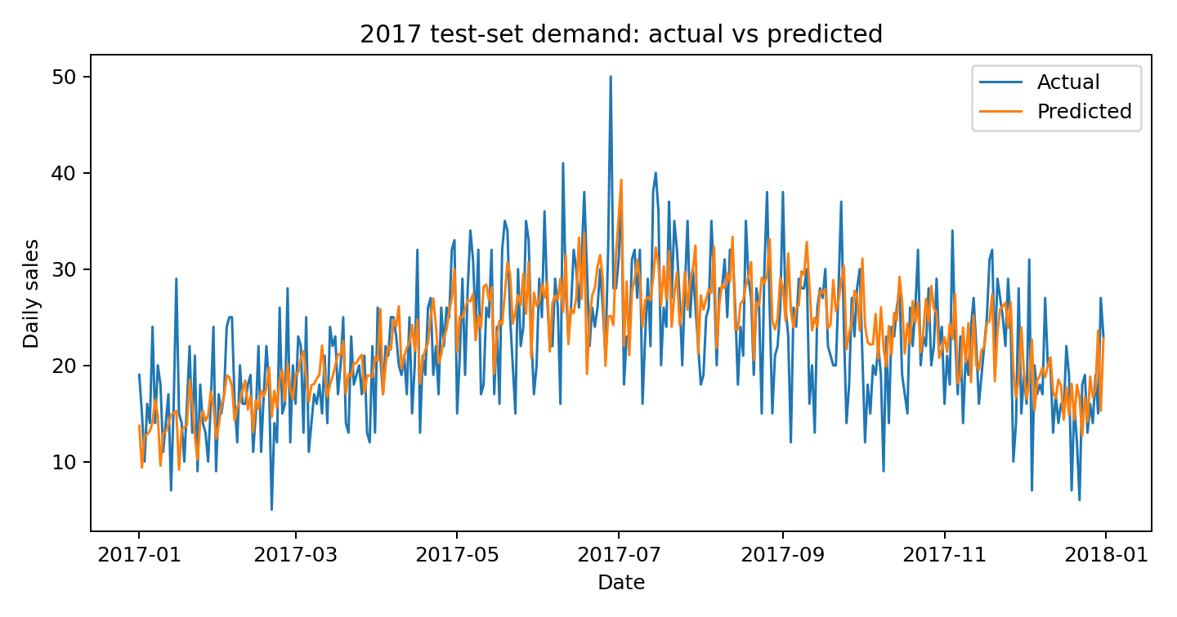
Figure 3. Actual versus predicted demand on the 2017 test set for the best main optimizer.

5. Conclusion
Polynomial regression can model useful nonlinear demand patterns when calendar and lag features are included. However, degree selection is critical: degree 2 generalized best in this experiment, while degrees 4 and 5 overfit strongly. L2 regularization improved generalization. For optimization, acceleration reduced training objective faster than plain Gradient Descent, proximal methods handled the non-smooth L1 objective, and adaptive stochastic methods provided an additional comparison relevant to machine learning practice.

Reproducibility
Run python src/main.py from the project root. The implementation uses only NumPy, pandas and matplotlib.

References
Course task: Final Project - Optimization Methods for Polynomial Regression.
Lecture notes: Optimization for Data Science, Christian Clason, University of Graz.
Dataset: Kaggle Store Item Demand Forecasting Challenge.

