**LEGOPLUS Component Review**

**User Interface**

**Rev 0.1**

Sommario

Revision History 3

References 3

Terms and Definitions 3

1. Job description 4

2. Overall Architecture 5

2.1. Package Diagram 5

2.2. Class Diagrams 6

3. Typical usage of UI 9

3.1. Creation and initialization 9

3.2. Triggering a label 10

1. Notification from/to 11

3. Anomalies 16

3.1. Architecture 16

3.2. File Name and Directory 16

3.3. Source code 17

3.4. Other anomalies 17

# Revision History

|  |  |  |  |
| --- | --- | --- | --- |
| **Rev** | **Date** | **Author** | **Description** |
| 0.0 | 17/12/2018 | E.L.Minthe | DRAFT |
| 1.0 | 20/12/2018 | E.L.Minthe | First issue |

# References

|  |  |  |  |
| --- | --- | --- | --- |
|  | **Title** | **Rev** | **Date** |
|  | FW_API_Lego Plus Project.docx | X3 | 22/02/2013 |
|  | SwAD_Addendum_LegoArchRules.docx | 1.0 | 20/12/2018 |

# Terms and Definitions

|  |  |
| --- | --- |
| **Terms** | **Definition** |
| UI | User Interface – Software component of LegoPlus. |
| Component | Part of a software system having one or more well-defined interfaces and implementing a well-defined functionality |
| Director | Is the mediator in the mediator-colleague design pattern |

# Job description

In the context of LEGO PLUS PROJECT a *manager* is defined as a component that implements a well-defined, high-level functionality of the scanner and is the gate of to a specific subsystem. The *User Interface Manager* is one of the components of that modular architecture which manages the interactions between the User and the device.

The UI-MGR fetches the input events (p.e. triggering the device) and gives feedback to the user by its sub component (led, beeper etc).

notification

Other managers

The UI consists of a series of components which are Led, Accelerometer, RGB array, Vibration, Audible device and Trigger. Each of these components has a specific purpose even though they share the fact that they all indicate to the UI the current status of the device.

1. **Vibration component**: It is an output that can be configured to give further feedback to the user.   
   E.g. after scanner power up then do a short vibration indicating that everything is ok. Also a good reading can be signaled by vibration feedback.
2. **Visual component**: can be a *Led* (on/off) or an *RGB* that varying the color and the intensity of the light, can have multiple visual patterns;
3. **Audible component**: it can be either a Beeper or an Audio device;
4. **Accelorometer**: aims to detect a movement of the device. The accelerometer is an input and can be switched to more output functionalities among which the aiming, virtual stand, and double tap.  
   Not all scanners have this functionality.

|  |  |  |
| --- | --- | --- |
| Node | Notification | type |
| *trigger* | Input | Mechanical |
| *led* | output | Visible |
| *rgb* | output | Visible |
| *sound* | output | Audible |
| *vibration* | output | Audible/mechanical |
| *Accelerometer* | input | Mechanical |

# Overall Architecture

The UI_MGR like the other Managers is an interface that handles input and output notifications from/to other Managers. It is composed of two parts: the first one is in the *Legoplus* directory which is generic and the second is in *Legoplus*-*target* that manage the specific product issues.

# Package Diagram

In the figure below we show the principal packages contained in the UI which are the *Led* package, the *RGB* package, the *Accelerometer* package, and the *Beeper* package.

The Framework/Include package is not part of the UI package but it is useful for our purpose because it contains interfaces implemented by UI classes.

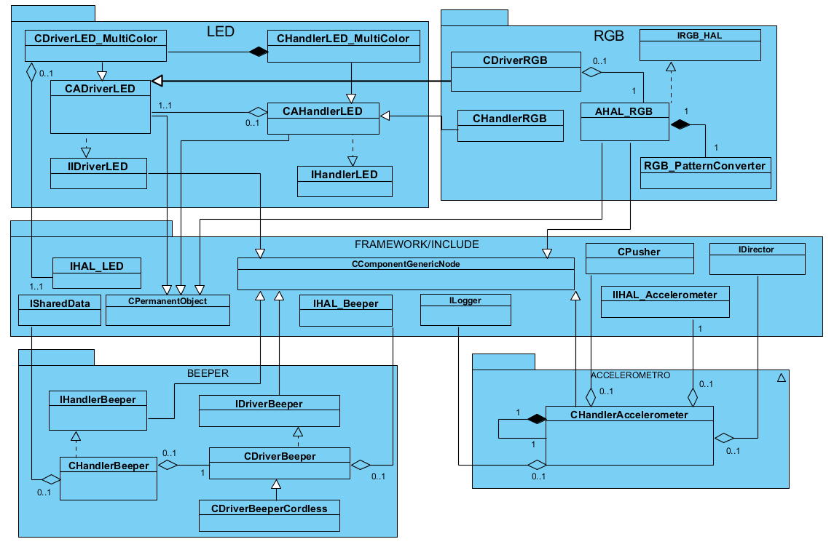

Figure 1: UI Package diagram

# Class Diagrams

We show the classes diagram of the following packages: Led, RGB, Accelerometer and Beeper.

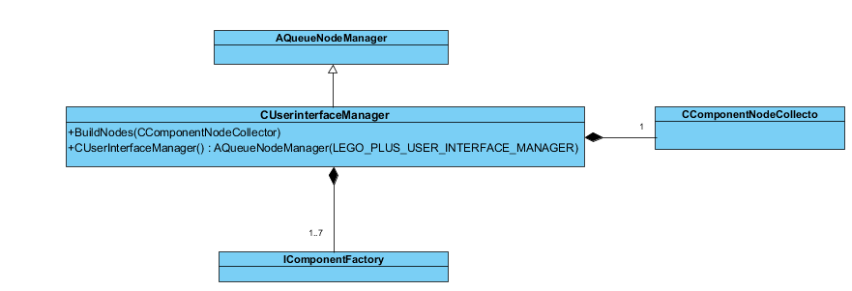

Figure 2 UI composition

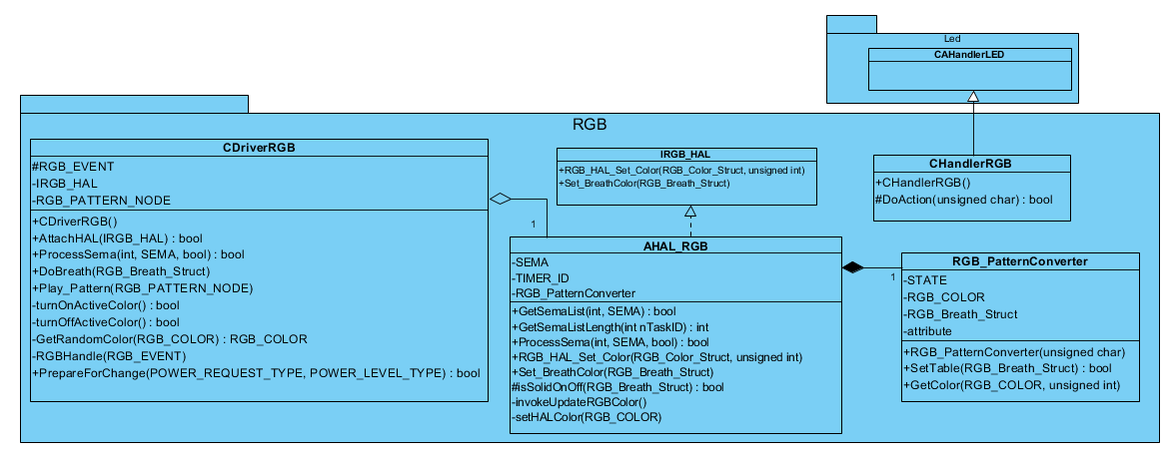

Figure 3 RGB package description

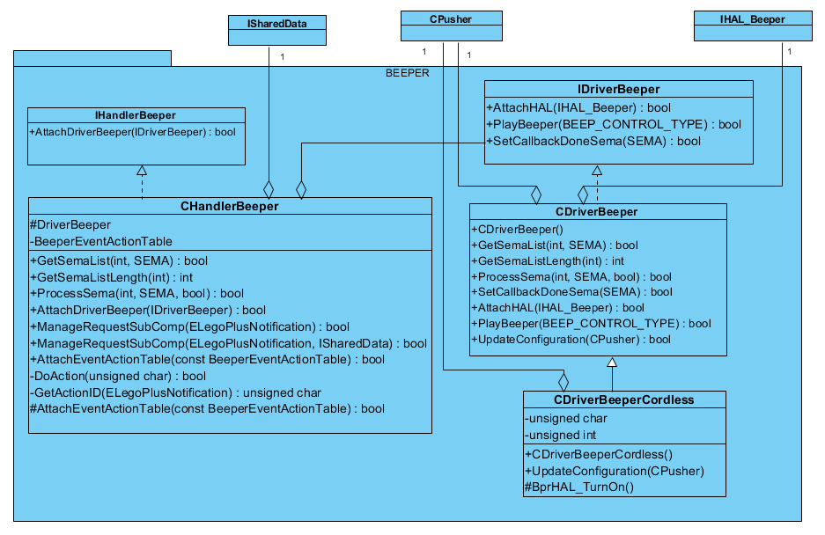

Figure 4 Beeper package description

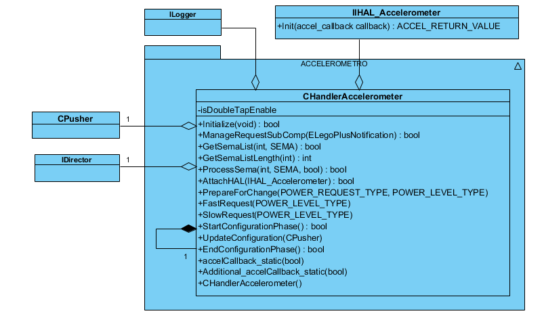

Figure 5 Accelerometer package description

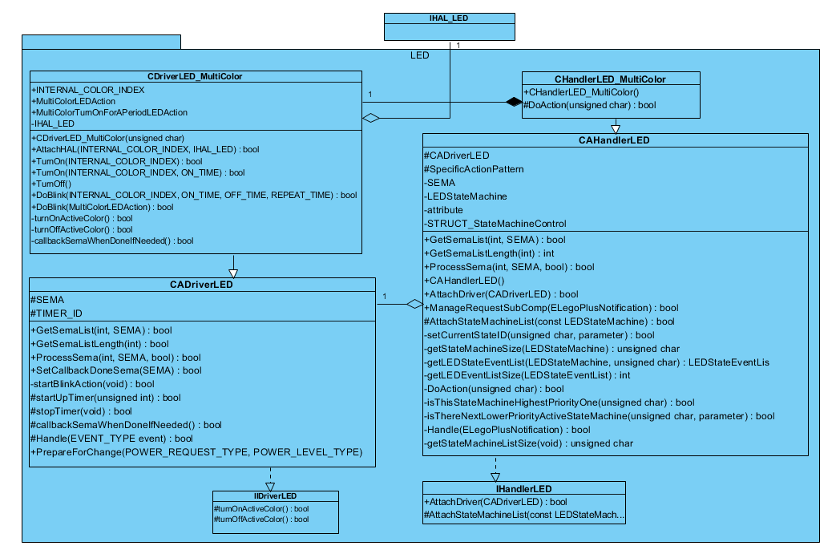

Figure 6 LED package description

# Typical usage of UI

# Creation and initialization

In this section, we use the UML sequence diagram to show the actual creation of UI manager and its components.

The diagram shows a typical creation of UI component starting from the Factory object through the UI assistant and, finally, the user interface manager.

Because the UI manager has many components the Figure 7 shows only one of those.

The actions from n.6 are iterated over the number of components belonging to UI. For the creation of each UI component will be created a Handler and a Driver, linked to the suitable HAL; then all the references will be collected into a “*component node list*”.

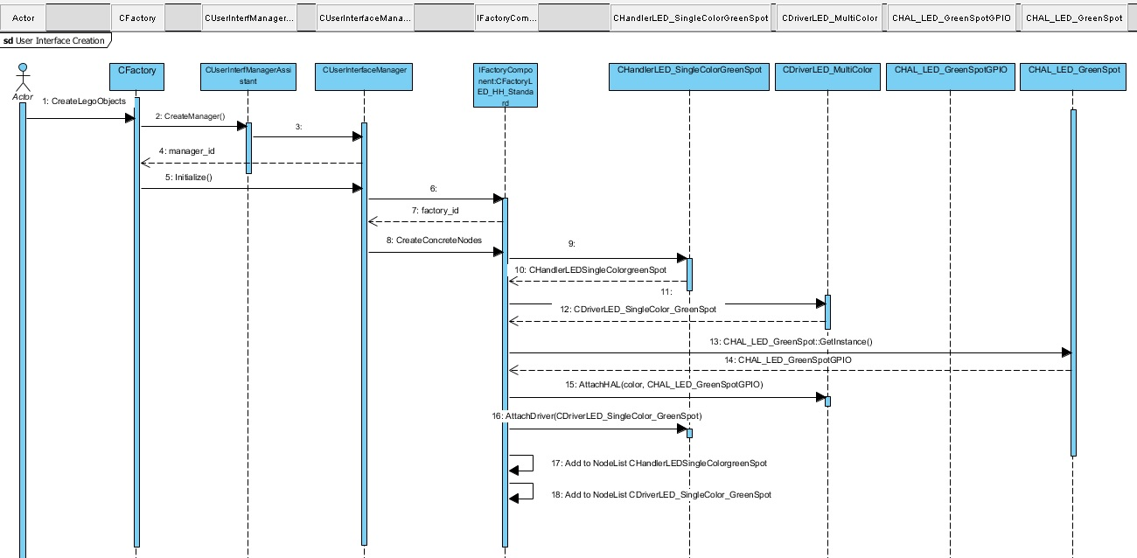

Figure 7: UI object creation

# Triggering a label

In this paragraph we show the sequence that take place when reading a bar code.

It should be noticed that this sequence diagram is a high-level one in the sense that it only shows the interaction between the *Director* and the *Managers* and notifications flow.

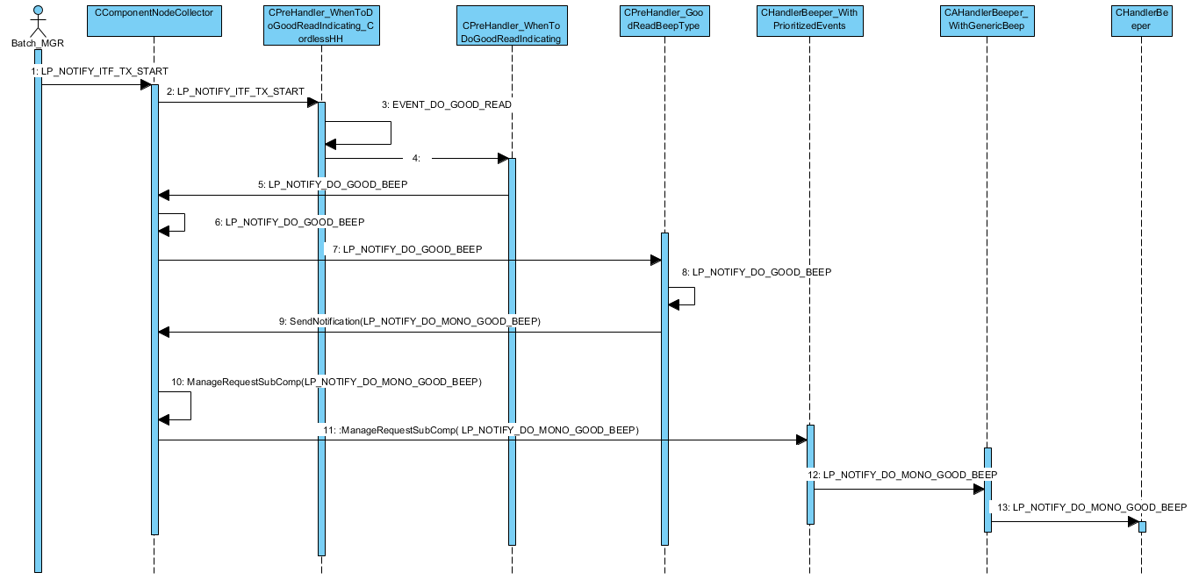

Figure 8: Triggering a label

# Notification from/to

1. **IDLE STATE**

From UI:

|  |  |  |  |
| --- | --- | --- | --- |
| Notification Sent | Destination Manager | Destination Manager Notification | Description |
| LP_NOTIFY_REGISTER_TO_CM | LEGO_PLUS_CONFIGSTATUS_MANAGER | LP_NOTIFY_REGISTER_TO_CM |  |
| LP_NOTIFY_SERVICE_MESSAGE_IN | LEGO_PLUS_SERVICE_MANAGER | LP_NOTIFY_SERVICE_MESSAGE_IN |  |

To UI:

|  |  |  |  |
| --- | --- | --- | --- |
| Source Manager | Notification Sent From Source | Notification to UI | Description |
| LEGO_PLUS_RF_MANAGER | LP_NOTIFY_INTERFACE_ENABLED_BY_HOST | LP_NOTIFY_INTERFACE_ENABLED_BY_HOST |  |
| LEGO_PLUS_RF_MANAGER | LP_NOTIFY_RF_DATA_CHANNEL_OPEN | LP_NOTIFY_RF_DATA_CHANNEL_OPEN |  |
| LEGO_PLUS_CONFIGSTATUS_MANAGER | LP_NOTIFY_FILE_EXCHANGE_STARTED | LP_NOTIFY_UI_GENERIC_PROCESSING_INDICATING_ENTER |  |
| LEGO_PLUS_CONFIGSTATUS_MANAGER | LP_NOTIFY_FILE_EXCHANGE_DONE | LP_NOTIFY_UI_GENERIC_PROCESSING_INDICATING_EXIT |  |

**ENABLE STATE**

From UI:

|  |  |  |  |
| --- | --- | --- | --- |
| Notification Sent | Destination Manager | Destination Manager Notification | Description |
| LP_NOTIFY_CM_REQUEST_DATA | LEGO_PLUS_CONFIGSTATUS_MANAGER | LP_NOTIFY_CM_REQUEST_DATA |  |
| LP_NOTIFY_ACC_MOTION | LEGO_PLUS_READING_MODE_MANAGER | LP_NOTIFY_ACC_MOTION |  |
| LP_NOTIFY_ACC_MOTION | LEGO_PLUS_RF_MANAGER | LP_NOTIFY_ACC_MOTION |  |
| LP_NOTIFY_ACC_QUIET | LEGO_PLUS_READING_MODE_MANAGER | LP_NOTIFY_ACC_QUIET |  |

To UI:

|  |  |  |  |
| --- | --- | --- | --- |
| Source Manager | Notification Sent From Source | Notification to UI | Description |
| LEGO_PLUS_READING_MODE_MANAGER | LP_NOTIFY_GO_TO_WATCH_WITH_AIM | LP_NOTIFY_DO_UI_ENTER_OBJECT_WATCH_INDICATING |  |
| LEGO_PLUS_READING_MODE_MANAGER | LP_NOTIFY_GO_TO_IDLE | LP_NOTIFY_DO_UI_EXIT_OBJECT_WATCH_INDICATING |  |
| LEGO_PLUS_READING_MODE_MANAGER | LP_NOTIFY_GO_TO_SCAN | LP_NOTIFY_DO_UI_EXIT_OBJECT_WATCH_INDICATING |  |
| LEGO_PLUS_READING_MODE_MANAGER | LP_NOTIFY_GO_TO_SCAN_WITH_MOTION | LP_NOTIFY_DO_UI_EXIT_OBJECT_WATCH_INDICATING |  |
| LEGO_PLUS_LUCE_MANAGER | LP_NOTIFY_STRUCTURE_APPENDED_BEEP | LP_NOTIFY_STRUCTURE_APPENDED_BEEP |  |
| LEGO_PLUS_IMAGE_CAPTURE_MANAGER | LP_NOTIFY_IMG_ACQUIRED | LP_NOTIFY_DO_IMAGE_CAPTURE_BEEP |  |
| LEGO_PLUS_SERVICE_MANAGER | LP_NOTIFY_ENTER_SW_SUPPORT_MODE | LP_NOTIFY_ENTER_SW_SUPPORT_MODE |  |
| LEGO_PLUS_SERVICE_MANAGER | LP_NOTIFY_EXIT_SUPPORT_MODE | LP_NOTIFY_EXIT_SUPPORT_MODE |  |
| LEGO_PLUS_SERVICE_MANAGER | LP_NOTIFY_ENTER_HW_SUPPORT_MODE | LP_NOTIFY_ENTER_SW_SUPPORT_MODE |  |
| LEGO_PLUS_SERVICE_MANAGER | LP_NOTIFY_PRECISE_STAND_CALIB_REQUEST | LP_NOTIFY_PRECISE_STAND_CALIB_REQUEST |  |
| LEGO_PLUS_SERVICE_MANAGER | LP_NOTIFY_PRECISE_STAND_CALIB_ERASE | LP_NOTIFY_PRECISE_STAND_CALIB_ERASE |  |
| LEGO_PLUS_RF_MANAGER | LP_NOTIFY_INTERFACE_ENABLED_BY_HOST | LP_NOTIFY_INTERFACE_ENABLED_BY_HOST |  |
| LEGO_PLUS_RF_MANAGER | LP_NOTIFY_RF_DATA_CHANNEL_OPEN | LP_NOTIFY_RF_DATA_CHANNEL_OPEN |  |
| LEGO_PLUS_UNDEFINED_MANAGER | LP_NOTIFY_DIRECTOR_EXIT_IDLE_STATE | LP_NOTIFY_STARTUP_EVENT |  |
| LEGO_PLUS_CONFIGSTATUS_MANAGER | LP_NOTIFY_FILE_EXCHANGE_STARTED | LP_NOTIFY_UI_GENERIC_PROCESSING_INDICATING_ENTER |  |
| LEGO_PLUS_CONFIGSTATUS_MANAGER | LP_NOTIFY_FILE_EXCHANGE_DONE | LP_NOTIFY_UI_GENERIC_PROCESSING_INDICATING_EXIT |  |

**DISABLE STATE**

From UI:

|  |  |  |  |
| --- | --- | --- | --- |
| Notification Sent | Destination Manager | Destination Manager Notification | Description |
|  |  |  |  |
|  |  |  |  |

To UI:

|  |  |  |  |
| --- | --- | --- | --- |
| Source Manager | Notification Sent From Source | Notification to UI | Description |
| LEGO_PLUS_UNDEFINED_MANAGER | LP_NOTIFY_DIRECTOR_EXIT_IDLE_STATE | LP_NOTIFY_STARTUP_EVENT |  |
| LEGO_PLUS_SERVICE_MANAGER | LP_NOTIFY_ENTER_SW_SUPPORT_MODE | LP_NOTIFY_ENTER_SW_SUPPORT_MODE |  |
| LEGO_PLUS_SERVICE_MANAGER | LP_NOTIFY_EXIT_SUPPORT_MODE | LP_NOTIFY_EXIT_SUPPORT_MODE |  |
| LEGO_PLUS_CONFIGSTATUS_MANAGER | LP_NOTIFY_FILE_EXCHANGE_STARTED | LP_NOTIFY_UI_GENERIC_PROCESSING_INDICATING_ENTER |  |
| LEGO_PLUS_CONFIGSTATUS_MANAGER | LP_NOTIFY_FILE_EXCHANGE_DONE | LP_NOTIFY_UI_GENERIC_PROCESSING_INDICATING_EXIT |  |
| LEGO_PLUS_RF_MANAGER | LP_NOTIFY_INTERFACE_ENABLED_BY_HOST | LP_NOTIFY_INTERFACE_ENABLED_BY_HOST |  |
| LEGO_PLUS_RF_MANAGER | LP_NOTIFY_RF_DATA_CHANNEL_OPEN | LP_NOTIFY_RF_DATA_CHANNEL_OPEN |  |

**LIMITED SCAN STATE**

From UI:

|  |  |  |
| --- | --- | --- |
| OUTPUT Manager | Output Notification | Description |
|  |  |  |
|  |  |  |

To UI:

|  |  |  |  |
| --- | --- | --- | --- |
| Source Manager | Notification Sent From Source | Notification to UI | Description |
| LEGO_PLUS_UNDEFINED_MANAGER | LP_NOTIFY_DIRECTOR_EXIT_IDLE_STATE | LP_NOTIFY_STARTUP_EVENT |  |
| LEGO_PLUS_RF_MANAGER | LP_NOTIFY_INTERFACE_ENABLED_BY_HOST | LP_NOTIFY_INTERFACE_ENABLED_BY_HOST |  |
| LEGO_PLUS_RF_MANAGER | LP_NOTIFY_RF_DATA_CHANNEL_OPEN | LP_NOTIFY_RF_DATA_CHANNEL_OPEN |  |
| LEGO_PLUS_SERVICE_MANAGER | LP_NOTIFY_ENTER_SW_SUPPORT_MODE | LP_NOTIFY_ENTER_SW_SUPPORT_MODE |  |
| LEGO_PLUS_SERVICE_MANAGER | LP_NOTIFY_EXIT_SUPPORT_MODE | LP_NOTIFY_EXIT_SUPPORT_MODE |  |
| LEGO_PLUS_CONFIGSTATUS_MANAGER | LP_NOTIFY_FILE_EXCHANGE_STARTED | LP_NOTIFY_UI_GENERIC_PROCESSING_INDICATING_ENTER |  |
| LEGO_PLUS_CONFIGSTATUS_MANAGER | LP_NOTIFY_FILE_EXCHANGE_DONE | LP_NOTIFY_UI_GENERIC_PROCESSING_INDICATING_EXIT |  |

**WAIT REINIT STATE**

From UI:

|  |  |  |  |
| --- | --- | --- | --- |
| Notification Sent | Destination Manager | Destination Manager Notification | Description |
|  |  |  |  |
|  |  |  |  |

To UI:

|  |  |  |  |
| --- | --- | --- | --- |
| Source Manager | Notification Sent From Source | Notification to UI | Description |
| LEGO_PLUS_SERVICE_MANAGER | LP_NOTIFY_EXIT_SUPPORT_MODE | LP_NOTIFY_EXIT_SUPPORT_MODE |  |
| LEGO_PLUS_RF_MANAGER | LP_NOTIFY_INTERFACE_ENABLED_BY_HOST | LP_NOTIFY_INTERFACE_ENABLED_BY_HOST |  |
| LEGO_PLUS_RF_MANAGER | LP_NOTIFY_RF_DATA_CHANNEL_OPEN | LP_NOTIFY_RF_DATA_CHANNEL_OPEN |  |

**COMMON STATE**

From UI:

|  |  |  |  |
| --- | --- | --- | --- |
| Notification Sent | Destination Manager | Destination Manager Notification | Description |
| LP_NOTIFY_TRIGGER_PULLED | LEGO_PLUS_READING_MODE_MANAGER | LP_NOTIFY_TRIGGER_PULLED |  |
| LP_NOTIFY_TRIGGER_PULLED | LEGO_PLUS_USER_INTERFACE_MANAGER | LP_NOTIFY_TRIGGER_PULLED |  |
| LP_NOTIFY_TRIGGER_PULLED | LEGO_PLUS_RF_MANAGER | LP_NOTIFY_TRIGGER_PULLED |  |
| LP_NOTIFY_TRIGGER_RELEASED | LEGO_PLUS_READING_MODE_MANAGER | LP_NOTIFY_TRIGGER_RELEASED |  |
| LP_NOTIFY_AIM_OFF_TIMEOUT | LEGO_PLUS_READING_MODE_MANAGER | LP_NOTIFY_AIM_OFF_TIMEOUT |  |
| LP_NOTIFY_STAND_DETECT_ON | LEGO_PLUS_READING_MODE_MANAGER | LP_NOTIFY_STAND_DETECT_ON |  |
| LP_NOTIFY_STAND_DETECT_OFF | LEGO_PLUS_READING_MODE_MANAGER | LP_NOTIFY_STAND_DETECT_OFF |  |
| LP_NOTIFY_RF_DATA_CHANNEL_OPEN_INDICATING_DONE | LEGO_PLUS_BATCH_MANAGER | LP_NOTIFY_RF_DATA_CHANNEL_OPEN_INDICATING_DONE |  |
| LP_NOTIFY_TRIGGER_RELEASED | LEGO_PLUS_BATCH_MANAGER | LP_NOTIFY_TRIGGER_RELEASED |  |

To UI:

|  |  |  |  |
| --- | --- | --- | --- |
| Source Manager | Notification Sent From Source | Notification to UI | Description |
| LEGO_PLUS_UNDEFINED_MANAGER | LP_NOTIFY_DIRECTOR_ENTER_LIMITED_STATE | LP_NOTIFY_ENTER_DEBUG_MODE |  |
| LEGO_PLUS_UNDEFINED_MANAGER | LP_NOTIFY_DIRECTOR_ENTER_WAIT_REINIT_STATE | LP_NOTIFY_INTERFACE_ENABLED_BY_HOST |  |
| LEGO_PLUS_UNDEFINED_MANAGER | LP_NOTIFY_EXIT_DEBUG_MODE | LP_NOTIFY_EXIT_DEBUG_MODE |  |
| LEGO_PLUS_INTERFACE_MANAGER | LP_NOTIFY_DO_WRONG_BEEP | LP_NOTIFY_DO_WRONG_BEEP |  |
| LEGO_PLUS_INTERFACE_MANAGER | LP_NOTIFY_DO_NOT_ON_FILE | LP_NOTIFY_DO_NOT_ON_FILE |  |
| LEGO_PLUS_INTERFACE_MANAGER | LP_NOTIFY_DO_LOW_TONE | LP_NOTIFY_DO_LOW_TONE |  |
| LEGO_PLUS_INTERFACE_MANAGER | LP_NOTIFY_DO_HIGH_TONE | LP_NOTIFY_DO_HIGH_TONE |  |
| LEGO_PLUS_INTERFACE_MANAGER | LP_NOTIFY_INTERFACE_DISABLED_BY_HOST | LP_NOTIFY_INTERFACE_DISABLED_BY_HOST |  |
| LEGO_PLUS_INTERFACE_MANAGER | LP_NOTIFY_INTERFACE_ENABLED_BY_HOST | LP_NOTIFY_INTERFACE_ENABLED_BY_HOST |  |
| LEGO_PLUS_INTERFACE_MANAGER | LP_NOTIFY_DO_GOOD_BEEP | LP_NOTIFY_DO_GOOD_BEEP |  |
| LEGO_PLUS_BATCH_MANAGER | LP_NOTIFY_ITF_TX_START | LP_NOTIFY_ITF_TX_START |  |
| LEGO_PLUS_BATCH_MANAGER | LP_NOTIFY_RF_TRANSMIT_OK | LEGO_PLUS_USER_INTERFACE_MANAGER |  |
| LEGO_PLUS_BATCH_MANAGER | LP_NOTIFY_RF_TRANSMIT_FAIL | LP_NOTIFY_RF_TRANSMIT_FAIL |  |
| LEGO_PLUS_BATCH_MANAGER | LP_NOTIFY_RF_ITF_CLOSED | LP_NOTIFY_ITF_TX_ERROR_INDICATING |  |
| LEGO_PLUS_BATCH_MANAGER | LP_NOTIFY_RF_ERROR | LP_NOTIFY_RF_ERROR |  |
| LEGO_PLUS_BATCH_MANAGER | LP_NOTIFY_BATCH_EVT_OUT_DUMPING_START | LP_NOTIFY_BATCH_EVT_OUT_DUMPING_START |  |
| LEGO_PLUS_BATCH_MANAGER | LP_NOTIFY_BATCH_EVT_OUT_DUMPING_START | LP_NOTIFY_UI_GENERIC_PROCESSING_INDICATING_ENTER |  |
| LEGO_PLUS_BATCH_MANAGER | LP_NOTIFY_BATCH_EVT_OUT_DUMPING_COMPLETE | LP_NOTIFY_BATCH_EVT_OUT_DUMPING_COMPLETE |  |
| LEGO_PLUS_BATCH_MANAGER | LP_NOTIFY_BATCH_EVT_OUT_DUMPING_COMPLETE | LP_NOTIFY_UI_GENERIC_PROCESSING_INDICATING_EXIT |  |
| LEGO_PLUS_BATCH_MANAGER | LP_NOTIFY_BATCH_EVT_OUT_DUMP_FAILED | LP_NOTIFY_UI_GENERIC_PROCESSING_INDICATING_EXIT |  |
| LEGO_PLUS_BATCH_MANAGER | LP_NOTIFY_BATCH_EVT_OUT_DUMP_FINISHED | LP_NOTIFY_RF_TRANSMIT_OK |  |
| LEGO_PLUS_BATCH_MANAGER | LP_NOTIFY_DO_BATCH_ITEM_REMOVED_INDICATION | LP_NOTIFY_DO_BATCH_ITEM_REMOVED_INDICATION |  |
| LEGO_PLUS_BATCH_MANAGER | LP_NOTIFY_DO_BATCH_CLEAR_INDICATION | LP_NOTIFY_DO_BATCH_CLEAR_INDICATION |  |
| LEGO_PLUS_BATCH_MANAGER | LP_NOTIFY_ACTION_LABEL_REJECT | LP_NOTIFY_ACTION_LABEL_REJECT |  |
| LEGO_PLUS_RF_MANAGER | LP_NOTIFY_INTERFACE_DISABLED_BY_HOST | LP_NOTIFY_INTERFACE_DISABLED_BY_HOS |  |
| LEGO_PLUS_RF_MANAGER | LP_NOTIFY_RF_DATA_CHANNEL_CLOSE | LP_NOTIFY_RF_DATA_CHANNEL_CLOSE |  |
| LEGO_PLUS_RF_MANAGER | LP_NOTIFY_RF_LINK_STATUS_UNLINKED | LP_NOTIFY_RF_LINK_STATUS_UNLINKED |  |
| LEGO_PLUS_RF_MANAGER | LP_NOTIFY_RF_LINK_STATUS_CONNECTION_ATTEMPT | LP_NOTIFY_RF_LINK_STATUS_CONNECTION_ATTEMPT |  |
| LEGO_PLUS_RF_MANAGER | LP_NOTIFY_RF_LINK_STATUS_CONNECTED | LP_NOTIFY_RF_LINK_STATUS_CONNECTED |  |
| LEGO_PLUS_RF_MANAGER | LP_NOTIFY_RF_PAGING | LP_NOTIFY_RF_PAGING |  |
| LEGO_PLUS_RF_MANAGER | LP_NOTIFY_UNLINK_BEEP | LP_NOTIFY_UNLINK_BEEP |  |
| LEGO_PLUS_RF_MANAGER | LP_NOTIFY_LEASH_BEEP | LP_NOTIFY_LEASH_BEEP |  |
| LEGO_PLUS_RF_MANAGER | LP_NOTIFY_DO_NOT_ON_FILE | LP_NOTIFY_DO_NOT_ON_FILE |  |
| LEGO_PLUS_RF_MANAGER | LP_NOTIFY_DO_LOW_TONE | LP_NOTIFY_DO_LOW_TONE |  |
| LEGO_PLUS_RF_MANAGER | LP_NOTIFY_DO_HIGH_TONE | LP_NOTIFY_DO_HIGH_TONE |  |
| LEGO_PLUS_RF_MANAGER | LP_NOTIFY_DO_BELL_BEEP | LP_NOTIFY_DO_GOOD_BEEP |  |
| LEGO_PLUS_RF_MANAGER | LP_NOTIFY_DO_WRONG_BEEP | LP_NOTIFY_DO_WRONG_BEEP |  |
| LEGO_PLUS_RF_MANAGER | LP_NOTIFY_DO_GOOD_BEEP_OVERRIDE | LP_NOTIFY_DO_GOOD_BEEP |  |
| *LEGO_PLUS_BATTERY_MANAGER* | *LP_NOTIFY_BATTERY_LEVEL_MED* | *LP_NOTIFY_BATTERY_LEVEL_MED* |  |
| *LEGO_PLUS_BATTERY_MANAGER* | *LP_NOTIFY_BATTERY_LEVEL_HIGH* | *LP_NOTIFY_BATTERY_LEVEL_HIGH* |  |
| *LEGO_PLUS_BATTERY_MANAGER* | *LP_NOTIFY_BATTERY_LEVEL_FULL* | *LP_NOTIFY_BATTERY_LEVEL_FULL* |  |
| *LEGO_PLUS_RF_MANAGER* | *LP_NOTIFY_DO_GOOD_BEEP* | *LP_NOTIFY_DO_GOOD_BEEP* |  |
| *LEGO_PLUS_CONFIGSTATUS_MANAGER* | *LP_NOTIFY_PROG_LABEL_SINGLE_ITEM_OK* | *LP_NOTIFY_PROG_LABEL_SINGLE_ITEM_OK* |  |
| *LEGO_PLUS_CONFIGSTATUS_MANAGER* | *LP_NOTIFY_PROG_ERROR_SINGLE_ITEM* | *LP_NOTIFY_PROG_ERROR_SINGLE_ITEM* |  |
| *LEGO_PLUS_SERVICE_MANAGER* | *LP_NOTIFY_REQUEST_BATTERY_STATUS* | *LP_NOTIFY_REQUEST_BATTERY_STATUS* |  |
| *LEGO_PLUS_SERVICE_MANAGER* | *LP_NOTIFY_REQUEST_POWER_OFF* | *LP_NOTIFY_PREPARE_POWER_OFF* |  |
| *LEGO_PLUS_UNDEFINED_MANAGER* | *LP_NOTIFY_POWER_DOWN_TIMER_EXPIRED* | *LP_NOTIFY_PREPARE_POWER_OFF* |  |
| *LEGO_PLUS_BATTERY_MANAGER* | *LP_NOTIFY_BATTERY_LEVEL_EMPTY* | *LP_NOTIFY_PREPARE_POWER_OFF* |  |
| *LEGO_PLUS_RF_MANAGER* | *LP_NOTIFY_RF_DATA_CHANNEL_OPEN_WITHOUT_CFG_EXCHANGE* | *LP_NOTIFY_RF_DATA_CHANNEL_OPEN* |  |
| *LEGO_PLUS_CONFIGSTATUS_MANAGER* | *LP_NOTIFY_EXIT_DEBUG_MODE* | *LP_NOTIFY_EXIT_DEBUG_MODE* |  |
| *LEGO_PLUS_CONFIGSTATUS_MANAGER* | *LP_NOTIFY_ENTER_DEBUG_MODE* | *LP_NOTIFY_ENTER_DEBUG_MODE* |  |
| *LEGO_PLUS_CONFIGSTATUS_MANAGER* | *LP_NOTIFY_CM_ENTER_SUPPORT_MODE* | *LP_NOTIFY_CM_ENTER_SUPPORT_MODE* |  |
| *LEGO_PLUS_SERVICE_MANAGER* | *LP_NOTIFY_ENTER_PROGRAMMING_LABEL* | *LP_NOTIFY_ENTER_PROGRAMMING_LABEL* |  |
| *LEGO_PLUS_SERVICE_MANAGER* | *LP_NOTIFY_EXIT_PROGRAMMING_LABEL* | *LP_NOTIFY_EXIT_PROGRAMMING_LABEL* |  |
| *LEGO_PLUS_SERVICE_MANAGER* | *LP_NOTIFY_PROG_ERROR_NO_PROG_LABEL* | *LP_NOTIFY_PROG_ERROR_NO_PROG_LABEL* |  |
| *LEGO_PLUS_SERVICE_MANAGER* | *LP_NOTIFY_PROG_ERROR_IN_SER_MODE* | *LP_NOTIFY_PROG_ERROR_IN_SER_MODE* |  |
| *LEGO_PLUS_SERVICE_MANAGER* | *LP_NOTIFY_PROG_ERROR_NOT_IN_PROG_SESSION* | *LP_NOTIFY_PROG_ERROR_NOT_IN_PROG_SESSION* |  |
| *LEGO_PLUS_SERVICE_MANAGER* | *LP_NOTIFY_LABEL_PROGRAMMING_TIMEOUT* | *LP_NOTIFY_LABEL_PROGRAMMING_TIMEOUT* |  |
| *LEGO_PLUS_SERVICE_MANAGER* | *LP_NOTIFY_PROG_LABEL_ENTER* | *LP_NOTIFY_PROG_LABEL_ENTER* |  |
| *LEGO_PLUS_SERVICE_MANAGER* | *LP_NOTIFY_PROG_LABEL_SINGLE_ITEM_OK* | *LP_NOTIFY_PROG_LABEL_SINGLE_ITEM_OK* |  |
| *LEGO_PLUS_SERVICE_MANAGER* | *LP_NOTIFY_PROG_ERROR_SINGLE_ITEM* | *LP_NOTIFY_PROG_ERROR_SINGLE_ITEM* |  |
| *LEGO_PLUS_SERVICE_MANAGER* | *LP_NOTIFY_PROG_LABEL_PARTIAL* | *LP_NOTIFY_PROG_LABEL_PARTIAL* |  |
| *LEGO_PLUS_SERVICE_MANAGER* | *LP_NOTIFY_PROG_LABEL_CANCEL* | *LP_NOTIFY_PROG_LABEL_CANCEL* |  |
| *LEGO_PLUS_SERVICE_MANAGER* | *LP_NOTIFY_PROG_LABEL_EXIT* | *LP_NOTIFY_PROG_LABEL_EXIT* |  |
| *LEGO_PLUS_SERVICE_MANAGER* | *LP_NOTIFY_PROG_ALL_IN_ONE* | *LP_NOTIFY_PROG_ALL_IN_ONE* |  |
| *LEGO_PLUS_SERVICE_MANAGER* | *LP_NOTIFY_PROG_ERROR_ALL_IN_ONE* | *LP_NOTIFY_PROG_ERROR_ALL_IN_ONE* |  |
| *LEGO_PLUS_SERVICE_MANAGER* | *LP_NOTIFY_DO_GOOD_BEEP* | *LP_NOTIFY_DO_GOOD_BEEP* |  |
| *LEGO_PLUS_SERVICE_MANAGER* | *LP_NOTIFY_ACTION_LABEL_REJECT* | *LP_NOTIFY_PROG_ERROR_NO_PROG_LABEL* |  |
| *LEGO_PLUS_IMAGE_CAPTURE_MANAGER* | *LP_NOTIFY_TRIGGER_PICTURE_MULTIPLE* | *LP_NOTIFY_START_IMG_CAPTURE_INDICATE* |  |
| *LEGO_PLUS_IMAGE_CAPTURE_MANAGER* | *LP_NOTIFY_CAPTURE_DECODE_MULTIPLE* | *LP_NOTIFY_START_IMG_CAPTURE_INDICATE* |  |
| *LEGO_PLUS_IMAGE_CAPTURE_MANAGER* | *LP_NOTIFY_EXIT_IMAGE_CAPTURE* | *LP_NOTIFY_END_IMG_CAPTURE_INDICATE* |  |

**SERVICE MODE HARDWARE IDLE STATE**

From UI:

|  |  |  |  |
| --- | --- | --- | --- |
| Notification Sent | Destination Manager | Destination Manager Notification | Description |
| *LP_NOTIFY_REGISTER_TO_CM* | *LEGO_PLUS_CONFIGSTATUS_MANAGER* | *LP_NOTIFY_REGISTER_TO_CM* |  |
|  |  |  |  |

To UI:

|  |  |  |  |
| --- | --- | --- | --- |
| Source Manager | Notification Sent From Source | Notification to UI | Description |
| *LEGO_PLUS_CONFIGSTATUS_MANAGER* | *LP_NOTIFY_FILE_EXCHANGE_STARTED* | *LP_NOTIFY_UI_GENERIC_PROCESSING_INDICATING_ENTER* |  |
| *LEGO_PLUS_CONFIGSTATUS_MANAGER* | *LP_NOTIFY_FILE_EXCHANGE_DONE* | *LP_NOTIFY_UI_GENERIC_PROCESSING_INDICATING_EXIT* |  |

**SERVICE MODE HARDWARE STATE**

From UI:

|  |  |  |  |
| --- | --- | --- | --- |
| Notification Sent | Destination Manager | Destination Manager Notification | Description |
|  |  |  |  |
|  |  |  |  |

To UI:

|  |  |  |  |
| --- | --- | --- | --- |
| Source Manager | Notification Sent From Source | Notification to UI | Description |
| LEGO_PLUS_UNDEFINED_MANAGER | LP_NOTIFY_INTERFACE_READY | LP_NOTIFY_STARTUP_EVENT |  |

# Anomalies

# Architecture

|  |  |  |  |
| --- | --- | --- | --- |
| **Rule ID** | **Review Result** | **Source Code** | **Actions todo** |
| [ARC_1] | OK |  | - |
| [ARC_2] | NOK | {legoplus-target}/ui_prehandlerfactorytarget.h | Additional review |
| [ARC_3] | OK |  | - |
| [ARC_4] | OK |  | Need review on topology of the UI subsystem managed by CComponentNodeCollector |
| [ARC_5] | OK |  |  |
| [ARC_6] | NOK | {legoplus_src}ui_manager.cpp  {legoplus-target}ui_managertarget.cpp | The LEGOPLUS UI manager is empty and actually does not perform any action and does not manage notifications directly.  The UI control is taken from a targetized ui_manager which inherits from a non-standard manager class.    Need investigations on porting some logic in LEGOPLUS |
| [ARC_7] | OK |  | Need more investigation on use of CComponentNodeCollector |
| [ARC_8] | OK |  |  |
| [ARC_9] | OK |  |  |
| [ARC_10] | NOK | {legoplus_src}ui_manager.cpp | Empty LEGO manager.  Need investigations on porting some logic in LEGOPLUS |
| [ARC_11] | OK |  |  |
| [ARC_12] | OK |  |  |
| [ARC_13] | NOK |  |  |
| [ARC_14] | OK |  |  |
| [ARC_15] | OK |  |  |
| [ARC_16] | OK |  |  |
| [ARC_17] | OK |  |  |

# File Name and Directory

|  |  |  |  |
| --- | --- | --- | --- |
| **Rule ID** | **Review Result** | **File Name** | **Action to do** |
|  | OK |  |  |
|  | OK |  | Some files satisfy the rule using “#pragma once” |
|  | OK |  |  |
|  | OK |  |  |

# Source code

|  |  |  |  |
| --- | --- | --- | --- |
| **Rule ID** | **Rule State** |  | **Action to do** |
|  | OK |  |  |
|  | OK |  |  |
|  | OK |  |  |
|  | OK |  |  |
|  | OK |  |  |
|  | OK |  |  |
|  | NOK | {legoplus_src}/ui_beeper.h, {legoplus_src}/ ui_led.h | Need more investigation on using template |
|  | OK |  |  |
|  | OK |  |  |
|  | OK |  |  |
|  | OK |  |  |
|  | OK |  |  |
|  | OK |  |  |
|  | OK |  |  |
|  | NOK | {legoplus}/framework/include/fw_api_comp_node.h | Need more investigation |
|  | NOK | {legoplus_src}/ui_rgb.h | Need more investigation |
|  | OK |  |  |
|  | OK |  |  |
|  | OK |  |  |
|  | OK |  |  |
|  | OK |  |  |
|  | NOK |  |  |
|  | NOK |  |  |

# Other anomalies

No coding standard followed.