# Artifical inteligence

# Q1: Are you familiar with artificial intelligence (AI)fields?

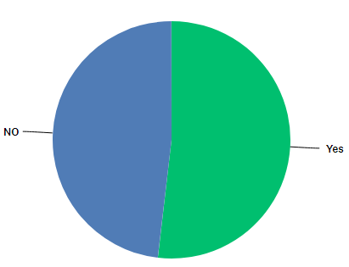

# Q2: How do you describe your level of expertise?

# 

# Q3: If you hear "Artificial Intelligence", what comes to your mind ?

# 

# Q4: Have you ever watched science fiction film about artificial intelligence?

# 

# Q5: Have you ever seen one of the following films?

# 

# Q6: Most of AI films predicted that robots will destroy human's race. Do you agree ?

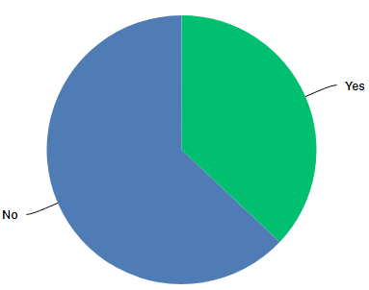

# Q7: Do you think that AI such as robots can not lead to real risk in future?

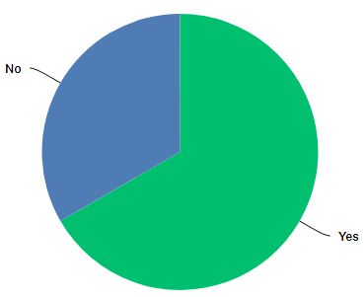

# Q8: What do you think about use of robots in our daily life?

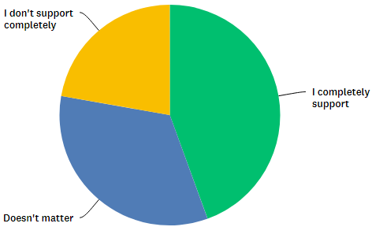

# Q9: Do you think that we could live in a world that entirely depend on robots ?

