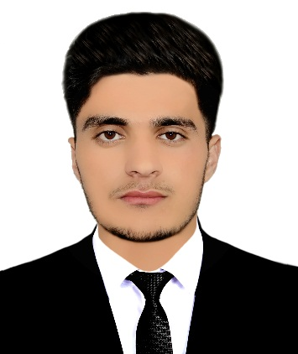

Summary
Provide analysis data in a company as a data operator, IT officer, Microsoft solution Engineer, Finance, I am a hard-working and professional qualified in IT, with 3 years of experience in this role, I am self-motivated and also enjoy working with others in a team, and enjoy doing individuals projects too.

Skill Highlights
- MOS Specialist  - Strong decision maker  - Graphic Designer | - Creative design  - Innovative  - Service-focused

Experience
01/2018 - 01/2020
Computer Teacher, Amin Institute of Modern Education, Jalalabad
Responsibilities:
- Help students learn different computer related skills based on case by case grade level.
- teaching students and employees about technical topics such as computer systems, servers, network hardware and workstation.
15/03/2023–to-15/03/2024
Computer lab Manager, at S.M.I (Scientific Medical Internet)
- Install, configure and troubleshoot hardware and software.
- Monitor and maintain computer system and networks.
- Provide system administration and maintenance.
Library manger, At S.M.I (Scientific Medical institute) 2023 up to now.

IT Assistant At Scientific Medical institute From.

Education
Graduated 2023
12 years, Nangarhar High School of Jalalabad, Afghanistan
NOW!
I Study BBA in A.U (Aryana university)

MASOOD KHALILI

Contact
Address:
Zirani Village, Jalalabad, Nangarhar

Phone:
+93 (0) 782629 438
+93 (0) 796453722

Email:
Masookhalili426@gmail.com

Languages
Pashto – Excellent
Dari – Very Good
English – Very Good

Certifications
MCSE (Microsoft Certified Solution Engineer)
DIT (Diploma in Information Technology)
DEL ( Diploma in English Language)
Madrassa Talimul-quran Walhadis

