Data Analysis Final Project (G2)

This project implements a SQL Server Data Warehouse for the AdventureWorks2022 database using the Medallion Architecture (Bronze, Silver, and Gold layers). It extracts, cleans, transforms, and integrates sales data into a star schema optimized for business intelligence and reporting, enabling efficient analysis of products, customers, sales performance, and geographic trends.
Members
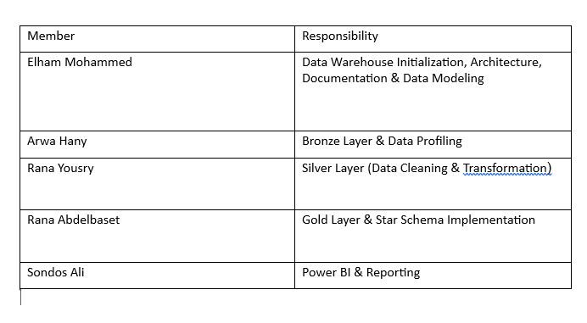

- Business Context
Business Context
AdventureWorks is a company that manufactures and sells bicycles, bicycle components, and accessories through both individual customers and reseller stores. The company records large volumes of operational data from sales, products, customers, shipping, and geographic locations. Although this transactional data supports daily business operations, it is not optimized for analytical reporting or business intelligence.
The objective of this project is to build a Data Warehouse using the Medallion Architecture (Bronze, Silver, and Gold layers). The project transforms raw operational data into clean, integrated, and business-friendly datasets that support decision-making and interactive reporting.
The final solution enables business users to analyze sales performance across products, customers, sales channels, territories, and time periods. It also provides a reliable foundation for Power BI dashboards that help management monitor key performance indicators (KPIs), identify sales trends, evaluate customer behavior, and support strategic business decisions.
Business Objectives
The main objectives of this project are:
- Build a centralized Data Warehouse from the AdventureWorks operational database.
- Improve data quality through data profiling and cleansing.
- Integrate data from multiple business entities into a consistent analytical model.
- Design a Star Schema to simplify analytical queries.
- Support business intelligence reporting using Power BI.
- Enable faster and more reliable business decision-making.

- Data Source
The data used in this project comes from the AdventureWorks2022 sample database, which is a Microsoft SQL Server Online Transaction Processing (OLTP) database. The database simulates the daily operations of a manufacturing and retail company and contains detailed information about customers, products, orders, sales, shipping, and geographic locations.
- Bronze Layer Data Profiling
Before starting the ETL transformation process, the Bronze layer was profiled to assess the quality of the source data. Several validation checks were performed to identify potential issues such as duplicates, missing values, invalid data, inconsistent categories, and broken relationships. The results of these checks were used to determine the appropriate cleaning actions before moving the data to the Silver layer.
Test 1: Duplicate Primary Keys
Objective
Verify that primary keys are unique.
SQL Used

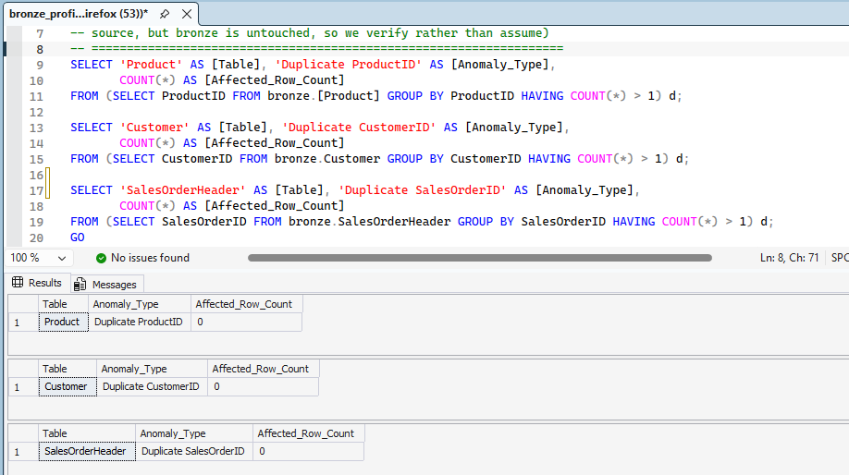
Result

- Duplicate ProductID = 0
- Duplicate CustomerID = 0
- Duplicate SalesOrderID = 0

Decision
No action was required because all primary keys are unique.

Test 2: Numeric Value Validation
Objective
Validate business rules for numeric fields.
SQL Used

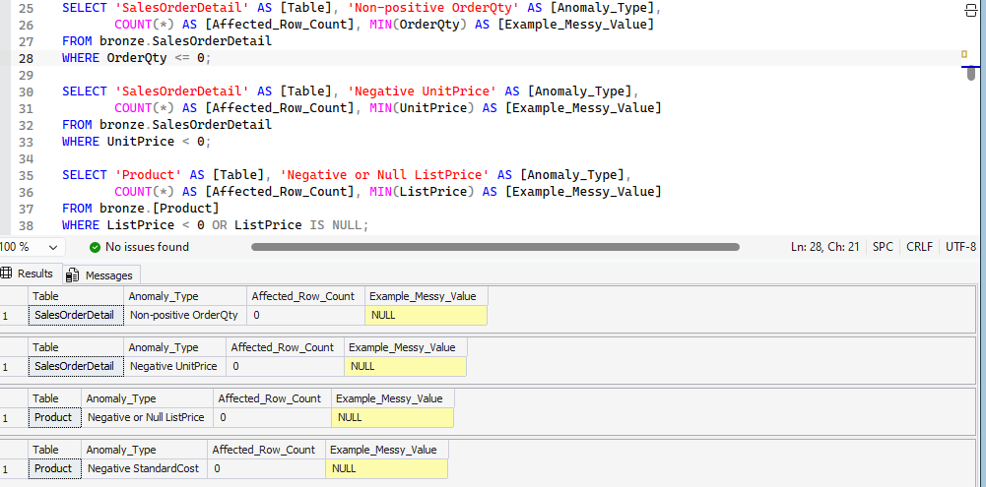
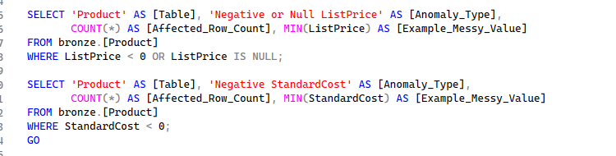

Result


All checks returned 0 invalid records.

Note: Whenever Example_Messy_Value appears as NULL, it does not indicate missing data. It simply means that no records violated the validation rule, so there was no invalid value to display.
Decision
No cleaning was required because all numeric values satisfy the business rules.

Test 3: Date Validation
Objective
Check that business dates follow the correct sequence.
SQL Used
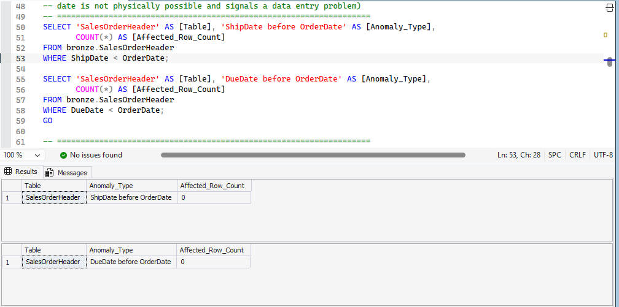

Result

Both checks returned 0 records.

Decision
No action was required because all dates are logically consistent.

Test 4: Missing Values Inspection
Objective
Identify missing values in important columns.
SQL Used
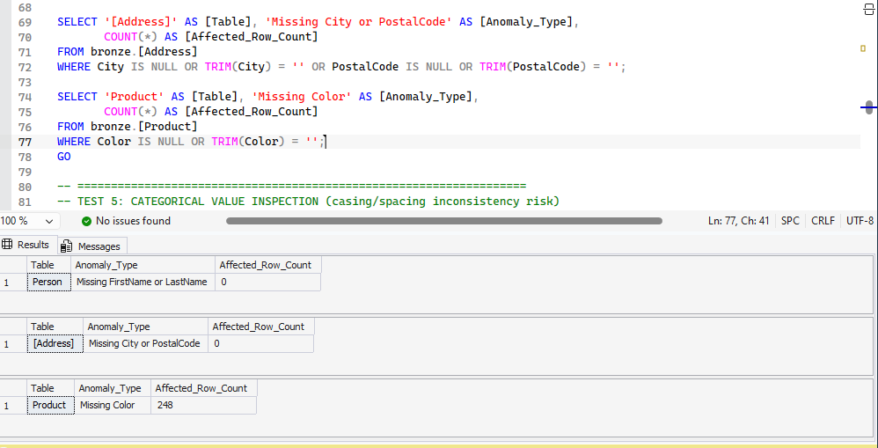
Result


- Missing FirstName/LastName = 0
- Missing City/PostalCode = 0
- Missing Color = 248

Additional Investigation
To understand why Color was missing:

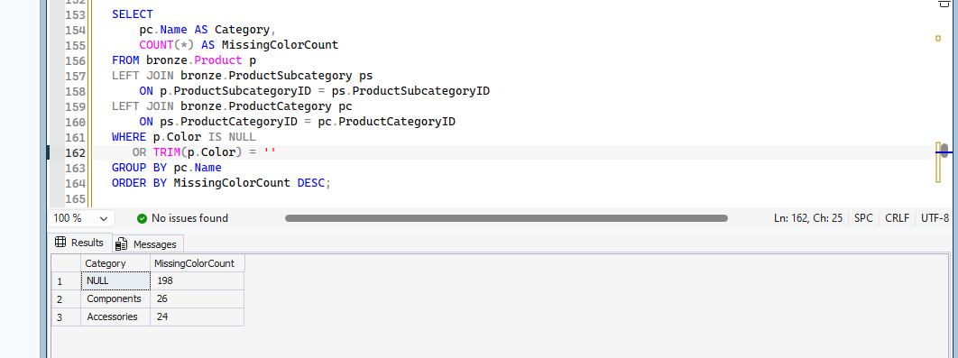
identifying the categories of products with missing colors
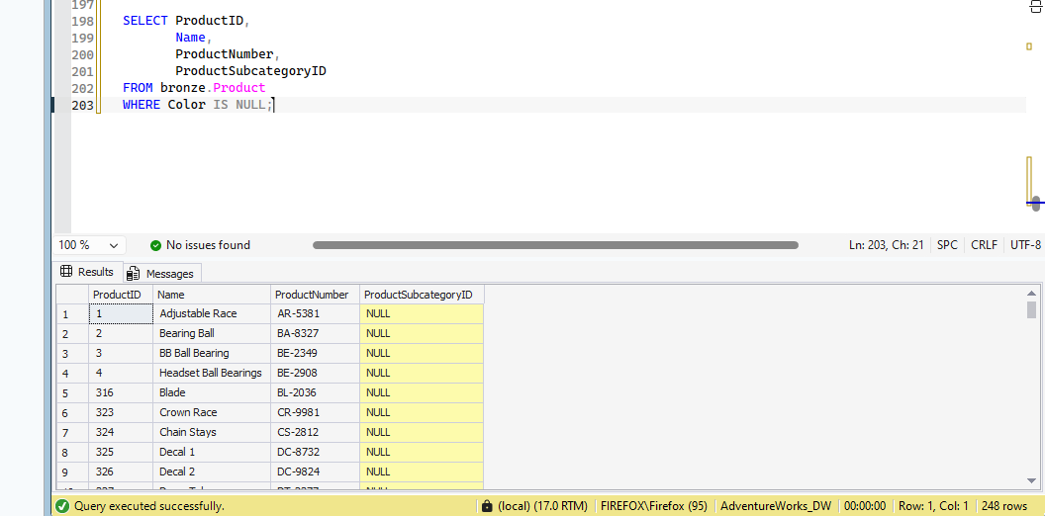
Understanding which products have missing colors
Result
Products such as Bearing Ball, Chainring, Flat Washer, Crankarm, Fork End, and other bicycle components were identified.

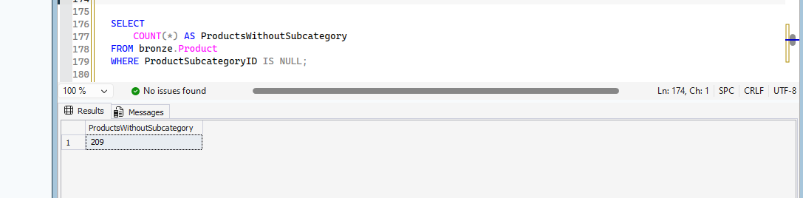
verifying whether products without a subcategory also have missing colors

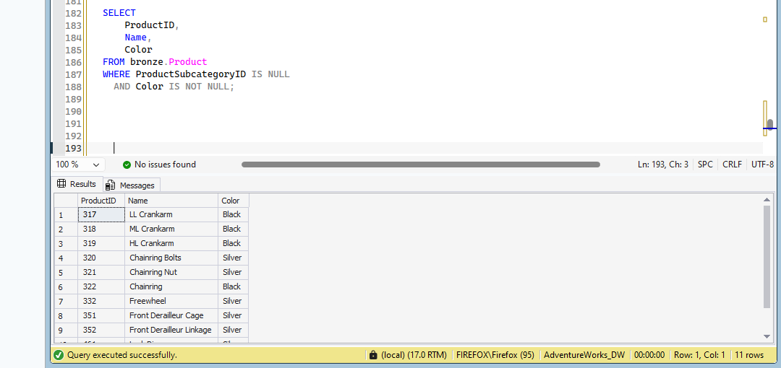
Identifying products without a subcategory but with an assigned color
Result

- 11 products have a valid color (Black or Silver), including products such as LL Crankarm, Chainring, Freewheel, and Lock Ring.

Decision
The profiling identified 248 products with missing Color values. Further investigation showed that most of these products are bicycle components or products without an assigned subcategory. Since Color is an optional descriptive attribute, the missing values do not affect business processes or analytical calculations. Therefore, the records were retained, and the missing values can be replaced with "Unknown" in the Silver layer for reporting purposes

Test 5: Categoprical Value Insection
Objective
Check for inconsistent text values caused by different casing or extra spaces.
SQL Used

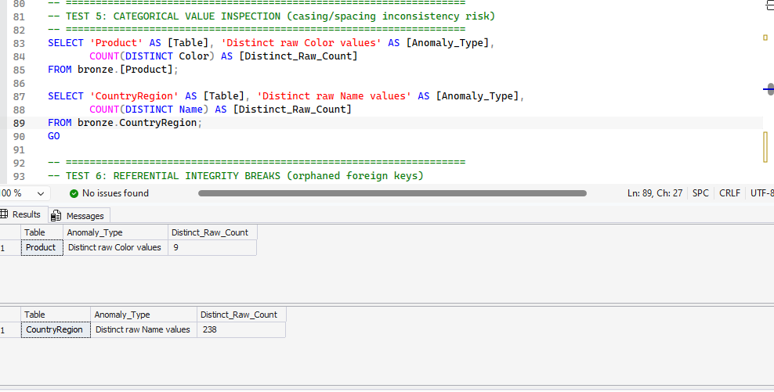



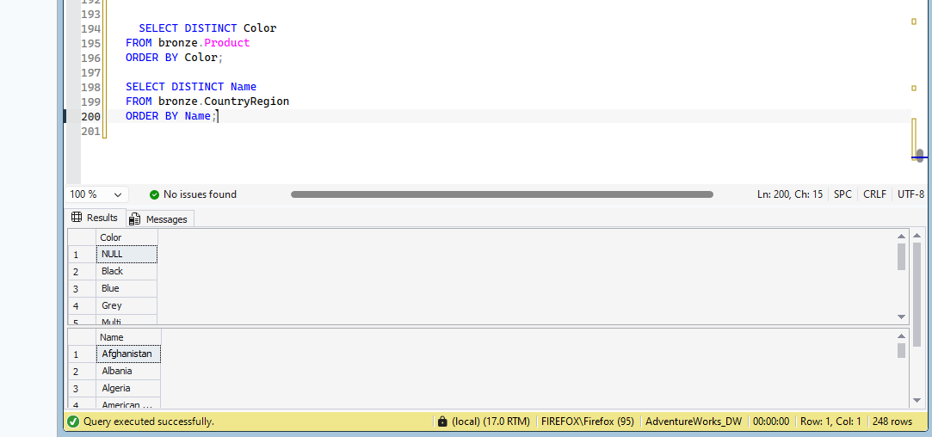
Result:
Result: SELECT DISTINCT confirmed that Product Color contains 9 consistent values and CountryRegion contains 238 unique names. No inconsistencies related to casing, spacing, or spelling were found. Therefore, no standardization was required.

Decision
No standardization was required.

Test 6: Referential Integrity Validation
Objective
Verify that all foreign keys reference existing parent records.
SQL Used
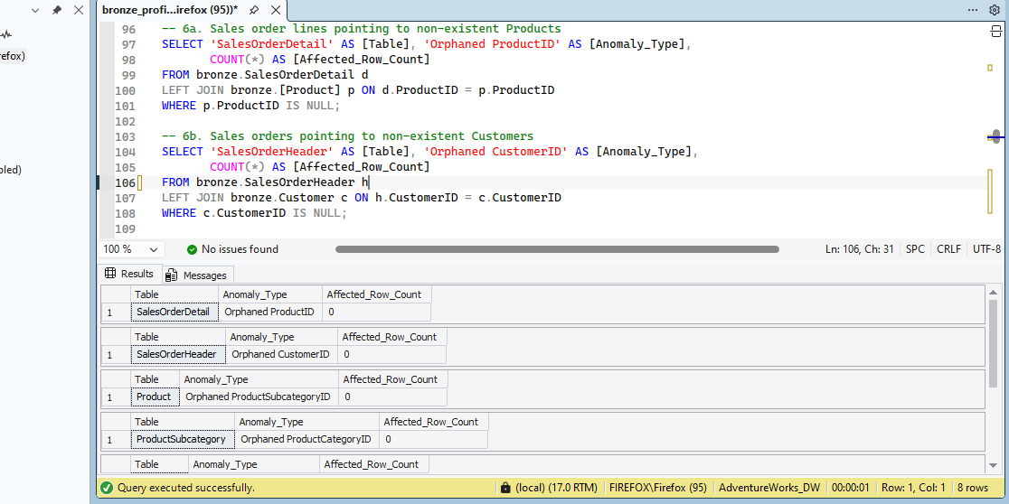

Result


All referential integrity checks returned 0 orphan records.
Decision
No action was required because all relationships are valid.

Profiling Conclusion
The data profiling process confirmed that the Bronze dataset is largely clean and consistent. Most validation tests passed without identifying any data quality issues. The only finding was missing values in the Color attribute, which were determined to be non-critical after further investigation. Since Color is an optional descriptive field, the records were retained, and the missing values may be handled in the Silver layer if needed. Overall, the dataset is ready for the next stage of the ETL pipeline.

4. Data Dictionary
Silver Layer

silver.ProductCategory
Top-level product classification (e.g. Bikes, Components, Clothing,
Accessories).
column | Description
ProductCategoryID | Primary key, unique category identifier
Name | Category name, standardized to uppercase

silver.ProductSubcategory
Second-level product classification, nested under a category.
Column | Description
ProductSubcategoryID | Primary key, unique subcategory identifier
ProductCategoryID | Foreign key reference to the parent category
Name | Subcategory name, standardized to uppercase

silver.Product
Cleaned catalog of all AdventureWorks products.
Column | Description
ProductID | Primary key, unique product identifier
Name | Product display name
ProductNumber | Manufacturer/internal product code
Color | Product color; blank values standardized to 'Unknown'
Size | Product size code
Weight | Product weight
ProductLine | Product line code
Class | Product class code
Style | Product style code
StandardCost | Standard manufacturing cost; guarded against negative values
ListPrice | Retail list price; guarded against negative/null values
ProductSubcategoryID | Foreign key reference to the subcategory

silver.SalesTerritory
Sales regions used to attribute revenue geographically.
Column | Description
TerritoryID | Primary key, unique territory identifier
Name | Territory display name
CountryRegionCode | Country code the territory belongs to
Group | Higher-level regional grouping (e.g. North America, Europe)
SalesYTD | Year-to-date sales for the territory
SalesLastYear | Prior-year sales for the territory
CostYTD | Year-to-date cost for the territory
CostLastYear | Prior-year cost for the territory

silver.CountryRegion
Reference list of countries/regions.
Column | Description
CountryRegionCode | Primary key, ISO-style country code
Name | Country/region display name

silver.StateProvince
State/province reference data, linked to both country and sales territory.
Column | Description
StateProvinceID | Primary key, unique state/province identifier
StateProvinceCode | Short state/province code
CountryRegionCode | Foreign key reference to the country/region
Name | State/province display name
TerritoryID | Foreign key reference to the sales territory

silver.Address
Cleaned physical address records used for billing and shipping.
Column | Description
AddressID | Primary key, unique address identifier
AddressLine1 | Primary street address line
AddressLine2 | Secondary street address line (optional)
City | City name
StateProvinceID | Foreign key reference to the state/province
PostalCode | Postal/ZIP code

silver.Person
Individual contact records (used for individual customers).
Column | Description
BusinessEntityID | Primary key, unique person identifier
PersonType | Short code identifying the type of person record
Title | Honorific title (Mr., Ms., etc.)
FirstName | First name
MiddleName | Middle name (optional)
LastName | Last name
Suffix | Name suffix (Jr., Sr., etc.), if any
EmailPromotion | Email promotion opt-in level
AdditionalContactInfo | Supplementary contact info, stored as plain XML
Demographics | Demographic survey data, stored as plain XML

silver.Store
Retail store records (used for reseller/store customers).
Column | Description
BusinessEntityID | Primary key, unique store identifier
Name | Store display name
SalesPersonID | Sales representative assigned to the store
Demographics | Store demographic/survey data, stored as plain XML

silver.Customer
Bridge entity linking either a Person or a Store to sales activity.
Column | Description
CustomerID | Primary key, unique customer identifier
PersonID | Foreign key reference to silver.Person (individual customers)
StoreID | Foreign key reference to silver.Store (reseller customers)
TerritoryID | Foreign key reference to the sales territory
AccountNumber | Customer account number

silver.SalesOrderHeader
One row per sales order (order-level information).
Column | Description
SalesOrderID | Primary key, unique order identifier
RevisionNumber | Order revision counter
OrderDate | Date the order was placed
DueDate | Date the order is due
ShipDate | Date the order was shipped
Status | Order status code
OnlineOrderFlag | 1 if placed online, 0 if placed through a sales rep/store
SalesOrderNumber | Human-readable order number
PurchaseOrderNumber | Customer's purchase order reference
AccountNumber | Customer account number on the order
CustomerID | Foreign key reference to the customer
SalesPersonID | Sales representative who processed the order
TerritoryID | Sales territory the order is attributed to
BillToAddressID | Foreign key reference to the billing address
ShipToAddressID | Foreign key reference to the shipping address
ShipMethodID | Foreign key reference to the shipping method
CreditCardID | Foreign key reference to the credit card used
CreditCardApprovalCode | Payment approval code
CurrencyRateID | Currency conversion rate applied
SubTotal | Order subtotal before tax/freight
TaxAmt | Tax amount
Freight | Freight/shipping charge
TotalDue | Total amount due
Comment | Free-text order comment

silver.SalesOrderDetail
One row per line item within a sales order.
column | Description
SalesOrderDetailID | Primary key, unique line item identifier
SalesOrderID | Foreign key reference to the parent order
CarrierTrackingNumber | Shipping carrier tracking number
OrderQty | Quantity ordered; guarded to be strictly positive
ProductID | Foreign key reference to the product
SpecialOfferID | Promotional offer applied to the line
UnitPrice | Price per unit; guarded to be non-negative
UnitPriceDiscount | Discount rate applied to the unit price
LineTotal | Total value of the line item

silver.ShipMethod
Reference list of shipping methods and their base rates.
Column | Description
ShipMethodID | Primary key, unique shipping method identifier
Name | Shipping method display name
ShipBase | Base shipping charge
ShipRate | Per-unit shipping rate

silver.CreditCard
Reference list of credit cards used for payment.
Column | Description
CreditCardID | Primary key, unique credit card record identifier
CardType | Card brand/type (Visa, MasterCard, etc.)
CardNumber | Card number (sensitive data -- consider masking in reporting)
ExpMonth | Expiration month
ExpYear | Expiration year

gold Layer
- gold.FactSales (Fact Table)
Fact table containing sales transactions at the order line level
Column | Description
SalesDetailKey | Unique identifier for each line item within a sales order.
- OrderKey | Foreign Key referencing the specific sales order header identifier.
OrderDateKey | Foreign Key referencing DimDate for order placement date (YYYYMMDD).
DueDateKey | Foreign Key referencing DimDate for payment due date (YYYYMMDD).
ShipDateKey | Foreign Key referencing DimDate for shipping date (YYYYMMDD).
DueDateKey | Foreign Key referencing DimDate for payment due date (YYYYMMDD).
ShipDateKey | Foreign Key referencing DimDate for shipping date (YYYYMMDD).
SK_Customer | Surrogate Key referencing the customer in DimCustomer.
SK_Product | Surrogate Key referencing the purchased product in DimProduct.
ShipGeographyKey | Surrogate Key referencing shipping destination in DimGeography
SK_ShipMethod | Surrogate Key referencing shipping method in DimShipMethod.
SK_CreditCard | Surrogate Key referencing credit card details in DimCreditCard.
SalesChannel | Indicator label denoting order origin ('Online' or 'Reseller / Store').
OrderQuantity | Number of units ordered for the specific line item.
UnitPrice | Selling price per unit of product.
UnitPriceDiscount | Discount amount applied per unit.
LineTotal | Extended total revenue for the line item after discounts.
OrderSubTotal | Order revenue subtotal before tax and shipping charges.
TaxAmount | Total tax amount billed for the sales order.
Freight | Total shipping fee charged for the sales order.

- gold.DimProduct
SK_Product | Primary Surrogate Key representing each individual product version.
ProductID | Original business identifier for the product.
ProductName | Official commercial name of the product.
ProductNumber | Unique alphanumeric product code.
ProductColor | Color attribute of the product.
Size | Size measurement attribute of the product.
Weight | Weight attribute of the product.
ProductLine | High-level product line category flag.
Class | Product quality or price class rating
Style | Design style category
StandardCost | Standard manufacturing or acquiring cost of the product.
ListPrice | Recommended retail listing price.
SubcategoryName | Subcategory group name for the product.
CategoryName | Top-level parent category name for the product.
StartDate | Effective start date for the record version (SCD Type 2).
EndDate | Expiration date for historical record versions (SCD Type 2).
IsCurrent | Active status flag (1 = Current active record, 0 = Historical).

3. gold.DimCustomer
SK_Customer | Primary Surrogate Key identifying each unique customer record.
CustomerID | Original business entity identifier for the customer account.
PersonID | Individual person business entity ID (NULL if reseller).
StoreID | Reseller store business entity ID (NULL if individual).
TerritoryID | Identifier for customer's assigned sales region
AccountNumber | Unique system account number assigned to the customer.
CustomerName | Full combined individual name or store company name.
StoreName | Retail store name or default label for individual accounts.
CustomerType | Account type flag ('Individual', 'Store', or 'Store & Individual').
StartDate | Effective start date for customer record version.
EndDate | Expiration date for historical customer record version.
IsCurrent | Flag indicating if customer record is currently active (1/0).

4. gold.DimGeography
SK_Geography | Primary Surrogate Key referencing a specific geographical address.
AddressID | Original system identifier for physical street address.
AddressLine1 | Primary street address line.
AddressLine2 | Secondary address detail (apt, suite, building).
City | Name of the city location.
StateProvinceID | Internal system ID for state or province
StateProvinceCode | Standard ISO code for state or province.
StateProvinceName | Full official state or province name.
CountryRegionCode | Full official name of the country.
CountryRegionName | Full official name of the country.
TerritoryID | Identifier for regional sales territory.
Territoryname | Name of assigned sales territory
TerritoryGroup | Continental or regional group for territory.

  - gold.DimShipMethod

SK_ShipMethod | Primary Surrogate Key for shipping method.
ShipMethodID | Original business identifier for shipment provider.
ShipMethodName | Commercial shipping option name.
ShipBase | Fixed base shipping charge fee.
ShipRate | Variable shipping fee rate per unit weight.

  - gold.DimCreditCard
SK_CreditCard | Primary Surrogate Key for credit card entry.
CreditCardID | Original business identifier for payment card.
CardType | Credit card brand type
CardNumber | Encrypted/masked credit card account number.
ExpMonth | Credit card expiration month
ExpYear | Credit card expiration year

  - gold.DimDate

DateKey | Primary integer key representing calendar date (YYYYMMDD).
Date | Standard calendar date value.
Year | Four-digit calendar year value.
Quarter | Numerical quarter of the year (1 through 4).
Month | Numerical month index (1 through 12).
MonthName | Full text name of month
Day | Day of the month (1 through 31).
DayOfWeek | Numerical index of day of the week (1 through 7).
DayName | Full name of weekday.

- How to Run the Project End-to-End

Follow the steps below to execute the complete ETL pipeline:

- Restore the AdventureWorks2022 database using the provided backup file (AdventureWorks2022.bak).
- Run initialize_db.sql
  - Creates the Data Warehouse database.
  - Creates the Bronze, Silver, and Gold schemas.
- Run bronze_load.sql
  - Extracts data from the AdventureWorks2022 source database.
  - Loads raw data into the Bronze layer without any transformations.
- Run bronze_profiling.sql
  - Performs data profiling to identify duplicates, NULL values, invalid data, and referential integrity issues.
- Run silver_clean.sql
  - Cleans and standardizes the Bronze data.
  - Applies business rules and creates the Silver layer.
- Run gold_views2_final.sql
  - Creates the Gold layer views.
  - Builds the dimensional model (Fact and Dimension views) for analytics.
- Open the Power BI report
  - Connect Power BI to the Gold layer.
  - Refresh the dataset.
  - Verify that the dashboard loads successfully.

