Option: Capstone Project

Git repository: <https://github.com/elhamvei/MobileAppG12>

Rentitus

Rentitus Mobile Application

Rentitus is an online platform to lend and rent item. For this project we built mobile application.

Group 12 Members:

|  |  |
| --- | --- |
| Name (first name, last name) | Student ID |
| 1. Abdelaziz Omar | 101292570 |
| 1. Artem Elagin | 101205569 |
| 1. Elham Veisouei | 101277407 |
| 1. Lale Mulati | 101255734 |
| 1. Mehlika Tozlu | 101337672 |

Rentitus Mobile Application Functionality (edited based on the project requirement):

(1) Application should store (add/edit/remove) the following information host

• Name – name of the host.

• Address – address of the item, your application should help user with proper

formatting

• Phone(s) – phone number(s)

• Description – description entered by the lender

• TAGs – an extensible list of tags (filters) like: kitchen, living room, office, party….

(2) Application should allow user to rate the lender (add/edit). You can use e.g. 1-5 stars system

(3) Application should allow user to show the location of the item on the map and get

direction from the current place using Google API

(4) Application should provide an option to share information about the item using email (5

pts bonus for Facebook sharing, 5 pts bonus for Twitter sharing)

(5) Application should provide search capabilities based on:

• name

• tags

(6) Application should have a list of items

(7) Selecting a restaurant from the list user should be presented with the Details screen

(8) User should have an option to see a full-screen map with the location of the items.

(9) User should have an option to get directions from users current location to the item.

(10) User should have an option to share information about the restaurant from the Details screen

(11) Application should have About screen with names of all team members

(12) Application should have a Splash screen with application logo

Logo:



Logo & members page

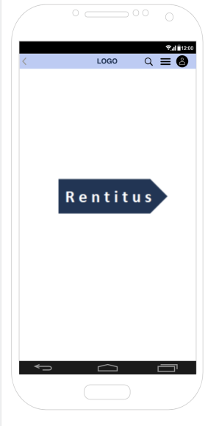 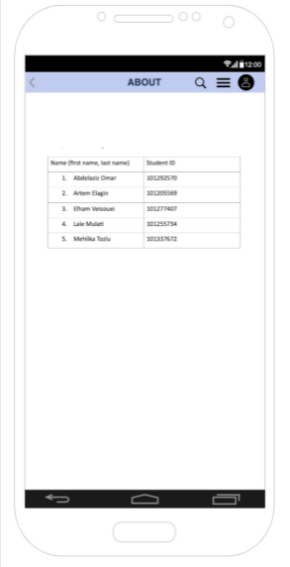

1. Home page. Home page we display the available items as a list with the name and price tag. After user click the items, user will be redirected to the next page (on the right), on this page item has a specific description and price.

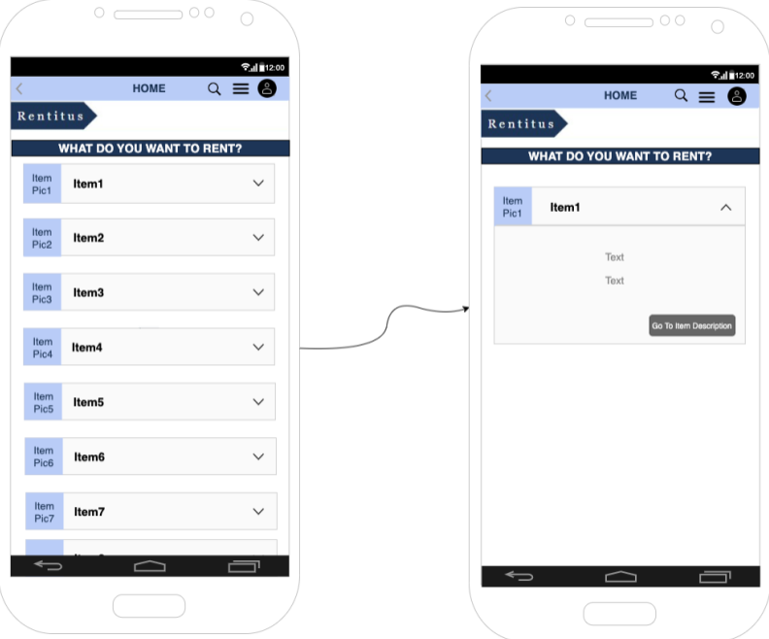

1. Sign-in and sign-up page. Users must sign up and then sign in to rent or list their items. On this page application gather users’ information (name, email, password)

1. Location page. After user clicked item location from the item list app will get direction from the current place using Google API. User can also click other location on the map, and access the host, application redirect the user to chat box.

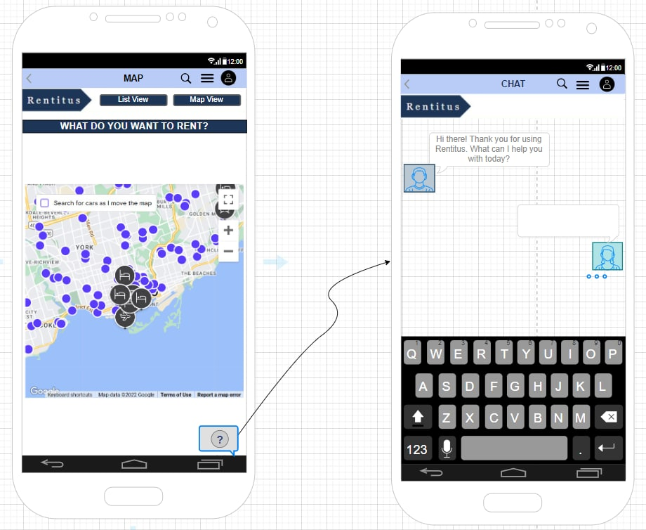

1. Host profile. User can check out host profile and see their review. If user received their service, they can also leave their review under the item “Customer review” page.

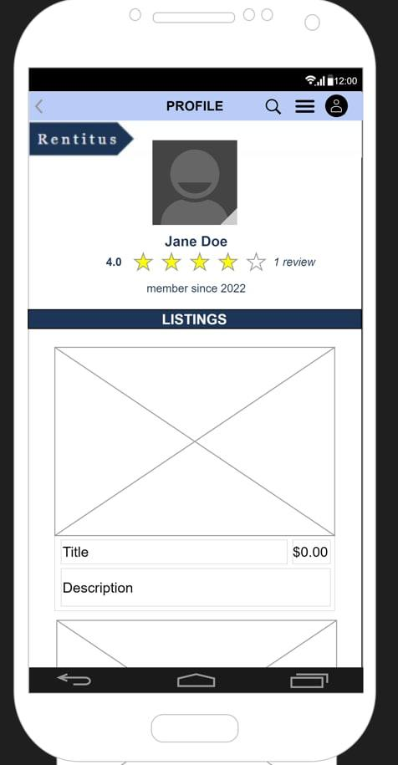 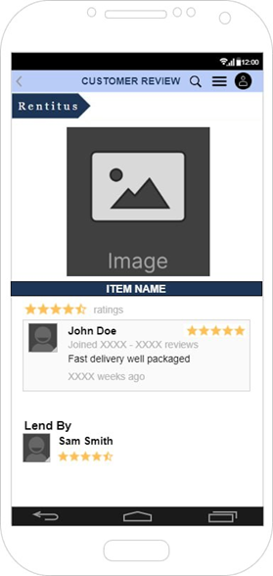

1. Checkout page. Before checkout, user put their items in the shopping cart, they can also adjust their selected items on shopping cart, after click “processed to checkout” box, user redirected to check out page to do the final payment process.

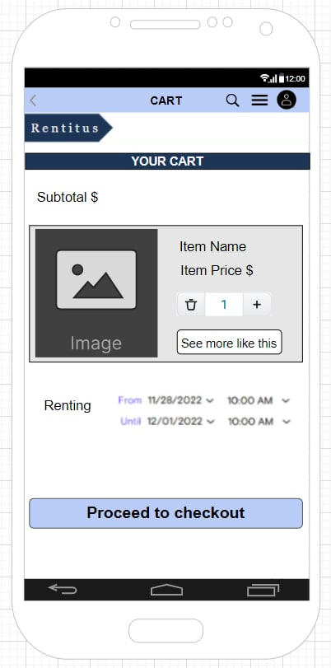 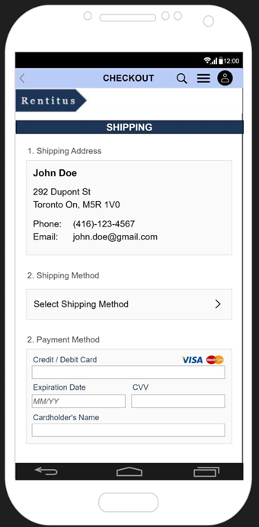

1. Filter page. User can search or find their items by using filter.

