4 SYSTEM ARCHITECTURE

4.1 Introduction
This section describes neostel camera system architecture. Firstly general description is provided. Afterwards software and hardware cooperation and digital system architecture in fpga is presented in detail.

4.2 general overview
From a system point of view, camera is a software – digital system device. What is meant by that is that camera works using software running in a APU (Application processing unit) and hardware implemented in FPGA fabric. Software controls the hardware and hardware provides necessary means for control of systems in a camera such as CCD control and readout and shutter control. Illustration 6 shows camera's system architecture.
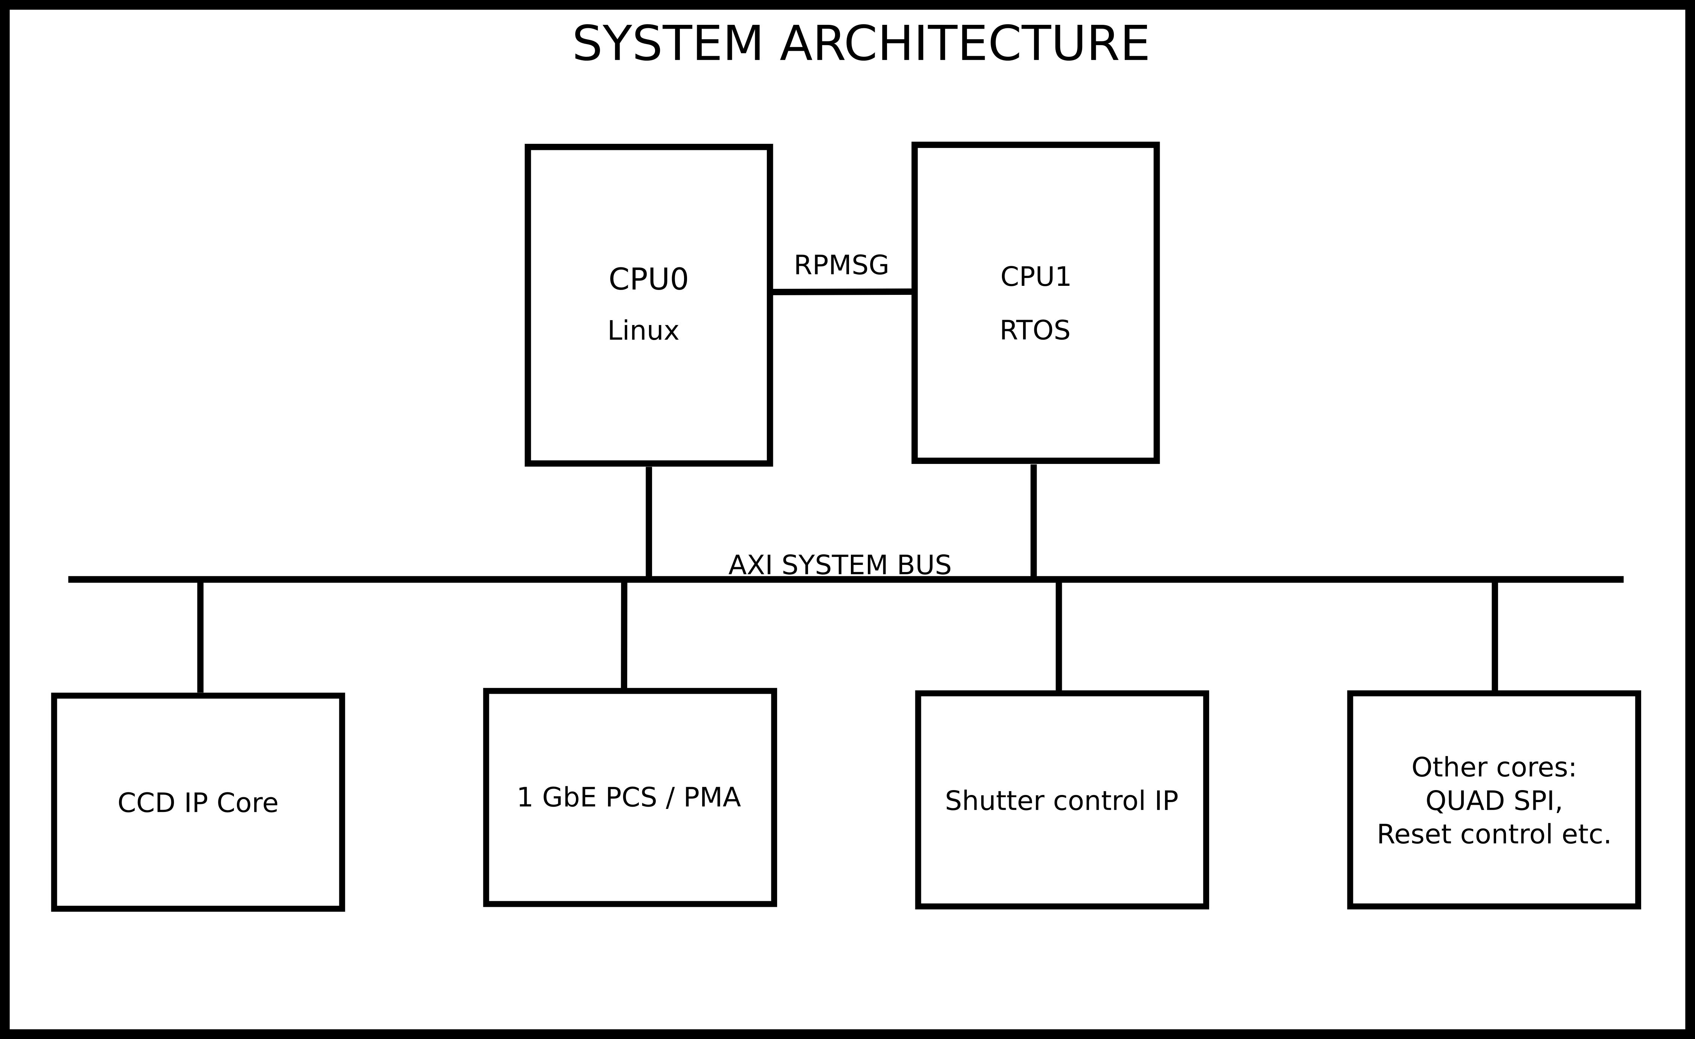

4.3 software based hardware control
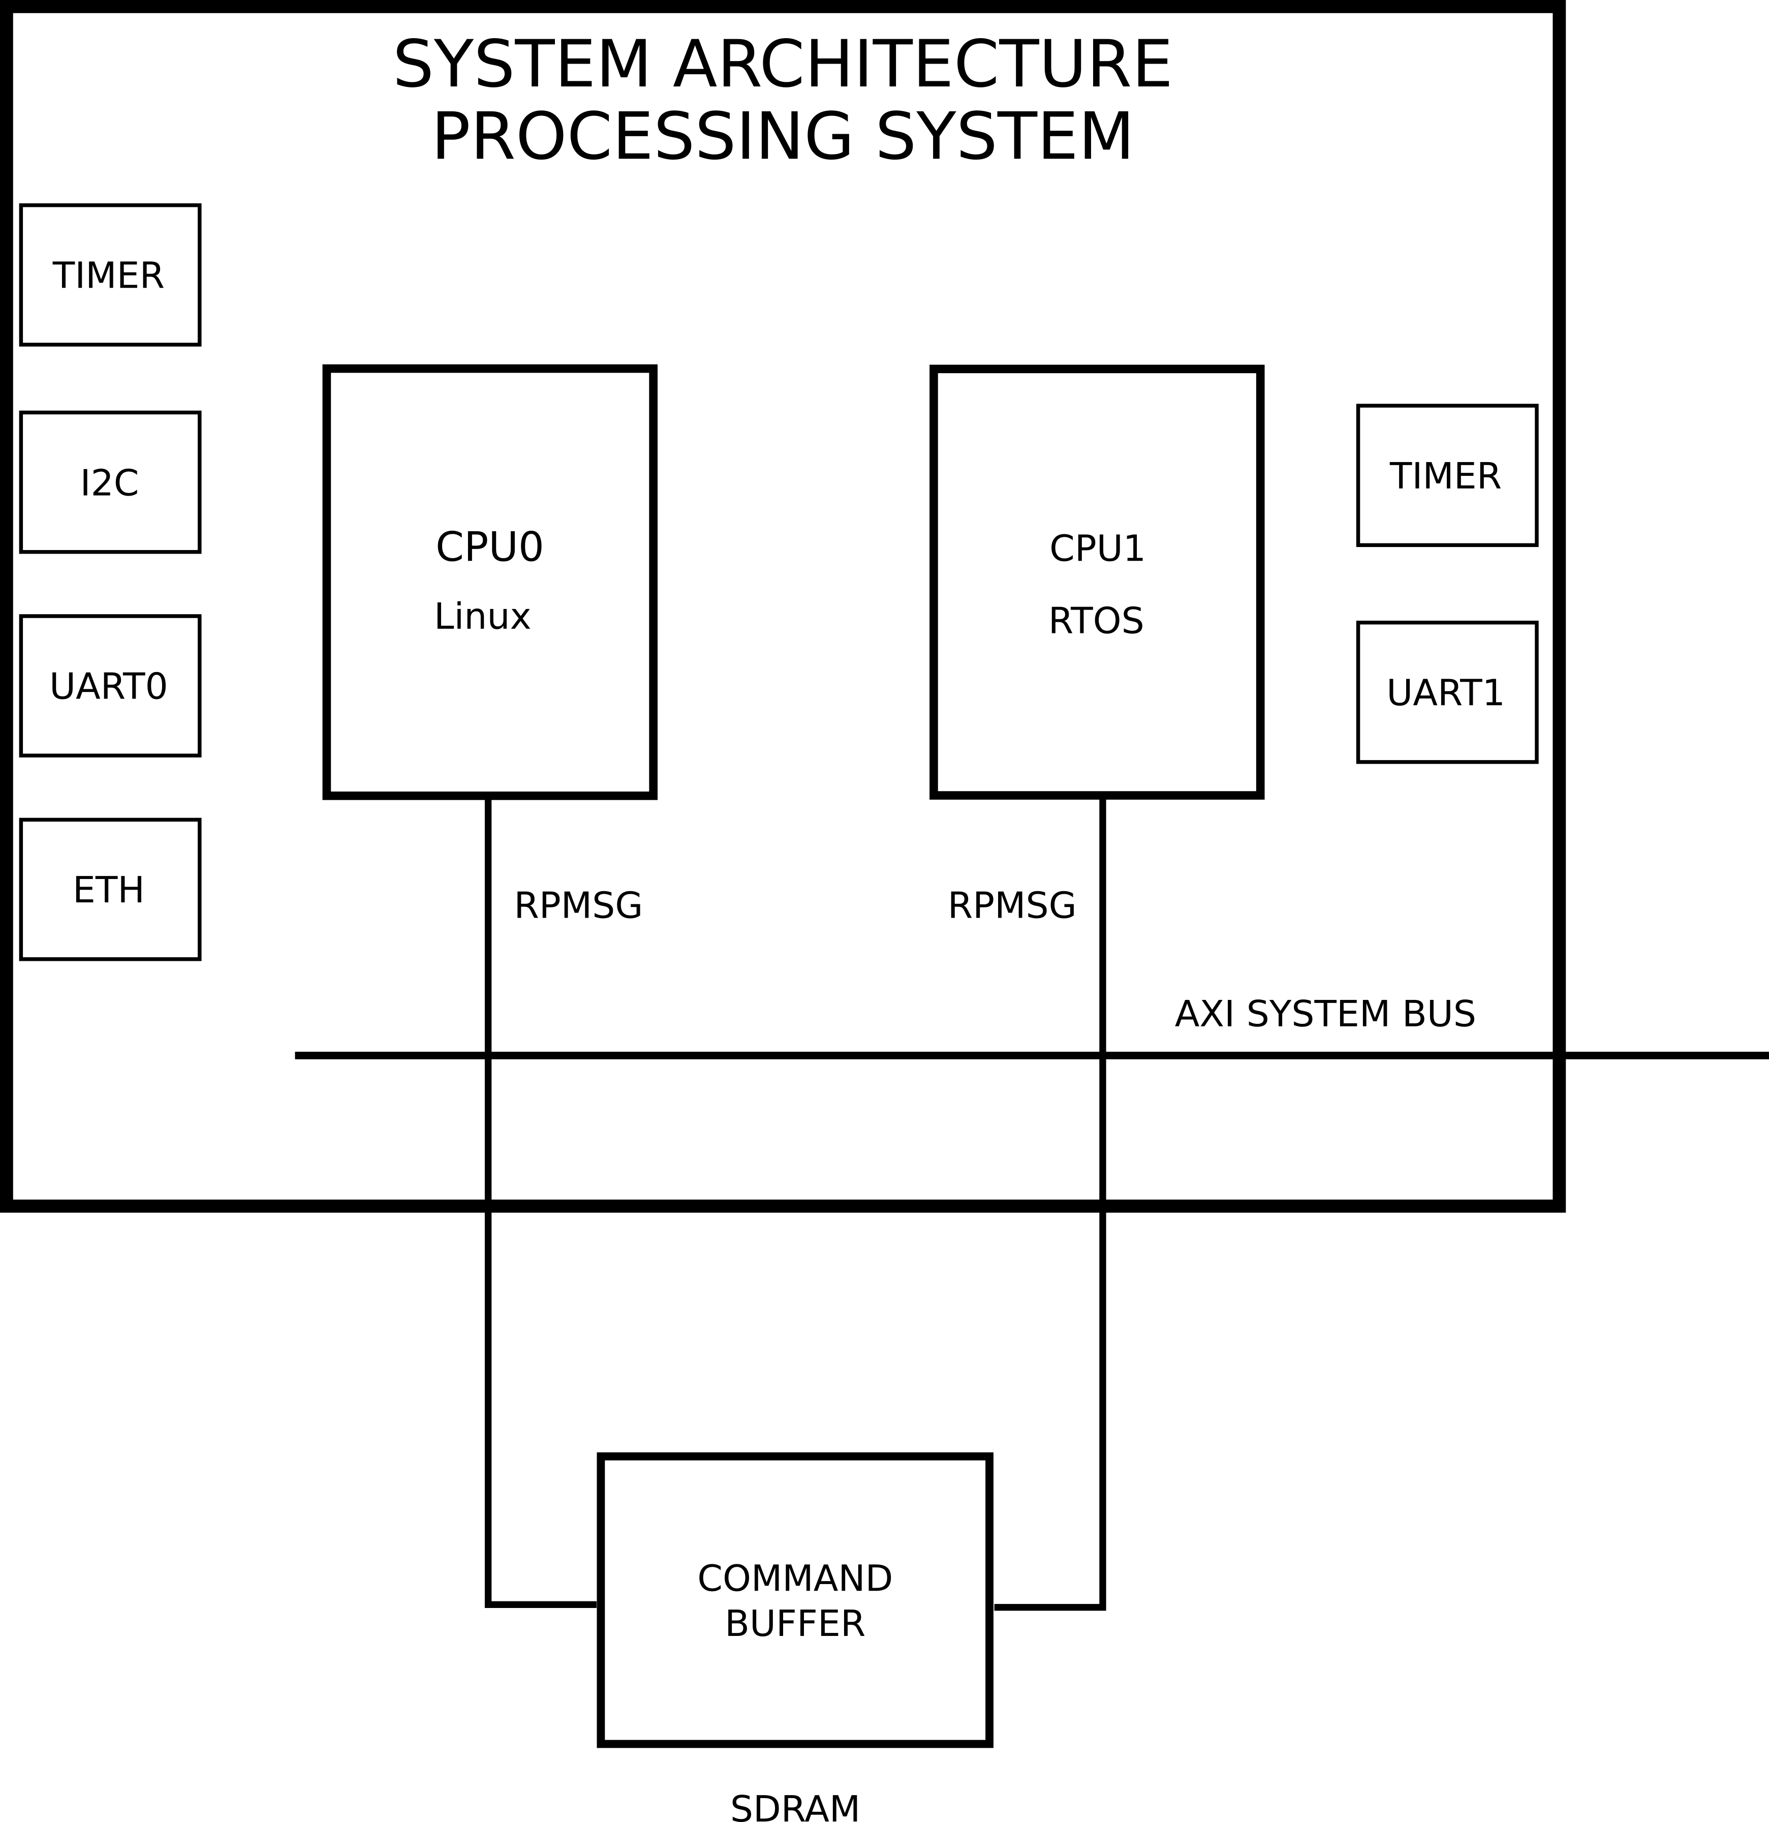

4.4 Digital hardware architecture

DATAPATH
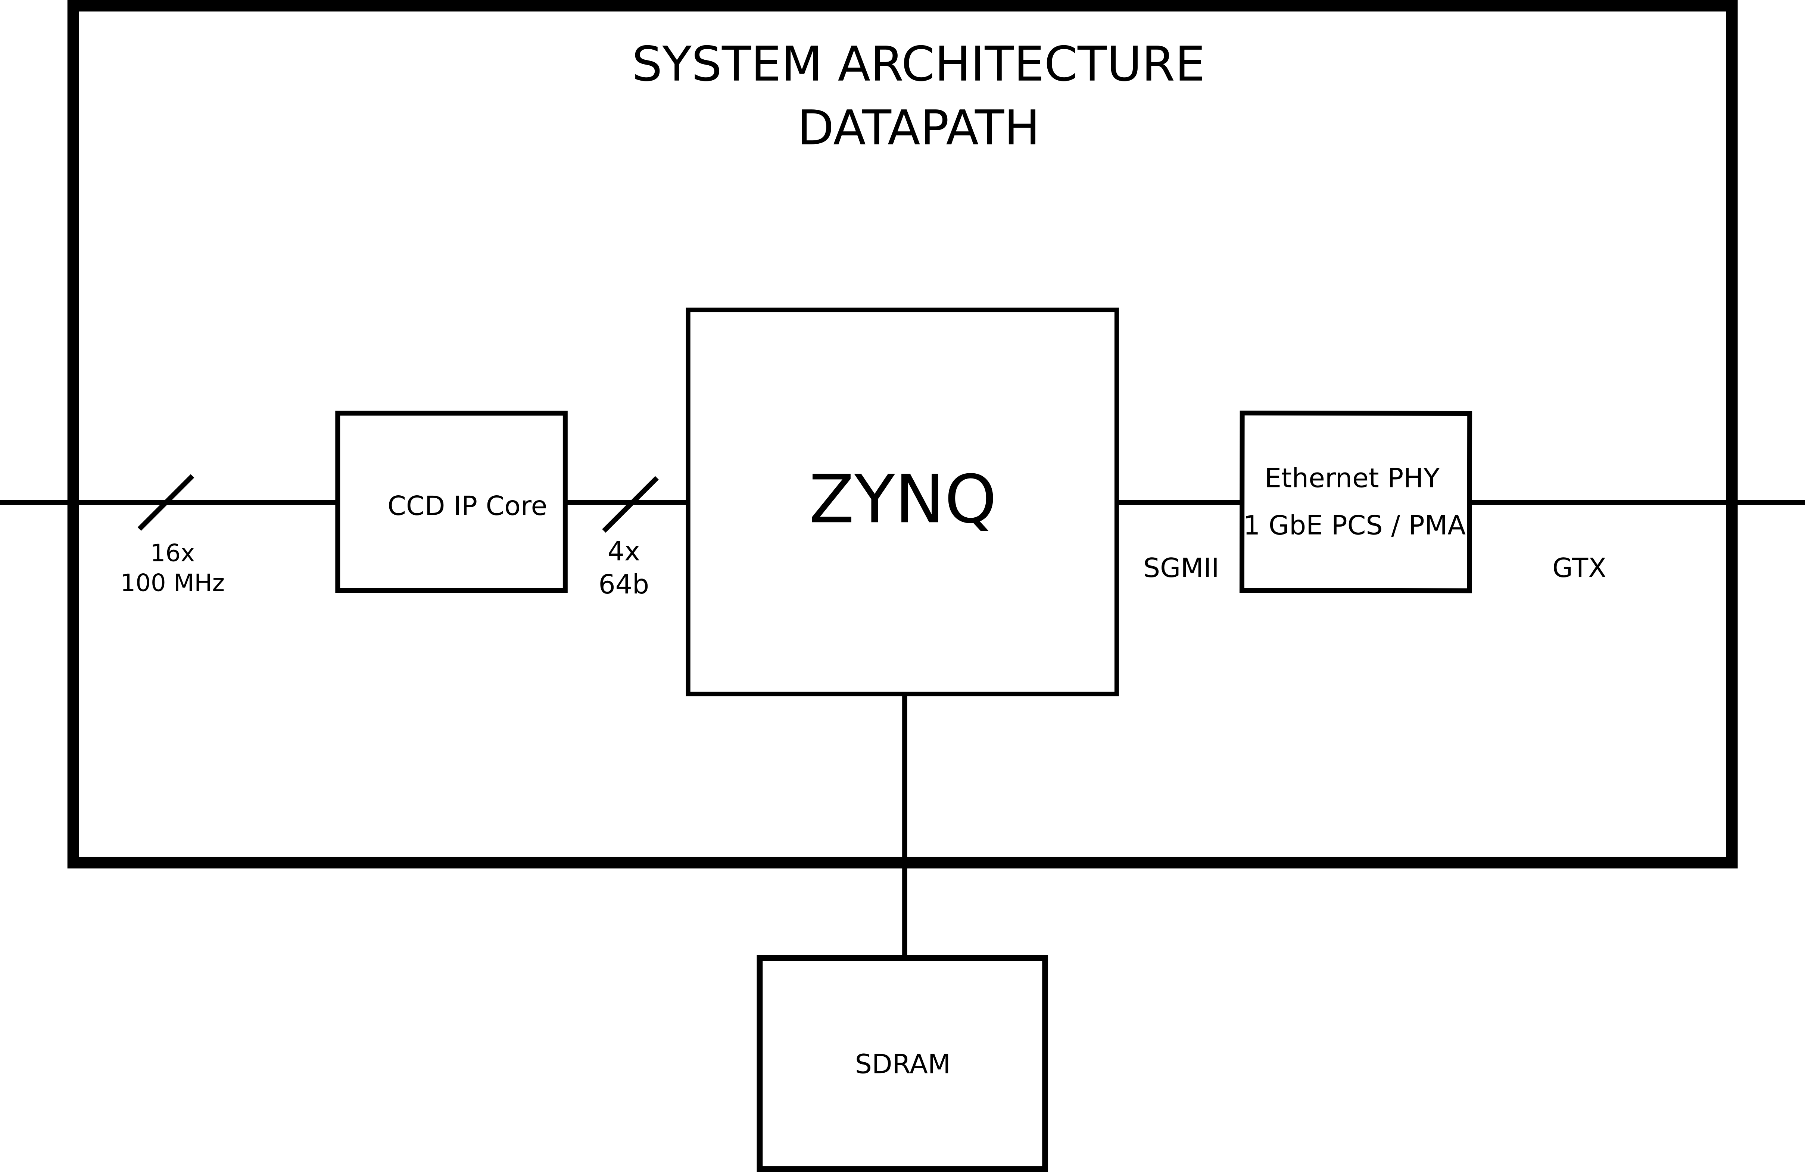

4.4.1 shutter ip core
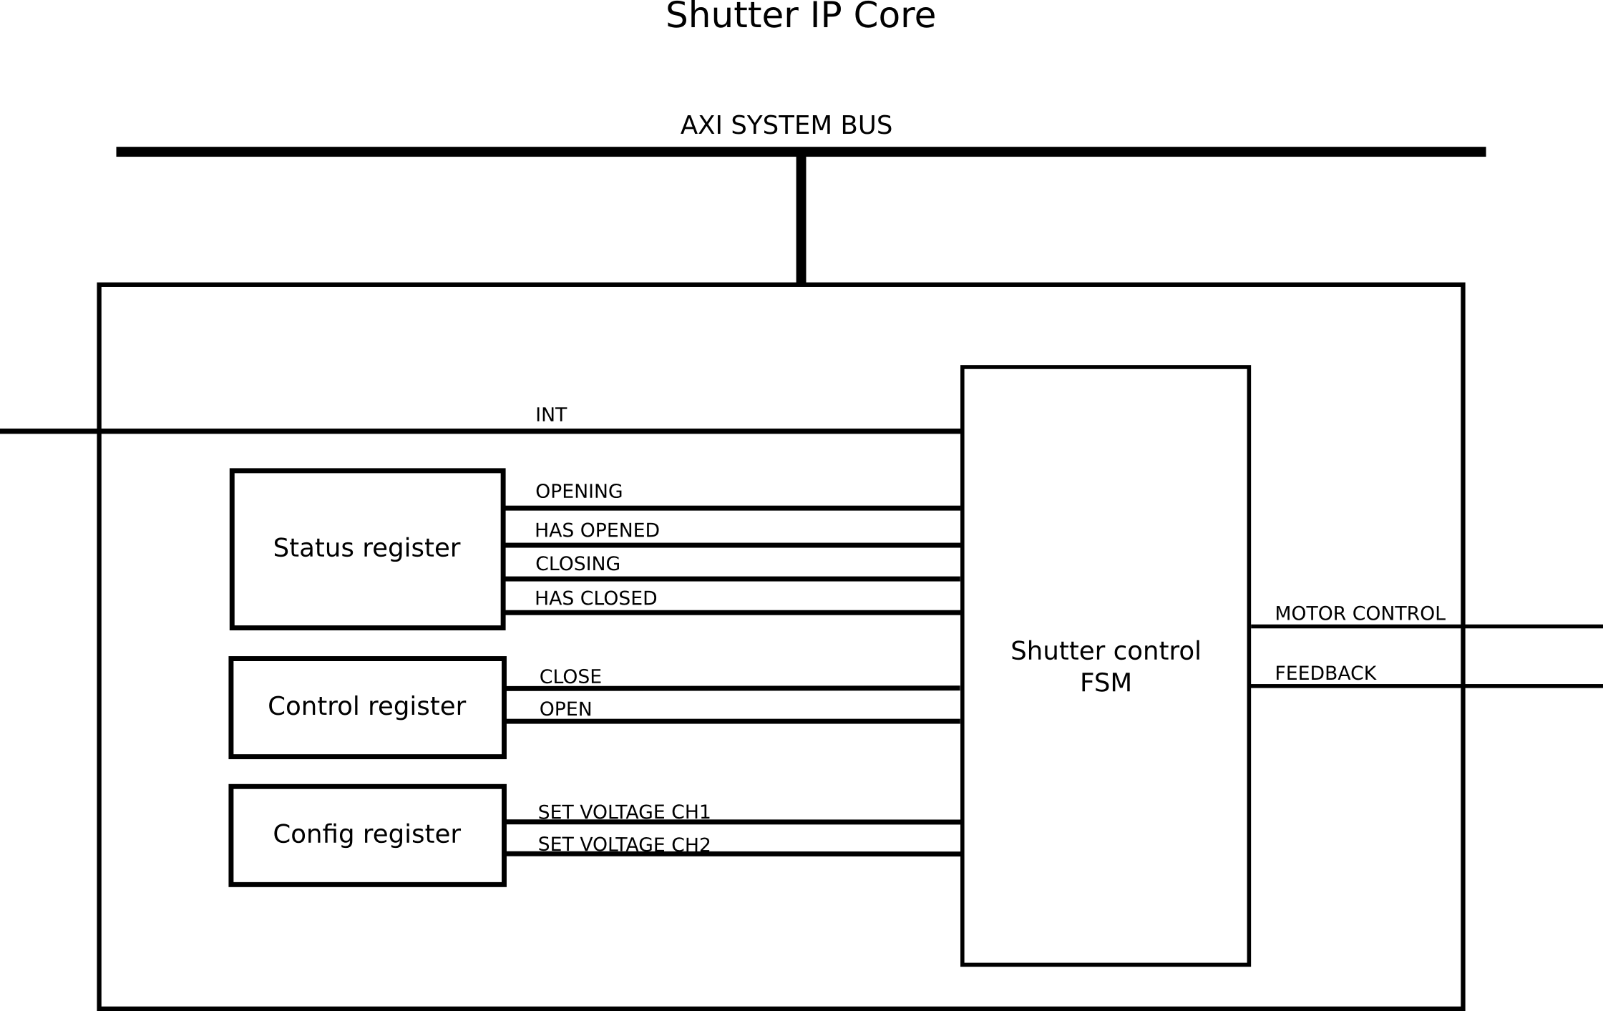

4.4.2 ccd ip core
