4 SYSTEM ARCHITECTURE

4.1 Introduction
This section describes neostel camera system architecture. Firstly general description is provided. Afterwards software and hardware cooperation and digital system architecture in fpga is presented in detail.

4.2 general overview
From a system point of view, camera is a software – digital system device. What is meant by that is that camera works using software running in an APU (Application processing unit) and hardware implemented in FPGA fabric. Software controls the hardware and hardware provides necessary means for control of systems in a camera such as CCD control and readout and shutter control.

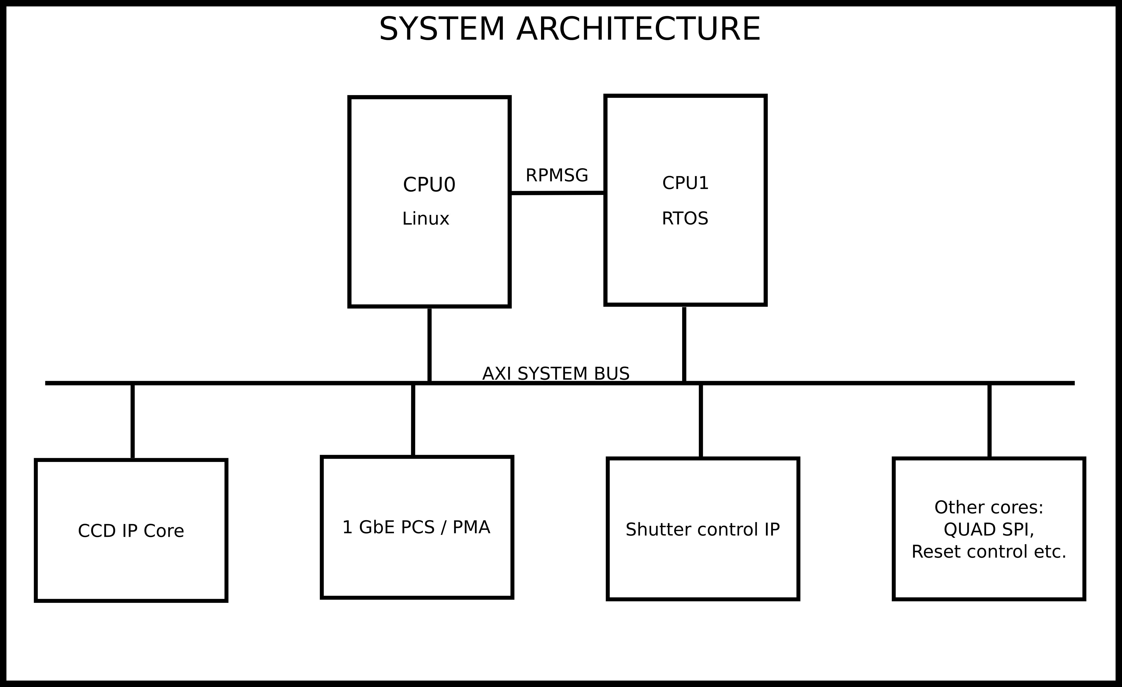

CPU0 runs Linux operating system which provides EPICS standard capabilities and CPU1 runs a Real Time Operating System, both CPUs run independently in an AMP scenario. Linux allows for high level functions for controling camera and RTOS provide soft real time capabilities for taks which require tight timing. Both cores are connected to AXI System Bus, which provides a communication to IP cores for control and data processing.

Main IP cores that are connected to the system bus are:
- CCD IP Core
- Shutter IP core
- Gigabit Ethernet PHY (Xilinx)
- QUAD SPI(Xilinx)
All IP Cores have got control, config and status registers which provide all information about the work of IP Core.

4.3 Assumptions
Main assumptions regarding digital parts are that:
- Single clock domain shall be used for the entire logic
- All IP cores are available via AXI bus
- The latency of

4.3 software based hardware control
Two core scenario provides a fleaxible means for controlling the camera. User can connect directly to the Linux operating system through SSH or other Ethernet beased interface. RTOS is not directly available for user due to safety reasons. Processes running on Linux which provide control for all systems components send command through RPMSG standard to CPU1 in order to issue a specific action. This way there is no deadlock issue in comparison to e.g. semaphores. Each CPU has it's own peripherials to use.
CPU0 can use:
- TIMER (Triple Timer Counter)
- I2C
- UART0
- Ethernet (with PTP)

CPU1 can use:
- Timer (Triple Timer Counter)
- UART1

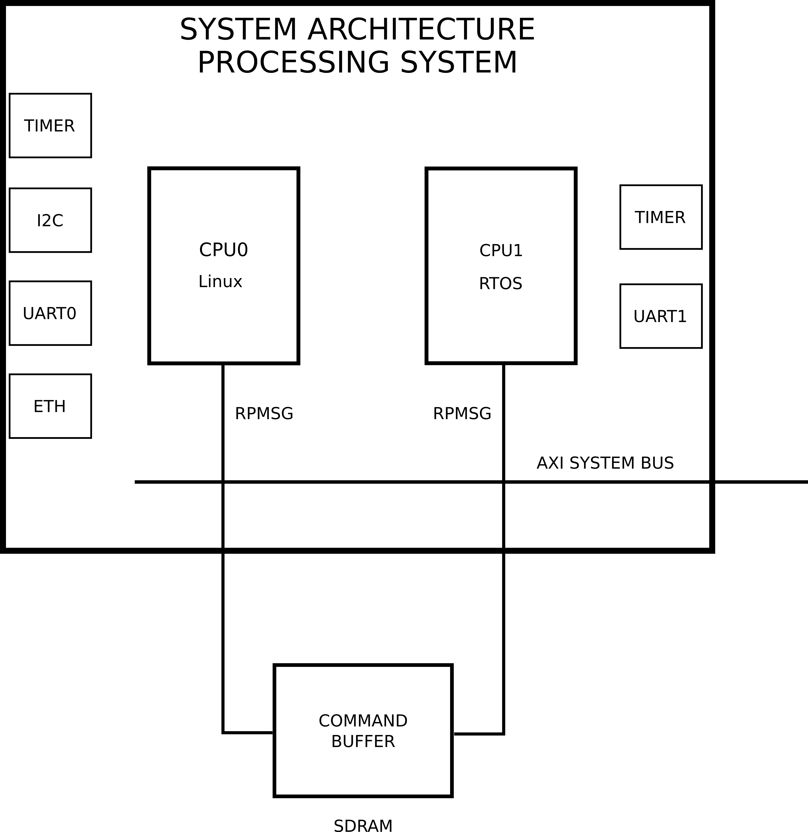

4.4 DATAPATH
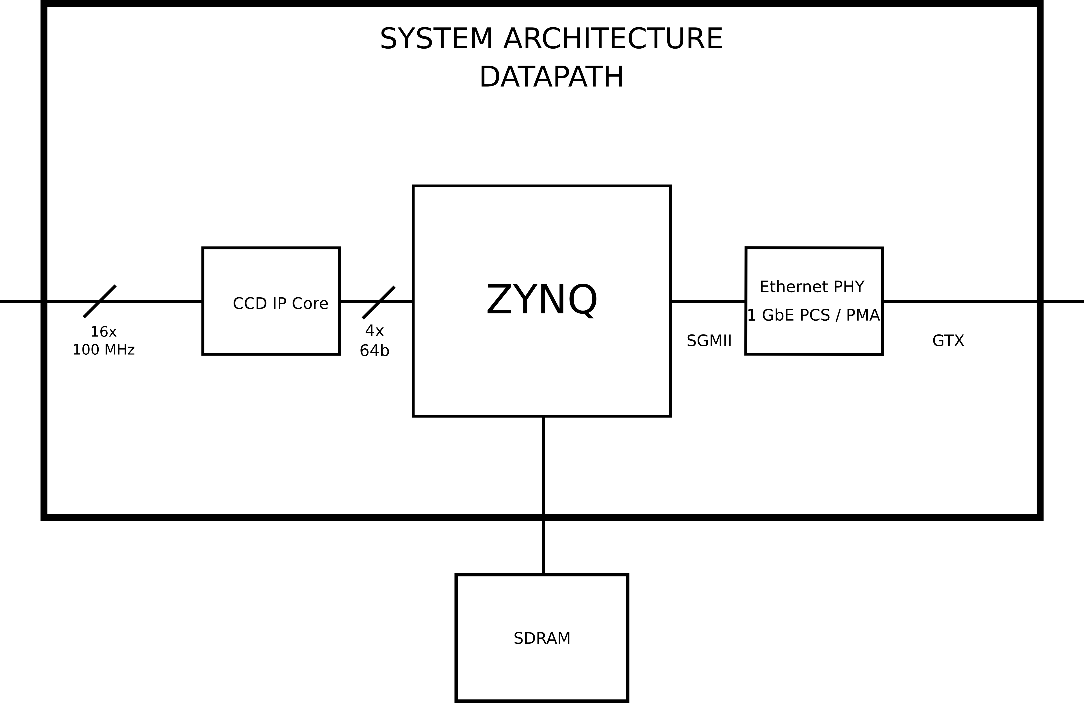
Main datapth goes from the CCD sensor readout ( 16 ADCs ) to the FPGA fabric in Zynq SoC. Data from senor are being read in real time and sent to the processing system which packages data into FITS format and sends it to the control system (PC server) via gigabit ethernet.

4.4.1 Shutter IP core
Shutter control is done entirely in logic. Two motors are controlled by controlling output voltage signal using DACs. IP core has got three internal registers which control, configure and provide status for the core. Setting those registers is done in software. Additionaly an interrupt signal is routed via a dedicated interrupt route to the processing system and certain actions as for example problem with closing the shutter can be signaled much faster than if it would be done via AXI System Bus.
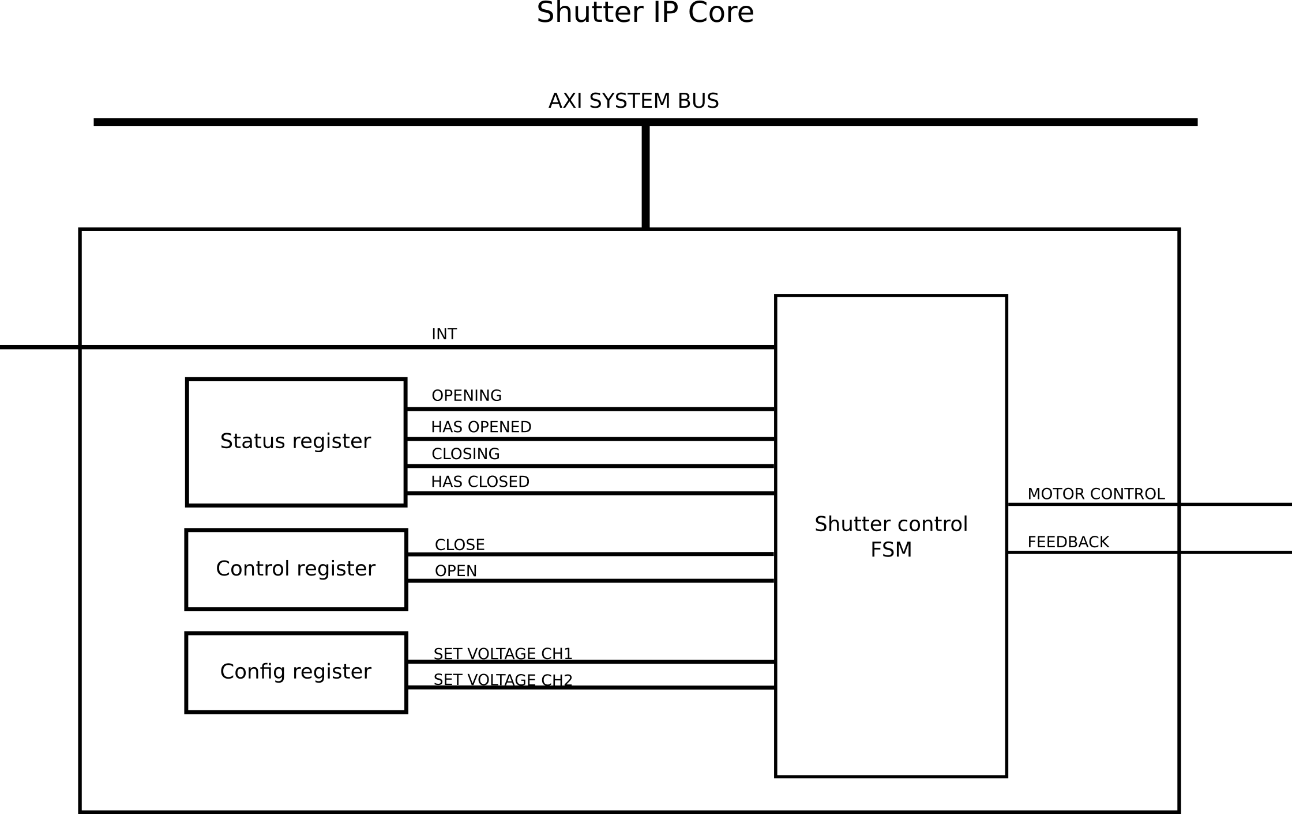

4.4.2 ccd ip core
Control and readout for CCD sensor is done also entirely in logic. 16 ADC are controlled to read CCD data. Just like in Shutter IP core this core also has got status, control and config register which are available via system bus. Two possible trigger signals can trigger the sensor frame acquisition: an external trigger or internal trigger. Internal trigger is controlled by software and can be synchronised via PTP (by a software running deamon). As mentioned in system diagrams, certain actions are timestamped and also an exposition time timer counts the frame exposition.

Another key aspect is the requirement of using different sensors. The CCD Control FSM consists of a programmable pattern generator which controls outputs that control analog front end of the sensor and generates the necessary clocks and resets signals. The internal program of the pattern generator can be changed it is implemented in the system as Block RAM memory.

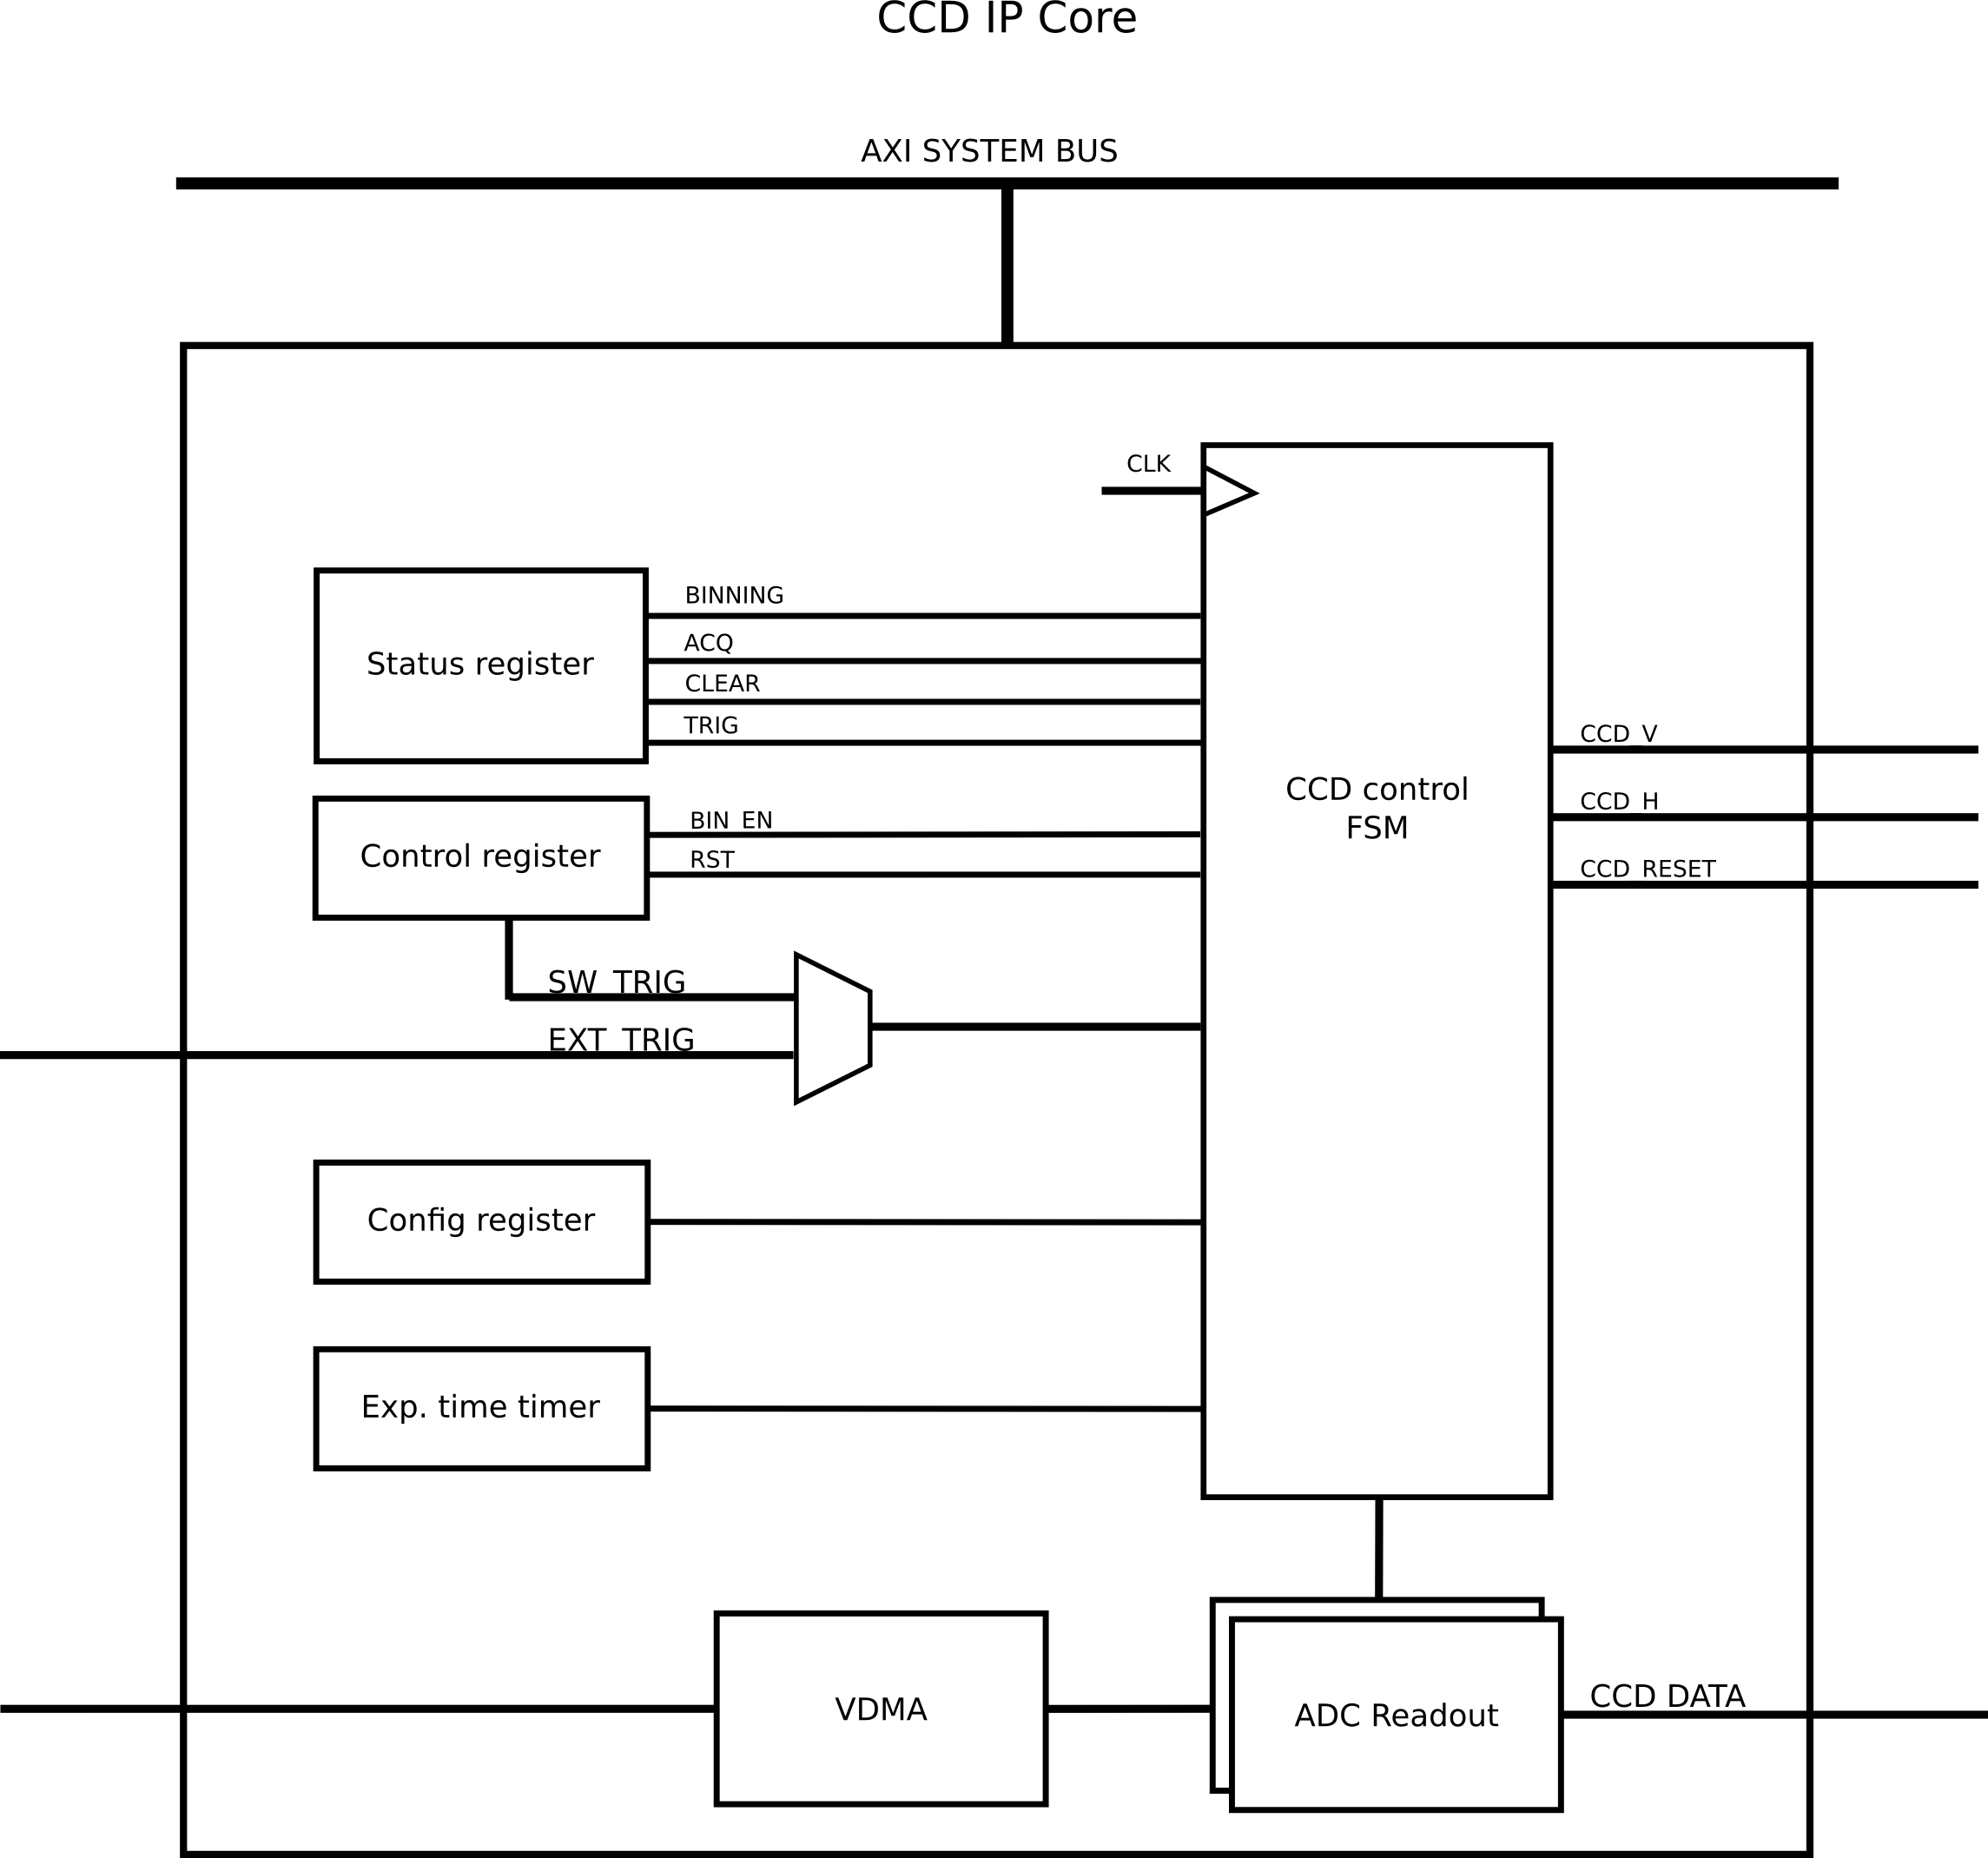

processing core description
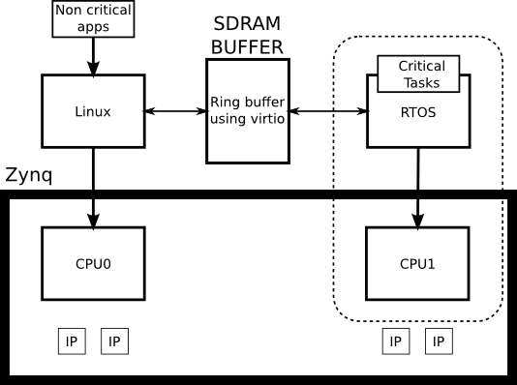
Operating system architecture is a combination of a Real time operating system (RTOS) and General purpose operating system (GPOS) which provide the necessary means of controlling the camera.

TASKS ON FREERTOS
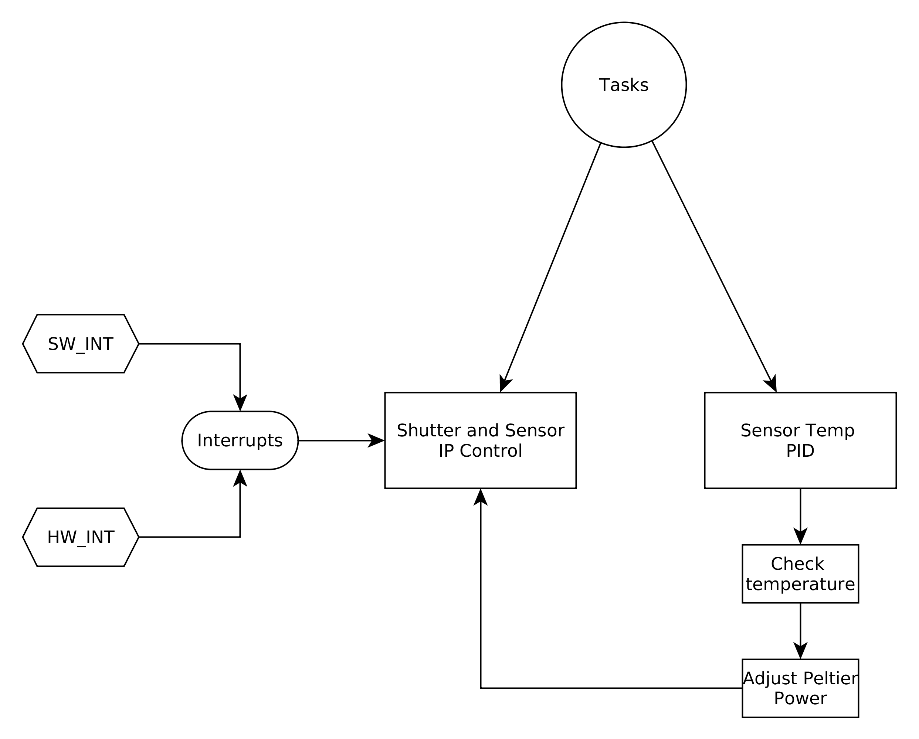
RTOS task is to control the process of taking a photograph. The external trigger (e.g. RS485) or internal trigger (via rpmsg) triggers the process of taking photo. In parallel other task is measuring temperature and adjusts the power on the cooling system. It is essential to note that the power adjusting of cooling system, during readout works in a way that depending on the required power that has to be applied cooling works on specfic number of lines that are read and only on baseline signal level so that it doesn't introduce any additional noise to the readout.

6. Software
System design is developed entirely with Xilinx tools.
Vivado Design Suite – HDL development and simulation
Xilinx SDK – C development for RTOS
Petalinux – Linux development, kernel customisation etc.

7. Coding standards and testing
HDL and C are being developed using internal standard. Each HDL IP core is tested with testbench.
RTOS and Linux C programs are check so that they comply with internal standard. In future it will possible for the code to be compliant with MISRA C standard. Testing is done on all levels, each part of the system is tested separately and also subsystem and system integrity tests are performed.

6. Camera modes of operation
Camera system can be put into multiple modes of operation. In each mode different capability is available for the user and for the operator. This is an essential feature which allows for easy maitenance of the system.

Diagnostic mode
In this mode it is known that there was an error in the system. Simple application is booted on the device which collects all the data from all of the sensors. This data as well as failure log from test mode is written onto SD CARD for debug purposes.

TEST mode (during boot)
Every time the system boots an internal test is performed. Test is done via uboot script. This process is run with the assumption that there is no ethernet connection. If the test fails the system boots into diagnostic mode.

Service mode (on runtime with linux)
Camera can be put into service mode in any time during runtime. This allows for service and maintenance of the camera. In this mode all processes run on the highes verbosity level, all operations are being logged and specific functions are available for the operator.

NORMAL MODE
In this mode camera system is seen as an EPICS controlled device which allows for frame data acquisition.

