|  |  |
| --- | --- |
|  | **NEOSTEL** |

|  |  |  |  |  |  |  |  |  |  |  |  |
| --- | --- | --- | --- | --- | --- | --- | --- | --- | --- | --- | --- |
| Tipo Doc.:  *Doc.Type:* | Detailed Design Document | | | | | N° DRD:  *DRD N°:* | |  | | | |
| N° Doc.:  *Doc. N°:* | **NEOSTEL-DD-CGS-005** | Ediz.:  *Issue:* | 1/Draft | Data:  *Date:* | xx/xx/2014 | | Pagina  *Page* | | **1** | Di  *Of* | 16 |
|  | | | | | | | | | | | |
| Titolo :  *Title :* | CCD & Camera Assembly Detailed Design and Analysis | | | | | | | | | | |

|  |  |  |  |  |  |  |  |  |  |  |  |  |  |
| --- | --- | --- | --- | --- | --- | --- | --- | --- | --- | --- | --- | --- | --- |
|  | Nome & Funzione  *Name & Function* | Firma  *Signature* | Data  *Date* |  | | LISTA DI DISTRIBUZIONE  *DISTRIBUTION LIST* | | N | | A | | I | |
| Preparato da:  *Prepared by:* | Piotr Zdunek | CTI | 03.12.2014 | Interna / *Internal* | |  | |  | |  | |
|  | |  | |  | |  | |
| Approvato da:  *Approved by:* |  |  |  |
| Applicazione autorizzata da:  *Application authorized by:* |  |  |  | Esterna / *External* | |  | |  | |  | |
|  | |  | |  | |  | |
| Customer / Higher Level Contractor | | | | |  | |  | |  | |  | |  |
| Accettato da:  *Accepted by:* |  |  |  |
| Approvato da:  *Approved by:* |  |  |  |
| N=Numero di copie A=Applicazione I=Informazione  *N=Number of copy A=Application I=Information* | | | | | | | |

|  |  |  |  |  |
| --- | --- | --- | --- | --- |
| Gestione documenti:  *Data Management:* |  |  |  |  |
| Firma / *Signature* Data / *Date* |  | File: | NEOSTEL-DD-CGS-005_sw_hdl.doc |

| **REGISTRAZIONE DELLE MODIFICHE / *CHANGE RECORD*** | | | |
| --- | --- | --- | --- |
| EDIZIONE  *ISSUE* | DATA  *DATE* | AUTORIZZAZIONE  *CHANGE AUTHORITY* | OGGETTO DELLA MODIFICA E SEZIONI AFFETTE  *REASON FOR CHANGE AND AFFECTED SECTIONS* |
| 1 | 03/12/2014 |  | First Issue |
|  |  |  |  |
|  |  |  |  |

| **LISTA DELLE PAGINE VALIDE / *LIST OF VALID PAGES*** | | | | | | | | | |
| --- | --- | --- | --- | --- | --- | --- | --- | --- | --- |
| PAGINA  *PAGE* | EDIZIONE  *ISSUE* | PAGINA  *PAGE* | EDIZIONE  *ISSUE* | PAGINA  *PAGE* | EDIZIONE  *ISSUE* | PAGINA  *PAGE* | EDIZIONE  *ISSUE* | PAGINA  *PAGE* | EDIZIONE  *ISSUE* |
| 1 - 6 | 1 |  |  |  |  |  |  |  |  |
|  |  |  |  |  |  |  |  |  |  |
|  |  |  |  |  |  |  |  |  |  |
|  |  |  |  |  |  |  |  |  |  |

**TABLE OF CONTENTS**

1. Introduction 5

1.1 Document SCOPE and Organization 5

1.2 Acronyms 5

1.3 Applicable Documents 5

1.4 Reference Documents 5

2. Section 6

**LIST OF FIGURES**

Non è stata trovata alcuna voce dell'indice delle figure.

**LIST OF TABLES**

Non è stata trovata alcuna voce dell'indice delle figure.

# Introduction

This document presents specification regarding software and digital system design of Neostel CCD Camera system. Description of the camera system is presented in Section 2, as well as the current state of the project. Section 3 contains a detailed system behaviour specification in regards to operating system.

## Document SCOPE and Organization

## Acronyms

|  |  |
| --- | --- |
| **AD** | Applicable Document |
| **CGS** | Compagnia Generale per lo Spazio (formerly Carlo Gavazzi Space) |
| **NEOSTEL** | NEO Survey Telescope |
| **FPGA** | Field Programmable Gate Array |
| **SoC** | System on a Chip |
| **CCD** | Charged Coupled Device |
| **GbE** | Gigiabit Ethernet |
| **PTP** | Precision Time Protocol IEEE1588 |
| **EPICS** |  |
| **FITS** |  |
| **MP** | Mega Pixel |

## Applicable Documents

1. Statement of Work P2-NEO-V ‘NEO Survey Telescope Detailed Design’, SSA-NEO-TEL-SOW-0001, Issue 1, 17/12/2013
2. Space Situational Awareness - NEO System Requirements Document, SSA-NEO-RS-RD-0001, Issue 1, Revision 4, 05/04/2013
3. CGS Proposal “NEO Survey TELescope Design NEOSTEL”, S14-003 Is.1, April 2014

## Reference Documents

1. TELAD Design Report, TELAD-RP-CGS-001, version 1, 25/10/2011

# General SPECIFICATION

This section describes general system behaviour from the software and digital system point of view.

2.1 System diagram

Illustration 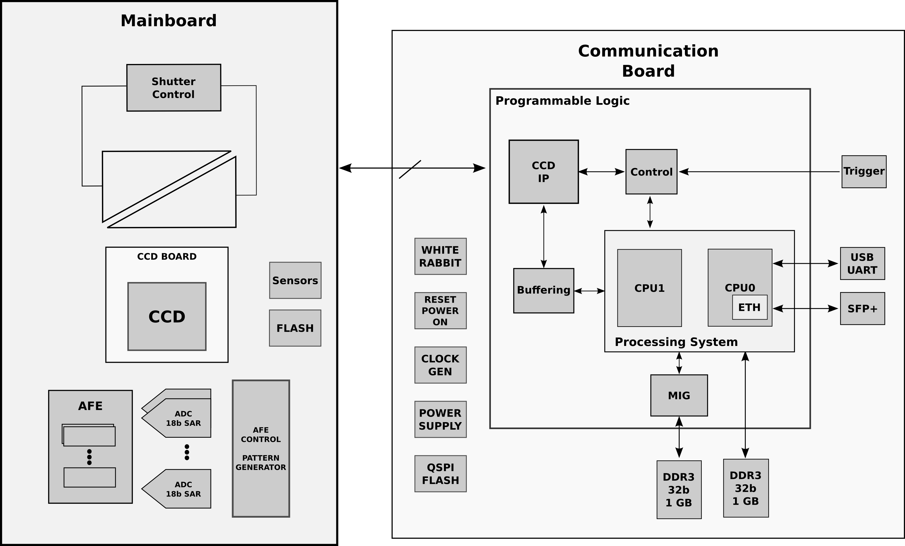1: System diagram

Illustration 1 provides a general overview of camera system. Mainboard with a CCD sensor and peripherials is connected to the Communication Board which controls the whole system.

## 2.2 Descritpion

**From** **the software and digital system perspective the camera is an embedded Linux device with camera capabilites.**

**Camera system is based on Xilinx Zynq SoC, which incorporates two core Cortex A9 application processors and an FPGA in one package. It also contains a number of integrated peripherials like Ethernet, SPI, I2C, CAN, USB etc. and an DDR3 memory controller.**

**System runs both Linux and RTOS operating system in an AMP scenario. Linux is responsible form high level control and maintence and RTOS for time critical tasks.**

**Communication is based on Ethernet. It provides microsecond synchronisation capability due to the use of PTP synchronisation. Also RS485 is used in the system as a standard console output.**

**Interface for CCD sensor analogue front-end and shutter mechanism is designed fully in logic in order to provide exact timing control.**

**System is controlled via EPICS standard and sends acquired pictures in FITS format.**

## 2.3 System Features

1. Low noise 16MP CCD sensor readout
   1. pictures are in FITS format
2. Shutter control
3. Envirionment measurements (humidity, temperature, position)
4. EPICS support
5. High speed interface: 1 GbE
6. Internal and external trigger
7. **Synchronisation via PTP**

2.4

# Specification

This section descibes the specification of Neostel camera system with a detailed diagrams of system behaviour.

## 3.1 Operating system architecture

Illustration 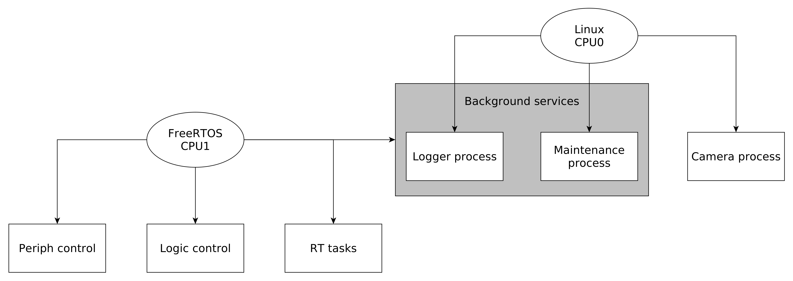2: Camera operating system architecture

Camera is running two operating systems. An embedded Linux system and a RTOS. First is used for communication and control of the whole system and RTOS is used for time critical taks.

SoC that is used in this design is a two core unit which supports AMP operation. This way one core is used for Linux and other is for RTOS.

## 3.2 BOOT Sequence

## 

Illustration 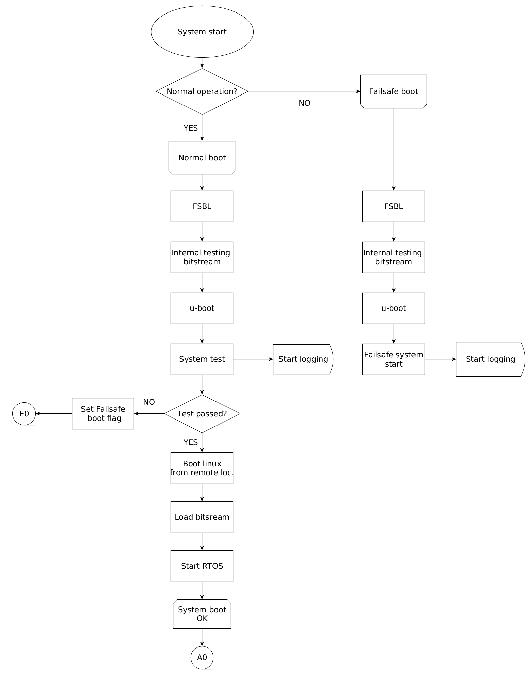3: Boot system diagram

## 

**When input power is applied to camera system starts booting. Inital boot sequence works as pictured on a diagram. Boot sequnce incorporates initial system test. Basic peripherials needed for operation are checked. Because of the fact that the system is a multi-camera design, the operational system image is stored remotely. (e.g. on a server available via NFS). Initialy a testing version is booted from QSPI Flash memory, if the initial test has passed, the remotely available image is loaded and system is restarted. In the second scenario a failsafe system version is booted. Initial testing will be done using uboot procedures.**

## 3.4 Linux start

Illustration 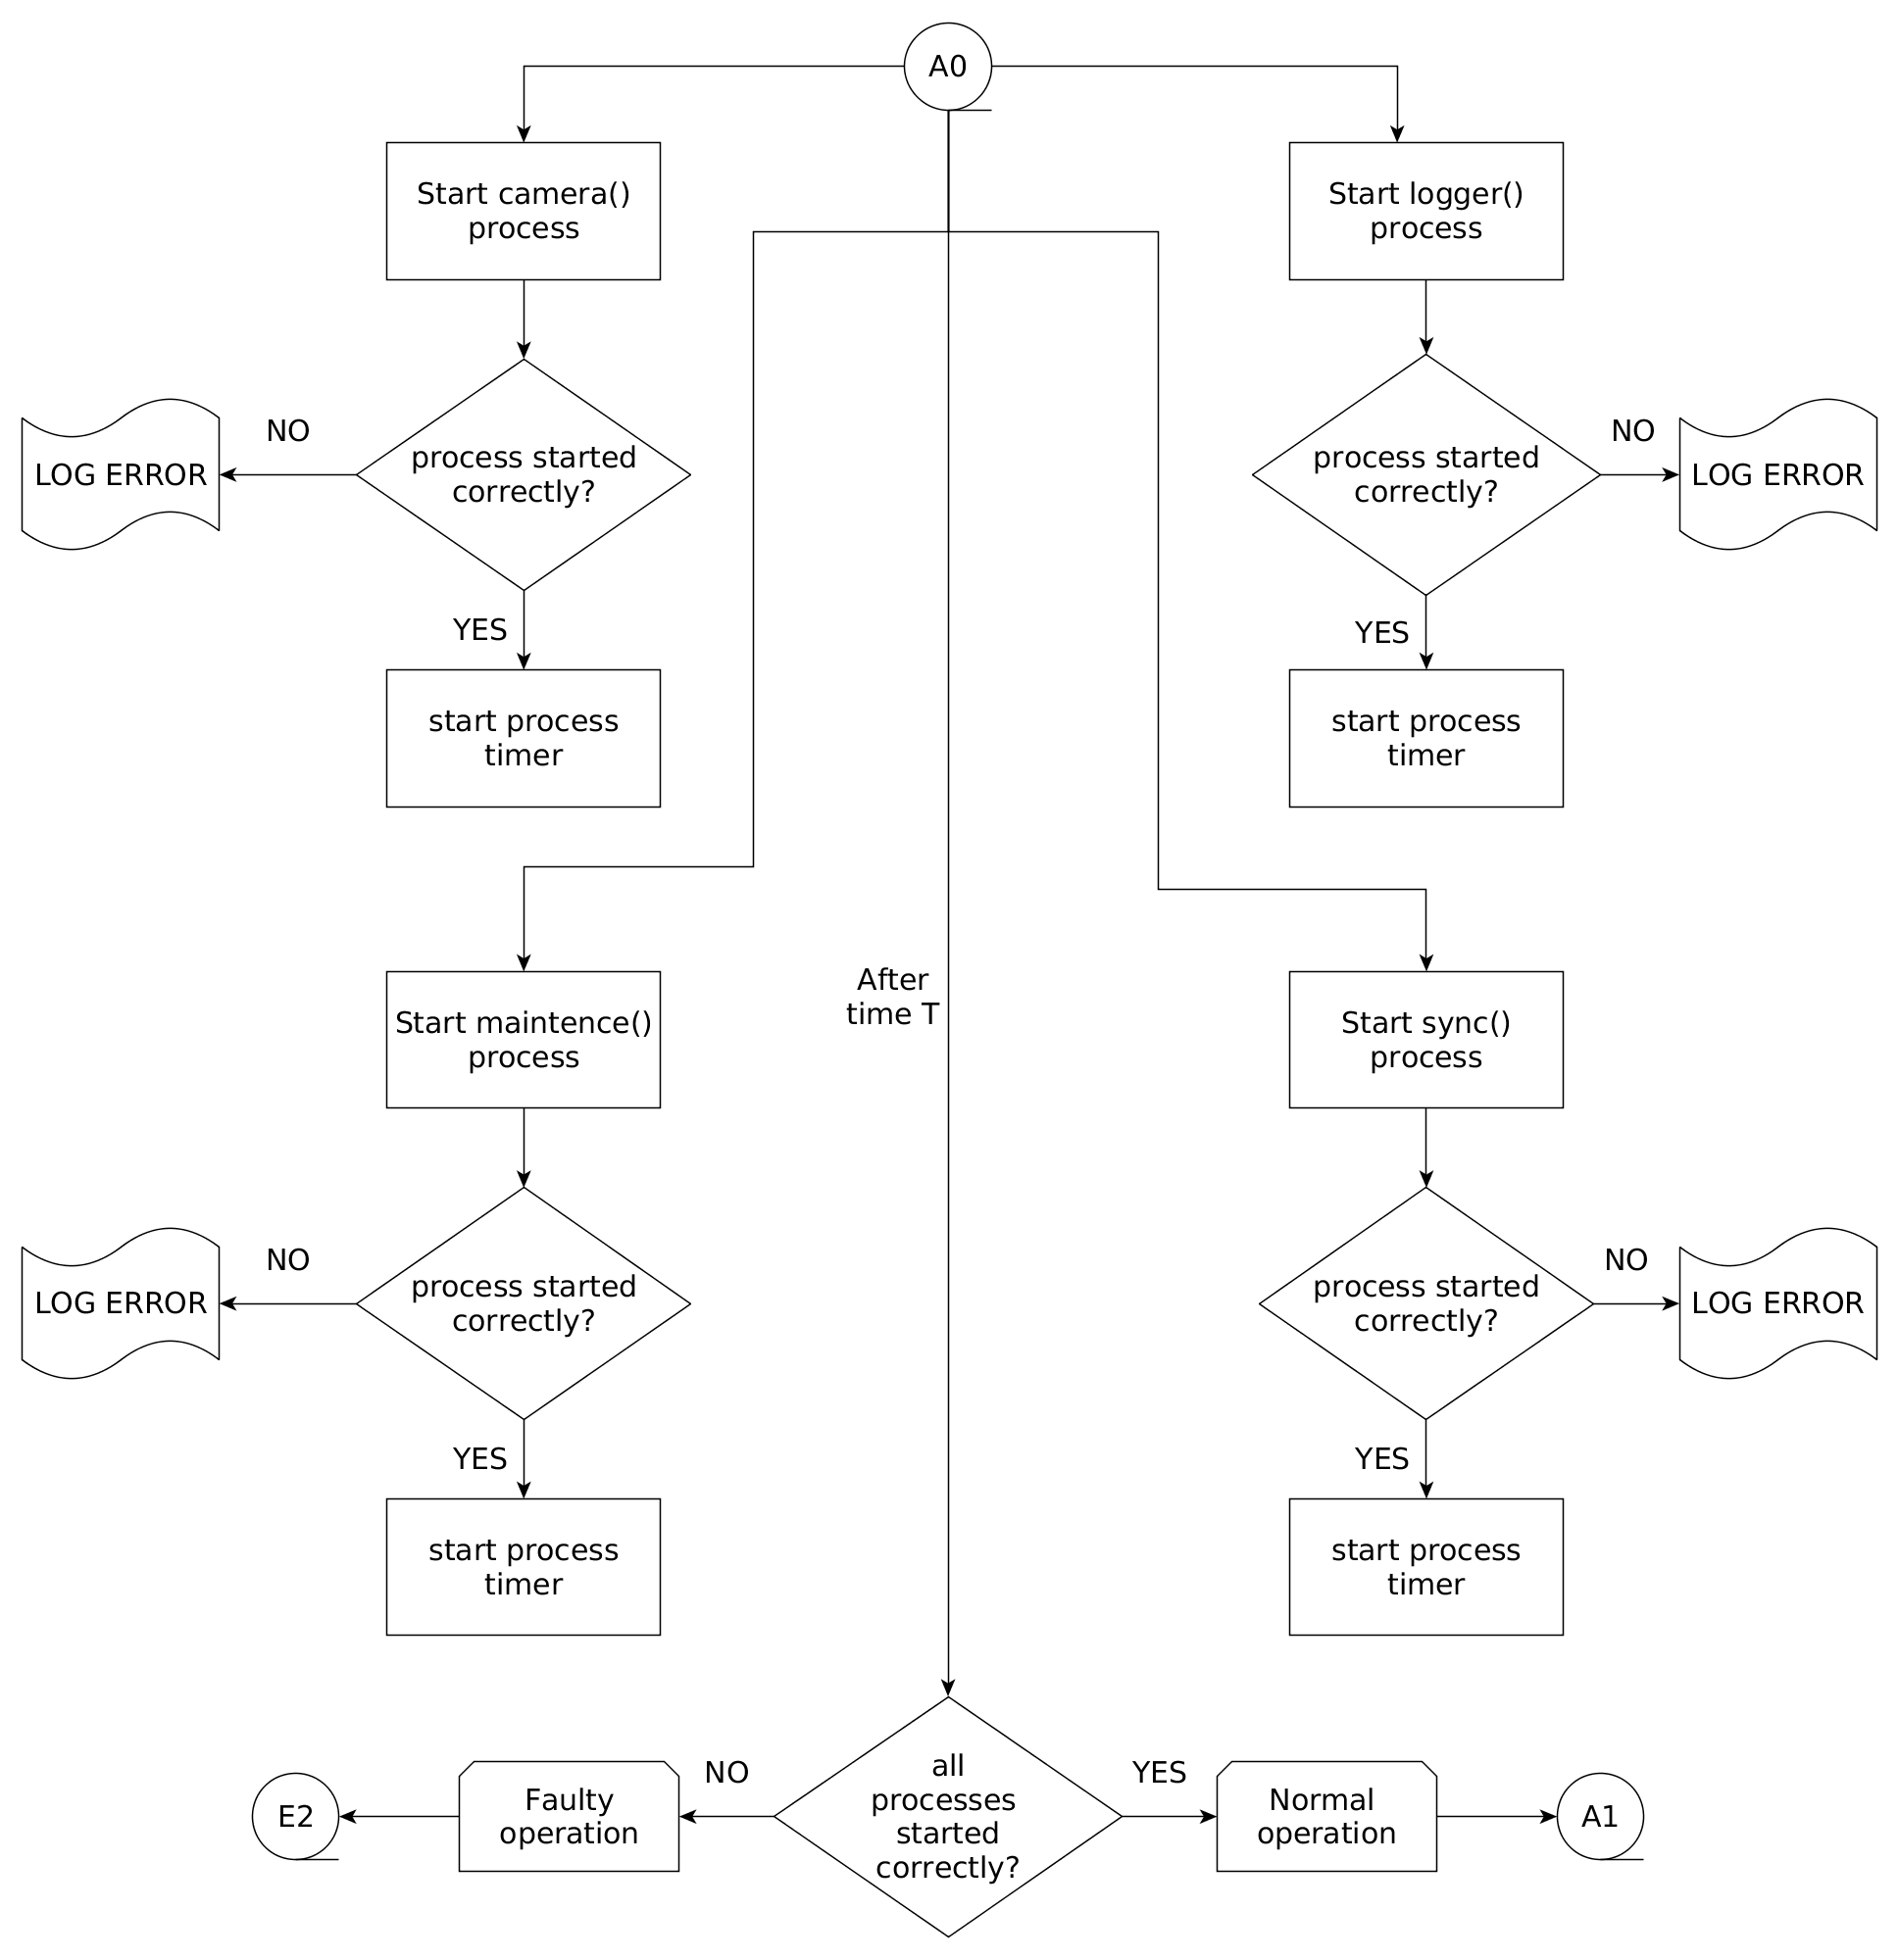4: Linux OS start sequence

After correct boot procedure Linux OS starts all processes needed for proper operation. This processes are responsible for controlling all peripherials and CCD data acquisition. At this moment normal embedded Linux OS is running and all typical applications and access methods such as *ssh* are available. Logs are stored internally and additionally they can be send via EPICS to the control system or viewed through serial console. If all processes started correctly system is moving into A1 state, which is normal operation. In the second scenario the system goes into E2 state which means that some sumsystems are not fully operational.

## 3.5 Operating system normal operation

Illustration 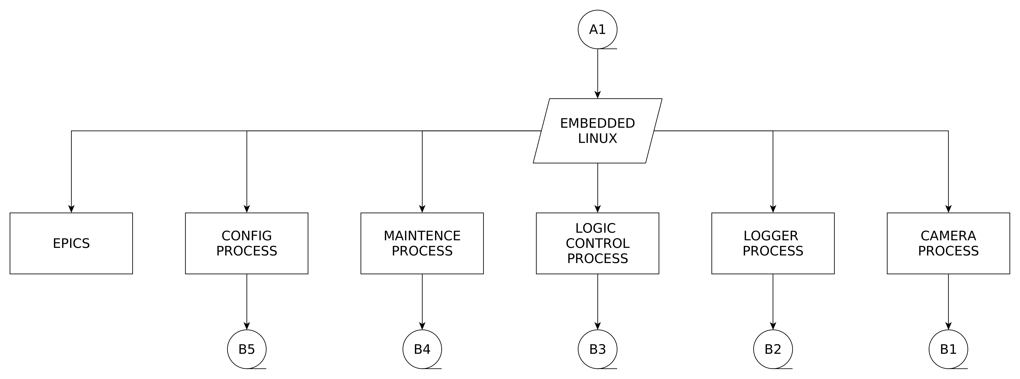5: Linux operation diagram

Ilustration 5 shows the normal system operation. Embedded Linux is running along with all processes. EPICS control is using processes and programs that control all of the peripherials.

At this point system can be controlled via EPICS or manually by logging directly on the system.

Initial setup script that is being run at the beginning of the boot sequence provides default configuration for the device.

The processes that are running on the camera are responsible for:

* maintence – checking all peripherials and runtime behaviour
* configuration – for setup of camera configuration
* logic control – IP Cores control and setup
* logging – storing all system beahaviour
* camera control – pictures acquisition, shutter and readout control

## 3.5 Camera process

Illustration 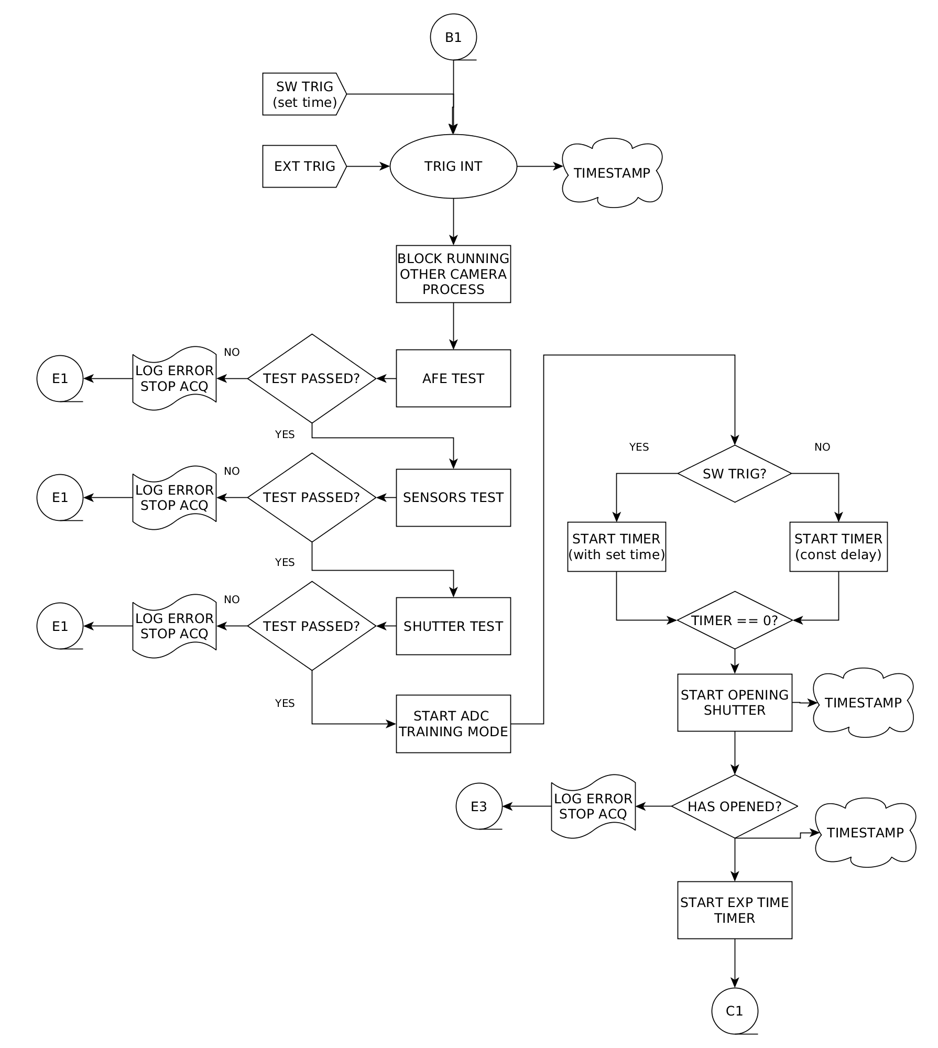6: Camera process beahaviour

Ilustration 6 shows the system behaviour when the picture trigger is started. First basic testing is run to check if all systems are operational. Then shutter opening is started.

## 3.5 Camera Process continued

Illustration 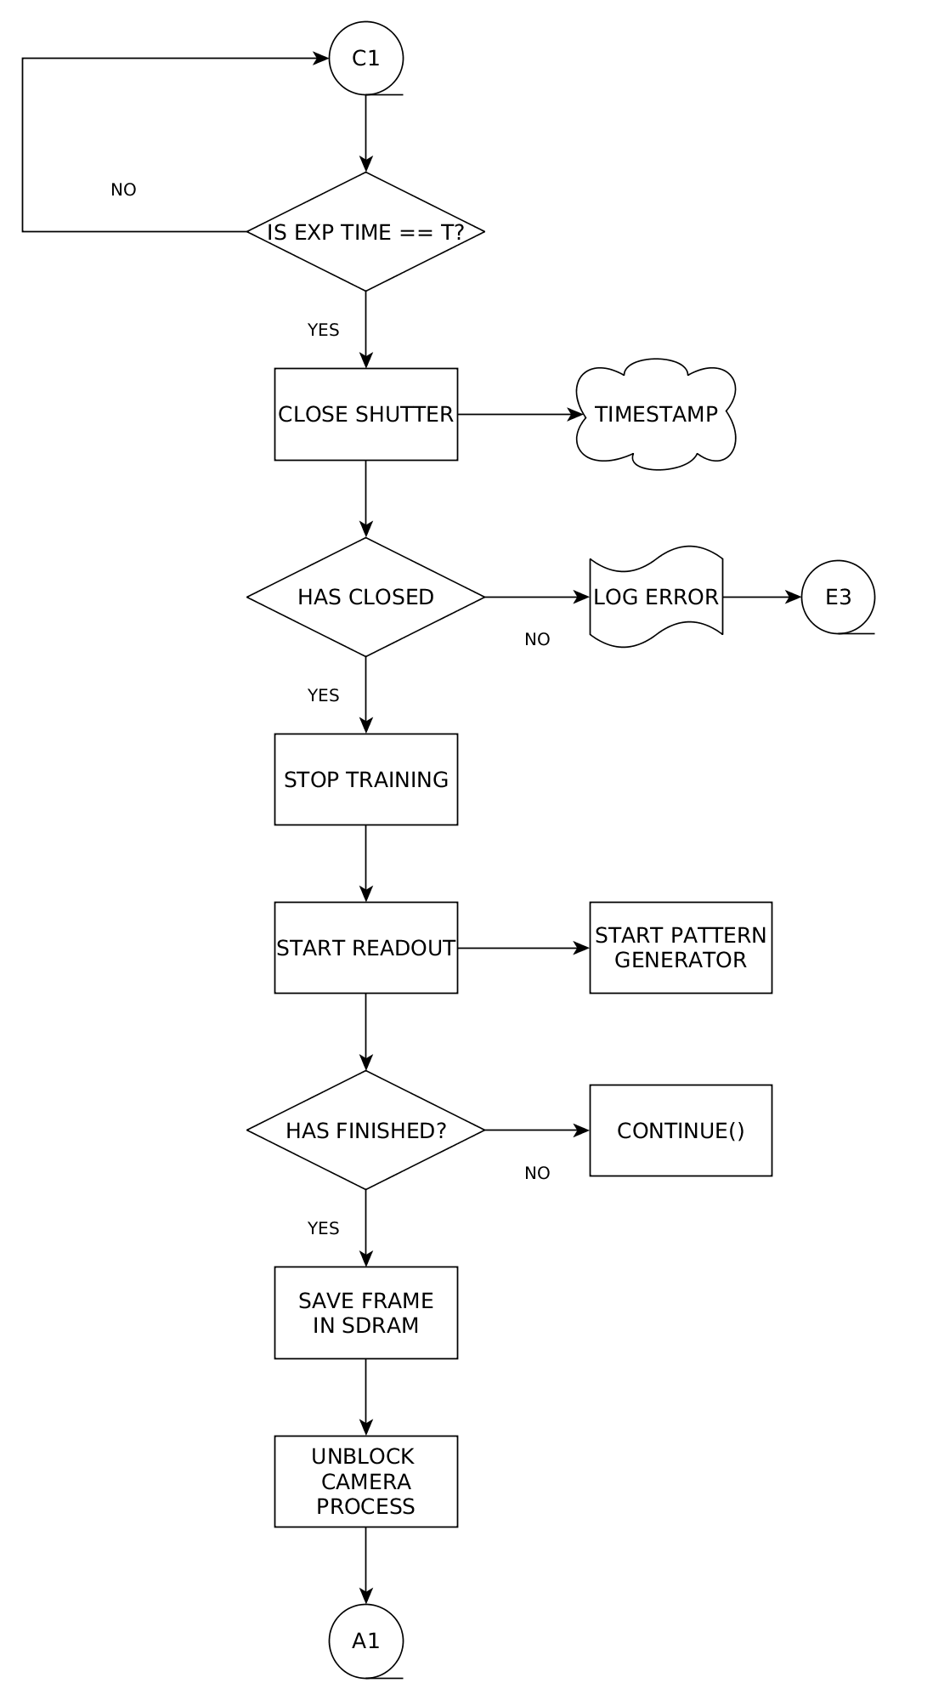7: Camera process behaviour after opening the shutter

## 3.7 Other processes

Illustration 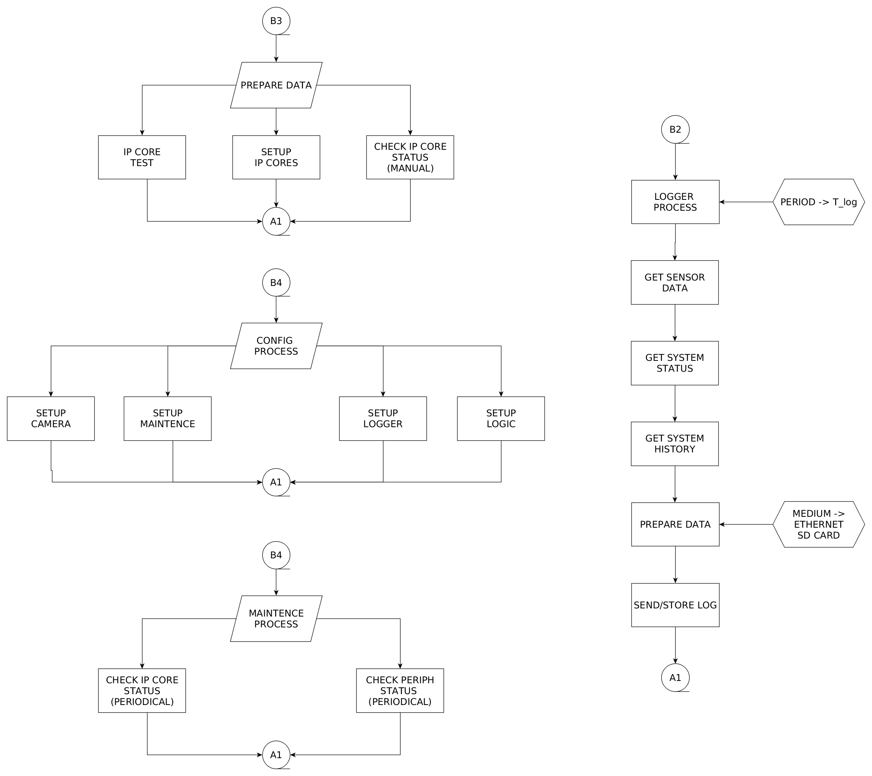8: Operation of other processes running in background

## 3.8 Error handling

Illustration 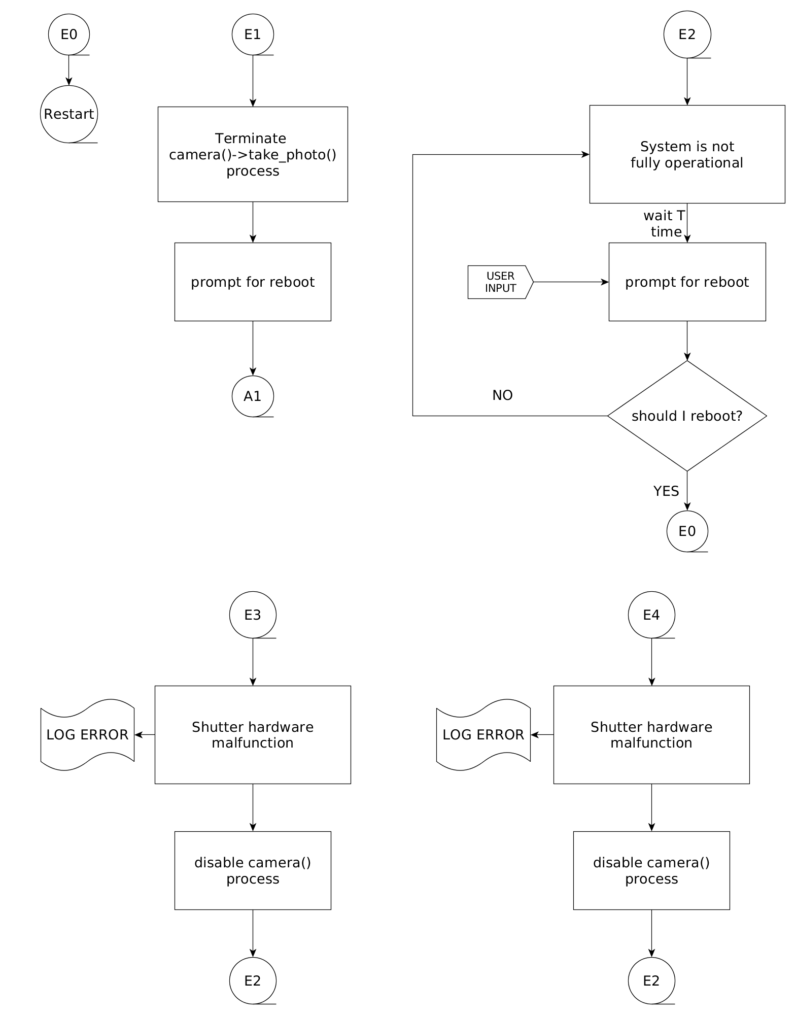9: Erronous operation diagrams