E_ Commercial Report
- Total Revenue
- 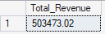

- Average purchase value
- 

- Top Customer’s emails spending

- 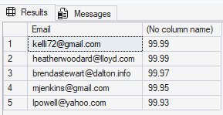

- Num of operations per times(AM,PM)
- 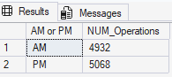

- Num operation per browsers
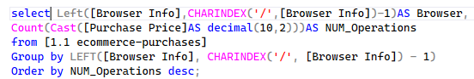
- 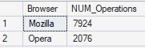
- Most Used Credit Card Provider
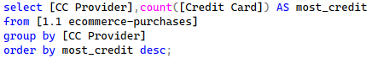
- 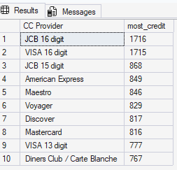
- Top jobs purchasing
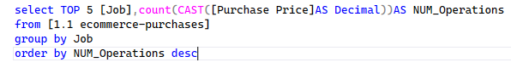
- 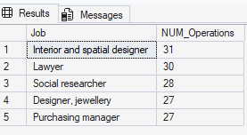

- Purchase by language

 