**Tracing Tutorial**

**Opening/saving files**

1. Choose an .nrrd file and add your name to the end of the filename.
   1. This specifies that the cube is being segmented by someone.
   2. If it does not include your name, do not also segment it!!
2. Open .nrrd as “main image”
3. 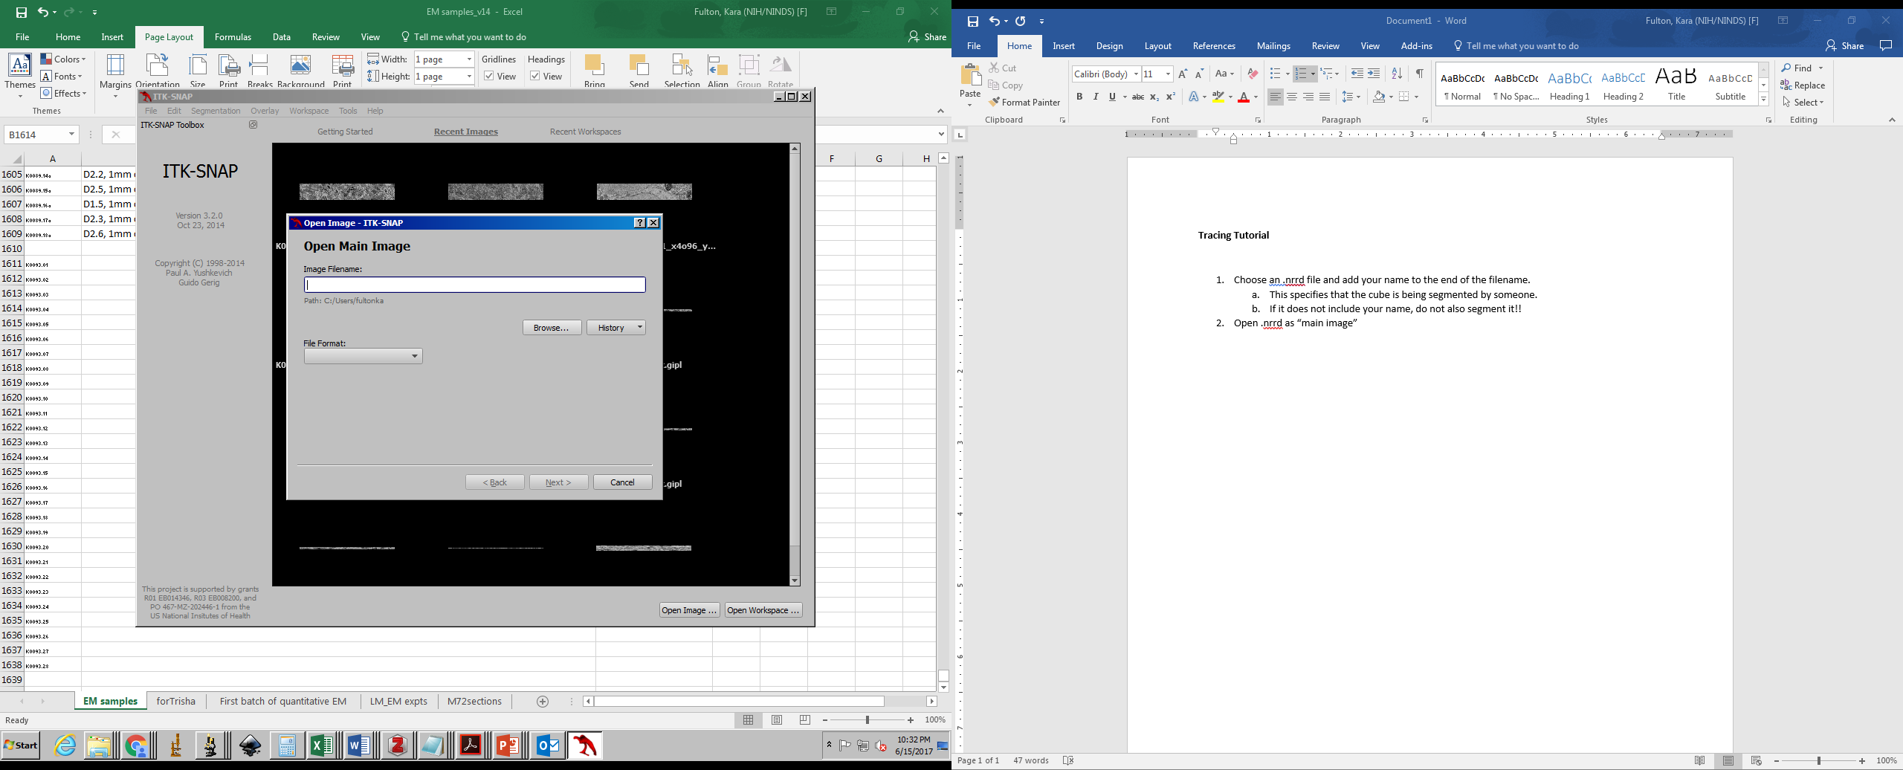
4. When saving the segmentation file, add “_labels” to the end of the filename
   1. Save as .nrrd
   2. If you forget, please save it as .gipl instead. These are the most compatible file formats that Paul would like us to use.

**Tracing**

1. DO NOT START WITH LABEL 1. Label 1 is for all extracellular space (ECS).
   1. Use the paintbrush tool at the end to fill in ECS with label 1.
   2. Use the region growing tool if there is a large amount of ECS in your volume.

Only label objects between and including z slices 17-48

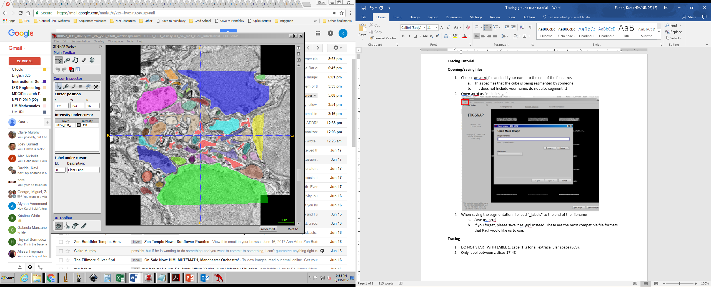

Color up to BUT NOT INCLUDING the membranes

Each object gets its own unique label that stays with it on every slice

This tool allows you to draw a shape. Press Enter twice to fill in the shape.

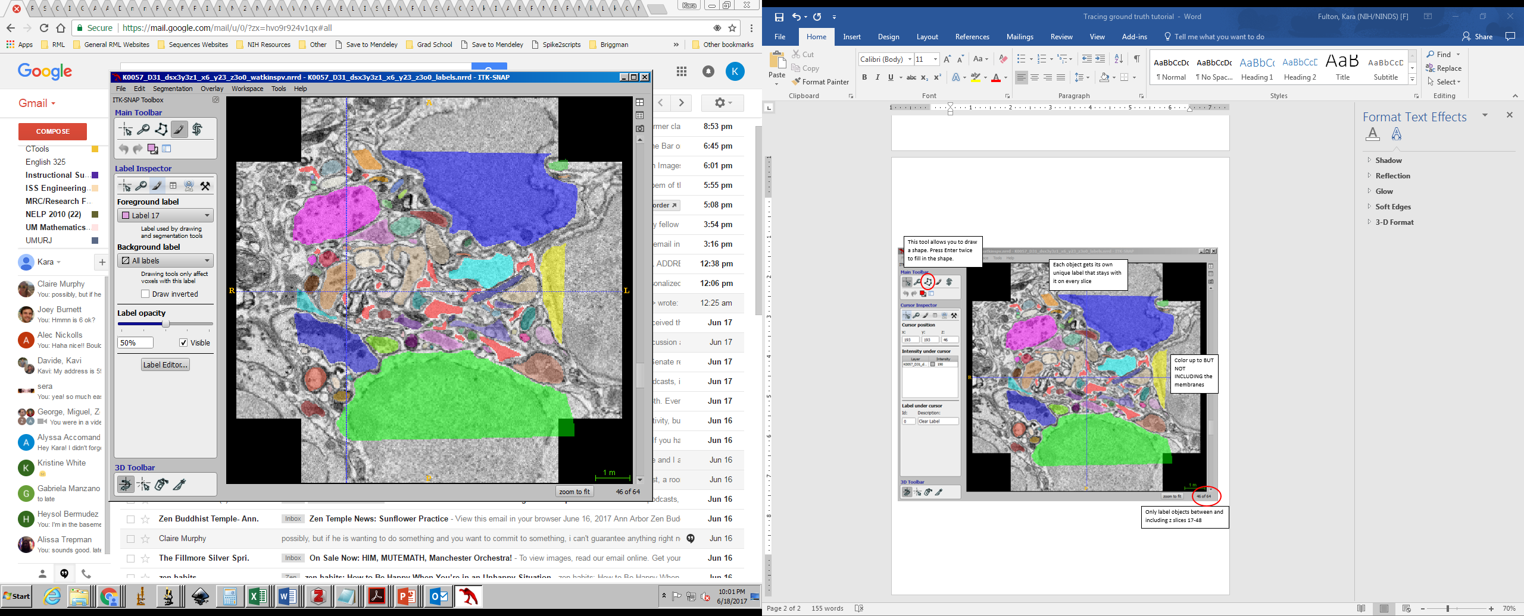**Some notes:**

This tool allows you to paint in more precisely by choosing different size brush.

While this tool is selected, right clicking allows you to erase.

1. Make sure every object has its own label.
   1. Especially objects that touch and are adjacent to each other.
2. Follow one object through slices 17-48 before moving on to the next object.
3. Use conservative tracing (do not trace the membrane)
4. Don’t trace the “blebs” unless it’s part of the object.
5. Only trace within the red region
6. In polygon tool, the Esc button removes whatever was there.
   1. Trace the polygon, enter🡪 fills in the line, enter🡪fills in the object
7. Only hit undo if you are on the same slice and you know exactly what you are undoing.
8. Clear label=eraser
9. The active label paints over whatever you specify as the background label.
   1. Generally, you always want a specific active label and “All labels” selected for the background label.
   2. When you are erasing, you may want to select the “Clear label” as the active label, and the specific label you want to erase as the background label
10. If you are returning to tracing the next day, you can identify which label you last used by selecting Segmentation🡪 Volumes and Statistics to find the last used label.

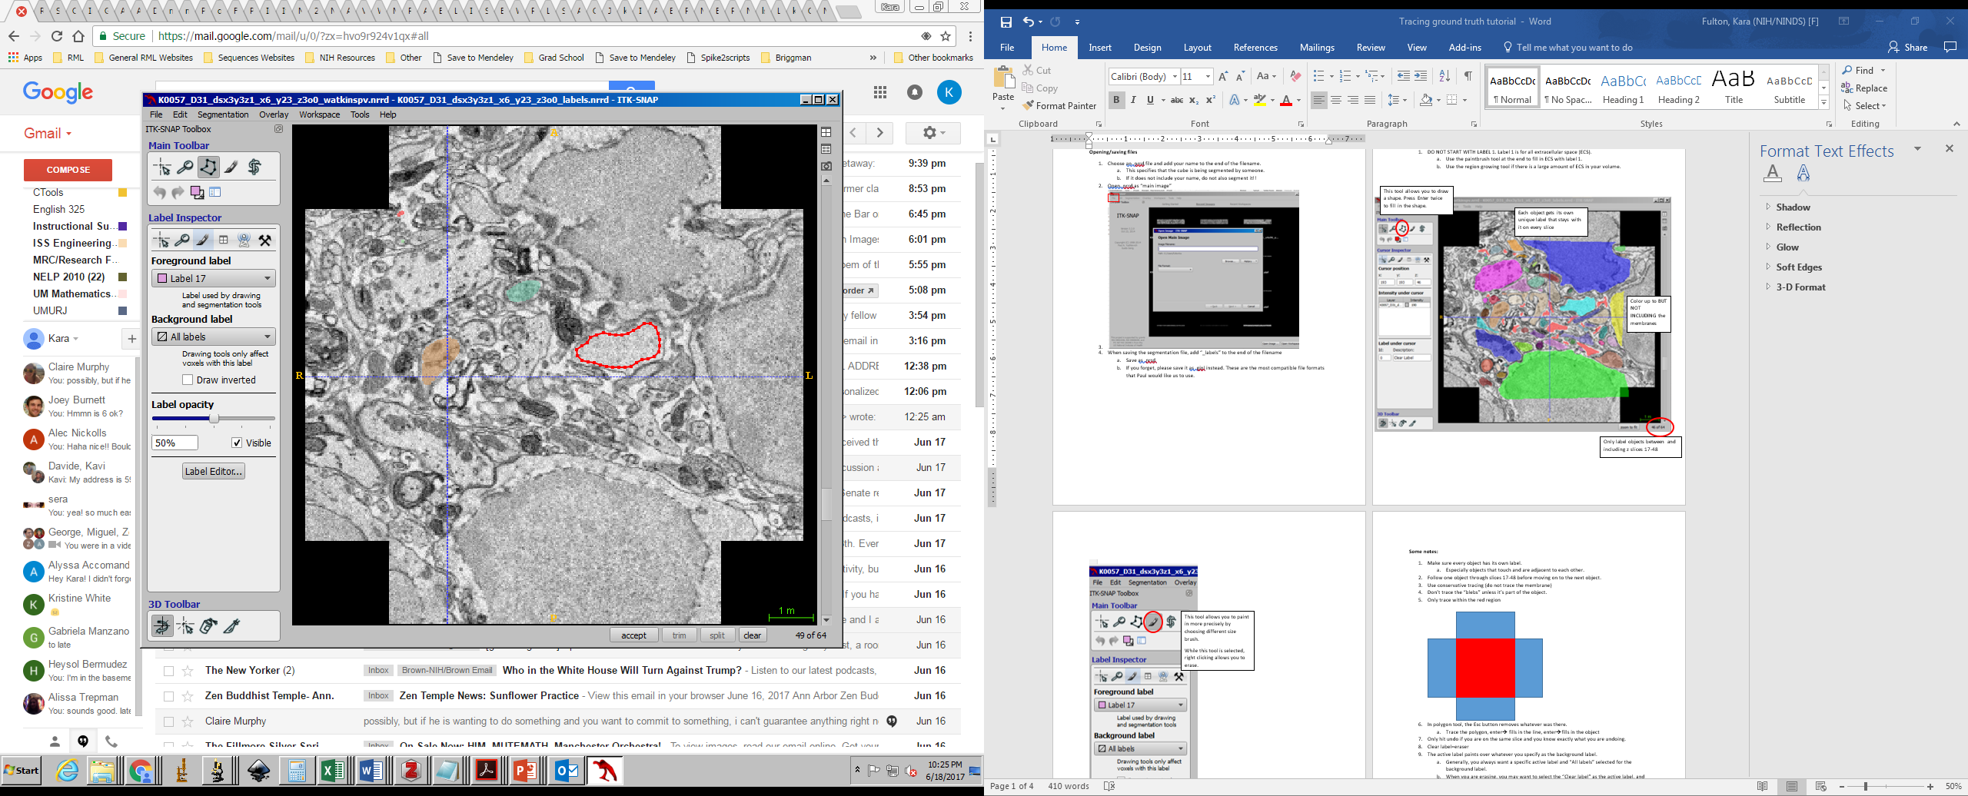

With polygon tool, I’ve traced and then clicked enter once. Enter again and it will fill in the object.

Bleb.

Do not trace.