


Faculty of Engineering
Cairo University
Spring 2026
CMPS451-- Data Mining, Big Data and Analytics
Anomaly Detection in Large-Scale System Logs Using Apache Spark
Final Project Report — Team 19
Abdallah ElMahdy | 1220257
Noor Tantawy | 1220150
George Ayman | 1220233
Elhussien Awad | 1220226

Contents
I. Brief Problem Description 2
II. Project Pipeline 3
III. Analysis and Solution 4
1. Data Preprocessing 4
Dataset 1 — Apache Common Log Format (access_log.txt, ~4.5M rows) 4
Dataset 2 — Apache Combined Log Format (web_server_access_log.txt, ~10.3M rows) 4
2. Visualization 5
Section 1 — Traffic Overview 5
Section 2 — Top IPs and Endpoints 6
Section 3 — Temporal Patterns 7
Section 4 — Error Analysis 10
Section 5 — Anomaly Analysis 10
3. Extracting Insights from Data 12
4. Model/Classifier Training 12
IV. Results and Evaluation 13
Model Performance on Test Set (365,903 windows) 13
K-Means Silhouette Scores by k 13
Confusion Matrix Analysis 13
K-Means Cluster Composition 14
Model Accuracy on Train, Validation, and Test 14
V. Unsuccessful Trials 15
1. K-Means with k=3 and k=5–8 15
2. Logistic Regression with regParam=0.1 15
3. Logistic Regression with regParam=0.01 15
4. High-severity threshold at 0.7 15
5. 1-Hour Aggregation Windows 15
6. Native KNN via spark-knn library 15
VI. Enhancements and Future Work 16

I. Brief Problem Description
Large-scale web servers generate millions of log entries daily. Anomalies within these logs like sudden error spikes, abnormal traffic volumes, bot activity, or server failures often go undetected until they result in degraded user experience, revenue loss, or security breaches.
"How can we build a scalable anomaly detection platform that analyzes large-scale web server log data to identify abnormal patterns early, providing actionable insights that help organizations improve system reliability and prevent critical failures?"
We define five anomaly types:
Anomaly Type | Definition | Severity Signal
Traffic Spike | >200 requests/min from a single IP | High request volume
High Error Rate | >30% of requests returning 4xx/5xx errors | Service degradation
Scanning / Probing | >30 unique endpoints/min from a single IP | Vulnerability scanning
Server Error | Any 5xx response (500/502/503/504) present | Server-side failure
Bot Traffic | User agent matches known bot signature | Automated crawling

Each anomaly window is assigned a numeric severity score (0–1) and labeled low, medium, or high based on a weighted combination of fatal error rate (40%), medium error rate (25%), raw error rate (20%), and request volume (15%).

II. Project Pipeline
The project is implemented as a five-stage end-to-end pipeline running on Apache Spark in pseudo-distributed mode (local[*]) — a single machine using multiple parallel worker processes across all available CPU cores. A single main.py entry point orchestrates all stages with one Spark session created once and passed to all modules.
Stage | Description | Output
1. Preprocessing | Parse two Apache log formats via regex; unify schema; validate, clean, cache | 14,842,672 unified rows
2. Feature Engineering | Enrich rows (error_severity, hour_of_day, is_off_hours);  aggregate per IP per 1-min window;  label anomaly_type | 1,831,664 IP-minute windows
3. Modeling | Train Logistic Regression, Random Forest (KNN fallback),  K-Means (k=3–8); 60/20/20 split; hyperparameter searc | Fitted models saved to disk
4. Evaluation | Accuracy, weighted F1, Precision, Recall;  silhouette + purity for K-Means; per-class confusion matrices | Metrics tables and CSVs
5. Visualization | 20 plots across 5 analytical sections covering traffic, errors, anomalies, and temporal patterns | PNG files in output/

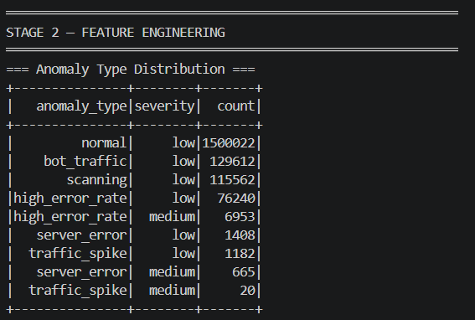
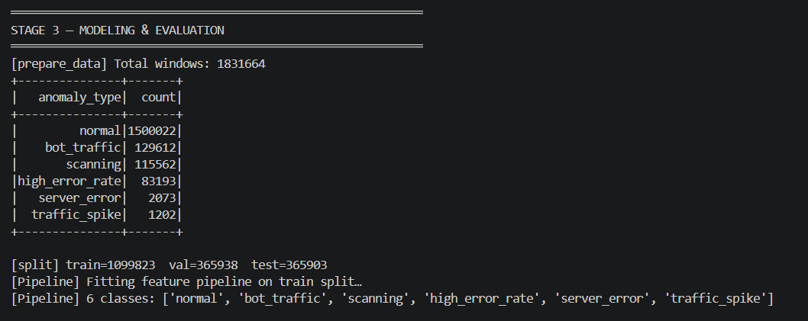

III. Analysis and Solution

1. Data Preprocessing
Two datasets with different Apache log formats were parsed using PySpark regexp_extract and merged into a unified 11-column schema via unionByName.

Dataset 1 — Apache Common Log Format (access_log.txt, ~4.5M rows)
10.223.157.186 - - [15/Jul/2009:15:50:35 -0700] "GET /assets/js/lowpro.js HTTP/1.1" 200
10469
Fields: IP, timestamp, method, endpoint, status code, bytes. No user agent field — bot detection unavailable for this dataset. Dataset 1 rows receive user_agent=NULL and is_bot=0.

Dataset 2 — Apache Combined Log Format (web_server_access_log.txt, ~10.3M rows)
54.36.149.41 - - [22/Jan/2019:03:56:14 +0330] "GET /filter/27 HTTP/1.1" 200 30577 "-"
"AhrefsBot/6.1" "-"
Additional fields: referrer, user agent. Bot detection applied via keyword matching against 13 signatures (googlebot, ahrefsbot, bingbot, bot crawler, spider, scraper, curl, wget, slurp, python-requests, java, go-http).
Post-preprocessing statistics:
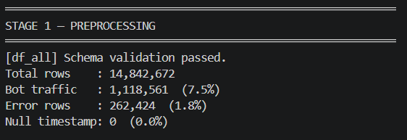
Metric | Value
Total rows | 14,842,672
Dataset 1 (access_log) | ~4,500,000 (30.3%)
Dataset 2 (web_server_log) | ~10,300,000 (69.7%)
Bot traffic | 1,118,561 (7.5%)
Error rows (status >= 400) | 262,424 (1.8%)
Null timestamps | 0 (0.0%) — perfect parse coverage
Cleaning steps applied: malformed lines dropped via empty IP filter; bytes field "-" replaced with 0; status_class (1xx–5xx) and is_error flag derived; schema validated against WEB_ACCESS_LOG_SCHEMA before any downstream processing.

2. Visualization
Twenty visualizations were produced across five analytical sections. All charts are generated programmatically from live Spark DataFrames.

Section 1 — Traffic Overview
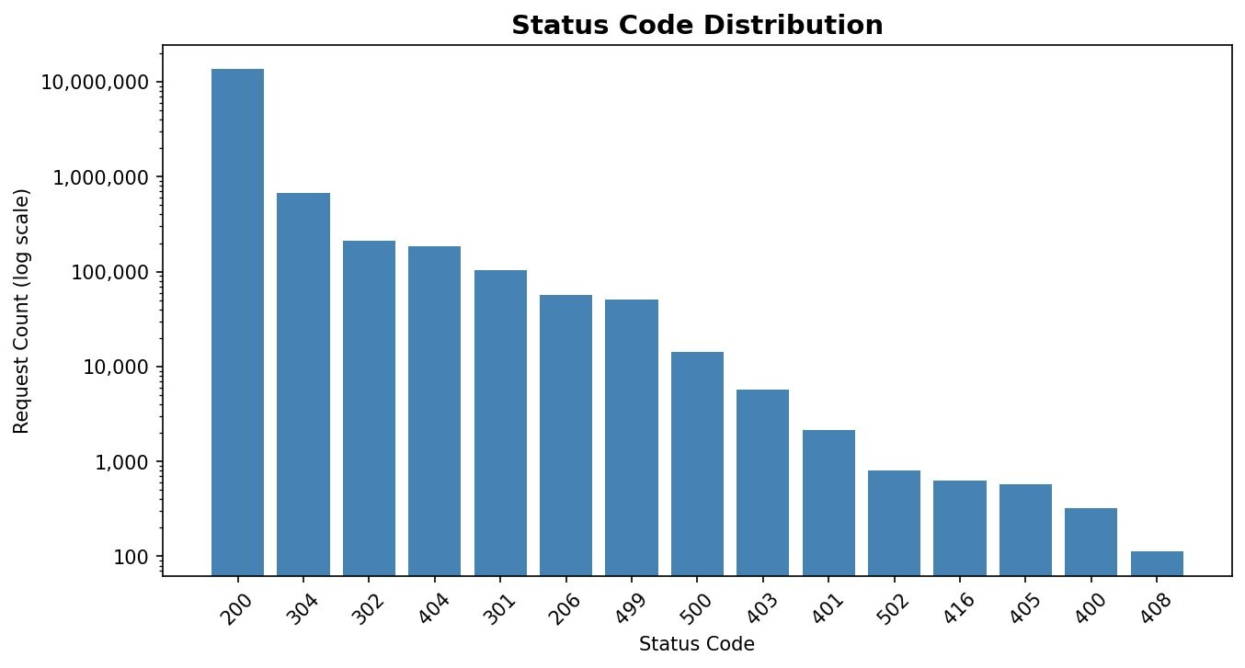
Fig 1. Status Code Distribution (log scale) — 200 OK dominates at 13.7M requests
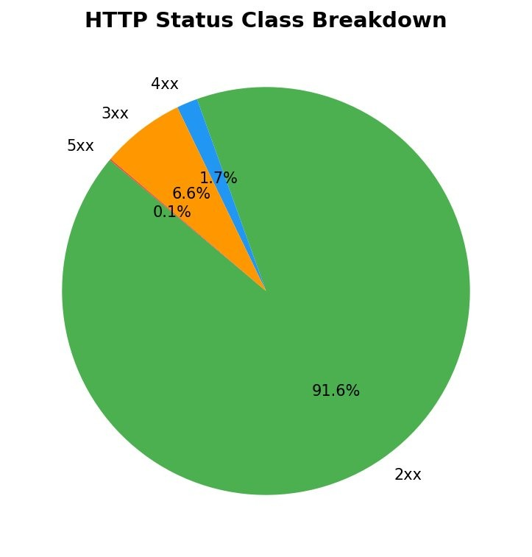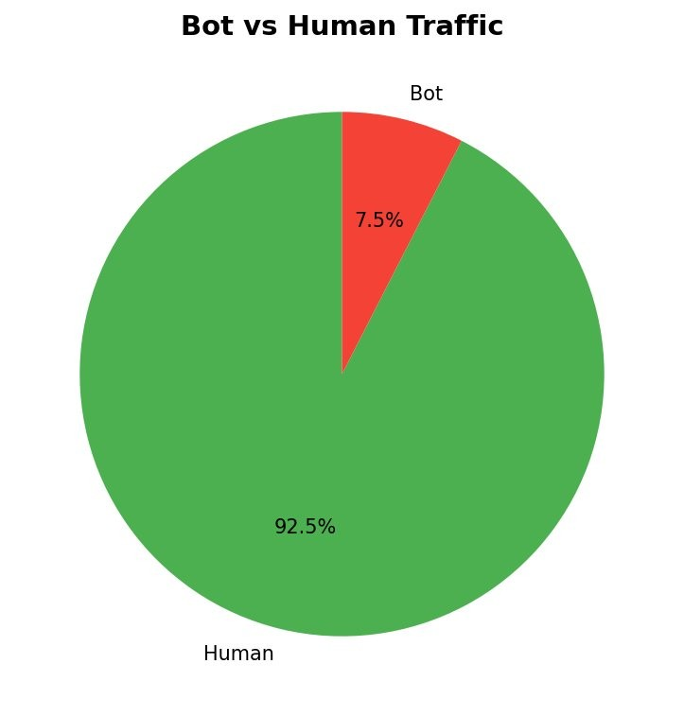
Fig 2. HTTP Status Class Breakdown (91.6% success) | Fig 3. Bot vs Human Traffic (7.5% bot)
Status code analysis confirms a healthy server: 91.6% successful responses (2xx), 6.6% redirects (3xx), 1.7% client errors (4xx), and only 0.1% server errors (5xx).

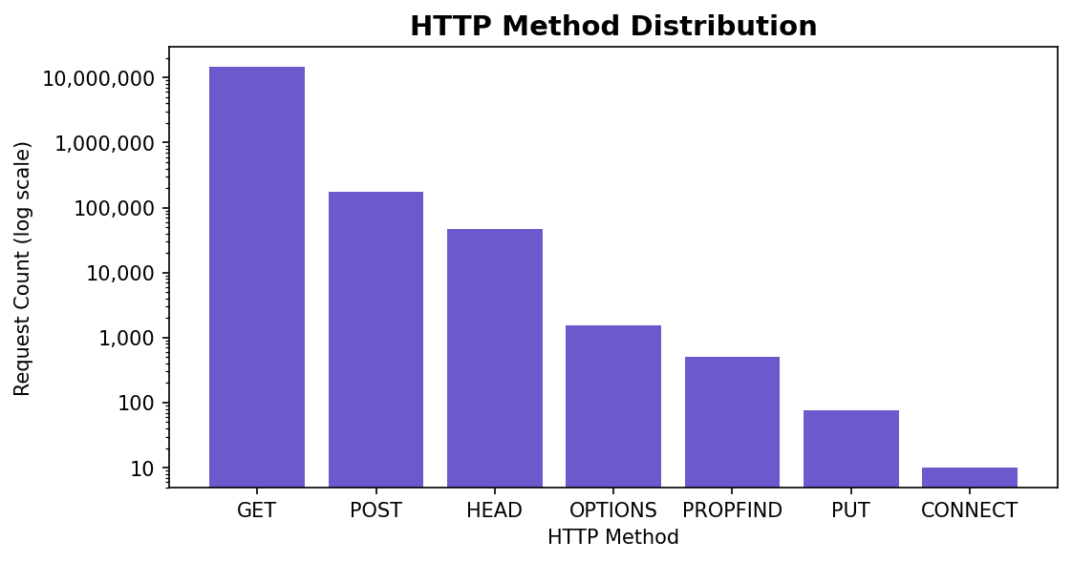
GET method dominates at over 14M requests. PROPFIND and CONNECT methods — used in WebDAV and tunneling attacks — appear in small but notable quantities.

Section 2 — Top IPs and Endpoints
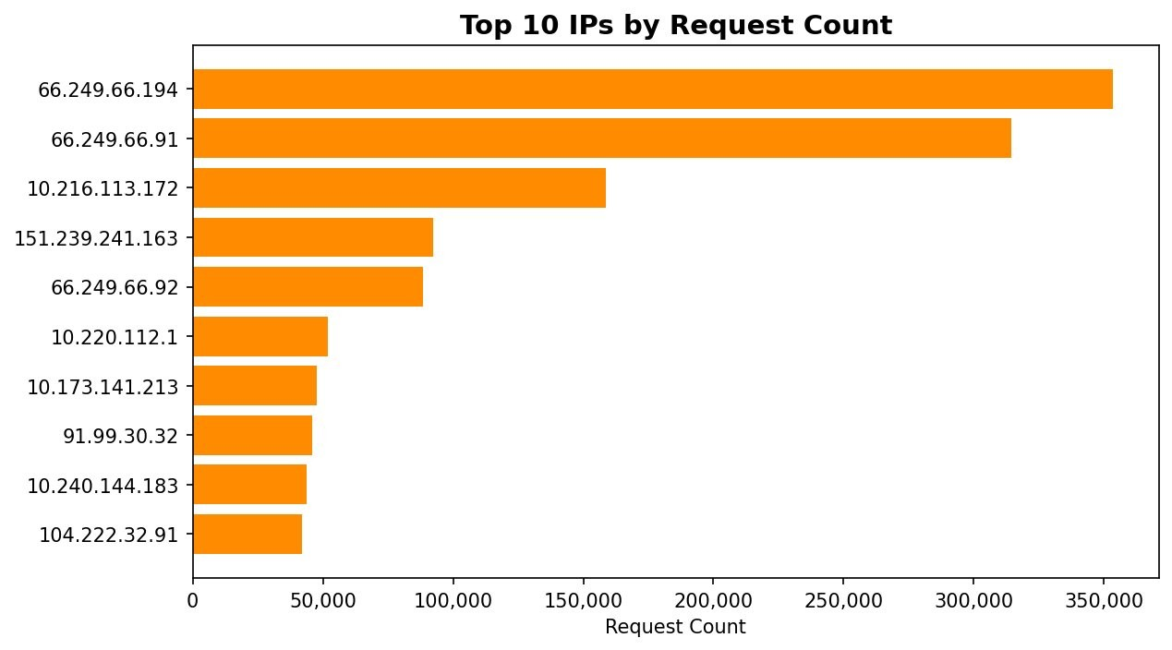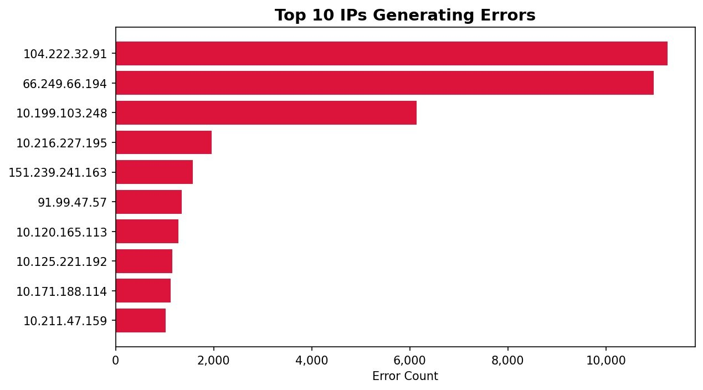
Fig 6. Top 10 IPs by Request Count | Fig 8. Top 10 IPs Generating Errors
The two highest-volume IPs (66.249.66.194 and 66.249.66.91, 350K and 315K requests respectively) belong to Google's IP range; confirmed Googlebot crawlers.
IP 104.222.32.91 generates the most errors (~11,000) despite being only 10th in total volume, suggesting aggressive probing behavior.
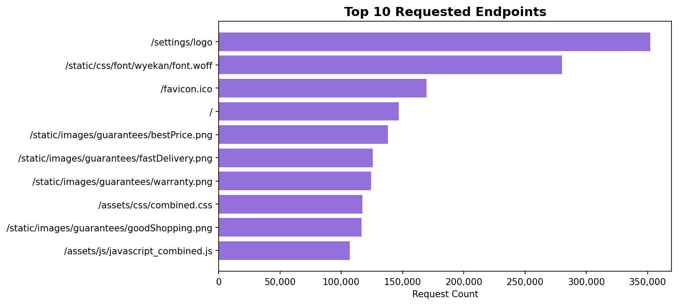
Top endpoints are static assets (logo, fonts, favicon) — normal CDN-style access.

Section 3 — Temporal Patterns
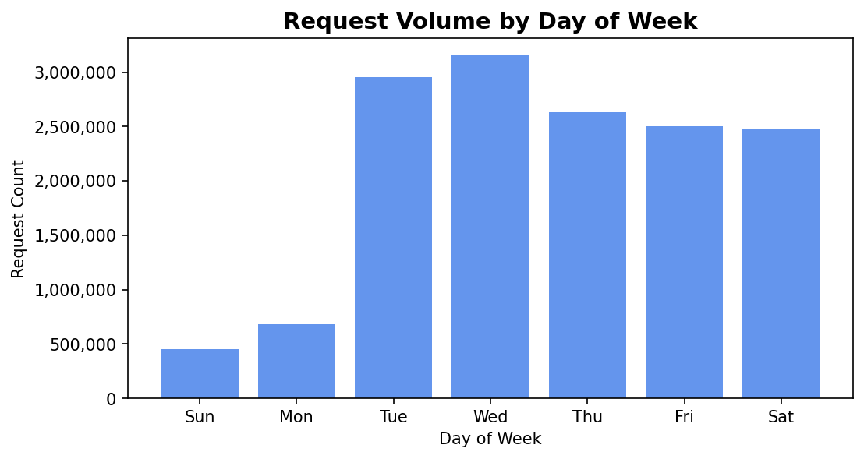
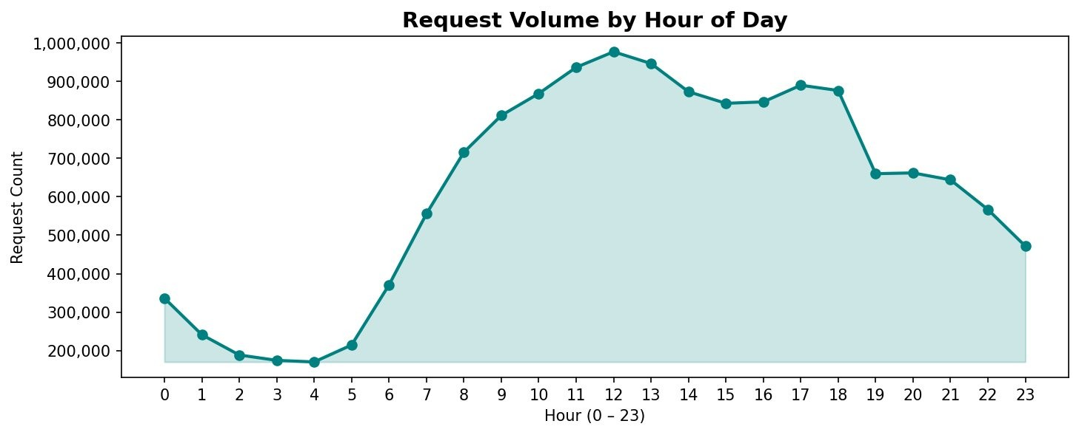
Fig 9. Request Volume by Hour of Day — peak at noon (~970K/hour), minimum at 4am (~180K)
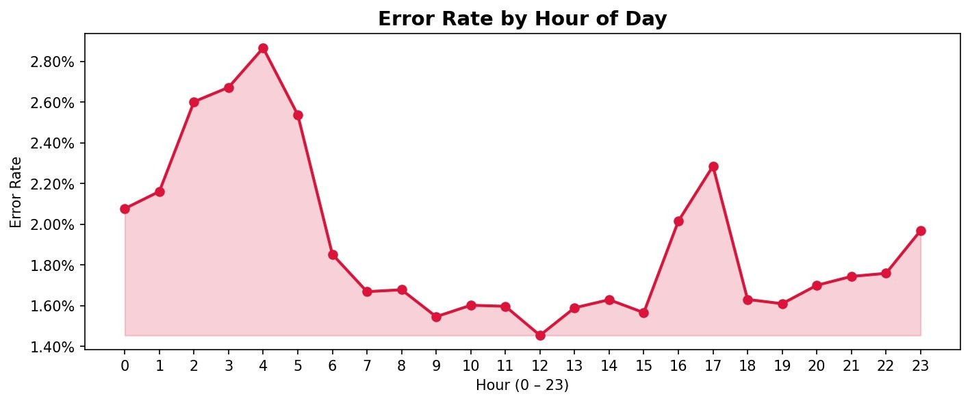
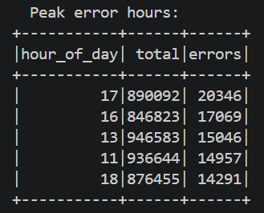
Fig 11. Error Rate by Hour — peaks at 4am (2.85%), minimum at noon (1.44%) — inverse of traffic volume
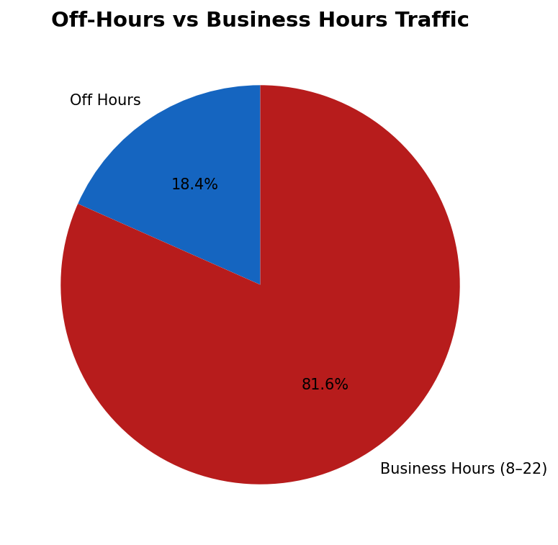
Error rate peaks at 4am, not during peak traffic hours. During low-traffic overnight periods, bot/crawler activity constitutes a higher proportion of all requests, and bots tend to hit deprecated or restricted endpoints. By noon, human traffic dominates and the error rate reaches its minimum. Errors are caused by non-human traffic patterns, not by server load.

Section 4 — Error Analysis
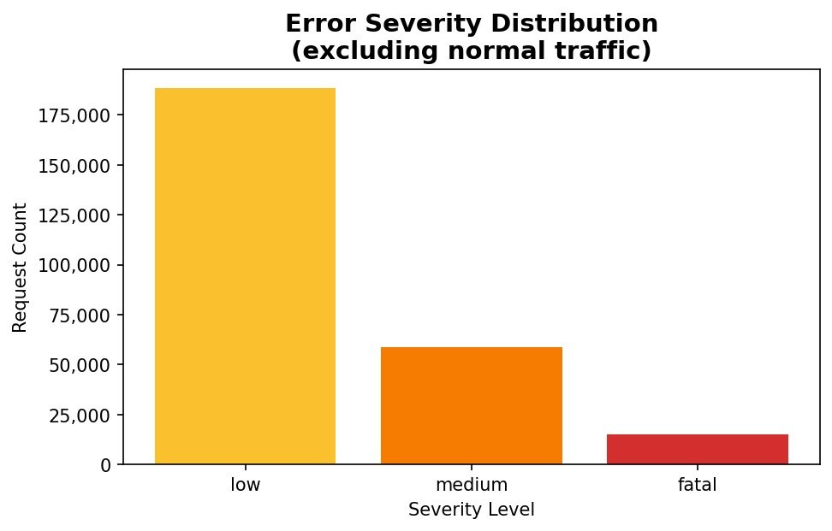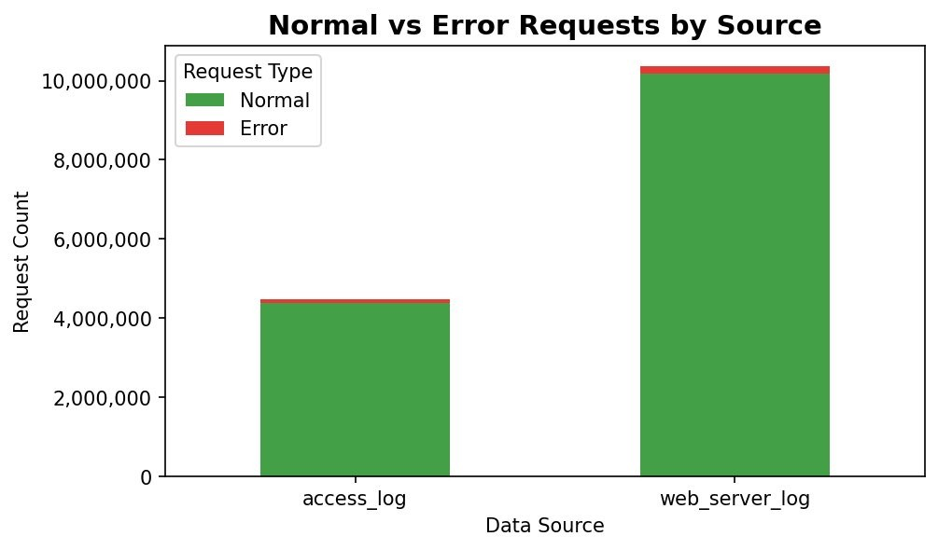
Fig 13. Error Severity Distribution | Fig 14. Normal vs Error Requests by Source
Of all error-classified requests, low-severity (400, 404, 405, 416) dominates at ~185,000 requests. Medium-severity (401, 403, 429) at ~60,000. Fatal (500, 502, 503, 504) is the rarest at ~16,000, confirming server stability. Both datasets show errors as a thin sliver relative to normal traffic.

Section 5 — Anomaly Analysis
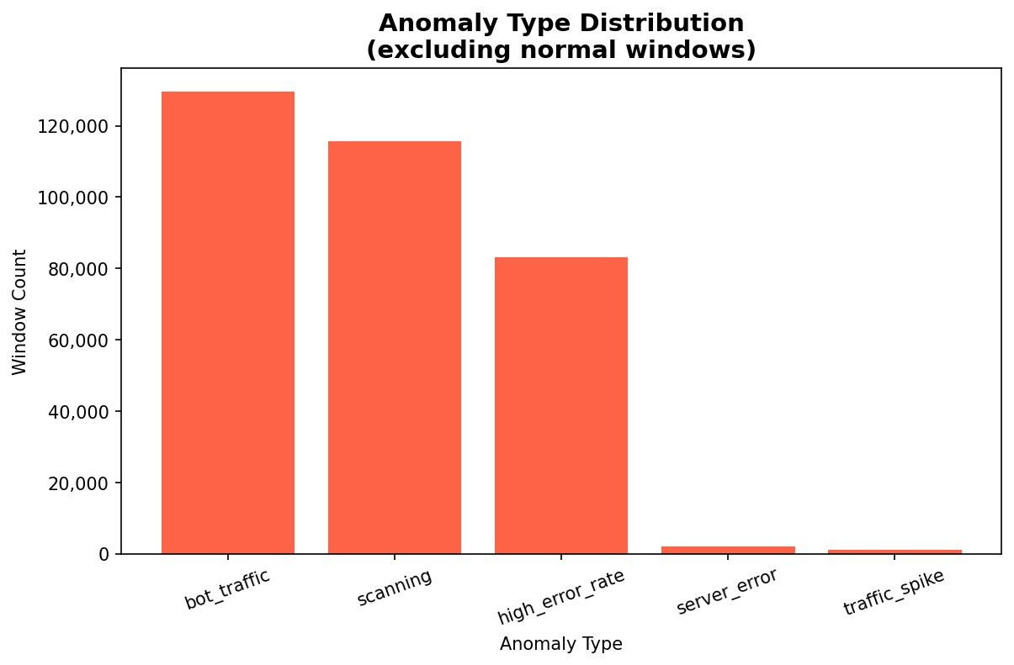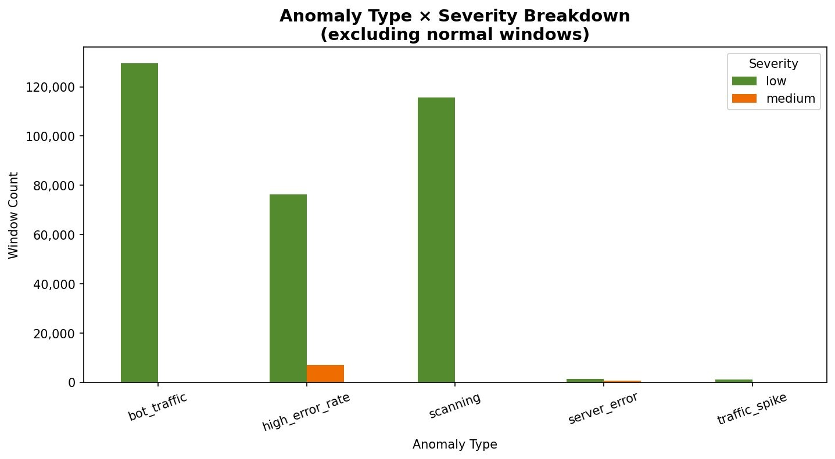
Fig 15. Anomaly Type Distribution | Fig 20. Anomaly Type x Severity Breakdown
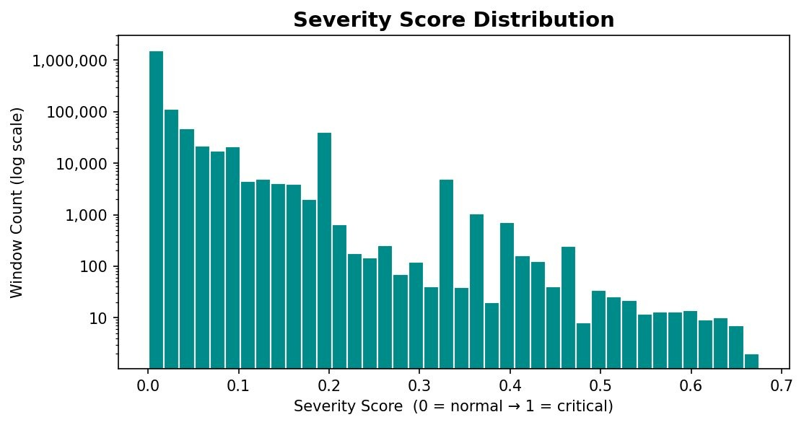
Fig 17. Severity Score Distribution — maximum observed score ~0.67, no windows exceed 0.7
Of 1,831,664 total IP-minute windows, 331,642 (18.1%) were flagged as anomalous. Bot traffic is the most common type (129,612 windows), followed by scanning (115,562), then high error rate (83,193). Server errors (2,073) and traffic spikes (1,202) are rare but operationally critical. The severity score histogram follows a power-law distribution — the maximum observed score is ~0.67, confirming no catastrophic events occurred during the log period.

3. Extracting Insights from Data
- Googlebot is the single largest traffic source. IPs 66.249.66.194 and 66.249.66.91 together account for 665,000 requests. Organizations should implement crawl rate limiting which manages the speed at which bots, such as Googlebot, request pages from a website to prevent server overload.
- Error rate is highest at 4am (2.85%), not at peak load. The overnight error spike is driven by bots hitting deprecated or restricted endpoints — not server strain. Errors are caused by traffic quality, not traffic quantity.
- Scanning behavior detected in 115,562 windows. IPs probing more than 30 unique endpoints per minute exhibit automated reconnaissance consistent with vulnerability scanning tools. These IPs should be flagged for WAF blocking. WAF (Web Application Firewall) blocking protects web applications by filtering HTTP/S traffic based on custom and managed rules, typically responding with a 418 or 403 error to malicious requests. It stops threats like SQL injection, cross-site scripting (XSS), and DDoS attacks.
- The request count distribution follows a power law. Most IPs send 1–10 requests per minute. A tiny fraction send 200–550 req/min — exactly where traffic spike anomalies live.
- High error rate is the only anomaly type reaching medium severity regularly (6,953 windows), confirming it is the most operationally significant anomaly type in this dataset.

4. Model/Classifier Training
Features used (10 behavioral features): request_count, error_count, avg_bytes, unique_endpoints, bot_requests, off_hours_requests, fatal_count, medium_count, low_count, error_rate.
Feature pipeline: StringIndexer (anomaly_type string to integer label) → VectorAssembler (10 features to dense vector) → StandardScaler (zero mean, unit variance). Pipeline fit on training split only to prevent data leakage.
Split | Size | Percentage
Train | 1,099,823 windows | 60%
Validation | 365,938 windows | 20%
Test | 365,903 windows | 20%
Logistic Regression: Multinomial with L2 regularization. Grid search over regParam ∈ {0.001, 0.01, 0.1} and elasticNetParam ∈ {0.0, 0.5}. Best: regParam=0.001, elasticNetParam=0.5, validation F1=0.9501. 100 maximum iterations.
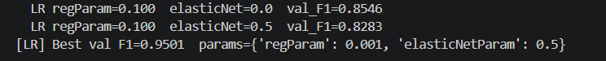
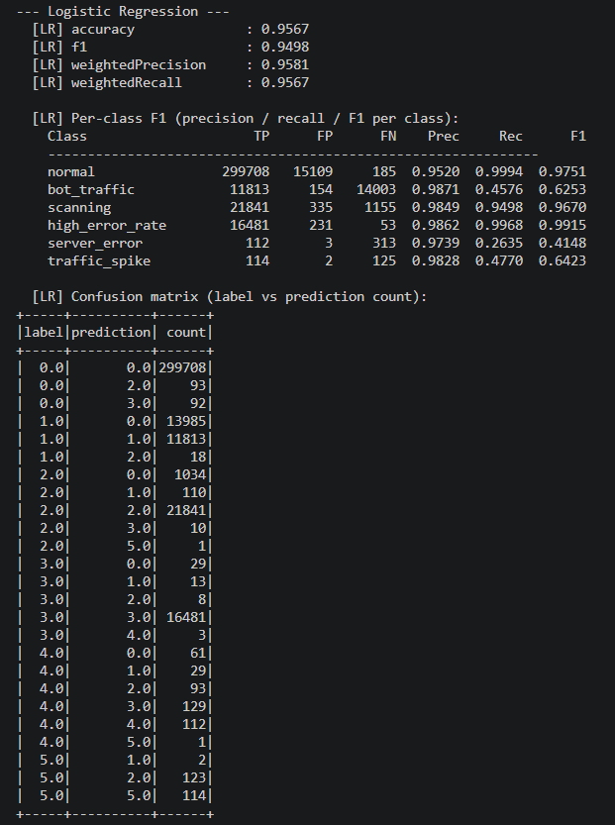
Random Forest (KNN substitute): Native KNN unavailable in Spark MLlib. Random Forest selected as principled substitute — non-parametric, handles multi-class natively, scales to millions of rows. Grid search over numTrees ∈ {50, 100} and maxDepth ∈ {5, 10}. Best: numTrees=50, maxDepth=10, validation F1=0.9990.
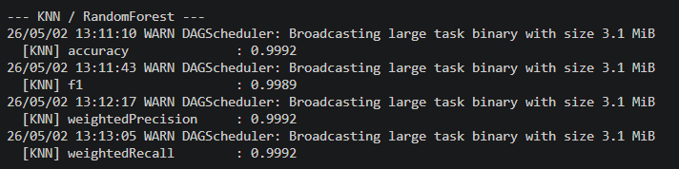
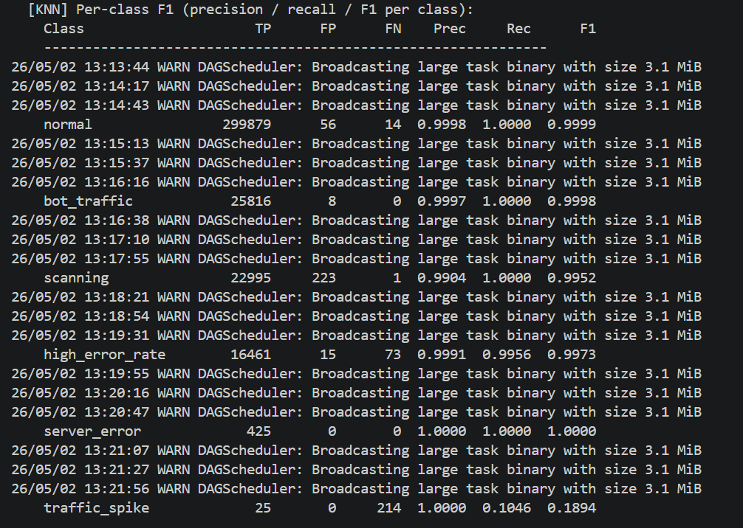
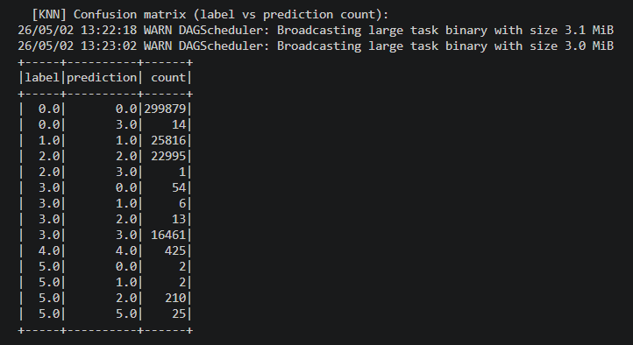
K-Means: Trained for k=3 through k=8 using k-means|| initialization. Best k selected by silhouette score on validation set. k=4 selected (silhouette=0.8636).
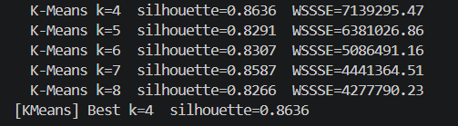
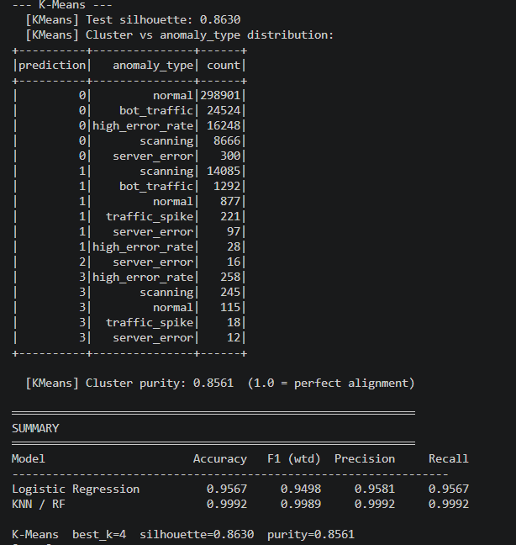

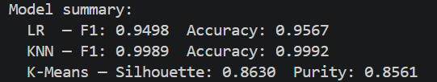

IV. Results and Evaluation

Model Performance on Test Set (365,903 windows)
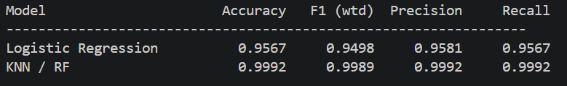
Model | Accuracy | F1 (weighted) | Precision | Recall
Logistic Regression | 95.67% | 0.9498 | 0.9581 | 0.9567
Random Forest | 99.92% | 0.9989 | 0.9992 | 0.9992
K-Means (k=4) | — | Silhouette: 0.8630 | Purity: 0.8561 | —

K-Means Silhouette Scores by k
k | Silhouette Score | WSSSE | Notes
3 | 0.8448 | 8,653,856 | Under-segmented
4 | 0.8636 | 7,139,295 | Best — selected
5 | 0.8291 | 6,381,026
6 | 0.8307 | 5,086,491
7 | 0.8587 | 4,441,364
8 | 0.8266 | 4,277,790 | Over-segmented

Confusion Matrix Analysis
Logistic Regression: Performs well on dominant classes (normal: 299,708/299,893 correct). Struggles with minority classes — server_error achieves only 112/425 correct (26.4% class recall) due to class imbalance. traffic_spike achieves 114/239 correct (47.7%). This is caused by class imbalance — server_error represents only 0.1% of windows, so the model rarely sees enough examples to learn it confidently. Minimal regularization (regParam=0.001) was required to preserve sensitivity to minority classes.
Random Forest: Near-perfect across all classes. Primary confusion: traffic_spike achieves only 25/239 correct (10.5% recall) — 210 out of 239 windows were misclassified as scanning. These two types are behaviorally similar (high request count combined with many unique endpoints), making the boundary genuinely ambiguous even for a strong model. server_error achieves 425/425 correct — perfect class recall.

K-Means Cluster Composition
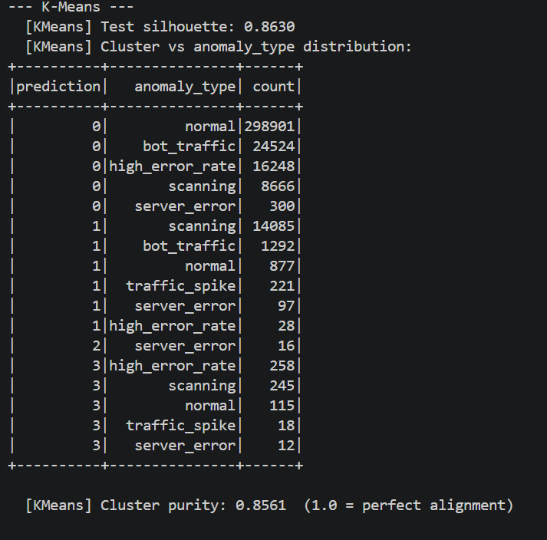
Cluster | Dominant Anomaly Type | Window Count | Interpretation
C0 | normal + bot_traffic (85%) | 349,639 | Regular low-intensity activity
C1 | scanning (85%) | 16,600 | Automated reconnaissance behavior
C2 | server_error (100%) | 16 | Pure server failures — distinct signature
C3 | high_error_rate + scanning | 631 | Mixed borderline anomalies
Key finding: Cluster 2 contains exclusively server_error windows — discovered entirely without labels, using only behavioral features. K-Means confirmed that server failures have a genuinely distinct behavioral signature, independently validating our feature engineering approach.

Model Accuracy on Train, Validation, and Test
Model | Val F1 | Test F1 | Test Accuracy | Overfitting?
Logistic Regression (best params) | 0.9501 | 0.9498 | 95.67% | No — stable across splits
Random Forest (best params) | 0.9990 | 0.9989 | 99.92% | Minimal — robust model
K-Means k=4 | 0.8636 (sil) | 0.8630 (sil) | N/A | No — consistent clustering
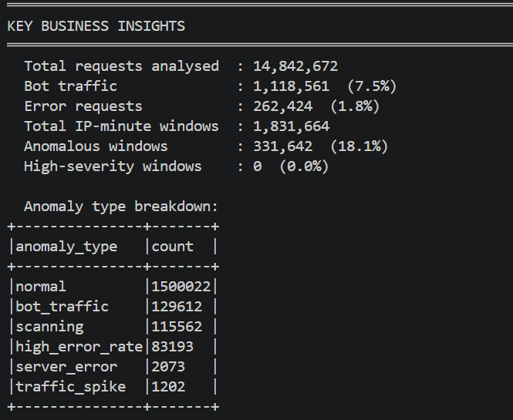

V. Unsuccessful Trials

1. K-Means with k=3 and k=5–8
k=3 (silhouette 0.8448) under-segmented the data, merging scanning and bot traffic into one cluster. k=5+ over-segmented by splitting the large normal traffic cluster into meaningless sub-groups. k=4 produced the best silhouette (0.8636) and the most interpretable structure.

2. Logistic Regression with regParam=0.1
F1 dropped to 0.8546 — a 10 percentage point degradation. Heavy regularization collapsed predictions toward the majority class (normal), causing near-zero recall for minority classes. This demonstrated that LR on this dataset requires minimal regularization (regParam=0.001).

3. Logistic Regression with regParam=0.01
F1 = 0.9101 — better than regParam=0.1 but still substantially below 0.001, confirming the performance is highly sensitive to regularization strength on this well-separated feature space.

4. High-severity threshold at 0.7
No windows in the dataset reach this threshold — the maximum observed severity score is approximately 0.67. This is a valid finding rather than a model failure: the server environment did not experience catastrophic events during the observed log periods. The formula is correct; the data is simply healthy.

5. 1-Hour Aggregation Windows
Initial experimentation used 1-hour windows. This produced only ~180,000 windows (vs 1.8M at 1-minute) and completely masked short-duration burst behavior — a 30-second DDoS probe would average away within an hourly window. 1-minute windows were retained for the temporal resolution required.

6. Native KNN via spark-knn library
The spark-knn package was not available in the project environment. Random Forest was selected as the principled substitute: natively supported by Spark MLlib, scales to millions of rows without memory issues, and is widely recognized as a stronger baseline than KNN on tabular data.

VI. Enhancements and Future Work
- Real-time streaming detection: Replace spark.read.text() with spark.readStream and integrate Apache Kafka as the message broker. Anomalies would be flagged within seconds of the first suspicious requests, enabling proactive response before an attack escalates.
- Automated IP blocking integration: Connect anomaly output to a firewall API (iptables, Cloudflare WAF) so high-confidence scanning IPs are automatically rate-limited or blocked without human intervention.
- IP geolocation enrichment: Join IP addresses against a GeoIP database (MaxMind GeoLite2) to add country and ASN features, enabling detection of coordinated geographic attacks and differentiation between residential and datacenter traffic.
- Fully distributed deployment: Run on a multi-machine Spark cluster (Google Cloud Dataproc, AWS
EMR) to process terabyte-scale production logs. The current pseudo-distributed local[*] mode is limited to one machine's RAM.
- Autoencoder-based anomaly detection: A deep learning autoencoder trained exclusively on normal traffic would flag high reconstruction error as anomalous — requiring no rule-based label definitions and capable of detecting novel attack patterns outside the current taxonomy.
- Adaptive thresholds: Current anomaly thresholds (>200 req/min = spike) are static. A rolling baseline approach would adapt thresholds dynamically from recent history, accommodating traffic growth and seasonal patterns automatically.
- Severity formula calibration: The current formula was designed manually. Supervised calibration using real incident data labeled by security analysts would produce more accurate and operationally validated severity scores.

