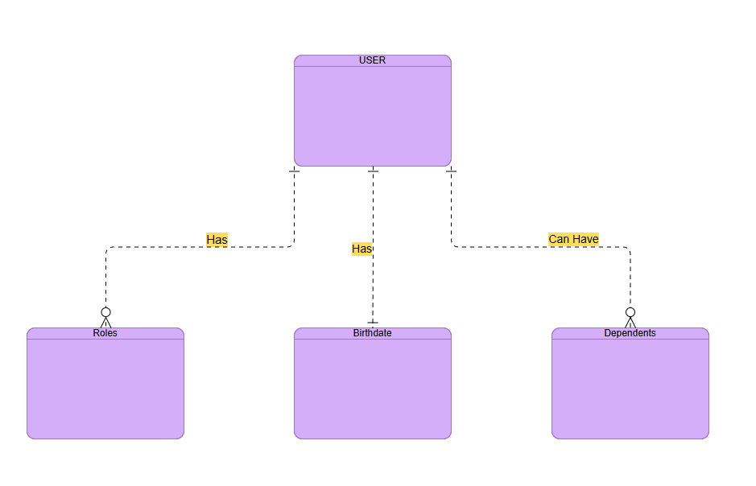

{
"User",
"Roles”,
“Birthdate",
"Dependents”
}

