The Independent Institute of education
Assessment Type: POE Part 2

Student Number: ST10129307
Student Name: ELI BENI IZE
Module Code: CLDV7111w
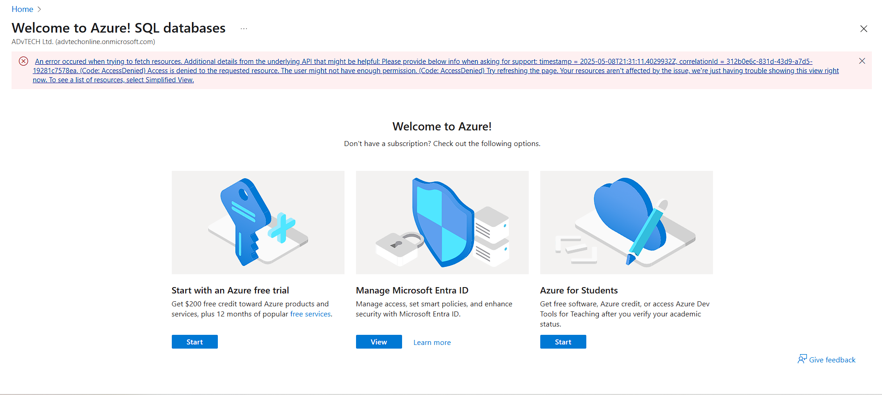
Issues note & alternatives:
I’ve made a change to the project to use MongoDB and my private VPS for publishing the App
Because I asked The IT team at Rosebank College Pretoria campus for assistance to add a subscription to my azure student account in the morning of the 7/05/2025 but I’m still waiting for a feedback
Please assist me in updating my Azure account, I had the same issue while publishing part 1

Link to my project on Github
https://github.com/eli-iie/eventEaseBookingSystem
IP address of my VPS
102.211.206.123
I will further include a subdomain to my portfolio website at st10129307.southclocks.co.za and route the address through Cloudflare
E. Database Design, Cognitive Search
1. How Azure's Cognitive Search Differs from Conventional Search Engines
By utilizing artificial intelligence (AI) for machine learning and natural language processing, Azure Cognitive Search improves on conventional keyword-based search engines by better comprehending user intent and context. Cognitive Search can interpret unstructured data and offer sophisticated features like faceted navigation, in contrast to typical search engines that just concentrate on keywords.
Use cases include: - Document indexing: Enhances the discoverability of various kinds of content.
E-commerce: Improves product recommendations and search.
Customer service: Makes searching the knowledge base easier.
Healthcare: Helps locate clinical information fast.
Restrictions and Countermeasures:
Complex Setup: For successful implementation, appropriate training and assistance are needed.
Cost: Controllable by streamlining searches and keeping only the most important information.
Data privacy: Information needs to be protected using strong
2. Importance of Database Normalization in Cloud-Based Design:|
In cloud contexts, normalization is crucial for maintaining data integrity, cutting down on redundancy, and improving storage.
Impact of Normalized vs. Denormalized Structures: Normalized structures can make searches more complex but can reduce duplication, resulting in faster updates and integrity maintenance.
Denormalized structures can speed up read operations, but they can also raise storage costs and result in abnormalities in the data.
In conclusion, denormalization can improve speed for read-heavy applications at the expense of complexity and data integrity issues, whereas normalization facilitates effective data management in cloud environments.

