Skip to contentSkip to site index
SUBSCRIBE FOR $1/WEEKLog in

The Unseen Toll of a Warming World
By Sarah Kerr, Noah Throop, Jack Healy, Aidan Gardiner and Rebecca LiebermanMarch 9, 2022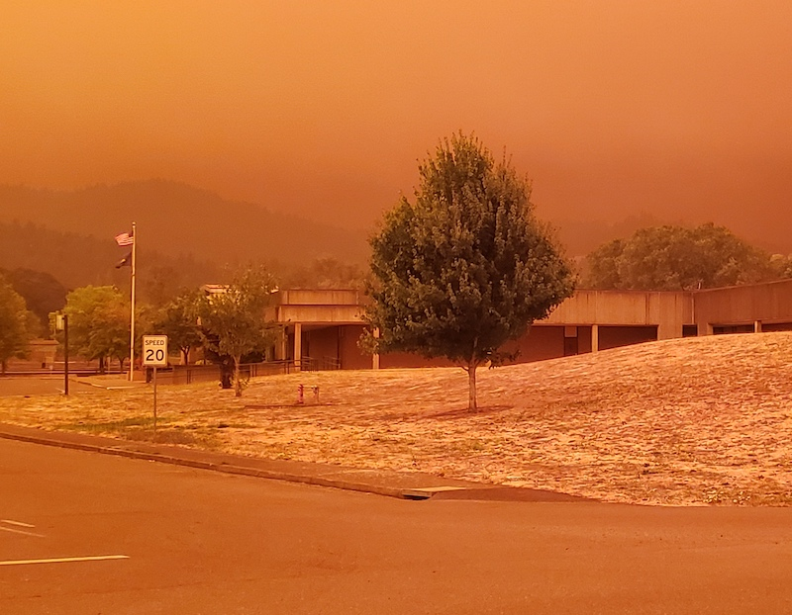

Corvallis, Ore.
The physical scars of our warming planet are everywhere — from rising sea waters to melting glaciers and charred forests.
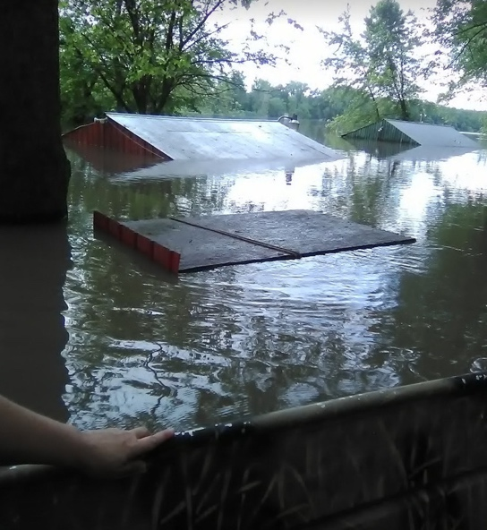
Loose Creek, Mo.
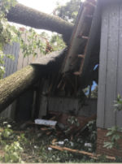
Dover, Del.
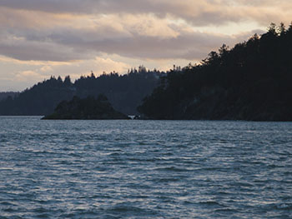
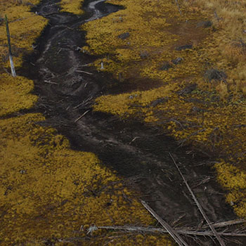
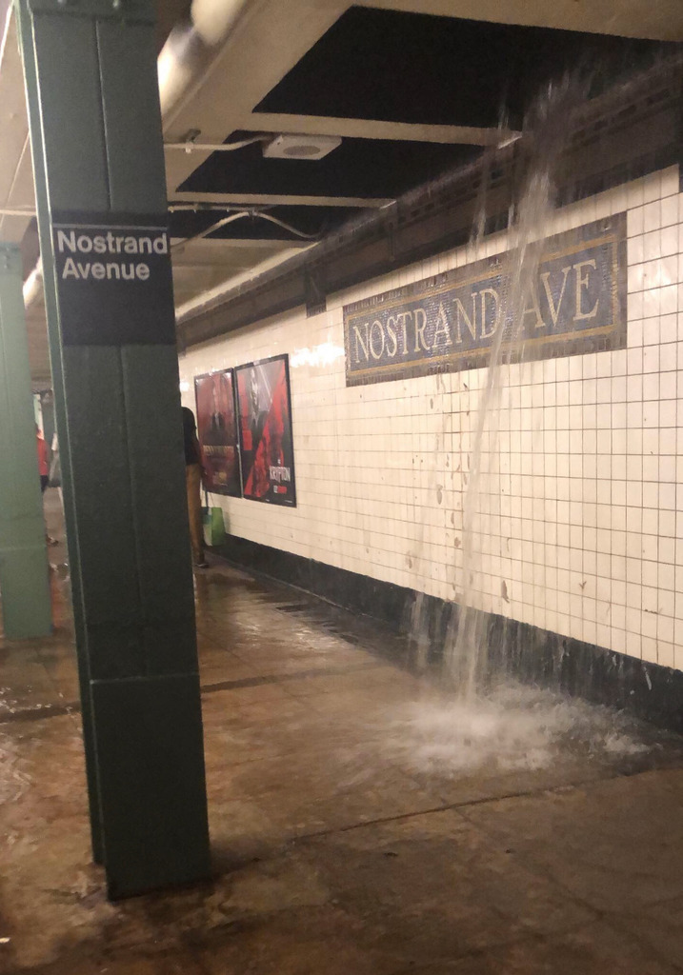
Brooklyn, N.Y.
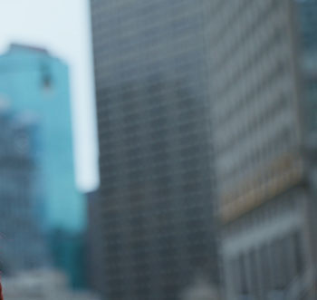
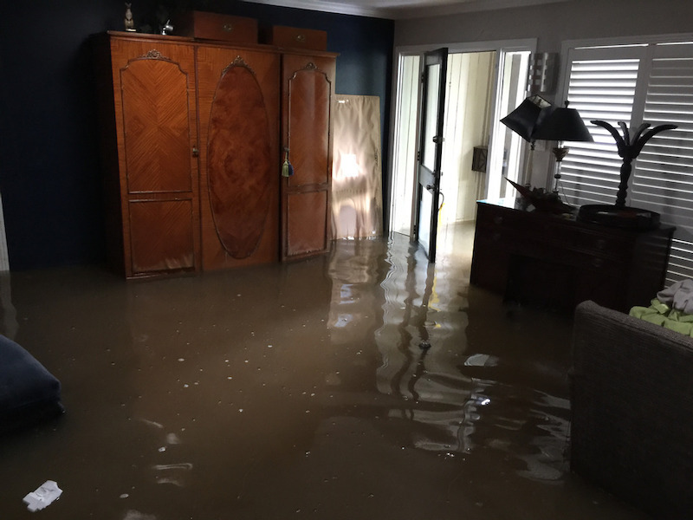
Houston
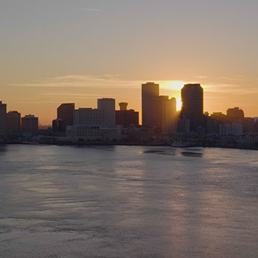
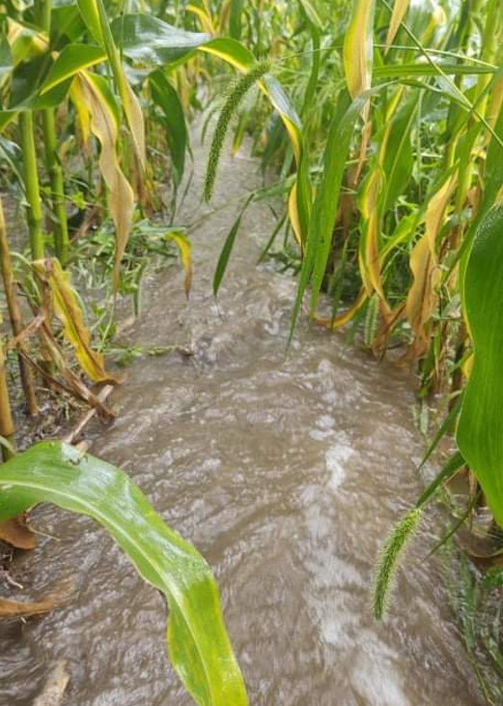
Munnsville, N.Y.
But climate change is also inflicting a growing, unseen toll on mental health. This is how Americans describe the stresses and strains of life on the front lines of a changing climate.
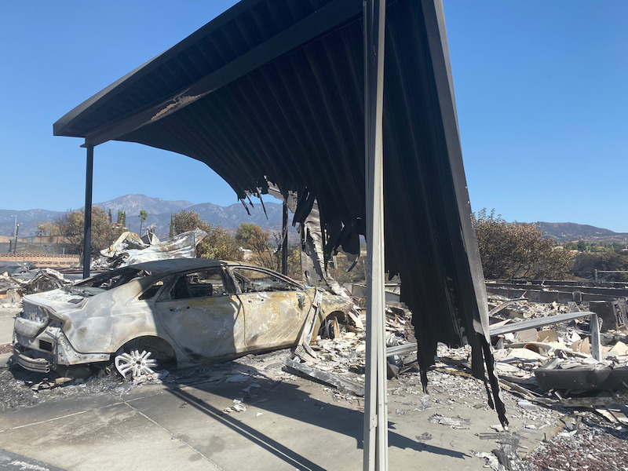
Redlands, Calif.
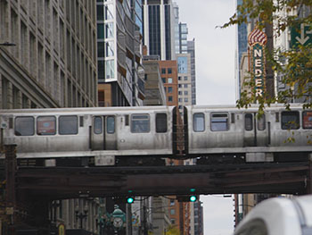
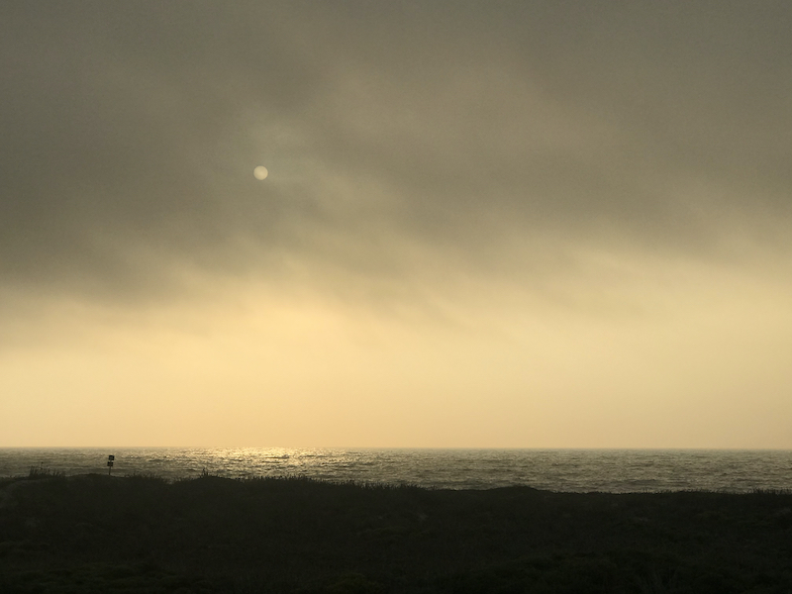
Moss Landing, Calif.
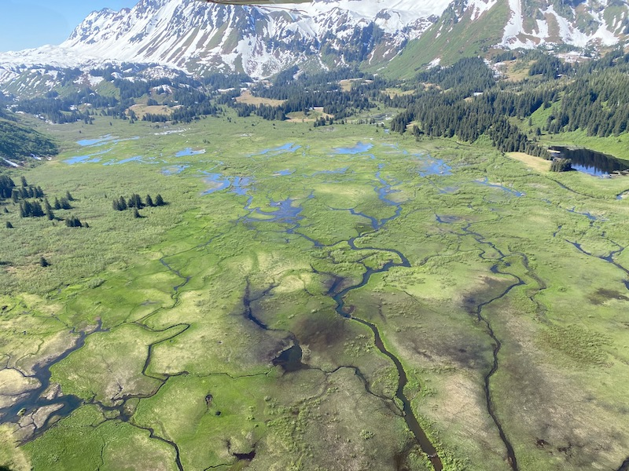
Cordova, Alaska
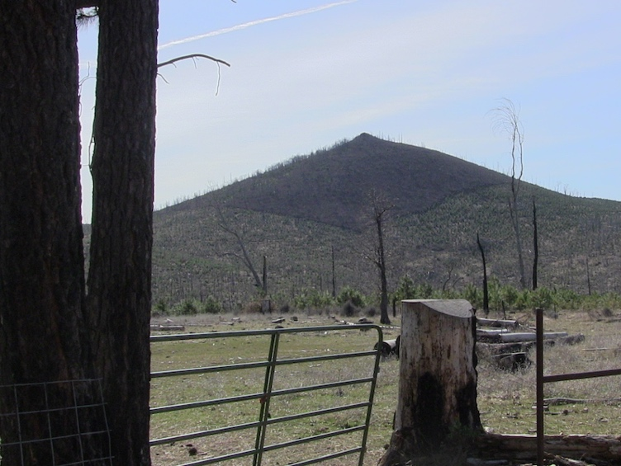
Manton, Calif.
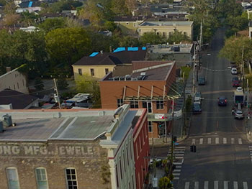

• • • Experts and psychologists are racing to understand how the torments of a volatile, unpredictable planet shape our minds and mental health. In February, a major new study highlighted the mental health effects of climate change for the first time, saying that anxiety and stress from a changing climate were likely to increase in coming years.
In addition to those who have lost their homes to floods and megafires, millions have endured record-breaking heat waves. The crisis also hits home in subtle, personal ways — withered gardens, receding lakeshores and quiet walks without the birdsong that once accompanied them.
To understand what the effects of climate change feel like in America today, we heard from hundreds of people. In cities already confronting the long-term effects of climate change, and in drought-scarred ranches and rangeland, many are trying to cope with the strains of an increasingly precarious future.
Play again

Alana Quintasket is a Swinomish tribal senator in Washington State. Warming seas and rivers are threatening ecosystems that are a lifeblood of tribal economies and cultures.
The feelings are complex.
Some people grieve the loss of serene hiking trails that have been engulfed by wildfire smoke while others no longer find the same joy or release from nature. Some are seeking counseling. Others are harnessing their anxiety by protesting for change or working to slow the damage.
“​​This is becoming a No. 1 threat to mental health,” said Britt Wray, a Stanford University researcher and author of “Generation Dread,” a forthcoming book about grappling with climate distress. “It can make day-to-day life incredibly hard to go on.”
Psychologists and therapists say the distress of a changing climate can cause fleeting anxiety for some people but trigger much darker thoughts for others. In a 2020 survey, more than half of Americans reported feeling anxious about the climate’s impact on their mental health, and more than two-thirds said they were anxious about how climate change would affect the planet.
Play again

Todd Tanner hunts and fishes in western Montana. Founder of the nonprofit Conservation Hawks, he sees firsthand the grim changes in the forests and rivers around him.
Young people say they are especially upset.
A survey of people 16 to 25 in 10 countries published in The Lancet found that three-quarters were frightened of the future. More than half said humanity was doomed. Some feel betrayed by older generations and leaders. They say they feel angry but helpless as they watch people in power fail to act swiftly.
Almost 40 percent of young people say they are hesitant about having children. If nature feels this unmoored today, some ask, why bring children into an even grimmer future?
Some of the worst physical effects of climate change are disproportionately felt by Black and Latino communities and Indigenous nations — who often live in places with a legacy of mining, energy drilling and other pollution. And while these groups are among the most concerned about the changing climate, community resources to deal with the emotional fallout may be more limited.
Play again

Tonyisha Harris is a young climate activist from Chicago’s South Side. Despite the work she does, she worries that climate change is robbing her generation and community of a future they deserve.
Experts are quick to emphasize that people are justified in their emotional response. The threat is real and growing as carbon levels in the atmosphere pass dangerous new thresholds. With rising temperatures, extreme weather events will become more and more common.
“Sometimes I feel hopeless or sad or worried,” said Andrew Bryant, a social worker in Seattle who treats patients with climate anxieties. “That’s part of being a human being at this point if we’re paying attention.”
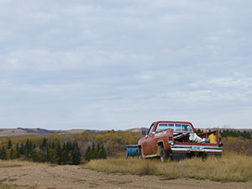
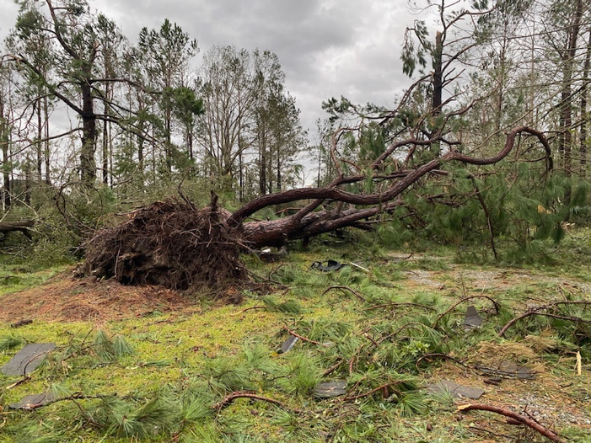
I lost a piece of my heart with the trees that I will never get back.
Isabela Walkin, 23. The forest her family planted was destroyed by Hurricane Laura, but protected her childhood home in Lake Charles, La.
I’m mad, I’m powerless, I’m exhausted and I'm only 18.
Hayley Clausen, Hayden, Idaho.
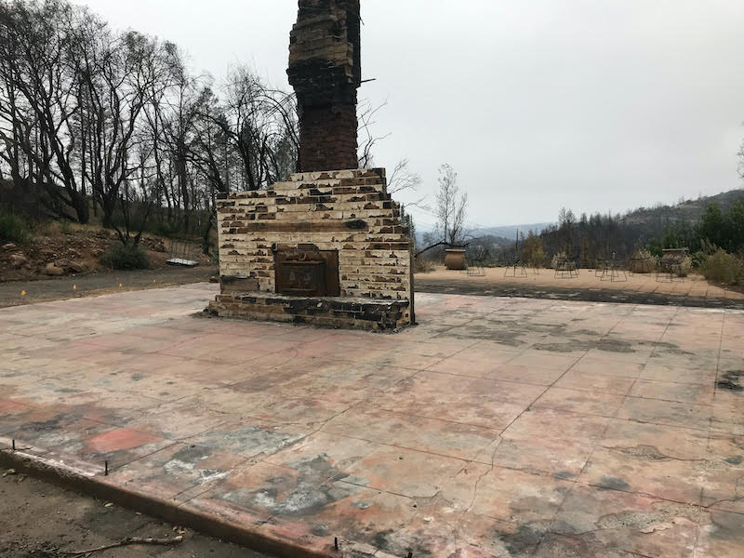
It is very difficult to proceed knowing the fires could come back, will be back. I feel confident that our family will find its heart again, but I’m just not sure how or where.
Ted Bucklin, 67, whose family has lost homes and barns in California’s Sonoma Valley to multiple fires.
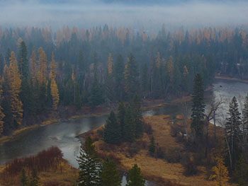
We ruined the world and we feel bad for the young people that are going to have to deal with this.
Ira Russianoff, 72, Dania Beach, Fla.
Our subsistence resources are being threatened or moving farther away. Scary for this 68-year-old Eskimo.
Jerry Ivanoff, of Unalakleet, Alaska, who has struggled in recent years to catch enough salmon to pay for the gas to fish for them.
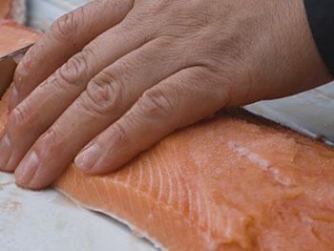
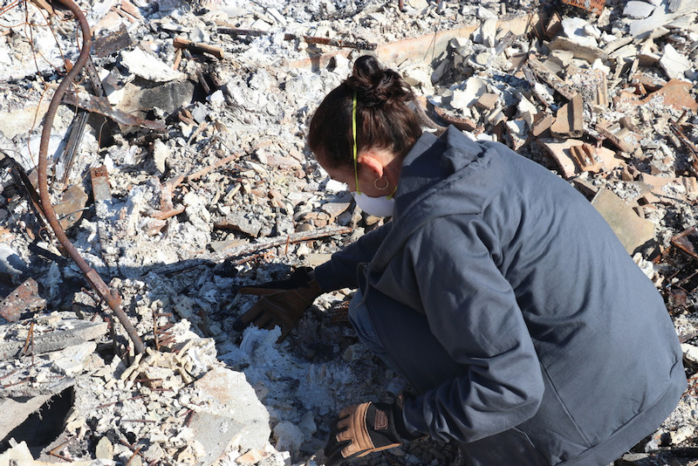
We haven’t rebuilt, since fire remains a risk, but with so much of my past erased, I can't let go of the small spot on this Earth that captured 11 happy years.
Dr. Heather Furnas, 64, lost photos, journals and decades of handwritten birthday notes from her children in the Tubbs fire in Santa Rosa, Calif., in 2017.

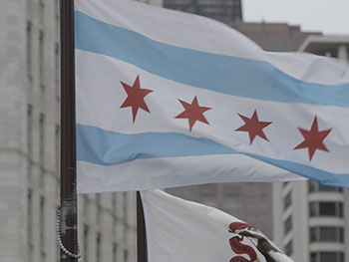
Climate change hangs heavy over me as a farmer who wants to be able to pass her operation on to her children and the next generation of farmers.
Anne Schwagerl, 36, Browns Valley, Minn.
I worry about the future and our ability to deal with these increasingly strong storms.
Kevin Heist, 37, Ypsilanti, Mich.
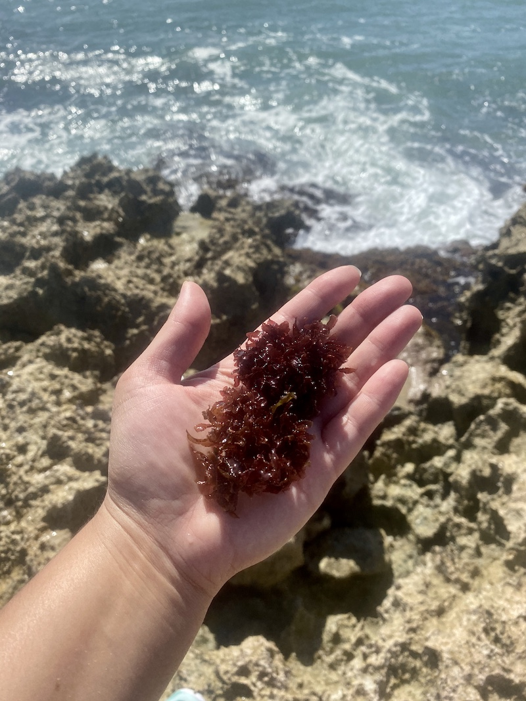
Our ancestral spirits live in land, sea and sky creatures that are now endangered or extinct. We also face the loss of our entire existence as an Indigenous community.
Kauʻi Baumhofer Merritt, 39, Makakilo, Hawaii.
A new world of drenching hurricanes and deadlier summer heat is also straining professions that once seemed removed from the front lines of climate change. Hospitals and police officers in the Pacific Northwest grappled with 500 heat deaths when temperatures shattered records last summer. Along the Gulf, emergency workers are facing down larger, more frequent storms that make their jobs even more dangerous.
“We want to believe that the world we live in won’t change very much,” said Susan Clayton, a professor at the College of Wooster and one of the first researchers to highlight climate anxiety. “But the very ground under our feet, the things we take for granted, can change.”
Play again

​​Laura Russell is a paramedic in New Orleans. Worsening floods and monster hurricanes have added a new burden to the work of helping people in crisis.
I feel hopeless all the time and none of my actions seem to make any positive impact. I just want to give up.
Alyse Lightfoot, 32, a former California parks worker living in Castro Valley, Calif., whose family has been evacuated during several wildfires.
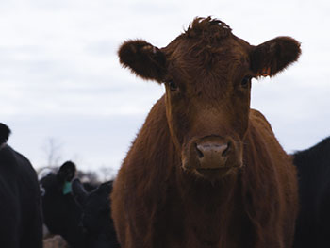
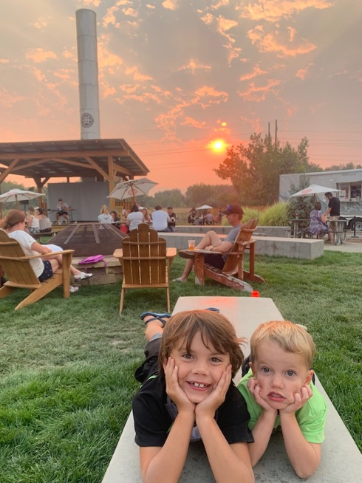
My kids are young, but they notice too. I don’t know what to say to them to prevent anxiety about the world we are leaving them.
Erika Killion, 42, Denver.
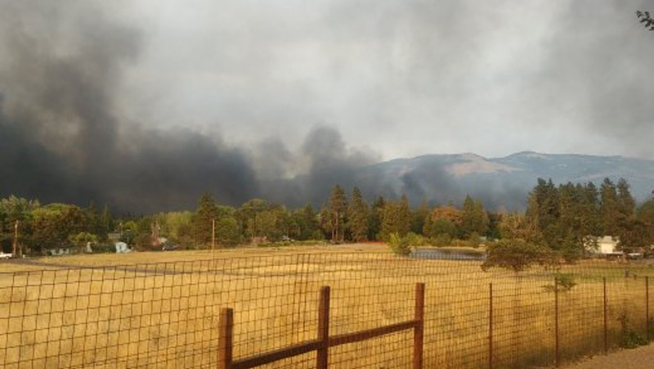
We are climate change refugees. I am 68 years old and too tired to start over. What has happened to my world?
Tina Reuwsaat, who is moving to Virginia to escape the threats of fire and drought in Oregon.

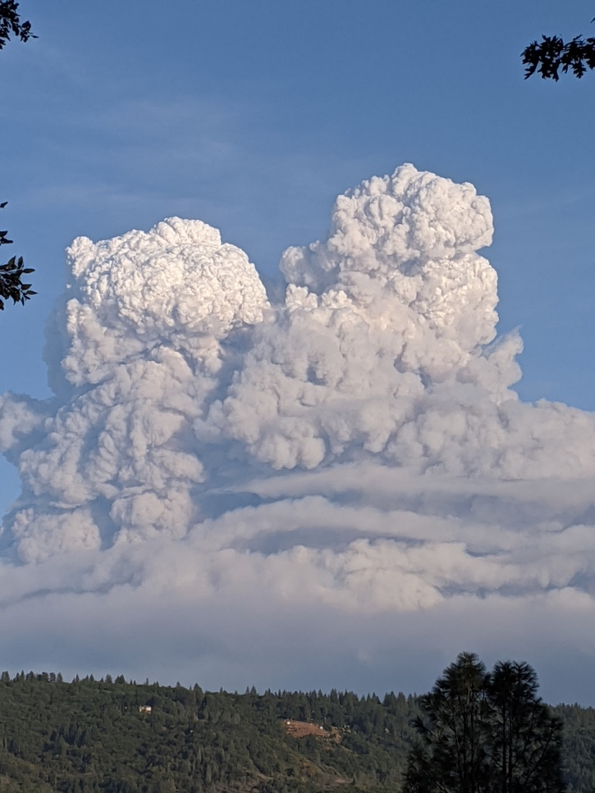
Summers used to be fun. Nowadays, we cannot leave the house overnight during the months of July through October.
Steve Mayo, 66, Forest Ranch, Calif.
My husband comes home tired. Sometimes he tells me he has muscle cramps, that his head aches. Just purely from the heat. I worry about it, but we don’t have another option.
Amalia Mejia, of Immokalee, Fla., whose husband is a farmworker and window installer.

The winter storm last February really knocked the wind out of me. If I had not sought help from my doctor and a therapist, I’m not sure I would still be farming.
Lorig Hawkins, 37, Bastrop, Texas.
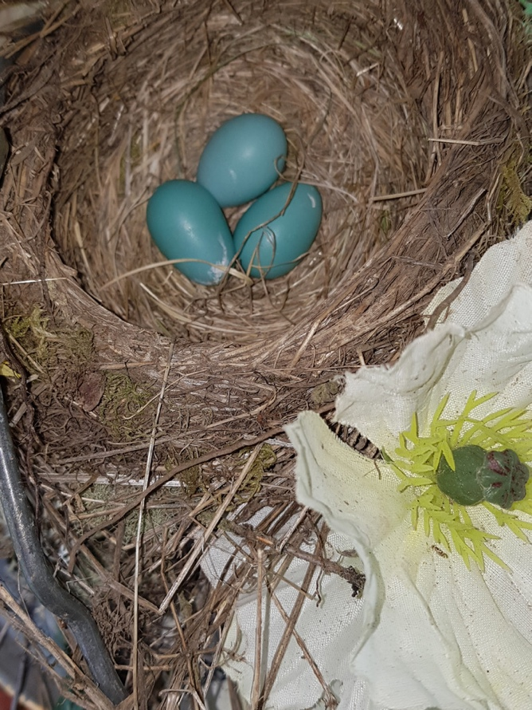
Robin’s eggs just before triple-digit weather in June. Afterward, we never saw the birds again.
Christyl Rivers, 63, Yelm, Wash.


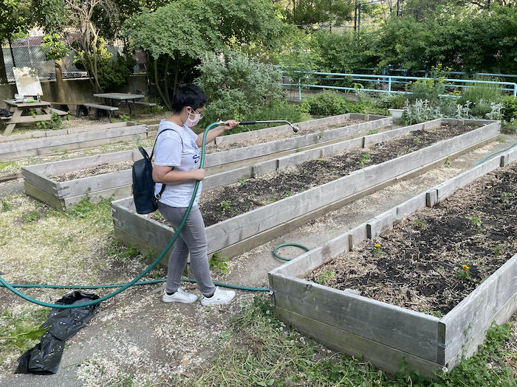
I worry that one day my kids and the next generation may not be able to experience the joy of gardening and growing your own food.
Adeeta Singh, 18, who volunteers at a community garden in the Bronx, N.Y.
Play again

Donald Nelson farms and raises cattle in North Dakota. Changing precipitation cycles are making farming increasingly difficult and placing more strain on ranchers.
Millions of Americans now brace for seasons with a sense of heightened worry. Will children be able to play outside without smoky skies? What storms will shroud the Atlantic Coast? Will the house survive another wildfire season?
The challenge going forward, therapists say, is not being overcome by those fears and sorrow.
To cope and find resilience, experts say, people must now figure out ways to forge ahead individually and collectively. Researchers added that humans have one significant built-in advantage: the ability to adapt to challenging circumstances.
Reporters
Sarah Kerr, Noah Throop, Aidan Gardiner, Jack Healy
Cinematography and video editing
Noah Throop
Design and development
Rebecca Lieberman, Aliza Aufrichtig
Research
Susan Campbell Beachy, Kitty Bennett, Sheelagh McNeill
Project editors
Sameen Amin, Clinton Cargill, Julie Bloom
Intro photographs from:
Maddie Azar, ​​Sarah Ficken, ​​Tracey Freezia, David Hart, Kathryn Hart, Jan Konesey, Dune Lankard, Mary-Brett O'Bryan, Lindsey Rabbitt, Marta Salas-Porras, Veronica Toebbenm, Lindsay Weiler-Leon, Marily Woodhouse
Additional photos in the body of the article from
Paco Canales and Brianna Morgan
Video Archival
@i_am_mr_randolph44 via Storyful, Getty, Reuters, Jabril Portlock

