Problem 1.

(a – f) Initially using 5 knots to generate the spline, the maximum error of the spline approximation of the Runge function was .42

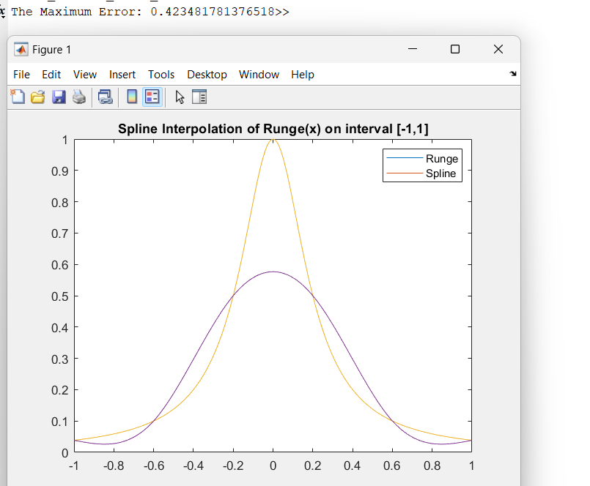

Increasing the number of knots to n=4,8,16,32,64…, we observe:

The spline appears to converge quadratically to the runge function, as each time the size of the intervals are halfed, the error is atleast 4x smaller. The spline s appears to converge to f, and this agrees with the theoretical result that splines can converge to f.

Problem 2