Testing a website – Booking
Diana-Elisa Tița

BUG REPORTS

Loss of validation caused by entering special characters in the search bar

Summary: Last searched location is shown when entering special characters for location in the search bar
Environment:
- OS: Windows 11 Enterprise
- Browser: Microsoft Edge
- Booking website app
- Search bar
Preconditions:
- The user is not authenticated
- The cache and cookies are active so the site can remember the last location
Steps:
- Open the browser
- Open booking.com on your laptop
- Go onto the main Booking website page
- Search for a location with dates and guests so it can be saved in memory
- Go back to the main page
- Enter %#$@* for the location
- Check that the reservation has the dates and guests
- Press the Search button
Expected: One error message for validation is shown
Actual: The location is set as the last valid location searched before entering the special characters sequence
Evidence:
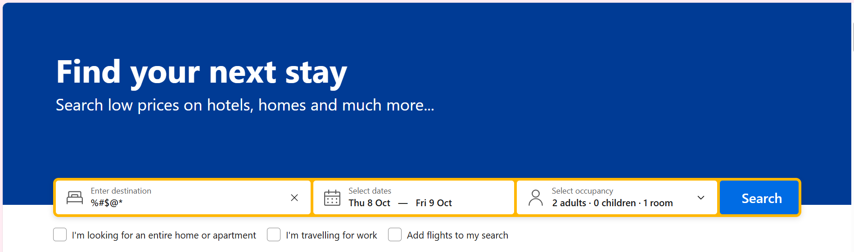
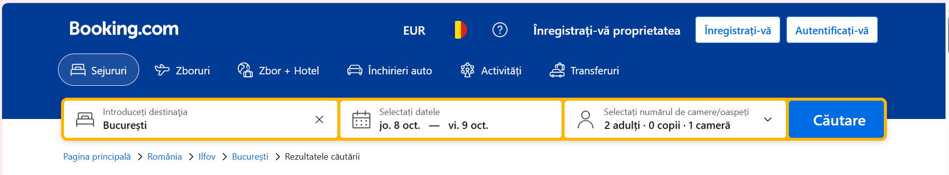
Impact: Medium user impact caused by the loss of the validation message

Disappearance of the keyboard when putting the screen in Landscape mode on the mobile

Summary: When searching for a destination on the mobile web and putting the screen in landscape mode, the keyboard disappears, forcing the user to tap the destination tab again
Environment:
- Version: Android 17
- Browser: Google Chrome
- Booking mobile website
- Search bar
Preconditions:
- The auto rotate function is enabled on the mobile device
Steps:
- Open the browser
- Open booking.com on your mobile
- Go onto the main Booking page
- Go to the location tab and start typing
- While the keyboard is active, rotate the phone and put it in landscape
Expected: The cursor and the keyboard are supposed to stay active and the text to not disappear
Actual: The keyboard disappears after rotating the screen

Evidence:
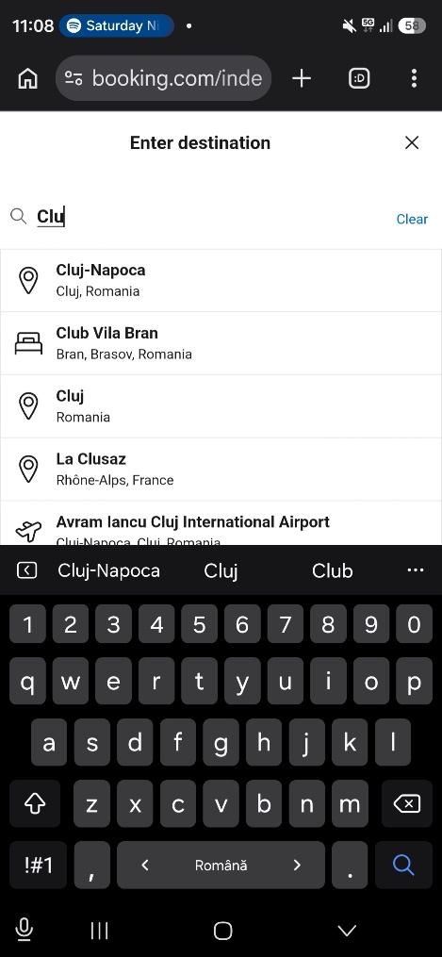

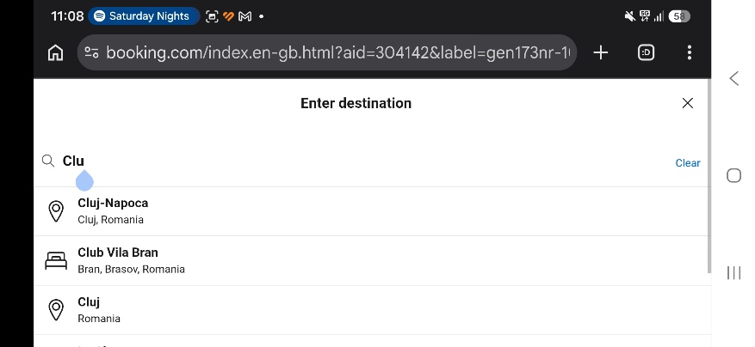
Impact: Low to medium user impact caused by the interruption of the writing flow

Ignoring the font size accessibility setting on the mobile website

Summary: After setting the font size to maximum from settings and accessing the mobile website, it fails to comply with the accessibility setting
Environment:
- Version: Android 17
- Browser: Google Chrome
- Booking mobile website
Preconditions:
- The user navigated to the mobile settings and set the Font size from Display to the maximum
Steps:
- Open the browser
- Open booking.com on your mobile
- Navigate the main page and observe that the text did not adapt to the system settings
Expected: The text elements on the site are supposed to adapt to changes in the font size from the phone settings
Actual: The text elements stay the same as before the change occurred

Evidence:
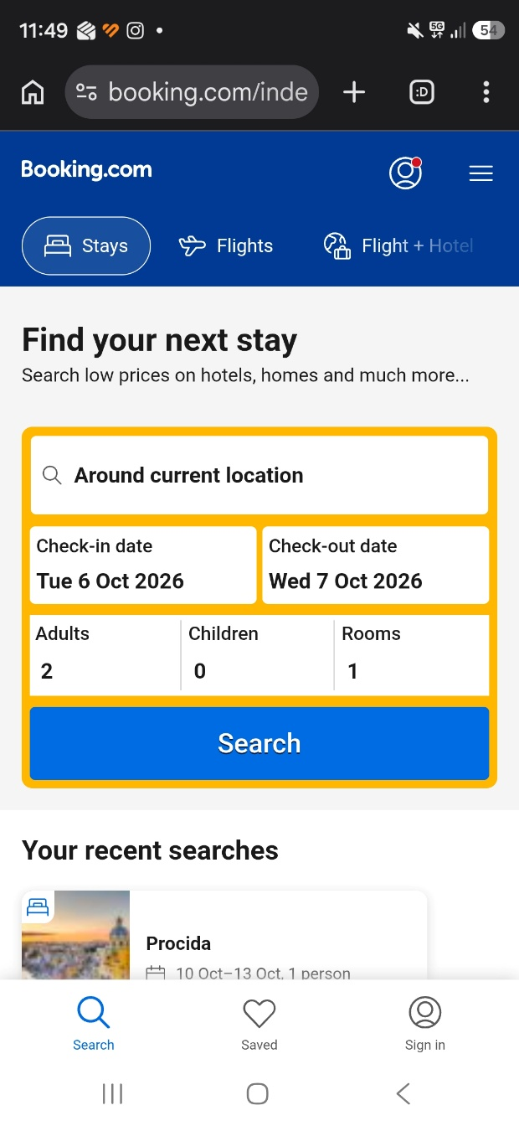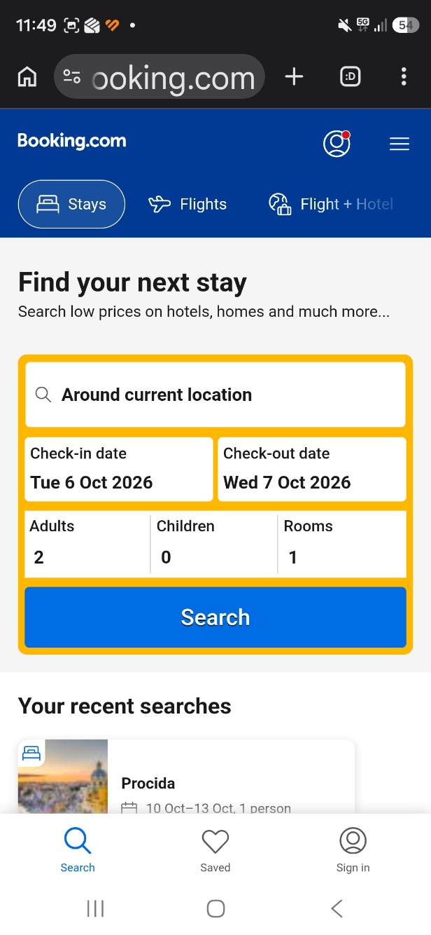
Impact: Medium to high user impact caused by reducing the accessibility of the platform for people with vision deficiencies

TEST CASES

TC01 – Viewing flights with the search

Purpose: To see if guests can get relevant flights with their reservation
Preconditions:
- Internet access
- Booking site opened on the device
Steps:
- Complete the destination, dates and occupancy fields from the main booking page
- Tick the “Add flights to my search” box
- Press Search
Expected results: If available, flights for the selected period will be displayed on a different tab, along with price details and filters

TC02 – Filtering by reviews and breakfast

Purpose: To see if guests can filter the results by properties rated 9 or higher that have breakfast included
Preconditions:
- Internet access
- Booking site opened on the device
Steps:
- Complete the destination, dates and occupancy fields from the main booking page
- Press Search
- Tick “9+” from Review score and “Breakfast included” from Meals
Expected results: The only properties that will appear will be those that have a rating of 9+ and breakfast included for their guests

TC03 – Adding an accommodation to favorites

Purpose: To see if guests can add a specific property they like to their “My next trip” list from the search results page and ensure it is saved properly
Preconditions:
- Internet access
- Booking site opened on the device
- The user already performed a valid search and is on the results page
Steps:
- Scroll down to whichever property you would like to save
- Click on the Heart icon located in the top right corner of the card
- Press on “My next trip” from the information message that appears
Expected results: The list opens and the specific hotel is visible with the correct name and details

USED TESTING TECHNIQUES

Negative Testing

Negative Testing ensures that the software does not fail or behave abnormally after the insertion of invalid data. This testing is performed in hopes of breaking the system and verifying the response of the app during unwanted inputs. The need for using Negative Testing is for delivering bug-free and qualitative products and it grows in importance when testing crucial applications like e-commerce, online stock, etc.

Accessibility Testing

Accessibility Testing ensures that a product can be easily used by all categories of people. A truly accessible website allows any user to navigate and interact with its content seamlessly. In the case of the 3rd bug, the Booking mobile website did not respond to the phone’s maximum font-size settings, making the page harder to read for users who need larger text.

