Doctor portal auth screens
Notes for the work committed and pushed on 19 Oct 2026. These notes were written after that push and are not part of the commit.

Commit
Commit | 4edfe05
Message | Add the doctor portal role chooser and sign-in so providers can reach the clinical dashboard from the new auth screens.
Branch | Nisarg's
Remote | origin/Nisarg's
Repository | https://github.com/eli7diaz/coimbatore-diabetes-app

What changed
Two Doctor Portal screens from the Indian Diabetes Remix design were added and wired into the existing Next.js app. The rest of the site stays the same, except for the sign-in links listed below.

Role selection — /auth/role
- Neither portal is selected until the user chooses one.
- Choosing Patient Portal switches the buttons to the existing patient sign-in (/auth/login) and patient registration (/auth/patient/register).
- Sign In to Doctor Portal opens /auth/provider/login.
- Create Doctor Account opens the existing provider registration (/auth/provider/register).

Doctor sign-in — /auth/provider/login
- Email and password sign-in sets the session as a provider and opens /provider/dashboard.
- Forget Password? explains that reset is handled by the clinic administrator.
- Go to Patient Portal opens /auth/login.
- Privacy Policy and Terms of Service open the existing legal pages. Help Center opens /landing.
The photograph on the left of the sign-in design could not be exported because the Figma file is view-only. That panel is a blue field with the India Care mark and the same headline.

Screenshots
Captured locally from the running app after the push.

Role selection
Neither portal is selected at first. Sign In and Create Account stay disabled until a portal is chosen.
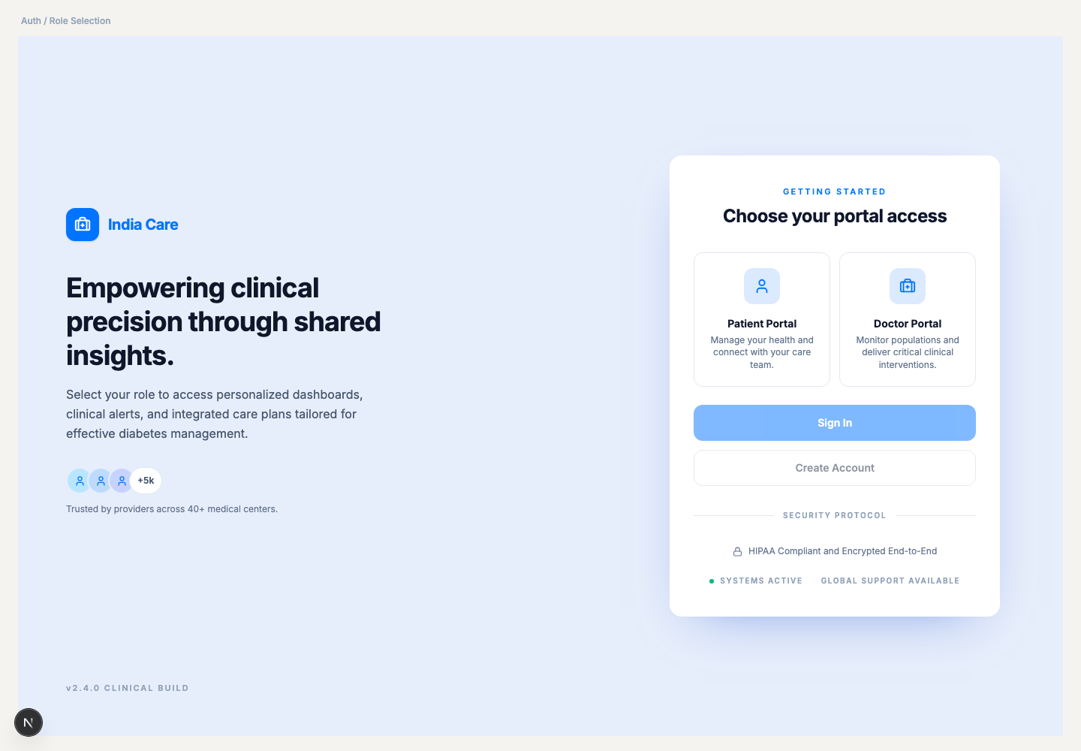

Doctor sign-in
Providers enter a medical email and password, then continue to the clinical dashboard.
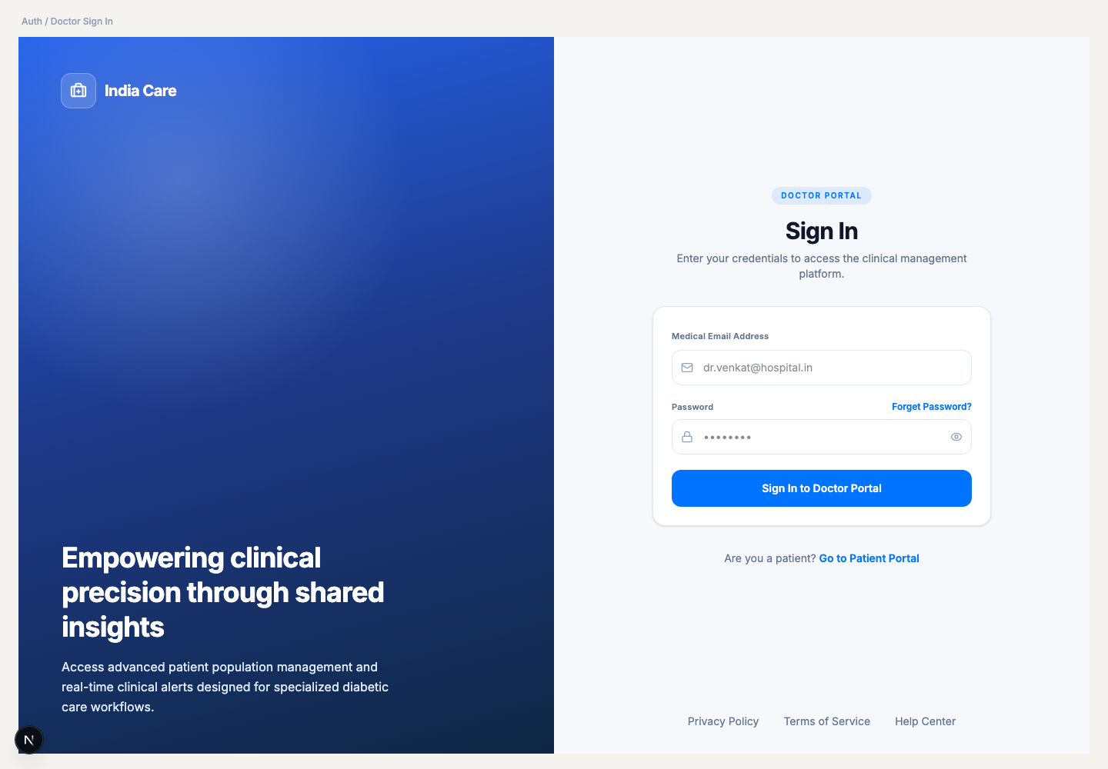

Files in the commit
File | Change
src/app/auth/role/page.tsx | New role-selection screen
src/app/auth/provider/login/page.tsx | New doctor sign-in screen
src/components/auth/IndiaCareMark.tsx | Shared India Care logo
src/components/layout/AppShell.tsx | Hides the site header, footer, and assistant on these two screens
src/lib/authRoutes.ts | Lists the full-page auth routes
src/app/layout.tsx | Renders pages through AppShell
src/app/auth/layout.tsx | Skips the old centered card on these two screens
src/components/layout/Header.tsx | Signed-out Sign In goes to /auth/role
src/components/layout/Footer.tsx | Footer Sign In goes to /auth/role
src/app/auth/provider/register/page.tsx | Returning doctor Sign In goes to /auth/provider/login

How to view
From the project folder, run:
npm run dev
Then open http://localhost:3000/auth/role

