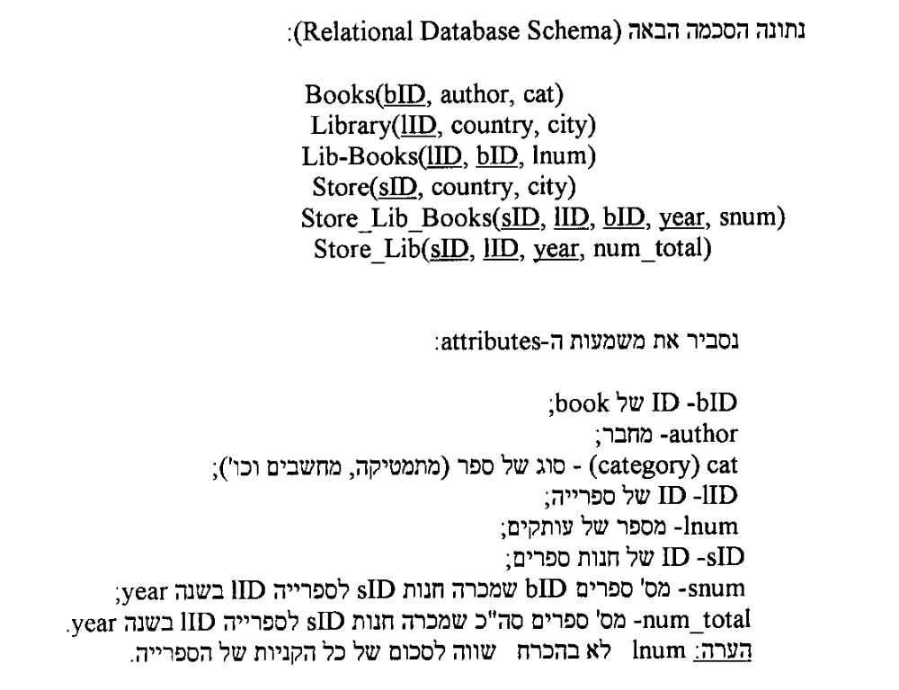
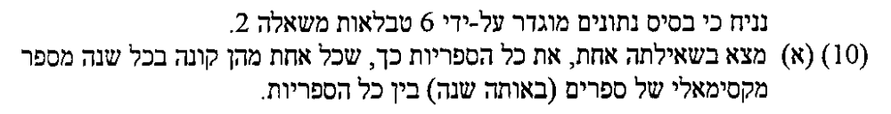

1)
Select lid
From Library
Where lid not in
(Select lid
From sl x
Group by lid,year
Having sum(num_total)<
(select max(sm)
From(select year,sum(num_total) sm
From sl
Group by lid,year)
Where year=x.year)
)
);

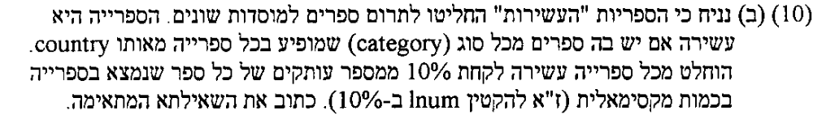

Update lb y
Set lnum=0.9*lnum
Where lnum=(select max(lnum) from lb
Where lid=y.lid)
and lid in
ספריה עשירה- יש בה ספרים מכל סוג שמופיע בכל ספרייה מאותה מדינה
(select lid from l x
Where not exists (select cat
From b,l,lb
Where l.lid=lb.lid and b.bid=lb.bid
And country=x.country
Minus
Select cat
From b,lb
Where b.bid=lb.bid
And lb.lid=x.lid)
);

