3.5 Activity diagram
The activity diagrams model the workflow logic of the CCACS, showing decisions, parallel activities, and process endpoints.

Registration & Login Activity

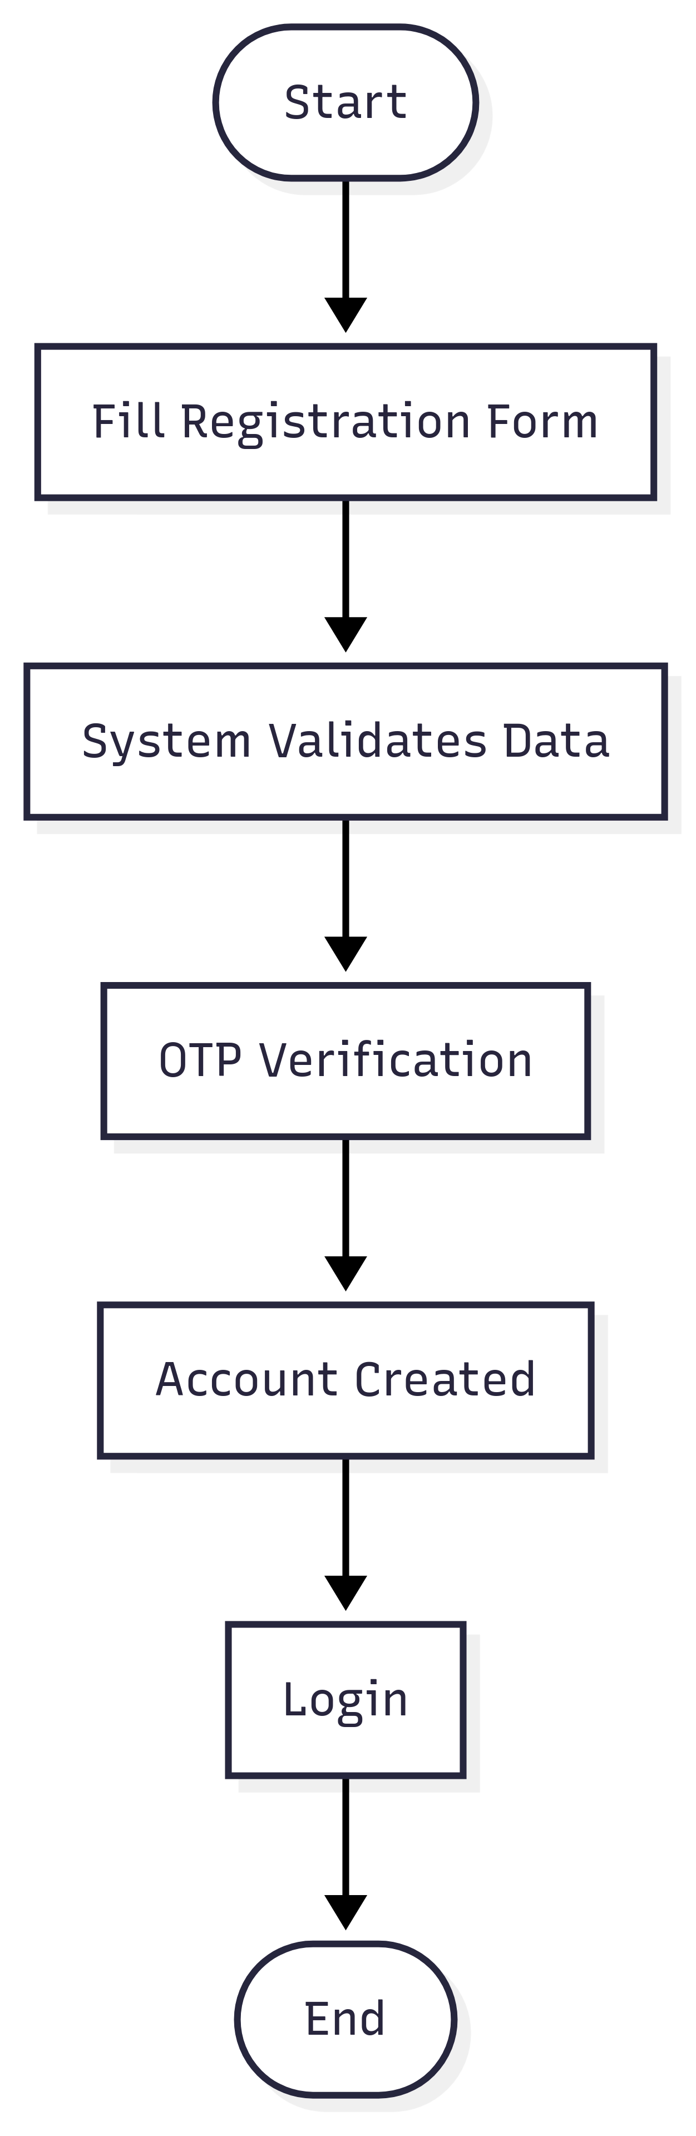

Application Submission Activity

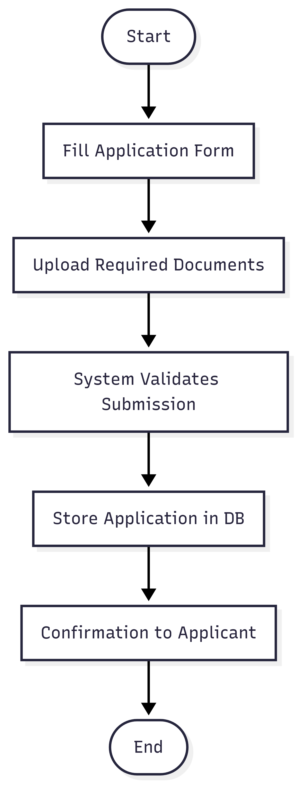

Application Review Activity

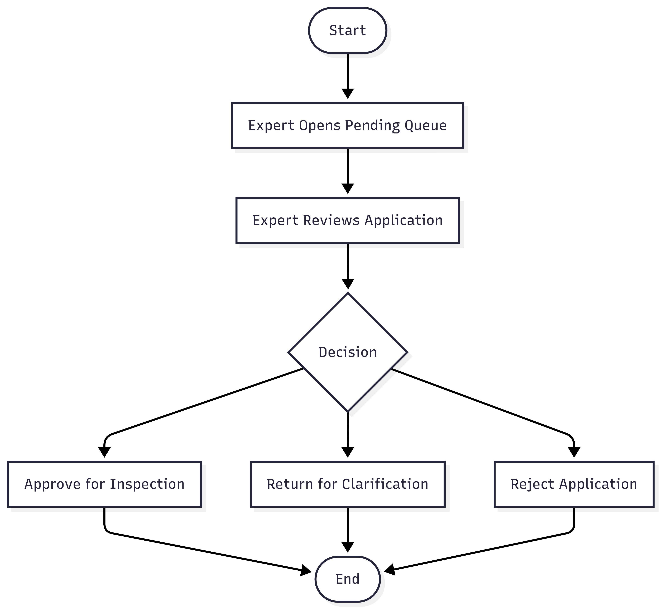

Inspection Process Activity
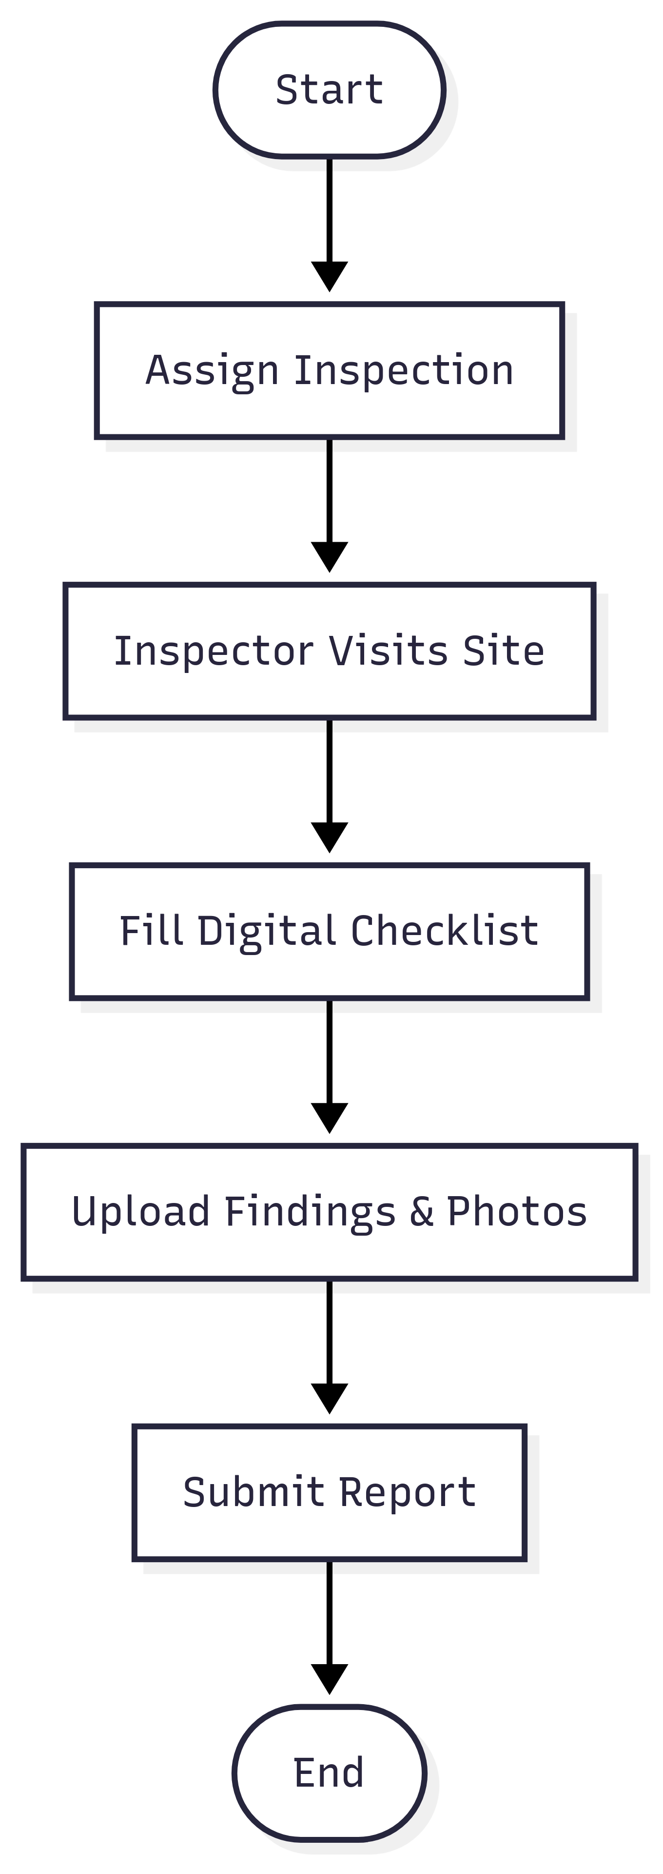

Certificate Issuance Activity
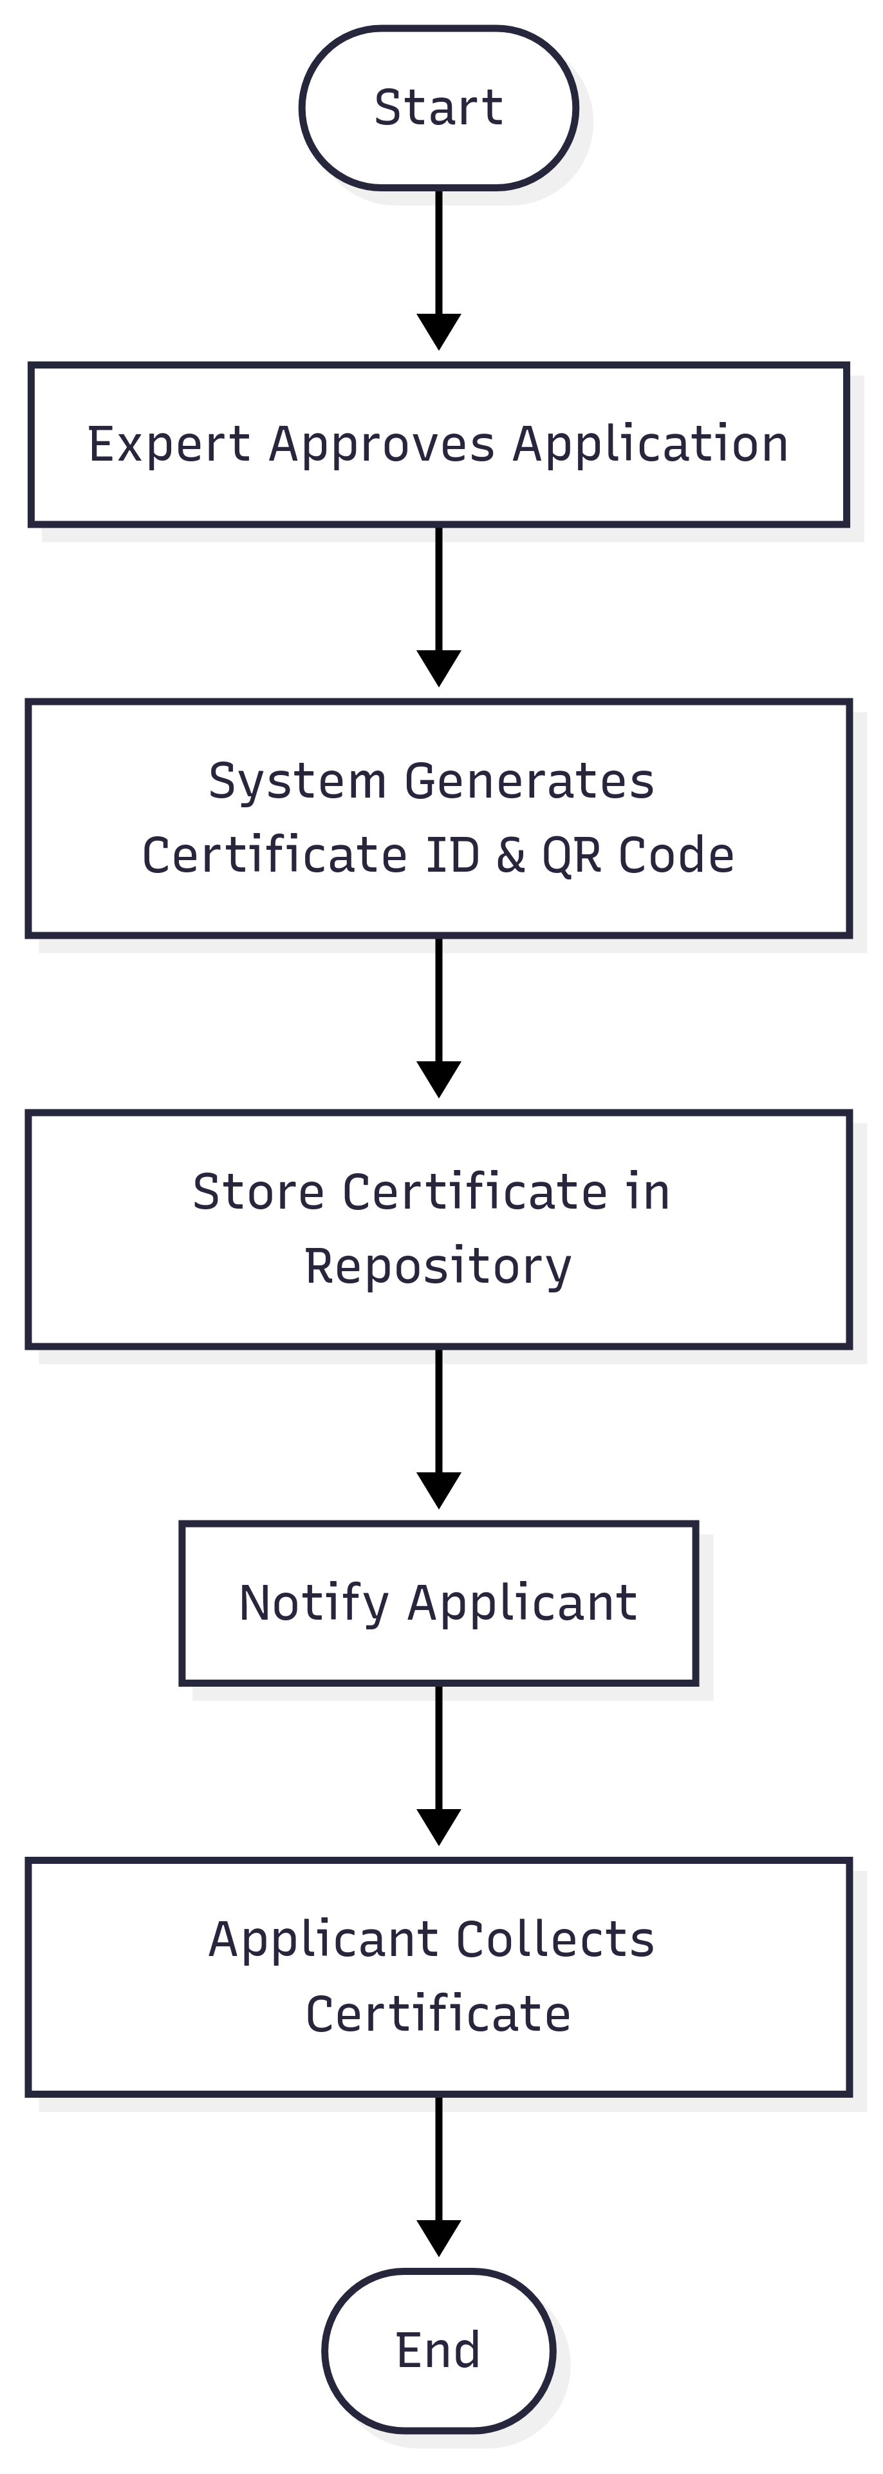

3.6 Preliminary Class Model & Object Model
The Preliminary Class Model of the Coffee Competency Assurance Certificate System (CCACS) defines the structural foundation of the software, describing how users, applications, inspections, certificates, and administrative services are represented within the system. This model ensures that every business process is mapped to a class with attributes and behaviors that reflect its role in the certification lifecycle.

A. User-Centric Classes
User (Abstract Class)
- Purpose: Provides a generic structure for all system users.
- Attributes:
  - userID (string, unique key)
  - username (string, login identifier)
  - passwordHash (string, encrypted password)
  - email (string)
  - phone (string)
  - role (enum: Applicant, Expert, Inspector, Administrator)
- Behaviors:
  - login() – Authenticate credentials
  - logout() – End session
  - resetPassword() – Allow password change via secure channel
This abstract class is extended by specialized classes such as Applicant, Expert, Inspector, and Administrator, ensuring reuse of common attributes while maintaining role-specific functions.

Applicant Class
- Purpose: Represents coffee exporters applying for certification.
- Additional Attributes:
  - licenseNumber (string) – government-issued license
  - businessName (string) – registered company name
  - address (string) – headquarters location
- Behaviors:
  - applyForCertificate() – initiate certification request
  - trackApplication() – check application status
  - downloadCertificate() – access issued certificates

Expert Class
- Purpose: Domain professionals who review and decide on applications.
- Additional Attributes:
  - expertID (string) – identifier
  - assignedApplications (list) – queue of applications under review
- Behaviors:
  - reviewApplication() – assess completeness and validity
  - approveForInspection() – forward application for inspection
  - rejectApplication() – mark application as failed
  - returnForClarification() – request more information

Inspector Class
- Purpose: Field officers performing site visits.
- Attributes:
  - inspectorID (string)
  - assignedInspections (list)
  - reports (list)
- Behaviors:
  - conductInspection() – carry out physical verification
  - uploadEvidence() – submit photos and documents
  - submitReport() – finalize inspection findings

Administrator Class
- Purpose: Manage users, configure workflows, and monitor compliance.
- Attributes:
  - adminID (string)
  - permissions (list of system privileges)
- Behaviors:
  - configureSystem() – update parameters like fees, templates, workflows
  - manageUsers() – add, update, suspend accounts
  - viewAuditLogs() – review actions for compliance

B. Business Process Classes
Application Class
Represents a certification request submitted by an applicant.
- Attributes:
  - applicationID (string, unique)
  - submissionDate (date)
  - status (enum: Pending, Under Review, Returned, Approved, Rejected)
  - documents (list of uploaded files)
- Behaviors:
  - updateStatus() – modify application state
  - attachDocument() – add supporting evidence

Certificate Class
Represents the official digital or printed certificate issued after approval.
- Attributes:
  - certificateID (string)
  - issueDate (date)
  - expiryDate (date)
  - qrCode (string, generated for verification)
  - status (Active, Revoked, Expired)
- Behaviors:
  - verify() – validate authenticity via QR code or ID
  - revoke() – invalidate due to non-compliance

Inspection Class
Represents an assigned site visit.
- Attributes:
  - inspectionID (string)
  - inspectionDate (date)
  - status (Scheduled, Completed, Pending)
  - findings (string)
- Behaviors:
  - assignInspector()
  - recordFindings()

Report Class
Represents the structured inspection results.
- Attributes:
  - reportID (string)
  - findings (string)
  - photos (list of attachments)
- Behaviors:
  - submit() – finalize and submit to system

SystemConfiguration Class
Stores configurable elements.
- Attributes:
  - configID
  - feeStructure
  - documentTemplates
  - workflowRules
- Behaviors:
  - updateConfig() – change system parameters

AuditLog Class
Represents permanent records of system actions.
- Attributes:
  - logID
  - userID
  - action
  - timestamp
- Behaviors:
  - logAction() – write event to log
  - retrieveLogs() – fetch for monitoring

C. Object Model (Runtime Example)
At runtime, the following object interactions take place:
- An Applicant object creates an Application object.
- The Application is linked to Inspector objects via Inspection objects.
- Each Inspection generates a Report object that is reviewed by an Expert object.
- Upon approval, the Application spawns a Certificate object.
- Administrative activities are logged as AuditLog objects.
This object model confirms how business rules map directly to runtime behaviors, ensuring that every functional requirement is covered by system interactions.

3.7 Data Dictionary
The Data Dictionary defines all entities and attributes within CCACS. It ensures consistency between developers, analysts, and evaluators.
Entity: Applicant
Attribute | Type | Description
applicantID | String | Unique system identifier
businessName | String | Registered exporter name
licenseNumber | String | Government export license
contactInfo | Object | Email, phone, address
Status | Enum | Pending, Active, Suspended

Entity: Application
Attribute | Type | Description
applicationID | String | Unique certification request ID
submissionDate | Date | Date of submission
status | Enum | Pending, Under Review, Returned, Approved, Rejected
documents | List | Uploaded files
assignedExpert | String | ID of reviewing expert

Entity: Certificate
Attribute | Type | Description
certificateID | String | Unique certificate number
issueDate | Date | Date of issuance
expiryDate | Date | Validity period
qrCode | String | Encoded QR for verification
status | Enum | Active, Revoked, Expired

Entity: Expert
Attribute | Type | Description
expertID | String | Unique expert identifier
Name | String | Full name
Role | String | Reviewer / Approver
assignedApps | List | Applications under review

Entity: Inspector
Attribute | Type | Description
inspectorID | String | Unique inspector identifier
Name | String | Full name
assignedInspects | List | Allocated inspections
Reports | List | Submitted reports

Entity: Inspection
Attribute | Type | Description
inspectionID | String | Unique inspection number
applicationID | String | Linked application
inspectionDate | Date | Scheduled inspection date
Status | Enum | Scheduled, Completed
Checklist | List | Compliance items

Entity: Report
Attribute | Type | Description
reportID | String | Report identifier
inspectionID | String | Linked inspection
findings | String | Summary of results
photos | List | Evidence images
submittedBy | String | Inspector ID

Entity: SystemConfiguration
Attribute | Type | Description
configID | String | Unique configuration entry
feeStructure | Map | Application & certification fees
templates | List | Document templates
workflowRules | List | Approval workflows

Entity: AuditLog
Attribute | Type | Description
logID | String | Unique log identifier
userID | String | ID of the user who acted
action | String | Description of action
timestamp | Date | Date and time
status | String | Success / Failure

11. Conclusion
The Coffee Competency Assurance Certificate System (CCACS), proposed by LEBAWI NET TRADING PLC, represents a transformative step in Ethiopia’s coffee certification process. The design, as outlined throughout this proposal, integrates modern technologies with rigorous compliance workflows to create a secure, efficient, and transparent digital system that addresses the needs of applicants, experts, inspectors, administrators, and verification stakeholders.
The CCACS is not simply a software platform—it is an ecosystem for quality assurance and trust in the Ethiopian coffee sector. Coffee is one of the nation’s most critical export commodities, and certification is both a regulatory requirement and a driver of credibility in international markets. A manual or fragmented certification process creates delays, errors, and opportunities for malpractice. Our system, therefore, ensures end-to-end automation: from applicant registration and application submission, through expert review and on-site inspection, to certificate issuance, public verification, and administrative oversight.

Alignment with Functional and Technical Requirements
This proposal has carefully mapped government requirements into clear system deliverables. Through detailed use case analysis, we demonstrated how applicants can register, submit applications, and track their status, while experts and inspectors interact with specialized portals to review documents and conduct inspections. Administrators are empowered with a full suite of management and configuration tools to ensure that the system remains adaptable to evolving policies.
We provided sequence diagrams and activity diagrams to illustrate how the process flows across the system, giving evaluators a transparent view of each decision point, interaction, and automated validation. Our component diagrams confirmed that the design is modular, with well-defined services such as authentication, workflow scheduling, notifications, document management, and certificate issuance. The preliminary class and object models ensured that data structures are consistent with business processes, while the data dictionary defined all entities in a manner that eliminates ambiguity during implementation.
By combining these layers of documentation, LEBAWI NET TRADING PLC has demonstrated that the CCACS is a well-architected solution, not only compliant with immediate project requirements but also prepared for future expansion and integration with other government systems.

Benefits and Value Proposition
The CCACS will deliver measurable benefits across the certification lifecycle:
- Efficiency Gains:
Applications and inspections that previously required manual paperwork and physical follow-up are digitized. Applicants save time, experts review documents more quickly, and inspections are logged in real-time.
- Transparency and Trust:
Every decision—approval, rejection, or return for clarification—is logged in the audit trail. Certificates carry QR codes for public verification, reducing fraud and increasing trust in Ethiopian coffee on the international market.
- Scalability and Future-Readiness:
The modular design allows additional features—such as integration with customs systems, payment gateways, or external verification APIs—to be added without redesigning the entire platform.
- Regulatory Compliance:
The workflows and validations built into the system enforce compliance with national coffee standards and export regulations, reducing human error and ensuring consistency.
- Data-Driven Governance:
Administrators and policymakers gain access to real-time dashboards and reporting tools, enabling better oversight of certification trends, inspection outcomes, and market readiness.

Sustainability and Maintainability
LEBAWI NET TRADING PLC emphasizes not only the delivery of the system but also its long-term sustainability. The CCACS is designed with:
- Maintainable Codebase: Structured, modular software that allows updates with minimal disruption.
- Robust Security: Role-based access control (RBAC), audit logging, and encryption ensure protection of sensitive applicant and inspection data.
- Training & Capacity Building: Training sessions will be provided for administrators, experts, and inspectors, ensuring local teams can operate and maintain the system effectively.
- Support & Upgrades: Ongoing support plans include bug fixes, enhancements, and adaptations to new regulatory requirements.
By considering the lifecycle beyond initial deployment, this proposal ensures that the system remains a valuable asset for years to come.

Strategic Importance for Ethiopia’s Coffee Industry
Coffee exports are at the heart of Ethiopia’s economic identity and global reputation. Certification is not merely a bureaucratic requirement; it is a guarantee of quality to international buyers. By implementing the CCACS:
- Exporters will experience a more predictable and efficient certification timeline.
- Buyers and regulators abroad will gain confidence in Ethiopian certification practices through verifiable digital certificates.
- Inspectors and experts will be empowered with modern tools that standardize and streamline their responsibilities.
- The government will strengthen its ability to monitor, enforce, and report on compliance across the sector.
In the long term, this digital transformation enhances Ethiopia’s competitiveness in global coffee markets, reducing barriers and aligning local processes with international best practices.

Commitment of LEBAWI NET TRADING PLC
As a company with a track record in delivering digital solutions tailored to regulatory and export processes, LEBAWI NET TRADING PLC is uniquely positioned to implement the CCACS. We bring a blend of:
- Technical expertise in software engineering and systems integration.
- Industry knowledge of export workflows and compliance frameworks.
- Commitment to capacity building so that local teams are fully equipped to manage the system independently.
We also commit to working collaboratively with the contracting authority, inspectors, exporters, and other stakeholders to ensure that the final system reflects both policy requirements and the practical realities of the certification process.

Closing Statement
In conclusion, the Coffee Competency Assurance Certificate System (CCACS) is more than a technology platform; it is a strategic enabler of trust, efficiency, and growth in Ethiopia’s coffee industry. By digitizing and automating the certification process, it ensures that Ethiopia remains a reliable and competitive supplier in global markets, while empowering local stakeholders with transparent, efficient, and secure tools.
LEBAWI NET TRADING PLC is fully prepared to implement this solution with professionalism, dedication, and a long-term vision. We believe that, with CCACS, the certification process will no longer be a bottleneck but rather a hallmark of Ethiopia’s leadership in quality coffee exports.

