Chapter 3: The NEXUS Architecture

1 The NEXUS Architecture

1.1 Introduction
Manufacturing Operations Management (MOM) sits at Level 3 of the ISA-95 functional hierarchy, between the business-planning systems of Level 4 and the process-control systems of Levels 2 and below (ISA Standards Committee 2010; Sprock et al. 2019). Level 3 is the layer at which the abstract production targets handed down by enterprise planning are turned into concrete, time-bounded decisions on the plant floor: which operation runs on which machine, when a machine is taken offline for maintenance, whether a batch is held for quality inspection, and how far ahead spare parts are ordered. ISA-95 decomposes this layer into four operations-management functions — production, maintenance, quality, and inventory (here treated as supply) — and models each as a separate activity model with its own information flows and its own performance criteria (ISA Standards Committee 2010). Figure 1.1 situates Level 3, and NEXUS within it, in the ISA-95 functional hierarchy.
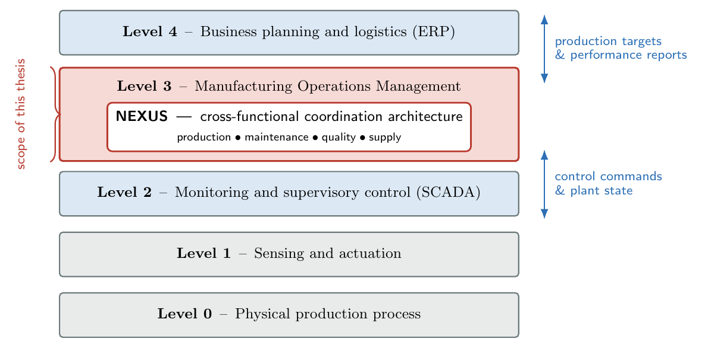
The ISA-95 functional hierarchy. NEXUS operates at Level 3 — Manufacturing Operations Management — between supervisory process control (Level 2) and business planning and logistics (Level 4), and is the scope of this thesis.
The decomposition is organisationally convenient but it is not decisionally clean. The four functions are coupled: a decision that is locally optimal for one function routinely degrades another. A maintenance window reclaims machine health but forgoes production hours. A quality hold suppresses defect-driven rework but delays throughput. A conservative supply preorder shortens stockout exposure but raises carrying cost. A faster production rate lifts short-term output but accelerates tool wear and, with it, both the breakdown hazard and the defect rate. None of these trade-offs is visible inside the activity model of a single function; each becomes visible only when the four functions are considered jointly. This is the cross-functional coordination gap that this thesis addresses.
In most installed plant-floor systems the gap is left open. Each function runs its own scheduler or its own rule set, optimising its own key performance indicator, and the interactions between functions are absorbed informally — by shift supervisors, by escalation meetings, or simply by whichever function happens to act first. The result is a siloed mode of operation in which the cross-functional trade-offs are never explicitly represented, let alone resolved against a shared objective. The coordination gap is not a modelling gap: a sufficiently detailed centralised model could, in principle, optimise the joint problem. It is a coordination gap, because the conditions under which such a centralised model could be built — full visibility of every function’s cost structure, machine state, defect history and supplier reliability — do not hold in practice. The functions are organisationally distinct, their information systems are heterogeneous, and the data each would have to surrender to a central optimiser is exactly the data each treats as its own (Section 1.7.2 returns to this point).
This chapter presents NEXUS — Negotiation-driven EXecution and Unified Synchronization — a reference architecture for closing the cross-functional coordination gap at ISA-95 Level 3 without violating the informational and organisational boundaries that make centralised optimisation infeasible. NEXUS is organised as four layers. A Worker layer hosts four Belief–Desire–Intention (BDI) agents, one per ISA-95 Level 3 function. A Marketplace layer hosts a multi-issue negotiation mediator that aggregates the agents’ utility-annotated proposals and resolves each cross-functional conflict into a single composite contract. A Fence layer audits every contract against a suite of pre-declared safety rules and classifies it into a three-tier severity scheme. A School layer — described here but deferred as future work — provides the architectural slot for continual adaptation of the agents’ preferences from operational history.
Two design commitments run through the whole architecture and are worth stating at the outset.
The contribution of NEXUS is the composition of established components into a coherent reference architecture for a specific problem — not the invention of a new negotiation mechanism or a new learning algorithm. The negotiation mechanism in the Marketplace layer is the multi-issue multi-lateral protocol of Ito, Hattori and Klein (Ito et al. 2007); the agent model is the BDI architecture of Rao and Georgeff (Rao and Georgeff 1995); the reference-architecture framing follows the lineage of PROSA (Van Brussel et al. 1998), ADACOR (Leitão and Restivo 2007) and HAPBA (Leitão et al. 2015). NEXUS chooses, adapts and integrates; it does not reinvent. This commitment is deliberate and is defended throughout the chapter: a reference architecture earns its keep by being a sound, reproducible composition, not by maximising novelty in any single component.
No component of NEXUS ever requires a function to publish its internal cost model, its private state, or its objective weights. Agents disclose only bid summaries — a bounded number of regions of the joint decision space, each annotated with a single scalar utility. This is the structural property that distinguishes NEXUS from a centralised optimiser and from distributed constraint optimisation, and it is treated as a first-class architectural requirement rather than an afterthought.
The remainder of the chapter is organised as follows. Section 1.2 presents the four-layer architecture as a whole, fixes terminology, and traces the information flow of a single coordination event. Section 1.3 describes the Worker layer and the four BDI agents, including the mono-dimensional output discipline that keeps each agent within its ISA-95 domain. Section 1.4 describes the Marketplace layer: the composite contract space, the bid representation, and the mediator’s admissible-heuristic search for the welfare-maximising joint contract. Section 1.5 describes the Fence layer and its three-tier safety classification. Section 1.6 describes the School layer at the level of detail needed to make it a coherent future-work proposal. Section 1.7 consolidates the mapping of the architecture onto the ISA-95 Level 3 functional model and states the privacy-preservation property precisely. Section 1.8 closes with an overview of the implementation architecture and forward references to Chapter [ch:implementation].

1.2 Architectural Overview

1.2.1 The four layers
NEXUS is a layered architecture. Each layer is a set of components with a single, well-defined responsibility, and the layers communicate only through narrow, explicitly typed interfaces. The layering is not merely a presentational device: it is the mechanism by which the two design commitments of Section 1.1 are enforced. Because the Worker layer can reach the Marketplace layer only by publishing bid summaries, no agent can leak its cost model downstream even if it wished to; because the Fence layer consumes only the Marketplace’s audit log, safety governance cannot couple itself into the negotiation protocol. The interface discipline turns the design commitments into structural invariants.
Figure 1.2 shows the four layers and the principal information flows between them. Table 1.1 summarises the responsibility, the principal components, and the inbound and outbound interface of each layer.
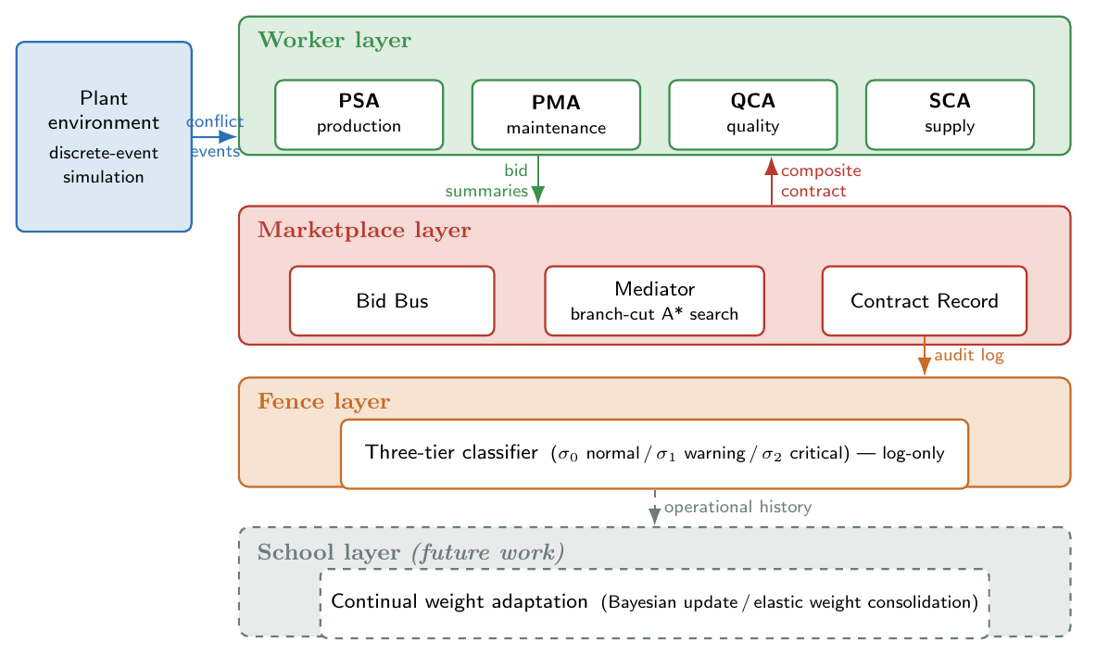
The four-layer NEXUS reference architecture. Solid arrows carry information exchanged during a coordination event; the dashed boundary of the School layer marks it as an architectural slot deferred to future work. The plant environment is the discrete-event simulation against which the architecture is evaluated.
The four layers of the NEXUS architecture.
Layer | Responsibility | Principal components
Worker | Represent each ISA-95 Level 3 function as an autonomous BDI agent; translate local beliefs and domain objectives into utility-annotated proposals over the joint decision space. | Four BDI agents: PSA (production), PMA (maintenance), QCA (quality), SCA (supply).
Marketplace | Aggregate the agents’ proposals for each cross-functional conflict and resolve them into one composite contract that maximises joint welfare. | Bid Bus, Mediator (admissible-heuristic search), Contract Record.
Fence | Audit every resolved contract against pre-declared safety rules and classify it into a three-tier severity scheme; emit an audit stream. Log-only within the scope of this thesis. | Rule suite, three-tier classifier, audit record stream.
School | Provide the architectural slot for continual adaptation of agent preference weights from operational history. Deferred as future work (Section 1.6). | Weight-adaptation module (specified, not implemented).
The layering admits a compact reading. The Worker layer is where domain knowledge lives: each agent knows its own function and nothing else. The Marketplace layer is where coordination happens: it is informationally limited — it sees only what the agents publish — but computationally active, since resolving a conflict requires a non-trivial search. The Fence layer is where governance happens: it neither participates in coordination nor holds domain knowledge; it observes the Marketplace’s output and judges it. The School layer is where adaptation would happen: it closes a slow outer loop from operational outcomes back to agent preferences. Domain knowledge, coordination, governance and adaptation are thus four separable concerns, and the architecture devotes exactly one layer to each.

1.2.2 Coordination events and the information flow
NEXUS is event-driven. The plant floor is modelled as a discrete-event simulation in which the four functions advance their own state until a cross-functional conflict arises — a situation in which two or more functions have a stake in the same upcoming decision. Three conflict types are distinguished, named for the function that first detects them: a maintenance conflict (a machine’s modelled health has fallen below the preventive-maintenance threshold), a quality conflict (an observed defect rate has crossed a control limit), and a supply conflict (a spare-part lead time has exceeded the shortage horizon). Every conflict, whatever its type, triggers the same coordination event, and every coordination event produces exactly one composite contract.
A coordination event proceeds in five phases, illustrated in Figure 1.3.
- Announcement. The conflict is published on the Bid Bus as a conflict announcement carrying the conflict type, the machine identifier, a timestamp, and the small set of observable signals the agents are permitted to read (machine health, defect rate, spare lead time). The announcement carries no agent’s private state.
- Bidding. Each of the four agents independently reads the announcement, updates its beliefs, derives its private constraint set, and emits a set of bids — utility-annotated regions of the joint contract space (Section 1.4).
- Mediation. The Mediator collects the four bid sets and searches for the combination of bids — one per agent — whose regions have a non-empty joint intersection and whose utilities sum to the maximum achievable value.
- Contract selection. Within the joint intersection of the winning bid combination the Mediator selects a single composite contract and publishes it back to all four agents, which then act on it.
- Audit. The Contract Record appends the resolved contract — together with the bids that produced it — to an append-only log. The Fence layer reads this log and classifies the contract into one of three safety tiers.
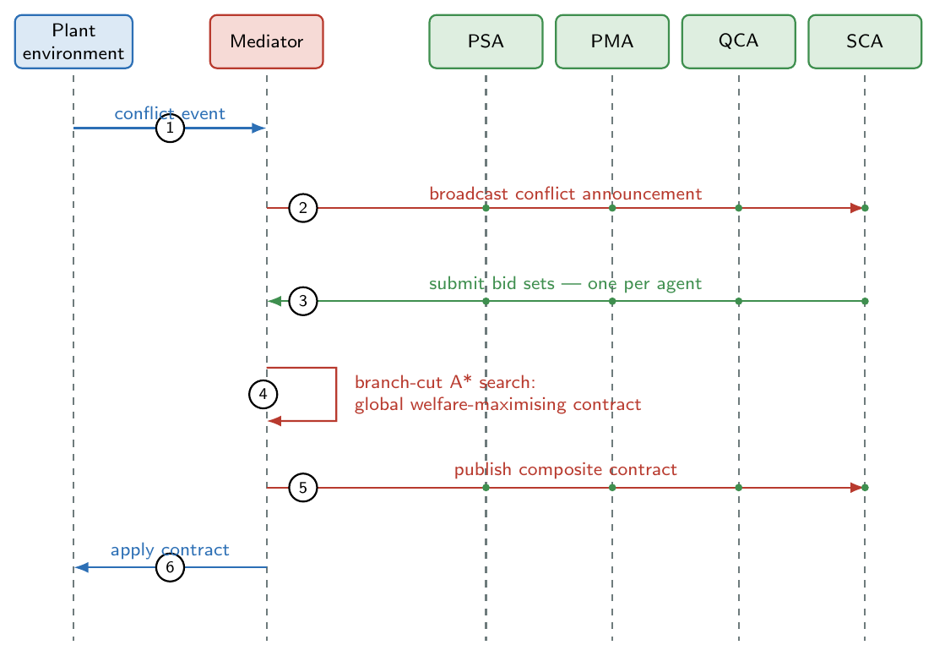
Sequence of a single coordination event. The plant environment raises a conflict; the Mediator broadcasts the announcement; the four agents return bid sets; the Mediator runs its branch-cut A* search and publishes the composite contract; the contract is applied. The Fence audit of phase 5 is post-hoc and is omitted from the sequence.
Two properties of this flow are load-bearing for the rest of the chapter. First, the negotiation is single-round: agents bid once, the Mediator resolves once, and the event closes. The protocol of Ito, Hattori and Klein admits a multi-round iterative-narrowing extension (Hattori et al. 2007), in which the Mediator returns partial-agreement feedback and agents resubmit refined bids; NEXUS deliberately implements only the single-round form and treats iterative narrowing as future work (the justification is given in Section 1.4.5). Second, the Fence audit in phase 5 is strictly post-hoc: it observes the contract after it has been published and acted upon, and within the scope of this thesis it does not block, alter, or roll back the contract. The consequences of this log-only stance, and the path to active enforcement, are the subject of Section 1.5.

1.2.3 Why a layered, distributed architecture
Before describing the layers in detail it is worth making explicit why the architecture is layered and distributed at all, rather than centralised. Three arguments support the choice.
The first is organisational fidelity. ISA-95 Level 3 is already decomposed into four functions, each with its own information system, its own staff and its own performance criteria (Sprock et al. 2019). An architecture whose components map one-to-one onto those functions can be deployed incrementally, function by function, and can be reasoned about by the people who own each function. A monolithic optimiser has no such correspondence; it must be adopted all at once and is owned by no one.
The second is informational feasibility. A centralised optimiser needs the joint problem in full: every function’s cost structure, every machine’s degradation model, every supplier’s reliability distribution. In a real plant these are held in separate, heterogeneous systems and are, for organisational reasons, not freely shared. NEXUS requires only that each function be able to express its preferences as bids over a shared, low-dimensional decision space — a far weaker requirement than full disclosure (Section 1.7.2).
The third is separation of concerns. Coordinating four functions, governing the safety of the coordinated decision, and adapting the functions’ preferences over time are three different problems with three different rates of change and three different owners. Folding them into one component couples them; giving each its own layer keeps them independently replaceable. The Fence layer, in particular, can be strengthened from log-only auditing to active enforcement (Section 1.5) without touching the Marketplace, exactly because it is a separate layer that consumes only an audit log.
These arguments place NEXUS in the established tradition of reference architectures for manufacturing control. PROSA (Van Brussel et al. 1998) introduced the idea of decomposing plant control into cooperating holons with distinct responsibilities; ADACOR (Leitão and Restivo 2007) added an adaptive coordination mechanism that shifts between a more centralised and a more distributed regime; HAPBA (Leitão et al. 2015) and the broader holonic and multi-agent manufacturing literature (Leitão 2009; Trentesaux 2009; Monostori et al. 2006) continued the line. NEXUS inherits the layered, distributed stance of this tradition and contributes a specific, well-characterised choice for the coordination layer: multi-issue mediated negotiation in place of the contract-net or hierarchical-dispatch mechanisms used by its predecessors.

1.3 The Worker Layer

1.3.1 Four agents, four functions
The Worker layer contains exactly four agents, one for each ISA-95 Level 3 operations-management function:
Owns the production function. Its concern is throughput and the timely completion of operations; its home decision is the production rate at which a machine is driven.
Owns the maintenance function. Its concern is machine health and the avoidance of unplanned breakdowns; its home decision is the maintenance window — whether and how urgently a machine is serviced.
Owns the quality function. Its concern is the defect rate and the cost of defect-driven rework; its home decision is the quality action — the intensity of any inspection hold placed on output.
Owns the inventory and supply function. Its concern is spare-part availability and stockout exposure; its home decision is the supply horizon — how far ahead spare parts are preordered.
The cardinality is fixed by the ISA-95 decomposition itself, not chosen for convenience: Level 3 defines four operations-management functions, so NEXUS has four Worker agents. Table 1.2 records the mapping and previews the home issue each agent decides — the issues themselves are defined in Section 1.4.
The four Worker agents, their ISA-95 Level 3 functions, their local beliefs, and the home issue each one owns in the composite contract.
Agent | ISA-95 L3 function | Principal local beliefs | Home issue
PSA | Production operations | Operation backlog, machine load, tardiness pressure | production_rate
PMA | Maintenance operations | Machine health, time since last service, breakdown hazard | maint_window
QCA | Quality operations | Observed defect rate, severity, rework backlog | quality_action
SCA | Inventory / supply operations | Spare-part stock, supplier lead time | supply_horizon

1.3.2 The BDI agent model
Each Worker agent is structured according to the Belief–Desire–Intention model of agency (Rao and Georgeff 1995; Wooldridge and Jennings 1995). The BDI model is a natural fit for an ISA-95 Level 3 function because the three mental attitudes map cleanly onto the three things a function must do: maintain a picture of its part of the plant, hold objectives, and commit to actions.
The agent’s local model of its slice of the plant. PSA believes things about operation backlogs and machine load; PMA about machine health and time since service; QCA about defect rates and severity; SCA about stock levels and supplier lead times. Beliefs are updated from the observations the agent is entitled to read and from the conflict announcement. Crucially, an agent’s beliefs are private: no agent observes another agent’s beliefs, and the Marketplace never reads them (Section 1.7.2).
The agent’s objectives, expressed as a small set of weighted goals within its own function — for PSA, for example, minimising tardiness, maximising throughput, and minimising disruption. The desire weights are parameters of the agent. Within the scope of this thesis they are fixed at calibrated values; the School layer (Section 1.6) is the architectural slot in which they would later be adapted.
The agent’s committed proposals for the current coordination event. In NEXUS an agent’s intentions materialise as a set of bids — the utility-annotated regions of the joint contract space defined in Section 1.4. The bid set is the only thing an agent makes public; it is the externally visible projection of the agent’s beliefs and desires.
Figure 1.4 shows the internal structure of a Worker agent and the deliberation pipeline that turns a conflict announcement into a bid set. The pipeline has two stages the agent specialises and one stage shared by all four agents. The specialised stages are belief update — how the agent revises its local model from a new observation — and constraint derivation — how the agent’s current beliefs and desires generate a private set of weighted constraints over the joint contract space. The shared stage is bid generation, which runs the same four-step procedure for every agent (Section 1.4.3).
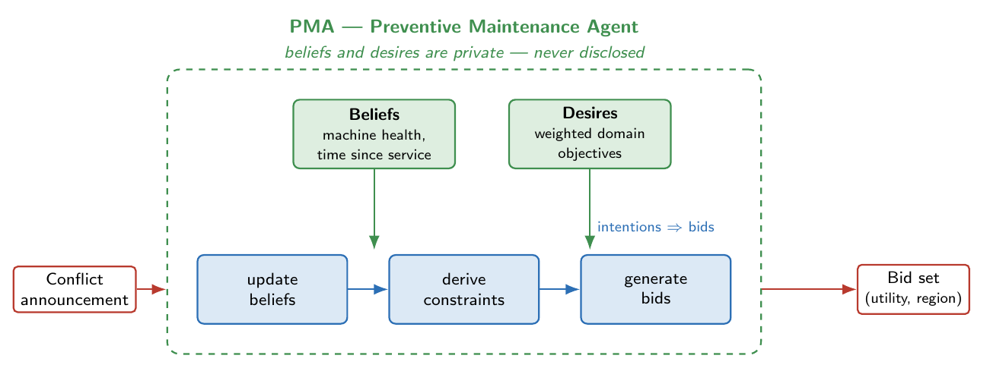
Internal structure of a Worker agent, with the Preventive Maintenance Agent shown as the example. The belief-update and constraint-derivation stages are specialised per agent; the bid-generation stage is shared. Beliefs and desires stay inside the agent boundary; only the bid set crosses it.

1.3.3 Mono-dimensional outputs and domain authority
A central discipline of the Worker layer is that each agent’s authority is mono-dimensional: an agent is the owner of exactly one issue of the composite contract — its home issue — and although it is permitted to express preferences over the other three issues, those cross-domain preferences are constructed to be, by design, an order of magnitude weaker than its preferences on its home issue.
This discipline answers a question that the multi-issue setting raises immediately. If every agent may bid on every issue, what stops QCA from effectively dictating the maintenance decision, or PSA from overriding a quality hold? In a single-winner mechanism the answer would have to be a separate priority rule layered on top of the mechanism. In NEXUS the answer is structural and lives inside the bid weights: each agent’s constraints on its home issue carry weights bounded by an agent-specific ceiling, while its constraints on other issues carry weights produced by multiplying a base weight by a small cross-domain damping factor. The home-issue ceilings — recorded in Table 1.3 — are roughly an order of magnitude above the typical damped cross-domain weight. The encoding realises ISA-95 functional authority operationally: a function’s preference on its own decision dominates the cross-domain stakes of its peers, so the maintenance decision is, in the normal case, PMA’s to make — but the peers still have a voice, and that voice shapes the outcome whenever PMA itself is indifferent between maintenance options.
Approximate per-agent home-issue weight ceilings (domain authority). Cross-domain constraint weights are damped to roughly a tenth of these values, so an agent’s preference on its home issue dominates its peers’ cross-domain stakes by about an order of magnitude.
Agent | Home issue | Home-issue weight ceiling
PMA | maint_window | $≈500$
PSA | production_rate | $≈200$
SCA | supply_horizon | $≈200$
QCA | quality_action | $≈175$
It is worth being precise about what “mono-dimensional” does and does not mean. It does not mean an agent estimates only its own issue: each agent emits constraints over the whole joint space, and the cross-domain constraints are what make the negotiation genuinely multi-issue rather than four parallel single-issue negotiations. It does mean three things. First, no agent observes another agent’s domain state — PSA never sees PMA’s health model, only the shared signals carried in the announcement; there is no inter-domain estimation and no cross-visibility of beliefs. Second, an agent’s cross-domain preferences are subordinate by construction, through the damping factor, so they act as tie-breakers and nudges rather than overrides. Third, ownership is exclusive: each issue has exactly one owning agent, and the architecture never asks two agents to arbitrate which of them owns a decision. The first point is an informational property and underpins the privacy claim of Section 1.7.2; the second and third are authority properties and underpin the claim that NEXUS respects the ISA-95 functional decomposition rather than dissolving it.
The empirical behaviour of the weight ceilings is discussed in Chapter [ch:results]; here it is enough to note that on the benchmark families studied the order-of-magnitude separation makes the exact cross-domain damping factor a low-sensitivity parameter — the qualitative outcome is stable across a range of damping values — which is the expected signature of a design in which cross-domain preferences are deliberately subdominant.

1.4 The Marketplace Layer
The Marketplace layer is where coordination happens. It receives the four agents’ bid sets for a conflict and returns one composite contract. This section defines the composite contract space (Section 1.4.1), the bid representation and the agent-side procedure that produces it (Sections 1.4.2 and 1.4.3), the mediator’s search for the welfare-maximising joint contract (Section 1.4.4), and the scope decisions that bound the protocol (Section 1.4.5).

1.4.1 The composite contract space
The defining decision of the Marketplace layer — and the decision that most sharply distinguishes NEXUS from a single-winner coordination mechanism — is that a coordination event is resolved not by selecting one agent’s preferred action but by producing a composite contract: a vector that assigns a value to every one of the four functional decisions simultaneously.
Formally, the composite contract space is the Cartesian product of four issue domains, one per agent home issue:
$$Ω = Ω_{PR}×Ω_{MW}×Ω_{QA}×Ω_{SH},$$
where $Ω_{PR}$ is the domain of the production rate, $Ω_{MW}$ of the maintenance window, $Ω_{QA}$ of the quality action, and $Ω_{SH}$ of the supply horizon. A contract is a single point $c∈Ω$. The four issue domains, with their discrete levels, are given in Table 1.4.
The four issues of the composite contract and their discrete domains. The joint space has $|Ω|=3×3×3×4=108$ contracts.
Issue | Owner | Levels | Interpretation
production_rate | PSA | slow, normal, fast | Speed at which the machine is driven; faster lifts output but accelerates wear.
maint_window | PMA | none, planned, immediate | Whether and how urgently the machine is serviced.
quality_action | QCA | no_hold, hold_light, hold_full | Intensity of the inspection hold placed on output.
supply_horizon | SCA | h0, h24, h48, h72 | Length, in hours, of the spare-part preorder window.
The joint space is small — $108$ contracts — and finite. This is a deliberate scope decision. The issue domains are kept discrete and coarse so that the joint space can be enumerated exactly and the mediator’s search can carry a global-optimality guarantee (Section 1.4.4); the alternative of continuous or finely discretised issues would force the mediator onto approximate search and would forfeit that guarantee for no benefit at the scale of an ISA-95 Level 3 coordination loop.
The composite structure is what makes the cross-functional trade-offs representable. A single-winner mechanism resolves a conflict by choosing a label — “maintenance wins” — and so can never express the statement “service the machine and hold quality light and keep the rate normal”; the composite contract expresses exactly such joint statements, because it is a point in $Ω$ rather than a choice among the agents. It is structurally impossible for the mechanism to collapse into fixed-priority routing, because its output is a vector by construction. This point is developed further when the contrast with single-winner mechanisms is drawn in Section 1.4.5.

1.4.2 Bids: utility-annotated regions
Agents do not reveal their utility functions to the Marketplace. They reveal bids. Following the multi-issue protocol of Ito, Hattori and Klein (Ito et al. 2007), a bid is a compact, public summary of one region of the contract space that the agent finds acceptable, annotated with the utility the agent assigns to it.
An agent $i$ holds, for the current conflict, a private set of weighted constraints. A constraint $k$ is a predicate over the contract space — it is satisfied by a subset $R_{ik}⊆Ω$ of contracts — carrying a non-negative weight $w_{ik}$. The agent’s utility for a contract $c$ is the additive sum of the weights of the constraints that $c$ satisfies,
Ui(c) = k : c ∈ Rik​wik,
which is the additive utility form of Ito, Hattori and Klein (Ito et al. 2007) and is the natural multi-issue generalisation of the weighted-goal scoring used in single-issue agent bidding. A bid $b_{ij}$ submitted by agent $i$ is then the pair
$$b_{ij} = \left( u_{ij}, R_{ij} \right),$$
where $R_{ij}⊆Ω$ is a region of the contract space — in practice a hyper-rectangle, the intersection of the regions of the agent’s most heavily weighted satisfied constraints — and $u_{ij}$ is the scalar utility the agent attaches to that region. The agent submits a small set of such bids per conflict.
The width of the bid region is governed by a relaxation parameter, written top-n: the region $R_{ij}$ is formed as the intersection of the $n$ most heavily weighted constraints the agent satisfies, while the annotated utility $u_{ij}$ aggregates the weights of all satisfied constraints. The parameter trades expressiveness against feasibility. With $n=1$ the region is just the single heaviest constraint’s region — wide, easy to intersect with other agents’ regions, but blind to the agent’s inter-issue trade-offs. With larger $n$ the region is the intersection of more constraints — narrower, more faithful to the agent’s joint preference, but more likely to leave no contract in common with the other agents, which would cause the negotiation to fail. NEXUS uses $n=2$: the bid region is the intersection of an agent’s two heaviest constraints, which captures the single most important inter-issue trade-off each agent holds while keeping the empirical negotiation-failure rate low. The calibration behind this choice, and the failure-rate-versus-expressiveness curve it sits on, are reported in Chapter [ch:results].
What an agent publishes is therefore exactly its bid set — a bounded number of (utility, region) pairs — and nothing else. It does not publish the constraints themselves, their weights, the beliefs that generated them, or the desire weights that scaled them. This is the precise sense in which NEXUS preserves informational locality, and Section 1.7.2 states the property formally.

1.4.3 Bid generation
Each agent turns its private constraint set into a bid set by a four-step procedure, shared by all four agents and adapted from the sampling-and-adjustment scheme of the multi-issue protocol (Ito et al. 2007; Klein et al. 2003):
- Sample. Draw a set of candidate contracts from the joint space $Ω$.
- Adjust. From each sampled contract, perform a local search — in NEXUS a greedy hill-climb — towards a nearby contract of higher private utility $U_{i}$.
- Bid. For each adjusted contract whose utility exceeds a reservation threshold, build a bid: the region is the top-n constraint intersection around the contract, the utility is the value of Equation [eq:utility].
- Submit. Emit the resulting set of bids to the Bid Bus.
The local-search step admits two implementations. The original protocol uses simulated annealing, accepting an uphill or a controlled downhill move with the Metropolis probability $exp\left((U_{i}(c^{′})−U_{i}(c))/T\right)$ at temperature $T$ (Klein et al. 2003). NEXUS retains simulated annealing as a selectable option but defaults to plain greedy hill-climbing. The reason is empirical and is documented in Chapter [ch:implementation]: at the scale of the NEXUS contract space the annealing temperature has no measurable effect on the resulting bids, so the simpler, faster, fully deterministic greedy search is preferred. Determinism is itself valuable here — it is part of what makes a coordination event byte-for-byte reproducible, which the reproducibility infrastructure of Chapter [ch:implementation] relies on.
Listing [lst:bid] sketches the data structures involved, in the notation of the implementation.
class Constraint: # private to the owning agent
region: FrozenSet[Contract] # contracts that satisfy the predicate
weight: float # non-negative; scaled by desire weight
class Bid: # public; the only thing that leaves an agent
utility: float # sum of ALL satisfied constraint weights
region: FrozenSet[Contract] # intersection of the top-n constraints
sample: Contract # a representative contract in the region

1.4.4 The mediator
The Mediator is the active component of the Marketplace layer. It receives one bid set per agent and must return one composite contract. Per the placement decision discussed in Section 1.4.5.0.1, it is a component within the Marketplace layer, not an agent and not a supervisor above the agents.

1.4.4.0.1 The optimisation problem.
Let agent $i$ submit bid set $B_{i}$. A combination is a selection of one bid per agent, $β=(b_{1},…,b_{4})$ with $b_{i}∈B_{i}$. The combination is feasible if the four bid regions have a non-empty joint intersection,
$$R(β) = \underset{i=1}{\overset{4}{⋂}}R_{i}(b_{i}) ≠ ∅,$$
which is the condition that there exists at least one contract acceptable to all four agents under the chosen bids. The Mediator searches for the feasible combination of maximum summed utility,
$$β^{⋆} = arg\max_{β : R(β)≠∅} \sum_{i=1}^{4}{u_{i}}(b_{i}),$$
and then commits to a single contract $c^{⋆}∈R(β^{⋆})$. Objective [eq:welfare] is a social-welfare maximisation: it picks the joint agreement that maximises the sum of the agents’ utilities. Under the cooperative, additive-utility setting of Equation [eq:utility], the maximiser of the sum cannot be Pareto-dominated — any contract that improved one agent without harming another would have a strictly greater sum and so would already have been chosen. The composite contract NEXUS produces is therefore Pareto-optimal with respect to the published bids by construction. This property is load-bearing for the comparison against a centralised Pareto optimiser in Chapter [ch:results].

1.4.4.0.2 Why search rather than enumerate.
The space of combinations is bounded — with four agents and at most $K$ bids each there are at most $K^{4}$ of them — and at the calibrated bid counts of NEXUS a brute-force enumeration would in fact be tractable. The Mediator nonetheless uses a search, for two reasons. The first is efficiency: most combinations are infeasible, and their infeasibility can be detected on a partial selection — once two bid regions fail to intersect, no extension of that partial selection can intersect either. A search that builds combinations one agent at a time can therefore prune (“branch-cut”) an infeasible partial selection before ever extending it, and so does work proportional to the feasible part of the search tree rather than to $K^{4}$. The second reason is that, with the right priority ordering, the same search yields a provable global-optimality guarantee at its first complete result — which a fixed enumeration order does not.

1.4.4.0.3 Branch-cut search with an admissible heuristic.
The Mediator performs a best-first search over partial combinations, expanding one agent at a time. Each partial combination $p$ at depth $d$ (i.e. with $d$ of the four agents’ bids chosen) is placed on a priority queue keyed by
f(p) = i≤d​ui(bi)⏟g(p) : utility committed + j>d​maxb∈Bju(b)⏟h(p) : optimistic remainder,
and partial combinations whose joint region has become empty are discarded (branch-cut) rather than queued. The term $g(p)$ is the utility already committed by the chosen bids; the term $h(p)$ is, for each not-yet-chosen agent, the largest utility any of its bids could contribute. Because branch-cutting can only ever remove feasible completions, $h(p)$ never underestimates the true utility reachable from $p$: it is an admissible heuristic in the sense of the A* algorithm of Hart, Nilsson and Raphael (Hart et al. 1968). Expanding the queue in decreasing order of $f$ is therefore A* search on a maximisation problem, and the standard A* optimality argument applies: the first complete combination the search returns is a global maximiser of Equation [eq:welfare].
The guarantee is not a cosmetic refinement. An earlier version of the Mediator keyed the queue on the committed utility $g(p)$ alone, omitting the optimistic remainder $h(p)$. That weaker key makes the search best-first on partial sums but not globally optimal: it can commit to a high-utility first bid all of whose feasible completions are poor, and never explore a lower-utility first bid with an excellent forced completion. On adversarially constructed inputs the resulting contract was found to be up to $85\%$ short of the optimum. Adding the admissible term $h(p)$ closes that gap and aligns the implementation with the social-welfare claim the architecture makes. The episode is recorded here because it illustrates a general point about reference architectures: a claimed property — here, “the mediator maximises joint welfare” — is only as good as the algorithm that is supposed to deliver it, and the two must be verified to agree.
A consequence of the admissible search is that cross-functional trade-off patterns are not programmed into any single component. The agents’ constraint catalogues encode weighted preferences over their home and peer issues; the mediator’s A* composition resolves them into a single composite contract under the social-welfare objective of Equation [eq:welfare]. Whatever joint pattern the resulting contracts exhibit — a deferred maintenance window under rush-and-budget pressure, a partial quality hold on a premium variant near the defect threshold — emerges from the structural arithmetic of the search, not from a special-case rule. This compositional-emergence property is validated on concrete cases in Chapter [ch:results].
Figure 1.5 illustrates the search on a small example. Algorithm [lst:mediator] gives the procedure in pseudocode.
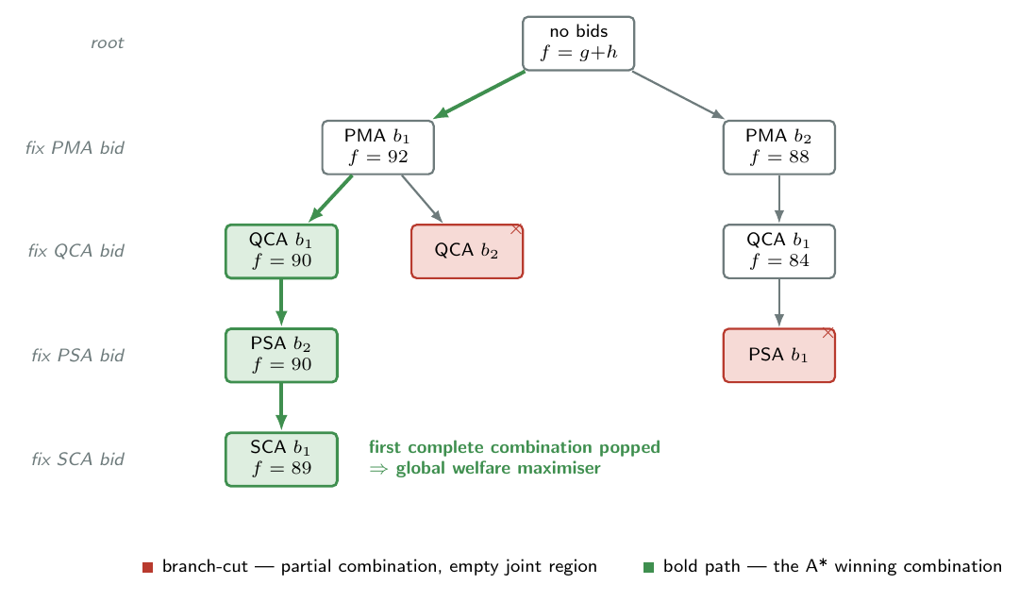
Branch-cut A* search over partial bid combinations. Each level of the tree fixes one more agent’s bid; each node carries its priority key $f=g+h$; a node shaded red is a branch-cut (empty joint region); the bold path is the first complete combination popped, which is the global welfare maximiser. The values shown are illustrative.
function SELECT_CONTRACT(bid sets B_1 .. B_4):
queue <- empty priority queue, ordered by f, largest first
push the empty partial combination, with f = sum_j ( max utility in B_j )
while queue is not empty:
p <- pop the partial combination of largest f
if p is complete (one bid chosen for all 4 agents):
return a contract c* from the joint region R(p) # global optimum
d <- number of bids already chosen in p
for each bid b in B_(d+1):
p' <- p extended with bid b
if the joint region R(p') is empty:
discard p' # branch-cut
else:
push p' with key f(p') = g(p') + h(p') # see Eq. 3.6
return FAILURE # no feasible combination exists

1.4.4.0.4 Contract selection within the joint region.
The search returns a winning combination $β^{⋆}$; its joint region $R(β^{⋆})$ typically still contains more than one contract. The Mediator selects the final $c^{⋆}$ from that region by a deterministic tie-break — maximising the summed agent utility over the contracts in the region, and, where that is itself tied, taking the lowest-indexed contract under a fixed enumeration order. Determinism in the tie-break is what makes the whole coordination event reproducible: the same bid sets always yield the same contract.

1.4.4.0.5 Negotiation failure.
If every combination is infeasible — the search empties its queue without ever popping a complete combination — the event is a negotiation failure: no contract is acceptable to all four agents under their submitted bids. The environment then falls back to a conservative default, and, as Section 1.5 describes, the Fence layer records the failure as a top-tier audit signal. The failure rate is a calibration concern — it is the quantity the top-n parameter trades against expressiveness — and is reported in Chapter [ch:results].

1.4.5 Mediator placement and protocol scope

1.4.5.0.1 The mediator is inside the Marketplace, not above the agents.
It would be possible to model the Mediator as a fifth agent — a “hyper-agent” sitting above PSA, PMA, QCA and SCA and arbitrating between them. NEXUS deliberately does not. The Mediator is a logical component within the Marketplace layer for a precise reason: it has no beliefs, no desires and no model of the plant. It does not know what a machine is. Its entire information set is the union of the bids published for the current conflict, and its entire function is the combinatorial search of Equation [eq:welfare] over that information set. A fifth BDI agent, by contrast, would have its own utility function and its own view of the plant state, and would re-introduce exactly the centralised problem-knowledge that the distributed architecture exists to avoid. Modelling the Mediator as an in-layer component keeps the architectural diagram honest: NEXUS has four agents, not five, and the coordination layer is a mechanism, not a master.

1.4.5.0.2 Single-round protocol.
NEXUS implements the single-round form of the multi-issue protocol: agents bid once, the Mediator resolves once. The iterative-narrowing extension (Hattori et al. 2007), in which the Mediator returns partial-agreement feedback and agents resubmit refined bids over several rounds, is not implemented. The decision is a scope decision and is justified by the scale of the problem. Iterative narrowing earns its cost on problems where the number of agents or the per-agent bid count is large enough that the single-round combination space becomes intractable; NEXUS has exactly four agents — fixed by the ISA-95 decomposition — and a small per-agent bid count, so the single-round search is comfortably tractable and carries the global-optimality guarantee of Section 1.4.4. Implementing iterative narrowing would add round management, convergence criteria and an agent-side refinement strategy for no gain at the demonstrated scale. The extension is a clean future-work item and is revisited in Chapter [ch:conclusions].
The single-round protocol has a structural consequence worth stating explicitly: the contract NEXUS produces is invariant under any permutation of the order in which the agents are presented to the mediator. Because every agent bids against the same announcement and the mediator’s A* search operates on the complete bid set in a single pass — with a deterministic tie-break within the chosen joint region (Section 1.4.4) — the contract is a function of the bid sets and the announcement alone, with no order-of-input dependence. This order-invariance property is verified empirically in Chapter [ch:results].

1.4.5.0.3 Why multi-issue mediation rather than a single-winner mechanism.
The Marketplace mechanism was selected from a field of candidate multi-agent coordination paradigms; Table 1.5 summarises the comparison, which Chapter [ch:literature] develops in full. The decisive consideration is the one already met in Section 1.4.1. A single-winner mechanism such as the Contract Net Protocol (Smith 1980; Deen 1997) resolves a conflict by awarding it to one bidder; its output is a label, and a label cannot express a cross-functional trade-off. Distributed constraint optimisation (Modi et al. 2005; Fioretto et al. 2018) does produce a joint assignment and does so with optimality guarantees, but it requires agents to publish full cost tables over the shared variables — precisely the disclosure that the bounded-disclosure commitment of Section 1.1 forbids. Bilateral negotiation (Faratin et al. 1998) scales poorly to four parties and has no native representation of joint trade-offs across more than two issues; generalised partial global planning (Decker and Lesser 1995) and argumentation-based negotiation (Rahwan et al. 2003) were set aside on grounds of implementation complexity and runtime cost respectively. Multi-issue multi-lateral mediation (Ito et al. 2007; Fatima et al. 2004) is the design point that satisfies all of NEXUS’s requirements at once: its output is a composite contract, its disclosure is bounded to bid summaries, and it is tractable at four agents.
Coordination paradigms considered for the Marketplace layer. Only multi-issue mediation produces a composite contract, bounds disclosure to bid summaries, and is tractable at four agents. Chapter [ch:literature] develops the comparison.
Paradigm | Composite | Bounded | Status in NEXUS
 | output | disclosure
Contract Net (single-winner) | no | yes | Rejected: label output cannot express trade-offs.
Bilateral negotiation | partial | yes | Rejected: poor scaling to four parties.
GPGP | yes | partial | Rejected: implementation complexity.
DCOP | yes | no | Rejected: requires full cost-table disclosure.
Argumentation-based | yes | yes | Rejected: runtime cost, ontology requirement.
Multi-issue mediation | yes | yes | Selected (Ito, Hattori & Klein).
Selecting multi-issue mediation settles the architectural question — the Marketplace layer produces composite contracts under bounded disclosure. It does not settle the empirical one: whether the joint, dynamic mediation of NEXUS actually outperforms a simpler static alternative, in which each domain applies a fixed threshold rule with no negotiation at all. That question is deferred to Chapter [ch:results], which compares NEXUS against both an uncoordinated siloed baseline and a rule-based coordination baseline across three benchmark families — including an industrial automotive benchmark whose objectives (product-mix cost asymmetry, rush-order priorities, a maintenance-budget cap) are designed to be sensitive to the cross-functional trade-offs on which joint mediation and static rules are expected to diverge.

1.5 The Fence Layer

1.5.1 Governance as a separate concern
The Marketplace layer maximises joint welfare over the agents’ published bids. It does not, and structurally cannot, guarantee that the resulting contract is safe. Welfare maximisation is an optimisation over preferences; safety is a constraint on outcomes, and the two are different things. A contract that runs a machine at the fast rate when its modelled health is already near the breakdown threshold may well be the joint-welfare maximiser for a given set of bids — if, for instance, PMA’s constraints happened not to fire strongly on that conflict — yet it is plainly unsafe. Some component must judge the contract against safety criteria that are independent of the agents’ preferences.
The Fence layer is that component. It is deliberately a separate layer rather than a check folded into the Mediator, for the separation-of-concerns reason given in Section 1.2.3: safety rules change at a different rate, and are owned by different people, than the coordination mechanism. Folding the rules into the Mediator would couple the two and would make the Mediator’s welfare guarantee conditional on the current rule set. Keeping the Fence separate, and having it consume only the Marketplace’s audit log, keeps the Mediator’s guarantee clean and lets the safety rules evolve independently. This structural integration of safety governance — as an audit layer over the coordination substrate, with no protocol-level coupling — is one of the architectural claims of the thesis.

1.5.2 Three-tier classification
The Fence holds a suite of pre-declared safety rules. Each rule is a pair of predicates over a contract and the plant signals associated with its conflict: a violation predicate, true when the contract hard-violates the rule, and a boundary predicate, true when the contract does not yet violate the rule but lies within a narrow band — ten per cent of the safe range — of doing so. For every contract in the Contract Record the Fence evaluates every rule and assigns a severity tier:
No rule is violated and no rule is at its boundary. The contract is safe.
No rule is violated, but at least one rule is within its boundary band. The contract is safe but is approaching a safety limit.
At least one rule is hard-violated. The contract breaches a safety limit. A negotiation failure — where the Marketplace produced no contract at all — is also classified $σ_{2}$ by convention: the absence of a feasible agreement is itself a critical audit signal.
The tiers are illustrated in Figure 1.6. The three-tier scheme is a coarse but operationally meaningful summary: it distinguishes contracts that are fine ($σ_{0}$), contracts that warrant attention ($σ_{1}$), and contracts that demand it ($σ_{2}$), and it does so with a granularity a plant supervisor can act on without further interpretation.
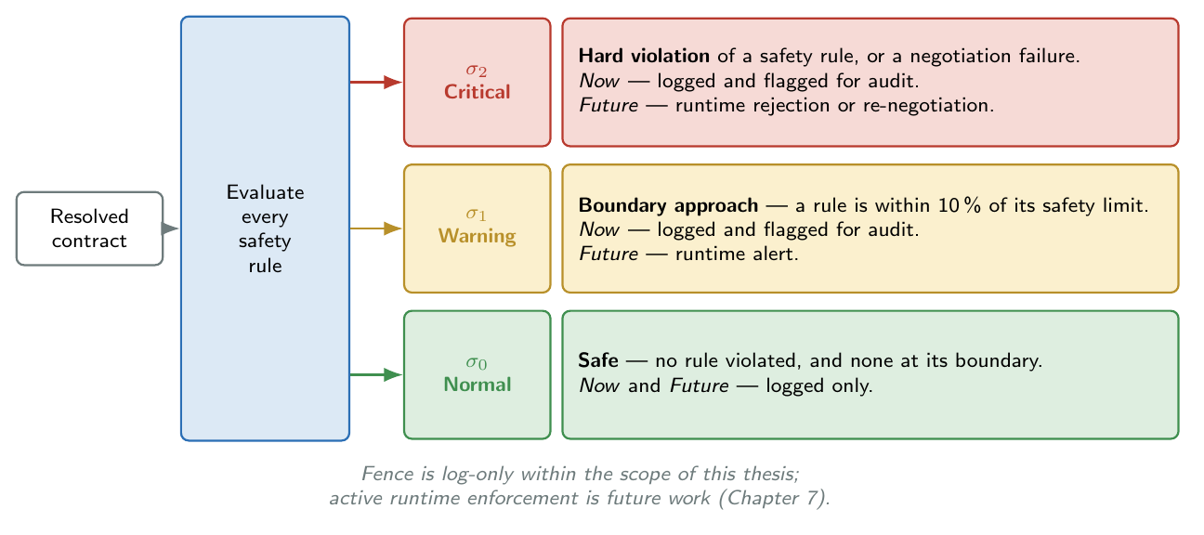
The three-tier Fence classification. Each resolved contract is checked against every safety rule and placed in the highest tier any rule triggers; the “Future” column previews the active runtime enforcement deferred to Chapter [ch:conclusions].
The default rule suite contains four rules, one anchored on each issue; they are listed in Table 1.6. Each rule encodes a domain safety invariant: do not run fast into an imminent breakdown, do not skip maintenance on a critically degraded machine, do not waive a quality hold on a severely defective batch, do not leave the supply horizon empty when the spare-part lead time is long. The rule suite is a parameter of the Fence: it can be extended or retuned without any change to the other three layers, which is the practical payoff of keeping governance in its own layer.
The default Fence safety rule suite. Each rule pairs a hard violation predicate ($σ_{2}$) with a boundary predicate ($σ_{1}$) that fires within ten per cent of the safe limit.
Rule | Violation condition ($σ_{2}$)
no_fast_when_breakdown_imminent | production_rate is fast while machine health is below the breakdown threshold.
maintain_when_health_critical | maint_window is none while machine health is below the preventive-maintenance threshold.
hold_quality_when_severe | quality_action is no_hold while the defect rate is at or above twice the quality control limit.
preorder_when_long_lead | supply_horizon is h0 while the spare-part lead time exceeds the shortage horizon.

1.5.3 Log-only enforcement, and the path to active governance
Within the scope of this thesis the Fence is log-only. It classifies every contract and emits an audit-record stream, but it does not block, alter, or roll back any contract — a $σ_{2}$ contract is executed exactly as a $σ_{0}$ one would be, and the tier is simply recorded. The audit stream is consumed downstream: it supports the safety analysis of Chapter [ch:results] and the deployment discussion of Chapter [ch:industrial].
The log-only stance is a deliberate scope boundary, and it is the right one for two reasons. First, it lets the thesis make and defend a clean, limited claim — that safety governance can be integrated structurally, as an audit layer over the coordination substrate, without coupling into the negotiation protocol — and demonstrate that claim without entangling it in the much harder questions that active enforcement raises. Second, log-only operation is in fact how a governance layer should be commissioned in practice: a plant would run the Fence in observe-only mode first, accumulate evidence on how often and why each tier fires, tune the rule suite against that evidence, and only then enable active control. The log-only Fence of this thesis is the first, necessary stage of exactly that commissioning path.
Active runtime enforcement — a $σ_{2}$ contract being rejected and sent back for re-negotiation, or overridden by a safe default — is the natural next step and is treated as future work in Chapter [ch:conclusions]. It raises questions the log-only layer is designed to sidestep: how to re-negotiate without looping, how to bound the latency an override adds to the coordination event, and how to keep an overriding Fence from silently becoming the de-facto coordinator. The runtime-verification and shielding literature (Raju et al. 2020; Alshiekh et al. 2018; Könighofer et al. 2019) offers mechanisms for the active case; integrating one of them into the Fence layer is a well-defined extension, and the layer boundary — the Fence already consumes the contract stream and already classifies it — is exactly the seam at which an enforcement mechanism would attach.

1.6 The School Layer
The fourth layer of NEXUS is the School. Unlike the other three it is not implemented within the scope of this thesis: it is described here, and carried in the architectural diagram with a dashed boundary, so that the architecture is presented complete and so that the future-work proposal of Chapter [ch:conclusions] has a concrete home. This section states what the School layer is for and how it would attach to the rest of the architecture; it does not claim an implemented mechanism.

1.6.0.0.1 The problem the School layer addresses.
The agents’ desire weights — the weights that scale each agent’s constraints, and through them its bids — are fixed parameters in the implemented architecture. They are calibrated once and held constant. But a real plant is not stationary: product mixes change, machines age, suppliers’ reliability drifts, and a set of desire weights that coordinates well in one operating regime may coordinate poorly in another. The School layer is the architectural slot for an outer loop that observes operational outcomes and slowly adapts the agents’ desire weights so that the coordination stays well-tuned as the plant evolves.

1.6.0.0.2 How it would attach.
The School layer would close a slow loop around the other three. It would consume the same audit stream the Fence consumes — the Contract Record together with the realised plant outcomes — and would adjust each agent’s desire weights in the direction that improves the observed outcomes. The adjusted weights would be written back to the agents, and the Marketplace would simply see better-calibrated bidders on subsequent conflicts; no protocol change is needed, because the desire weights are internal to the agents and the bid interface is unchanged. The loop is deliberately slow — it adapts over many coordination events, not within one — which keeps it cleanly separated from the per-event coordination loop of the Marketplace.

1.6.0.0.3 Candidate mechanisms.
Two mechanism families are natural candidates and are recorded here as the substance of the future-work proposal. The first is Bayesian weight adaptation: treat each agent’s desire weights as a posterior distribution updated from observed outcomes, so that the weights track the plant’s operating regime with a principled account of uncertainty. The second addresses a hazard the first does not. If the weights are simply re-fitted to the current regime, the agents may forget how to coordinate well in a regime that recurs — catastrophic forgetting. Elastic Weight Consolidation (Kirkpatrick et al. 2017) is the reference mechanism for exactly this problem: it slows adaptation of the weights that were important for previously seen regimes, so that the agents accumulate competence across regimes rather than overwriting it. A School layer built on Elastic Weight Consolidation would let NEXUS adapt to a changing plant without losing coordination skill it had already acquired.

1.6.0.0.4 Why it is deferred.
The School layer is deferred for scope reasons, not because it is ill-defined. The three implemented layers already constitute a complete, testable reference architecture for the cross-functional coordination problem; continual adaptation is a second-order improvement on top of a working coordinator, and folding it into the present scope would broaden the empirical work beyond what the thesis timeline allows. Deferring it is consistent with the treatment of the School-like adaptation slot in the holonic-architecture lineage, where the adaptive element is typically named in the architecture and elaborated separately. The detailed future-work treatment is given in Chapter [ch:conclusions].

1.7 ISA-95 Mapping and Privacy Preservation
This section consolidates two cross-cutting properties of the architecture that the preceding sections established piecewise: the mapping of NEXUS onto the ISA-95 Level 3 functional model, and the privacy-preservation property that the layered, bid-mediated design delivers.

1.7.1 Mapping onto ISA-95 Level 3
ISA-95 Part 1 places Manufacturing Operations Management at Level 3 of the functional hierarchy and decomposes it into operations-management activities for production, maintenance, quality and inventory (ISA Standards Committee 2010; Sprock et al. 2019). NEXUS maps onto this model directly, and the directness of the mapping is itself a design argument: an architecture whose components are in one-to-one correspondence with the standard’s functions can be explained to, and owned by, the people who already operate those functions.
Mapping of ISA-95 Level 3 operations-management functions onto NEXUS components. Each function becomes one Worker agent owning one contract issue; the cross-function coordination the standard leaves informal becomes the explicit task of the Marketplace layer.
ISA-95 L3 function | NEXUS agent | Owned issue | Decision authority
Production operations management | PSA | production_rate | Sets the production rate; subordinate voice on the other three issues.
Maintenance operations management | PMA | maint_window | Sets the maintenance window; subordinate voice elsewhere.
Quality operations management | QCA | quality_action | Sets the quality hold; subordinate voice elsewhere.
Inventory / supply operations management | SCA | supply_horizon | Sets the supply horizon; subordinate voice elsewhere.
Cross-function coordination (informal in ISA-95) | Marketplace layer | — | Resolves the joint decision as one composite contract.
Operations safety / governance | Fence layer | — | Audits each contract against pre-declared safety rules.
Table 1.7 records the mapping. Each of the four Level 3 functions becomes one Worker agent that owns one issue of the composite contract — the operational realisation of the “cross-functional decision authority” notion: an agent has decision authority over its home issue and a subordinate, damped voice over the others (Section 1.3.3). The element ISA-95 leaves implicit — the coordination between the four functions — is exactly what NEXUS makes explicit and assigns to the Marketplace layer. The standard acknowledges that the functions must be reconciled but does not prescribe a mechanism; NEXUS contributes one. The Fence layer, finally, occupies the operations-safety slot, auditing the coordinated decision against rules that sit outside any single function’s remit.

1.7.2 Privacy preservation

The privacy property of NEXUS can now be stated precisely, because all the pieces have been introduced. By construction of the Worker and Marketplace layers:
For each coordination event, an agent discloses only its bid set — a bounded number of (utility, region) pairs. It never discloses its beliefs, its constraint set, its constraint weights, or its desire weights. The Mediator’s entire information set is the union of the bid sets disclosed for that event.
The disclosure is bounded in a strong sense: the number of regions an agent publishes per event is capped by a protocol parameter and is independent of the size of the agent’s underlying belief and constraint model. An agent with a rich internal model and an agent with a sparse one publish bid sets of the same bounded shape. The Mediator therefore never learns an agent’s utility function; it learns only a bounded sample of values of that function, at regions the agent itself chose to nominate. Figure 1.7 traces the information flow of a coordination event and marks the privacy boundary that this property formalises.
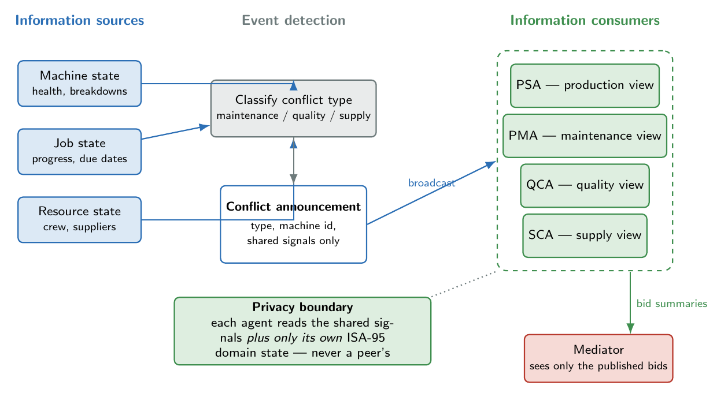
Information flow and privacy boundaries of a coordination event. Plant signals are classified into a conflict announcement that carries shared signals only; each agent reads that announcement together with its own ISA-95 domain state — never a peer’s — and the Mediator sees only the published bid summaries.
Table 1.8 places this property against the two reference points. A centralised optimiser such as NSGA-III (Deb and Jain 2014) — used as the centralised comparator in Chapter [ch:results] — requires the entire joint problem: every function’s cost structure, in full. Distributed constraint optimisation (Modi et al. 2005; Fioretto et al. 2018) distributes the computation but still requires each agent to publish complete cost tables over the shared variables. NEXUS requires neither: it discloses bid summaries only. It occupies a distinct point in the disclosure–coordination trade-off space — coordinated joint decisions under bounded disclosure — and that point is the architectural contribution the privacy property names.
Information disclosure under three coordination regimes. NEXUS produces a coordinated joint decision while disclosing only bounded bid summaries.
Regime | What each function must disclose | Joint decision
Centralised optimiser (NSGA-III) | Full cost structure, state, and models — the entire joint problem. | yes
DCOP | Complete cost tables over all shared variables. | yes
NEXUS | Bid summaries only: a bounded set of (utility, region) pairs per event. Beliefs, constraints, weights stay private. | yes
Siloed operation | Nothing — but no joint decision is produced. | no
Two qualifications keep the claim honest. First, the privacy of NEXUS is organisational, not cryptographic. The claim is that the architecture never requires an agent to publish its model — not that a determined adversary observing many events could learn nothing. An observer who collected an agent’s bid sets across a long run could in principle reconstruct a coarse approximation of the agent’s utility function from the nominated regions and their annotated values. Quantitative, differential-privacy-style guarantees over bid disclosure are out of scope and are noted as future work in Chapter [ch:conclusions]. Second, the bound is on disclosure per event: it is the shape of a single event’s disclosure that is independent of model size, and the cumulative disclosure over a run grows with the number of events, as the first qualification reflects. With those qualifications stated, the property stands: NEXUS coordinates four functions into a joint decision while requiring each to disclose only bounded bid summaries, and that is what no centralised or DCOP-style alternative achieves.

1.8 Implementation Architecture
The architecture described in this chapter is realised as a Python codebase, described in full in Chapter [ch:implementation]. The codebase mirrors the four-layer decomposition — one package per layer, plus a shared core/ for the data structures that cross layer boundaries — and the whole assembly is held in place by an automated regression suite that lets the architecture be modified and extended with confidence. Figure 1.8 recapitulates the architecture as an end-to-end operational sequence, from the detection of a plant condition to the safety audit of the resulting contract.
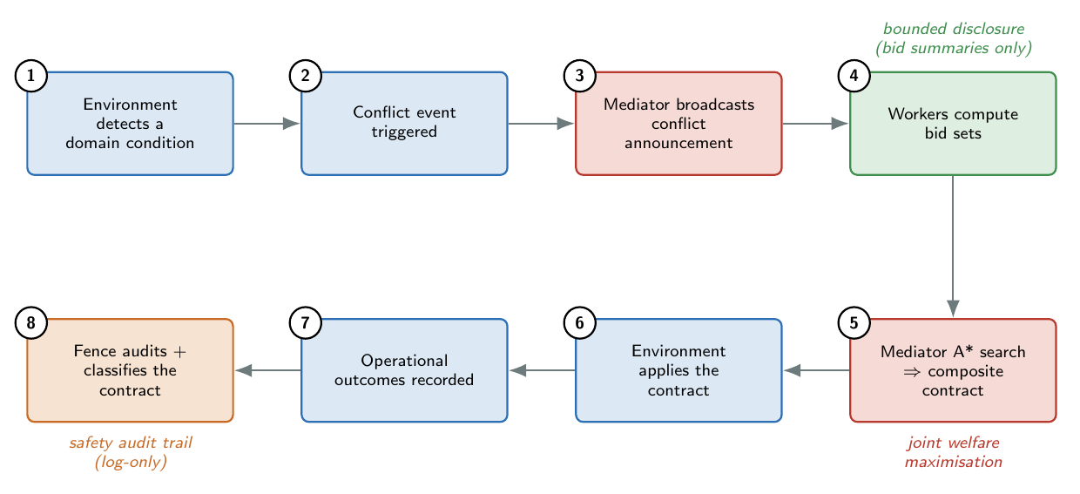
The end-to-end decision lifecycle of a coordination event, from the environment detecting a domain condition, through negotiation and contract execution, to the Fence safety audit. Bounded disclosure, joint welfare maximisation, and the log-only audit trail are annotated at the stages where they apply.
One scope boundary of the present implementation should be stated plainly, because it bears on the empirical chapters. The conflict announcement an agent receives carries the conflict type, the machine identifier, and a small set of shared plant signals — machine health, defect rate, spare-part lead time — and nothing more. It does not carry the wider cross-functional context that a fully industrial setting would supply: the priority of the job currently on the machine, the product variant being processed, or the remaining state of a maintenance budget. Within the benchmark families on which NEXUS is characterised in this thesis this is sufficient, because those benchmarks do not express such context. The industrial automotive benchmark introduced in Chapter [ch:results] does express it, and exposes a corresponding requirement: for the agents to coordinate well on context-dependent objectives, that context must be made visible in the announcement and in the agents’ constraint derivation — a mechanism-awareness extension of the present design. The extension is a candidate item for future work and is taken up in Chapter [ch:conclusions]; it changes the information content of the announcement, not the four-layer architecture of this chapter.

Summary
This chapter has presented NEXUS as a four-layer reference architecture for cross-functional coordination at ISA-95 Level 3. The Worker layer represents each of the four Level 3 functions as a BDI agent with mono-dimensional authority over one issue of a composite contract. The Marketplace layer resolves each cross-functional conflict into a single composite contract by an admissible-heuristic search that maximises joint welfare over the agents’ published bids, with a global-optimality guarantee and a consequent Pareto-optimality property. The Fence layer audits every contract against a suite of pre-declared safety rules and classifies it into a three-tier severity scheme, integrated structurally as a log-only audit layer with no coupling into the negotiation protocol. The School layer, deferred as future work, provides the architectural slot for continual adaptation of the agents’ preferences. Across all four layers the architecture holds to bounded information disclosure: each function reveals only bid summaries, never its internal model, so NEXUS produces a coordinated joint decision without the full-disclosure requirement that makes centralised optimisation infeasible in practice. The next chapter turns from the architecture to its implementation.

References
Alshiekh, Mohammed, Roderick Bloem, Rüdiger Ehlers, Bettina Könighofer, Scott Niekum, and Ufuk Topcu. 2018. “Safe Reinforcement Learning via Shielding.” Proceedings of the AAAI Conference on Artificial Intelligence 32 (1). https://doi.org/10.1609/aaai.v32i1.11797.
Deb, Kalyanmoy, and Himanshu Jain. 2014. “An Evolutionary Many-Objective Optimization Algorithm Using Reference-Point-Based Nondominated Sorting Approach, Part I: Solving Problems with Box Constraints.” IEEE Transactions on Evolutionary Computation 18 (4): 577–601. https://doi.org/10.1109/TEVC.2013.2281535.
Decker, Keith S., and Victor R. Lesser. 1995. “Designing a Family of Coordination Algorithms.” Proceedings of the First International Conference on Multi-Agent Systems (ICMAS-95), 73–80. https://doi.org/N/A.
Deen, S. M. 1997. “Performance Evaluation of Contract Net-Based Heterarchical Scheduling for Flexible Manufacturing Systems.” Intelligent Automation and Soft Computing 3 (2): 105–16. https://doi.org/10.1080/10798587.1997.10750705.
Faratin, Peyman, Carles Sierra, and Nicholas R. Jennings. 1998. “Negotiation Decision Functions for Autonomous Agents.” Robotics and Autonomous Systems 24 (3–4): 159–82. https://doi.org/10.1016/S0921-8890(98)00029-3.
Fatima, Shaheen S., Michael Wooldridge, and Nicholas R. Jennings. 2004. “An Agenda-Based Framework for Multi-Issue Negotiation.” Artificial Intelligence 152 (1): 1–45. https://doi.org/10.1016/S0004-3702(03)00115-2.
Fioretto, Ferdinando, Enrico Pontelli, and William Yeoh. 2018. “Distributed Constraint Optimization Problems and Applications: A Survey.” Journal of Artificial Intelligence Research 61: 623–98. https://doi.org/10.1613/jair.5565.
Hart, Peter E., Nils J. Nilsson, and Bertram Raphael. 1968. “A Formal Basis for the Heuristic Determination of Minimum Cost Paths.” IEEE Transactions on Systems Science and Cybernetics 4 (2): 100–107. https://doi.org/10.1109/TSSC.1968.300136.
Hattori, Hiromitsu, Mark Klein, and Takayuki Ito. 2007. “Using Iterative Narrowing to Enable Multi-Party Negotiations with Multiple Interdependent Issues.” Proceedings of the 6th International Joint Conference on Autonomous Agents and Multiagent Systems (AAMAS-07). https://doi.org/10.1145/1329125.1329424.
ISA Standards Committee. 2010. ANSI/ISA-95.00.01: Enterprise-Control System Integration — Part 1: Models and Terminology. Standard. International Society of Automation (ISA).
Ito, Takayuki, Hiromitsu Hattori, and Mark Klein. 2007. “Multi-Issue Negotiation Protocol for Agents: Exploring Nonlinear Utility Spaces.” Proceedings of the 20th International Joint Conference on Artificial Intelligence (IJCAI-07), 1347–52. https://doi.org/N/A.
Kirkpatrick, James et al. 2017. “Overcoming Catastrophic Forgetting in Neural Networks.” Proceedings of the National Academy of Sciences 114 (13): 3521–26. https://doi.org/10.1073/pnas.1611835114.
Klein, Mark, Peyman Faratin, Hiroki Sayama, and Yaneer Bar-Yam. 2003. “Negotiating Complex Contracts.” Group Decision and Negotiation 12 (2): 111–25. https://doi.org/10.1023/A:1023068821218.
Könighofer, Bettina, Roderick Bloem, Rayna Dimitrova, Suda Bharadwaj, and Ufuk Topcu. 2019. “Synthesis of Minimum-Cost Shields for Multi-Agent Systems.” Proceedings of the American Control Conference (ACC), 1986–93. https://doi.org/10.23919/ACC.2019.8815233.
Leitão, Paulo. 2009. “Agent-Based Distributed Manufacturing Control: A State-of-the-Art Survey.” Engineering Applications of Artificial Intelligence 22 (7): 979–91. https://doi.org/10.1016/j.engappai.2008.09.005.
Leitão, Paulo, and Francisco Restivo. 2007. “A Holonic Approach to Dynamic Manufacturing Scheduling.” Robotics and Computer-Integrated Manufacturing 24 (5): 625–34. https://doi.org/10.1016/j.rcim.2007.09.005.
Leitão, Paulo, Francisco Restivo, and Jose Barbosa. 2015. “HAPBA: A Holonic Adaptive Plan-Based Architecture.” IFAC-PapersOnLine 48 (3): 2149–54. https://doi.org/10.1016/j.ifacol.2015.06.408.
Modi, Pragnesh Jay, Wei-Min Shen, Milind Tambe, and Makoto Yokoo. 2005. “ADOPT: Asynchronous Distributed Constraint Optimization with Quality Guarantees.” Artificial Intelligence 161 (1–2): 149–80. https://doi.org/10.1016/j.artint.2004.09.003.
Monostori, L., J. Váncza, and S. R. T. Kumara. 2006. “Agent-Based Systems for Manufacturing.” CIRP Annals 55 (2): 697–720. https://doi.org/10.1016/j.cirp.2006.10.004.
Rahwan, Iyad, Sarvapali D. Ramchurn, Nicholas R. Jennings, Peter McBurney, Simon Parsons, and Liz Sonenberg. 2003. “Argumentation-Based Negotiation.” The Knowledge Engineering Review 18 (4): 343–75. https://doi.org/10.1017/S0269888904000098.
Raju, Dhananjay, Suda Bharadwaj, and Ufuk Topcu. 2020. “Online Synthesis for Runtime Enforcement of Safety in Multi-Agent Systems.” arXiv Preprint arXiv:1910.10380, ahead of print. https://doi.org/10.48550/arXiv.1910.10380.
Rao, Anand S., and Michael P. Georgeff. 1995. “BDI Agents: From Theory to Practice.” Proceedings of the First International Conference on Multi-Agent Systems (ICMAS-95), 312–19.
Smith, Reid G. 1980. “The Contract Net Protocol: High-Level Communication and Control in a Distributed Problem Solver.” IEEE Transactions on Computers 29 (12): 1104–13. https://doi.org/10.1109/TC.1980.1675516.
Sprock, Timothy, Conrad Bock, Keith Stouffer, Michelle Steves, Karl Pollard, and Paul Witherell. 2019. “Challenges in Integrating ISA-95 Levels 3 and 4.” IFAC-PapersOnLine 52 (13): 2494–99. https://doi.org/10.1016/j.ifacol.2019.11.466.
Trentesaux, Damien. 2009. “Distributed Control of Production Systems.” Engineering Applications of Artificial Intelligence 22 (7): 971–78. https://doi.org/10.1016/j.engappai.2009.05.001.
Van Brussel, Hendrik, Jo Wyns, Paul Valckenaers, Luc Bongaerts, and Patrick Peeters. 1998. “Reference Architecture for Holonic Manufacturing Systems: PROSA.” Computers in Industry 37 (3): 255–74. https://doi.org/10.1016/S0166-3615(98)00102-X.
Wooldridge, Michael, and Nicholas R. Jennings. 1995. “Intelligent Agents: Theory and Practice.” The Knowledge Engineering Review 10 (2): 115–52. https://doi.org/10.1017/S0269888900008122.

