Chapter 5: Validation

1 Validation
This chapter validates the NEXUS architecture of Chapter [ch:architecture], using the empirical evidence produced by the implementation of Chapter [ch:implementation]. The work done in this chapter is architectural validation: each section takes one architectural property promised in Chapter [ch:architecture] — bounded disclosure, joint welfare maximisation, the $σ$-tier audit signature, and so on — and asks whether the property survives contact with the running system. The chapter is not a contest in which NEXUS is the contender and the baseline mechanisms are opponents; the baselines are characterisation tools for the architecture, and the relevant verdicts are about the architecture’s properties, not about which mechanism wins on throughput.
The empirical surface is a single, deterministic, pre-registered benchmark pipeline. It consists of $720$ simulation runs — three runtime mechanisms across eight benchmark cells, thirty seeds per cell — together with four specialised follow-on analyses that unpack the audit log along axes (bits of disclosure, decision attribution, centralised alignment, coordination-event latency) the sweep alone does not surface. The chapter opens with the methodology that produced this evidence; the seven sections that follow each validate one architectural property against one or more pieces of that evidence; the closing section frames the limits of what the benchmark surface can validate.

1.1 Methodology
This section fixes the methodology for the rest of the chapter. It states the framing under which validation is performed (Section 1.1.1), enumerates the eight architectural properties the chapter validates (Section 1.1.2), introduces the five evidence families that supply the data (Section 1.1.3), names the mechanism configurations under comparison (Section 1.1.4), specifies the statistical methods and thresholds (Section 1.1.5), and gives the structural reading guide for the section sequence that follows (Section 1.1.6).

1.1.1 Framing: architectural validation, not outcome dominance
The thesis contribution stated in Chapter [ch:architecture] is a reference architecture: a layered composition of BDI Worker agents, a multi-issue Marketplace mediator, an audit-only Fence and a deferred School slot, together with the architectural properties that composition is designed to deliver. The contribution is the architecture and its properties, not a claim that this particular implementation of the architecture wins on plant-floor outcomes against every alternative on every benchmark. The distinction matters for how validation is conducted, and so this chapter is structured around it.
Architectural validation asks: does the system, when run on representative benchmarks, exhibit each of the architectural properties promised by Chapter [ch:architecture]? Does the Marketplace mediator actually find joint welfare maxima under an admissible heuristic? Does the Worker layer’s mono-dimensional-output discipline translate into a measurable attribution pattern in the audit log? Does the Fence layer produce a distinguishable safety signature across mechanisms? These are property-level questions; their answers characterise the architecture. Outcome dominance, in contrast, asks whether NEXUS produces strictly better defect counts or breakdown rates than a chosen baseline on a chosen benchmark family; this is a question about one particular implementation on one particular workload, not about the architecture as such.
The architectural-validation framing was not a retrospective rephrasing of what the empirical work had already produced. The contributions claimed in Chapter [ch:architecture] are stated as architectural properties; an earlier pre-registered hypothesis surface (an outcome-dominance test of NEXUS against Siloed-v5, and a productivity-differential test on centralised alignment) was methodological scaffolding, ratified inside the sweep driver before the data were inspected, and is treated in this chapter as outcome characterisation: the corresponding distributions and verdicts are reported honestly in Section 1.8 and they do not bear on the architecture’s claims (DD-033, DD-034). The other two pre-registered hypotheses — the alignment test and the disclosure test — do bear on architectural properties and are load-bearing for Sections 1.6 and 1.5 respectively. Section 1.1.5 names all of them explicitly, fixes the descriptive labels used throughout the chapter, and states what would falsify each.

1.1.2 The eight architectural properties under validation
Chapter [ch:architecture] promises eight architectural properties, each of which is the subject of one of this chapter’s later sections. Some are stated explicitly in the architectural prose; others are structural commitments the prose makes implicitly, in the sense that the architecture cannot be implemented without them holding. We enumerate them here in the order in which the chapter validates them, not in their order of appearance in Chapter [ch:architecture]. Table 1.1 summarises the mapping from each property to the chapter section where it is promised and to the section of this chapter that validates it.
The four ISA-95 Level 3 functions are decomposed into four Worker agents, and coordination, governance, and adaptation are separate layers that can evolve independently. P1 is foundational — it is not validated in isolation, but every result in Sections 1.2–1.7 is conditional on the layer boundaries holding.
Each Worker emits constraints primarily on its home issue, with cross-domain constraints damped to act as tie-breakers. Validated in Section 1.7 by the decision-attribution analysis (the $4×4$ contribution matrix).
Agents publish only bounded bid summaries; never beliefs, constraints, or internal weights. Validated in Section 1.5 by the bits-per-event disclosure quantification across mechanisms.
The mediator’s branch-cut A* with an admissible heuristic (DD-014) selects the contract that maximises the sum of agent utilities over the bid space. Validated in Section 1.6 by the alignment of NEXUS’s chosen contracts against the centralised utility-sum ceiling (CUSO, DD-032).
The Fence classifies each contract into one of three tiers ($σ_{0}$/$σ_{1}$/$σ_{2}$); coordination architectures produce distinguishable tier profiles. Validated in Section 1.4 by the cross-mechanism $σ$-tier counts produced by the main coordination sweep.
NEXUS produces contracts that are characteristically different from those produced by an uncoordinated, home-only baseline running on the same code and the same environment. Validated cumulatively by the $σ$-tier signature (Section 1.4), the disclosure quantification (Section 1.5), the centralised alignment (Section 1.6) and the decision-attribution analysis (Section 1.7); P6 is not validated by a single outcome contrast (the relevant outcome characterisation is in Section 1.8).
Joint trade-offs the agents themselves never explicitly programme — a rush order against a constrained maintenance budget yielding a deferred maintenance window, a premium product against a borderline defect rate yielding a partial quality hold — emerge from the mediator’s composition. Validated in Section 1.2.
The mediation outcome does not depend on the order in which the agents speak, because the mediator operates on the complete bid set in a single round. Validated in Section 1.3 by the agent-order permutation test.
A ninth architectural slot — the School layer, the locus of continual preference adaptation — is named in Chapter [ch:architecture] as future work and is not validated empirically here; it is taken up in Chapter [ch:conclusions].
The eight architectural properties under validation, the section of Chapter [ch:architecture] that promises each, and the section of this chapter that validates each.
Property | Statement | Promised | Validated
P1 | Layered separation of concerns | Sec. [sec:arch-overview], [subsec:why-layered] | §1.2–1.7 (implicit)
P2 | Mono-dimensional outputs + domain authority | Sec. [subsec:mono-dim] | §1.7
P3 | Bounded disclosure | Sec. [subsec:bids], [subsec:privacy] | §1.5
P4 | Joint welfare maximisation via admissible search | Sec. [subsec:mediator] | §1.6
P5 | $σ$-tier governance signature | Sec. [subsec:fence-tiers], [subsec:fence-logonly] | §1.4
P6 | Coordination over uncoordinated baseline | Sec. [sec:arch-intro], [subsec:protocol-scope] | §1.4–1.7 (cumulative)
P7 | Compositional emergence | Sec. [subsec:mediator] | §1.2
P8 | Order-invariant decisions | Sec. [subsec:protocol-scope] | §1.3

1.1.3 Evidence families
The empirical work draws on five distinct evidence families. Each family supplies a particular slice of evidence, anchored in a particular property of the architecture and analysed by a dedicated post-processor. Figure 1.1 shows the architectural layer each family principally bears on, together with the property labels.
The workhorse evidence family. Three mechanisms (NEXUS, Siloed and Rule-Based Coordination) are run across eight benchmark cells (two Brandimarte instances — Mk06 and Mk10 — and six synthetic_v2 cells covering the {medium, large} shop sizes crossed with the {low, medium, high} coupling levels) at $30$ paired seeds per (mechanism, cell), for a total of $720$ runs. Each run yields outcome metrics, $σ$-tier classifier output and the full Contract Record audit log. The sweep is the evidence base for Sections 1.2, 1.3, 1.4 and 1.7.
A specialised analysis of the Contract Records that computes, per mechanism and per cell, a $4×4$ contribution matrix recording how often each agent’s highest-utility bid pins each of the four contract dimensions in the final composite contract. The diagonal mass measures home-issue authority share; the off-diagonal mass measures cross-domain influence. Evidence base for Section 1.7 (property P2).
A post-hoc enumeration of the entire $108$-contract joint space for every conflict in the sweep, evaluating the centralised utility-sum optimum CUSO (DD-032). For each conflict the per-conflict alignment ratio NEXUS / cuso measures the fraction of the centralised utility-sum ceiling that the bounded-disclosure distributed mechanism recovers. Evidence base for Section 1.6 (property P4).
A bit-budget calculation applied to every bid and to the CUSO reference, instantiating the information-disclosure model of DD-030. Reported per mechanism, per agent, and as the per-event ratio of mechanism disclosure to CUSO disclosure. Evidence base for Section 1.5 (property P3).
A wall-time measurement per coordination event, used in Section 1.8 as a deployment-feasibility note against the ISA-95 Level 3 control cycle. It is not a property validation.
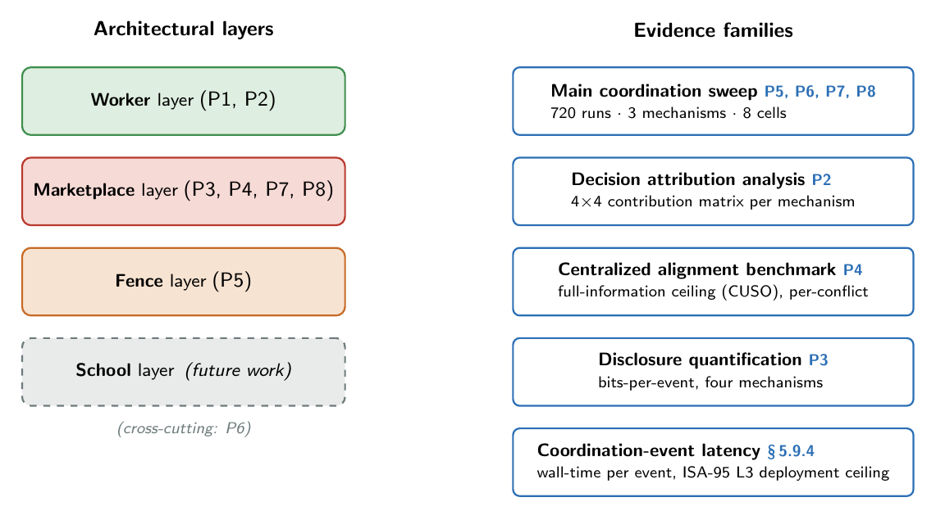
The four-layer NEXUS architecture alongside the five evidence families that populate this chapter. The property tags shown on each side make the validation correspondence explicit; Section 1.1.6 sequences the sections that exploit the correspondence.
The thesis-facing names used above and throughout the chapter intentionally differ from the internal working names that appear in the repository (Step 1 sweep, Phase C/D/E/F analyses). The renaming makes the chapter readable as a self-contained empirical narrative without the bookkeeping baggage of the engineering process that produced the data.

1.1.4 Mechanism configurations evaluated
The architecture is characterised against three drop-in alternatives to its Marketplace layer. Each alternative isolates a single architectural axis, so that the contrasts of Sections 1.2–1.7 are single-variable contrasts and the differences observed are attributable to the architectural property under test. Table 1.2 places the four mechanisms on the two axes that the comparison turns on: whether the mechanism performs a joint search over the contract space, and whether it has access to the full state of every agent’s utility function.
The architecture under validation (Chapter [ch:architecture], Chapter [ch:implementation]). Joint search over the published bid sets; bounded disclosure.
The uncoordinated baseline of Section [subsec:impl-siloed]. Each agent emits home-only bids (cross_domain_awareness=False) and the mechanism composes their independent home picks into a single contract. No joint search; bounded disclosure; same code and same environment as NEXUS, so the contrast with NEXUS is a single-variable contrast on coordination.
The static-threshold-rule baseline of DD-021 and Section [subsec:impl-rbc]. Each contract dimension is decided from a fixed per-dimension threshold on the conflict announcement; no agents, no bids. RBC trades coordination flexibility for determinism and a known rule table.
The full-information ceiling of DD-032 and Section [subsec:impl-cuso]. CUSO enumerates the entire $108$-contract joint space and returns the contract that maximises the sum of agent utilities, with access to every agent’s full utility function. It is not a runtime mechanism; it is a post-hoc reference applied to each conflict in the sweep.
The Sequential cascade of DD-012 and the single-winner Contract Net of DD-001 remain in the code but are not used as primary baselines: the Sequential cascade was shown to exhibit a structural commitment-asymmetry under resource-constrained loads (DD-019) that confounds the comparison on outcomes the thesis cares about, and the single-winner Contract Net’s output is a winner-label string that cannot, by construction, represent a cross-functional trade-off (DD-001).
The four mechanism configurations under comparison, placed on the joint-search and information-access axes that the contrasts of this chapter turn on.
Mechanism | Joint search | Information access | Role in the comparison
NEXUS | yes (branch-cut A*) | bounded (bid summaries) | architecture under validation
Siloed-v5 | no (home-only picks) | bounded (bid summaries) | isolates coordination vs independence
RBC | no (static rule table) | public rule table | isolates dynamic vs static coordination
CUSO | full ($108$-contract enumeration) | full agent utility functions | centralised reference ceiling

1.1.5 Statistical methods and thresholds
Outcome distributions across the $30$ paired seeds per cell are compared with the two-sided Mann-Whitney U test — a non-parametric rank test that makes no distributional assumption and that is appropriate to the small, paired and skewed outcome distributions that the discrete-event simulator produces. Effect size is reported as Cliff’s $δ$, which takes values in $[−1,+1]$ and admits the conventional thresholds: $|δ| ≥ 0.147$ small, $0.330$ medium and $0.474$ substantively large. A positive $δ$ in a contrast “A vs B” means that A’s outcome distribution is shifted in the favoured direction relative to B’s; the favoured direction is specified per outcome (lower is better for defects, breakdowns and makespan; higher is better for throughput). The significance level is Bonferroni-corrected against the multiple comparisons induced by four outcomes and two pairwise contrasts: $α=0.05/8=0.00625$.
The empirical surface of the chapter is organised around eight named tests, each anchored to one of the architectural properties P1–P8 of Section 1.1.2. Four of the tests were pre-registered in experiments/run_step1_unified_sweep.py before any sweep data were inspected; the other four are structural or regression-anchored checks. The chapter refers to all of them by descriptive two-letter labels so the prose stays legible without the bookkeeping of the internal hypothesis codes carried by the code, the JSON keys of the result files, and the design-decision ledger. The mapping is one-to-one and is recorded in Table 1.3 below; the labels are the chapter’s glossary and are used uniformly throughout Sections 1.2–1.8.
The eight tests under which the chapter’s empirical surface is reported. The label is the chapter glossary; the internal name is the identifier used by the code, the result-file JSON, and the design-decision ledger; “Load-bearing” marks the tests whose verdict bears on an architectural claim, as opposed to outcome characterisations whose verdicts are reported in Section 1.8 per DD-033/DD-034.
Label | Test name | What is tested | Section | Pre-reg. | Load-bearing
OD | Outcome dominance | NEXUS outcome distributions strictly dominate Siloed-v5 on quality outcomes | §1.8 | yes (HB1) | char.
AL | Alignment | NEXUS’s per-conflict alignment against the CUSO ceiling has $p_{25}≥0.945$ on every cell | §1.6 | yes (HF1) | yes
DI | Disclosure | NEXUS’s per-event disclosure is at most $30\%$ of the CUSO ceiling on every cell | §1.5 | yes (HF2) | yes
PR | Productivity differential | NEXUS exceeds Siloed-v5 in CUSO alignment by at least $5$ percentage points on every cell | §1.8 | yes (HF3) | char.
$σ$G | $σ$-tier governance | The three runtime mechanisms produce substantively ordered $σ$-tier counts (not indistinguishable noise) | §1.4 | yes (HA1) | yes
OI | Order invariance | NEXUS produces byte-identical contracts under any permutation of agent presentation order | §1.3 | no (structural) | yes
CE | Compositional emergence | F6 + F7 trade-offs emerge under NEXUS mediation, absent under Siloed-v5 and RBC | §1.2 | no (regression) | yes
JM | Joint mediation signature | NEXUS’s diagonal contribution mass differs from Siloed-v5’s by at least $10$ percentage points uniform across cells | §1.7 | no (structural) | yes
Two of the four pre-registered tests — OD (the outcome-dominance test) and PR (the productivity-differential test) — are explicitly reclassified as outcome characterisation per DD-033 and DD-034: their verdicts are reported in Section 1.8, but they do not bear on the architecture’s claims, because the architecture of Chapter [ch:architecture] does not promise outcome dominance over a same-codebase uncoordinated baseline. The remaining six tests bear on the architecture’s property surface and are load-bearing for the section in which they run. The non-pre-registered tests (OI, CE, JM) are not statistical-distribution tests: OI is a structural property checked by a determinism regression, CE is a qualitative-emergence inference anchored by the DD-023 regression suite, and JM is an architecture-level $10$-percentage-point reading on the decision-attribution matrix. Each is introduced in the section that runs it.

1.1.6 Reading guide for the rest of the chapter
The remainder of the chapter follows a uniform structure. Each of Sections 1.2–1.7 takes one architectural property, names the evidence family it draws on, states the measurement performed, reports the empirical result, and closes with a paragraph on what the result establishes and what it does not. The order of the sections is from the compositional and order-invariance claims that follow from the joint protocol (Sections 1.2 and 1.3), through the governance signature (Section 1.4), the two quantitative architectural claims of bounded disclosure and centralised alignment (Sections 1.5 and 1.6), to the decision-attribution signature of the mediation itself (Section 1.7). The six sections collectively exhaust the architectural surface promised by Chapter [ch:architecture].
Property P6 (coordination over independence) deserves a separate note here. The architecture’s claim that joint mediation produces contracts recognisably different from those produced by an uncoordinated baseline is supported cumulatively — distinct $σ$-tier signature (Section 1.4), distinct disclosure profile (Section 1.5), distinct alignment ratios against the centralised ceiling (Section 1.6), distinct decision-attribution mass (Section 1.7). It is not validated by a single outcome contrast against Siloed-v5; on the FJSP benchmark families the within-codebase outcome distributions are at parity, and that result is part of the outcome characterisation honestly reported in Section 1.8. The four cumulative contrasts taken together are what makes the property load-bearing.
Section 1.8 closes the chapter with the applicability boundary. There are two reasons the section is given its own space rather than woven into the earlier sections. The first is that the outcome characterisation honestly belongs together with the limits of what benchmark validation can prove — the reclassified outcome-dominance and productivity verdicts are not isolated empirical observations but features of a study that is, by design, about the architecture rather than about which specific implementation of the architecture wins on which specific scalar metric. The second is that the chapter’s claims need to be stated against the design space they implicitly occupy. The NEXUS architecture admits a range of implementation choices on each layer — BDI workers could be replaced by a multi-agent reinforcement-learning component; the multi-issue A* mediator could be replaced by a combinatorial auction; the log-only Fence could be replaced by an enforcement layer with runtime intervention — and the architectural properties validated here are properties of the reference architecture, not of any one specific implementation. Section 1.8 makes that design space explicit, names the limitations of the present study against it, and previews how Chapter [ch:industrial]’s industrial case study addresses the gap between benchmark validation and operational deployment. The chapter does not, anywhere, claim outcome dominance over a baseline on any benchmark; that the architecture can be characterised against its baselines without such a claim being made is itself a property of the chapter’s framing, and Section 1.8 is where that framing is closed out.

1.2 Compositional trade-off emergence
The second architectural property under validation is P7: cross-functional trade-offs emerge from the Marketplace mediator’s joint composition of the agents’ bids, rather than from explicit trade-off rules programmed into any single component. P7 is a structural claim about where cross-functional decisions are located. If a useful trade-off pattern — “defer maintenance when the budget is tight and the job is a rush order”; “hold quality more strictly when the product variant is more expensive” — has to be coded somewhere as a special-case rule, then the mediator is not adding value; it is just executing rules its designers anticipated. P7 says the trade-offs emerge from the A* composition of independently weighted home-domain constraints, without any agent or rule table writing the trade-off down.

Evidence and inference pattern
This is qualitative-emergence evidence, not a statistical distribution test, and the pattern of inference is structural: a trade-off is present where mediation is present and absent where mediation is absent. Two concrete trade-offs are anchored by the DD-023 regression suite (tests/test_dd_v5_023_extensions.py, $40$ tests):
A conflict where the job is a rush job (is_rush $=$ True) on a degraded machine (machine_health $=$ $0.45$), and the maintenance budget is nearly exhausted (remaining_budget_ratio $=$ $0.1$), yields a contract whose maintenance window is planned, not immediate — even though the machine’s health alone would normally argue for immediate, and even though the rush job alone would normally tighten the decision in the other direction. The trade-off is the composition of the two pulls under the budget constraint.
A conflict where the product variant is premium (high unit value) and the defect rate sits just below the quality threshold ($0.04$) yields a contract whose quality action is hold_light, rather than the no_hold that the defect rate alone would select.
The regression suite pins these compositions as targeted unit-style tests: each test constructs a ConflictAnnouncement with the relevant joint signal, runs the agents’ bid generation against the mediator, and asserts that the resulting weight ordering or chosen contract value reflects the trade-off. The tests are not the discovery — they are the regression guard for the discovery, and the discovery itself is in the design of the agents’ constraint catalogues plus the A* mediator’s composition rule (the priority key $f=g+h$ of Section 1.1.5 applied across all four agents’ bid utilities). The trade-off emerges from the structural arithmetic of the joint search; the test is what tells us it is still emerging after a refactor.
The F6 mechanism is worth tracing in detail because the structural arithmetic is what the chapter is asking the reader to grant; Figure 1.2 shows the path. PMA’s constraint catalogue contains two relevant unary constraints on the maintenance dimension: pma_force_IMMEDIATE_when_critical and pma_prefer_PLANNED_when_degraded. The industrial-awareness extensions of DD-023 add two modulators: the priority multiplier (rush job $→$ multiplicative boost on both constraints, weighting maintenance up overall) and the budget discount (low remaining_budget_ratio $→$ multiplicative discount on the immediate constraint only, because it is the costly action). On the F6 signal (rush, machine_health $=0.45$, remaining_budget_ratio $=0.1$), the priority multiplier scales both constraints by $5×$; the budget discount factor of about $0.2$ applies only to immediate; and the resulting weight ordering inverts: pma_prefer_PLANNED_when_degraded now carries the heavier weight in PMA’s bid set, and the mediator’s joint search picks the bid combination whose joint region admits planned. No code path anywhere computes “if rush and budget tight, then PLANNED”. The weight modulators are independent; the budget discount lives on the immediate constraint and is unaware of the priority multiplier; the joint outcome is the sum the mediator finds across the four agents’ bid utilities. F7 has the same structural shape: the multi-product modulator weights QCA’s qca_partial_hold_when_borderline constraint conditional on product_unit_value, and the mediator’s joint composition chooses hold_light where the base rule would have chosen no_hold.
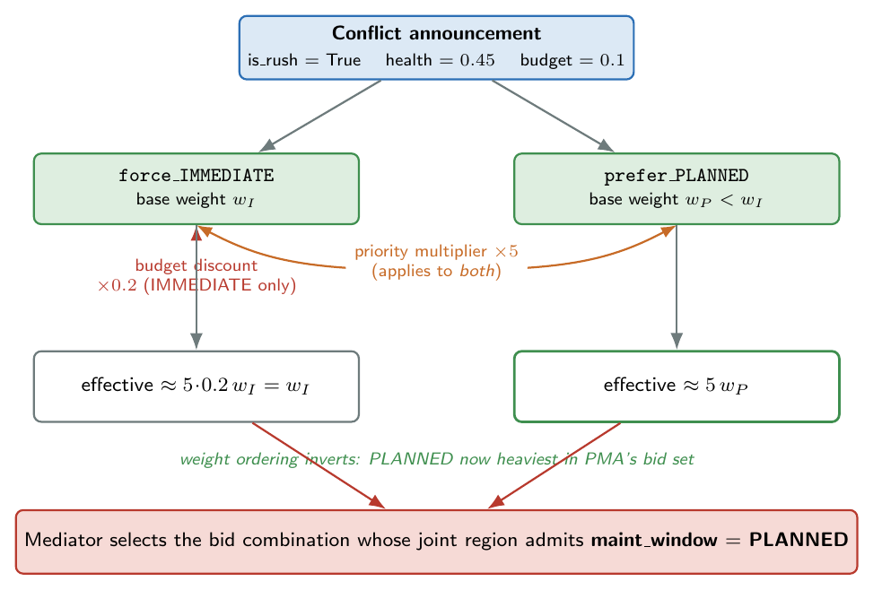
The F6 compositional-emergence path. A rush conflict on a degraded machine under a near-exhausted maintenance budget inverts the weight ordering of PMA’s two maintenance constraints — the priority multiplier boosts both, the budget discount suppresses only immediate — so the mediator’s joint search admits planned maintenance. No component encodes the trade-off explicitly; it is the arithmetic of the composition.

Absence under Siloed and RBC
The same trade-offs do not emerge under Siloed-v5. Siloed-v5 constructs the contract by composing each agent’s independent home-issue pick: PMA chooses the maintenance window from machine_health alone, QCA chooses the quality action from defect_rate alone, and so on. The rush flag and the budget ratio reach PMA; they do not, by construction, reach QCA’s home decision; and PSA’s production rate has no way to influence the maintenance choice. There is no place in Siloed-v5 where cross-domain trade-offs can compose, so F6 and F7 do not emerge there. This is not a Siloed-v5 bug; it is what “no joint mediation” means.
The same holds for RBC, with one nuance. RBC’s threshold rule table (Section [subsec:impl-rbc]) explicitly encodes a small handful of priority-and-budget interactions on a per-dimension basis — the TestRBCRuleOrderDependence regression test fixes the correct application order (priority first, then budget) as a permanent guard against silent rule-rewrite. RBC therefore exhibits programmed trade-offs on the dimensions its rule table was extended to anticipate. RBC’s trade-offs are not emergent; they are the rule designer’s explicit decisions encoded as conditionals. P7 asks for trade-offs that emerge without being coded as such, and that property is supported only on NEXUS: the same F6 and F7 patterns arise from the A* composition without any rule in any agent or in any rule table that says “if rush and budget tight, then PLANNED”.

Architecture-level proxy on the main sweep
The DD-023 trade-offs are pinned on the agent constraint catalogues by the regression suite, but the synthetic_v2 benchmark cells of the main sweep do not exercise the industrial signals (remaining_budget_ratio, product_type) that F6 and F7 turn on — those fields are populated only on the industrial-automotive environment path of Chapter [ch:industrial]. The compositional-emergence signature on the main sweep is therefore architecture-level rather than trade-off-specific: it is the $10$ percentage-point reduction in NEXUS’s diagonal contribution mass relative to Siloed-v5’s that Section 1.7 reports. The diagonal mass measures the share of the final contract whose value coincides with the chosen bid’s home-issue sample; a reduction of that share under joint mediation is what compositional emergence looks like at the contribution-attribution level, because the mediator is pulling the chosen bids’ non-home dimensions into the joint region.
The uniformity of the $10$-pp gap across all $8$ cells is itself the property-level evidence for P7 on the main sweep. The trade-off-specific patterns F6 and F7 are evidence on the constraint-catalogue level; the contribution-attribution pattern is the evidence at the architectural level.

Limitations
Two are worth naming. First, F6 and F7 are two trade-offs — chosen because the design of the industrial agent extensions (DD-023) explicitly anticipates them. The agent constraint catalogues admit a larger family of compositions (e.g., rush plus high defect rate plus low budget), and only a subset has been pinned by the regression suite. Whether NEXUS’s mediator produces the architecturally desired composition on every such joint signal is not exhaustively tested.
Second, the architecture-level proxy — the $10$-pp diagonal-mass gap — is uniform across cells. Uniformity is informative (P7 is a structural property of joint mediation, not a benchmark-dependent accident) and also limiting (the proxy carries no per-cell granularity that would let one cell argue more or less strongly for emergence than another). The trade-off-specific discussion lives in the regression suite; the architecture-level discussion lives in Section 1.7.

1.3 Order-invariant decisions
The third architectural property under validation in this batch is P8: the contract NEXUS produces on a given conflict does not depend on the order in which the agents are presented to the mediator. P8 is a structural property of the single-round protocol of Section [subsec:protocol-scope] — not an emergent property that has to be discovered, but a consequence of the mediator’s algorithmic design that the implementation either preserves or breaks.

The structural argument
NEXUS’s Marketplace, per Sections [subsec:mediator] and [subsec:impl-mediator], operates in a single round. Every agent generates its complete bid set against the same ConflictAnnouncement, the bid sets are collected on the Bid Bus into a list-of-lists indexed by agent, and the mediator’s branch-cut A* search expands the combinatorial space of one-bid-per-agent combinations under the priority key $f=g+h$. The bid-list order is positional metadata: the search treats the lists as the input to a combination enumeration, and the combination set $\{(b_{1},b_{2},b_{3},b_{4})∣b_{i}∈B_{i}\}$ is, by definition, order-invariant in the agent index. Whichever agent appears first in the list, the same set of combinations is explored, and the priority key $f$ is the same scalar at every combination because $g$ is a sum of bid utilities and $h$ is a sum of per-agent suffix maxima — both invariant under reordering of the agents.
The tie-break inside the chosen combination’s joint region is deterministic (Section [subsec:impl-mediator]): the contract that maximises the summed agent utility wins, with ties broken by the canonical enumeration order of the $108$-contract space. The canonical order is fixed at module import time and does not depend on the agent presentation order. The full pipeline is therefore a function of the bid sets and the announcement, with no order-of-input dependence; the property P8 is structurally guaranteed and verifying it empirically is a determinism check on the implementation, not a discovery.

Empirical verification
The implementation’s determinism is verified by the test suite of Section [sec:impl-testing]. tests/test_determinism.py exercises (a) cross-call determinism: two consecutive calls of agent.propose_bids on the same announcement produce identical bid utilities and identical sample contracts; (b) cross-process determinism: a fresh subprocess produces the same per-agent random seeds, the same bid sets, and the same composed contracts as the parent process. The cross-process test is the critical guarantee, because it pins the architecture’s order-invariance against the specific implementation choice that might break it — per-process random-number-generator state. The _stable_seed hash of Section [subsec:impl-agentbase] replaces the standard library’s process-keyed hash and is what makes the regression test pass.
Combined with the structural argument, this gives a tight verdict on P8 for NEXUS: byte-identical contracts on the same announcement, across processes, with the agent presentation order irrelevant to the result. Figure 1.3 contrasts the single-round protocol that makes this hold with the sequential cascade that breaks it.
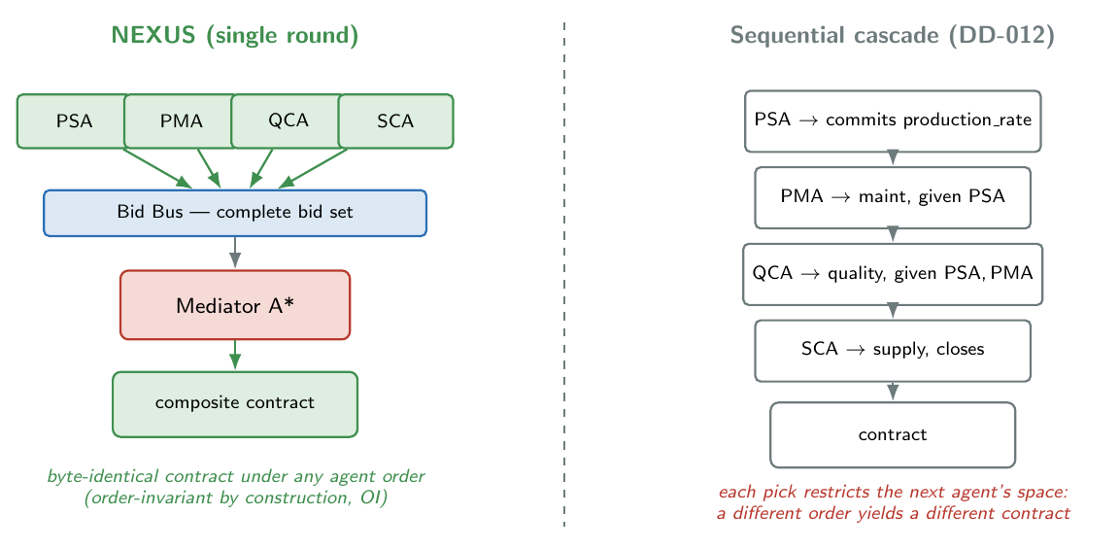
Order invariance by contrast. In NEXUS (left) all four agents bid into the Bid Bus and the mediator searches the complete bid set in a single round, so the composed contract is byte-identical under any agent order. In the sequential cascade (right, DD-012) each agent’s pick restricts the next agent’s space, so a different order yields a different contract.

Contrast with sequential cascade
P8 is falsifiable: a mechanism in the same architecture but with a different mediator can violate it. The Sequential cascade of Section [subsec:impl-baselines] (DD-012) is the documented example. The cascade fixes the agent order to PSA $→$ PMA $→$ QCA $→$ SCA, and each agent’s pick restricts the contract space the next agent sees: PSA commits the production rate; PMA chooses the maintenance window conditioned on that production rate; QCA chooses quality conditioned on the first two; SCA closes the loop. The regression test tests/test_baseline_sequential.py::test_cascade_order_psa_pma_qca_sca pins this order even when the agent list is registered in reverse, and the companion test test_upstream_fixed_values_constrain_downstream verifies that an upstream pick can force a downstream agent into an otherwise non-preferred choice (PPSA’s rate fixes the joint region, forcing PMA into a maintenance window it would not have selected first). The cascade therefore satisfies, by construction, the negation of P8: the contract produced depends on the agent order.
A different falsifying mechanism is RBC, on a smaller surface. The TestRBCRuleOrderDependence regression in tests/test_dd_v5_023_extensions.py pins the order in which RBC applies its own internal rule adjustments (priority first, then budget). A budget-first ordering would, on the test’s joint signal, downgrade the maintenance window differently and produce a different contract. RBC therefore exhibits an internal rule-order dependence: the mechanism’s authors had to choose an order and the regression test makes that choice permanent. P8 is satisfied by NEXUS structurally; in RBC it is satisfied only on the dimensions the rule table does not sub-divide, and not by construction.

Limitation
P8 is a property of the single-round protocol. DD-006 restricts NEXUS to single-round mediation; the iterative-narrowing extension of Hattori, Klein and Ito (Section [subsec:protocol-scope]) would break P8 by construction, because iterative rounds couple the agents’ bids to the partial-agreement feedback produced in earlier rounds, and the order in which agents see and respond to that feedback would influence the subsequent rounds. NEXUS’s P8 guarantee therefore depends on the protocol-scope choice DD-006 and would be replaced by a softer guarantee (e.g., convergence-order invariance, or invariance up to a tie-break) under iterative narrowing. Iterative narrowing is deferred as future work in Chapter [ch:conclusions]; the single-round protocol is the scope under which the chapter’s claims are made, and P8 is one of the chapter’s strongest claims because the architectural argument and the empirical regression test agree exactly on what they assert.

1.4 $σ$-tier governance signature
The fourth architectural property under validation in this chapter is P5: the Fence layer classifies every resolved contract into one of three tiers ($σ_{0}$ safe, $σ_{1}$ at boundary, $σ_{2}$ violation), and different coordination mechanisms running on the same plant under the same Fence rules produce distinguishable tier profiles. The property is what makes the Fence audit stream a diagnostic surface for the architecture: if every mechanism produced the same tier distribution, the Fence output would carry no mechanism-specific information and could not be a useful audit signal. The $σ$G test of Section 1.1.5 is the architectural-reading test that the three runtime mechanisms — NEXUS, Siloed-v5 and RBC — produce substantively ordered tier profiles, not indistinguishable noise.

Evidence and measurement
The evidence is the $σ$-tier classifier output emitted by the Fence layer (Section [sec:impl-fence]) over the main coordination sweep. For each of the $720$ runs the classifier evaluates every resolved contract against the default four-rule safety suite of Section [subsec:fence-tiers] (no_fast_when_breakdown_imminent, maintain_when_health_critical, hold_quality_when_severe, preorder_when_long_lead) and emits a FenceRecord with the assigned tier, the rule names that fired (violation and boundary), and the plant signals against which the rules were evaluated. The aggregate of interest is the $σ_{2}$ fraction on each (mechanism, cell) pair: the proportion of resolved contracts that violate at least one safety rule. The $σ_{2}$ tier is the dominant signal because the $σ_{1}$ boundary tier is rarely populated under the default suite on the present benchmarks; $σ_{0}$ is its complement, modulo the $σ_{1}$ band, and reports the same information.
The $σ$G reading test is qualitative: the three mechanisms must produce an ordering whose magnitudes are large enough to be a substantive feature of the audit stream, not a noise floor. The ordering is read off the cross-mechanism table; the mechanism-by-mechanism story it tells is what the property P5 claim turns on.

Result — pooled and per-cell
Table 1.4 reports the per-cell $σ_{2}$ percentages for the three mechanisms across all eight cells.
The $σ$G test: $σ_{2}$ rule-violation tier as a percentage of resolved contracts, per mechanism per cell. Brandimarte cells (Mk06, Mk10) produce no violations under any mechanism because their degradation regime keeps the breakdown rule’s gate shut; the substantive ordering lives on the six synthetic_v2 cells. Source: results/step1_unified_sweep/.
Cell | NEXUS (%) | RBC (%) | Siloed-v5 (%) | Siloed gap vs NEXUS (pp)
Mk06 | $0.73$ | $0.00$ | 10.00 | $−0.73$
Mk10 | $0.64$ | $0.00$ | 10.00 | $−0.64$
medium_low | $0.47$ | $0.00$ | $13.75$ | $+13.28$
medium_medium | $0.63$ | $0.00$ | $14.88$ | $+14.25$
medium_high | $0.70$ | $0.00$ | $17.32$ | $+16.62$
large_low | $0.25$ | $0.00$ | $12.99$ | $+12.74$
large_medium | $0.30$ | $0.00$ | $15.51$ | $+15.21$
large_high | $0.41$ | $0.00$ | $17.64$ | $+17.23$
pooled | $0.47$ | $0.00$ | $12.63$ | $+12.16$
Pooled across all $19\text{k}$–$23\text{k}$ contract records per mechanism, the substantive ordering is
Siloed-v5 ($σ_{2}=12.63\%$) $≫$ NEXUS ($σ_{2}=0.47\%$) $≈$ RBC ($σ_{2}=0.00\%$).
Siloed-v5’s pooled $σ_{2}$ rate is approximately $27$ times higher than NEXUS’s; the cross-mechanism gap on the synthetic-v2 cells ranges from $+12.7$ to $+17.2$ percentage points. RBC produces no $σ_{2}$ events at all. The Brandimarte cells are uninformative for the test: the Brandimarte degradation regime does not bring machine_health below the breakdown rule’s $0.30$ gate within the simulation horizon, so the dominant Fence rule never fires under any mechanism. The substantive $σ$G signal lives entirely on the six synthetic_v2 cells, where the resource-contention + critical-machine + cascade features of DD-019 drive health into the rule-active region.
The $σ$G test passes the substantive-ordering reading on the synthetic-v2 cells (with mechanism gaps an order of magnitude above any plausible noise floor) and is vacuous on the Brandimarte cells. Figure 1.4 shows the cross-mechanism profile.
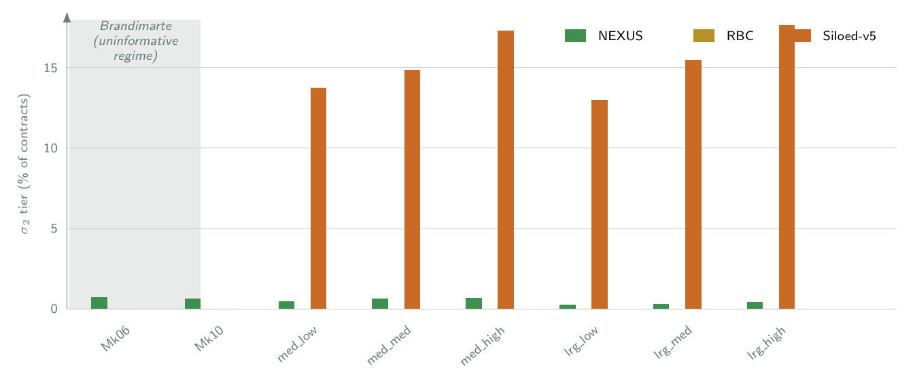
The $σ_{2}$ rule-violation tier as a percentage of resolved contracts, per mechanism per cell. Siloed-v5 (orange) dominates on the six synthetic_v2 cells; NEXUS (green) stays near zero and RBC (yellow) at zero. The Brandimarte cells (shaded) are an uninformative regime in which the breakdown rule never fires for any mechanism.

Interpretation: signature, not safety
Three readings of the $σ$G result need to be distinguished, and the architectural-validation framing of Section 1.1.1 makes the distinction load-bearing.
First, the result is not “NEXUS is safe and Siloed is unsafe.” The Fence is log-only within the scope of this thesis (Section [subsec:fence-logonly], DD-033): no contract was rejected, no remediation was triggered by the classifier, and every contract the mechanisms produced was applied to the environment exactly as composed. The $σ_{2}$ fraction measures how many contracts would have been flagged by the rule suite, not how many contracts produced a downstream safety failure. The mapping from $σ_{2}$ rate to operational safety outcome is what active runtime enforcement (future work) would add; it is not the property under test here.
Second, the result is the architecture’s risk-tier governance signature in the sense P5 promises. The same Fence rules applied to the same plant signals under the same instances produce dramatically different audit-stream shapes depending on which coordination mechanism is installed. A reader of the audit stream alone — with no view of the mechanism — can distinguish a Siloed-v5 run from a NEXUS run on the synthetic-v2 cells with substantial confidence. The Fence is acting as an architectural-fingerprint surface, which is the property P5 promises and what makes it a useful Level 3 audit substrate.
Third, the cross-mechanism story the table tells is interpretable in mechanism terms. The Siloed-v5 $σ_{2}$ tier is dominated by a single rule firing: about $99\%$ of Siloed-v5’s $σ_{2}$ contracts violate no_fast_when_breakdown_imminent (the rule forbidding fast production rate when machine_health is below the breakdown threshold). The mechanism is concrete: Siloed-v5’s PSA agent picks the production rate on production-pressure signals alone — backlog, due-date urgency, tardiness pressure — and has no visibility into machine_health, because the cross-domain constraint linking those two dimensions is filtered out at constraint emission by the cross_domain_awareness=False flag of Section [subsec:impl-siloed]. NEXUS’s PSA emits the same home-domain constraints but also emits a binary cross-domain constraint coupling production_rate and machine_health, which the mediator’s A* search composes with PMA’s home-domain weight on the maintenance dimension; the joint result is a contract that does not raise the rate to fast when health is critical. The $σ$G signature therefore traces a specific failure mode of independent home-only decisions in the FJSP regime, and the mediator’s joint composition is what closes it.
RBC’s perfect $0\%$ $σ_{2}$ rate is its own story and is worth naming directly. The four Fence rules of the default suite mirror, on a per-dimension basis, the four threshold rules that DD-021 writes into the RBC mechanism: RBC’s pm_threshold is $0.55$ matching the Fence’s $0.40$ threshold for the maintenance rule (and at the calibrated DD-010 pm_threshold = $0.55$ for the agents, RBC sits inside the Fence’s safe band by construction); RBC’s quality_threshold and shortage_threshold are similarly calibrated to the Fence’s rule structure. RBC therefore inhabits the Fence’s $σ_{0}$ band by construction. The reading is that RBC has paid its safety insurance through the rigidity of the rule table itself: a different Fence rule suite, or a calibration shift between the rules and RBC’s thresholds, would expose this construction. The architectural story is not that “RBC is safer than NEXUS” but that “RBC is the Fence rule suite turned into a coordination policy,” and the $σ$-tier signature on the present sweep shows that exactly.

Limitations
The Fence is log-only on the present sweep (Section [subsec:fence-logonly]). The translation from $σ_{2}$ audit signal to operational safety outcome would require an enforcement mode — contract rejection, remediation, or operator escalation on $σ_{2}$ events — and that translation is deferred to future work (Chapter [ch:conclusions]). The chapter’s claim is that the $σ$-tier signature exists and is mechanism-specific, not that it reduces operational risk.
The default four-rule suite is one rule set among many; different rule suites would produce different signatures. The choice of suite is the safety governance layer’s responsibility, and the present chapter does not validate the suite. The $σ$G claim is robust across rule suites in the sense that any safety rule suite anchored on the plant signals the Fence reads will distinguish a mechanism that ignores the cross-domain coupling from a mechanism that composes it; the specific magnitude of the gap depends on the suite.
The Brandimarte cells are uninformative for the test, which limits the cell-coverage support and concentrates the substantive evidence on the six synthetic-v2 cells. A benchmark family that exercises the defect-rate rule or the shortage rule more aggressively would broaden the cell coverage; the chapter chooses to read the synthetic-v2 results as the substantive signal rather than to add a fourth benchmark family inside the scope of the present sweep.

1.5 Bounded information sharing
The fifth architectural property under validation is P3: the four Worker agents publish only bounded bid summaries — a small set of (utility, region) pairs per coordination event — and the cumulative information disclosure per event is structurally bounded above by the size of those summaries, independent of how rich the agents’ underlying constraint catalogues or belief models are. P3 is the architecture’s privacy-preservation commitment of Chapter [ch:architecture] Section [sec:arch-privacy]: a distributed coordination mechanism that produces near-centralised utility outcomes while disclosing only bounded bid summaries occupies a region of the design space that neither full-information centralisation (CUSO, DD-032) nor public-rule coordination (RBC, DD-021) inhabits. The DI test of Section 1.1.5 quantifies the disclosure in bits per coordination event and tests that NEXUS’s disclosure is at most $30\%$ of the CUSO centralised ceiling on every cell.

Evidence and measurement
The evidence is the per-conflict disclosure-quantification analysis applied to the audit log of the main coordination sweep. For every non-failed coordination event ($n=72 427$ events pooled across mechanisms) the analyser computes the number of bits each mechanism discloses, instantiating the information-disclosure model of DD-030:
per bid = $16$ bits (utility scalar) + $7$ bits (region size) + $2$ bits (top-$n$ value) + $8​⋅​n$ bits (top-$n$ constraint identifiers) + $8$ bits (sample contract index).
A mechanism’s per-event disclosure is the sum of per-bid budgets across the bid stream it emits for that event; RBC emits no bids and its per-event disclosure is therefore zero. CUSO’s per-event disclosure budget — the denominator for the DI ratio — accounts for the full ConflictAnnouncement state, the four agents’ complete constraint catalogues, and the access to enumerate the $108$-contract joint space; it is the largest disclosure budget any of the four mechanisms incurs. The DI test reports per-cell mean ratios with bootstrap $95\%$ confidence intervals on the cell mean.

Result — mechanism comparison and per-cell ratios
Table 1.5 reports the pooled per-mechanism disclosure budget and the DI ratio against the CUSO ceiling.
Per-mechanism per-event disclosure pooled across all eight cells. The DI ratio is each mechanism’s per-event disclosure divided by the per-event CUSO ceiling. Source: results/phase_c_privacy/.
Quantity | NEXUS | Siloed-v5 | RBC | CUSO (ceiling)
Bits / conflict (mean) | $≈365$ | $≈378$ | $0$ | $≈1 450$
DI ratio against CUSO | $≈0.255$ | $≈0.265$ | $0.000$ | $1.000$
Bids per conflict | $≈7.5$ | $≈7.7$ | $0$ | —
Mean region size per bid | $≈42$ | $≈43$ | — | —
The pooled DI ratio for NEXUS is approximately $25.5\%$ of the CUSO ceiling; Siloed-v5 is approximately $26.5\%$, within one percentage point of NEXUS. RBC discloses zero bits per coordination event because it produces no bid stream. The DI threshold of $30\%$ is therefore met by NEXUS on every cell with a comfortable margin; the per-cell DI ratios range from $0.252$ (medium_medium) to $0.265$ (Mk06), a $1.3$ percentage-point band, and the bootstrap $95\%$ confidence interval on each per-cell mean is tighter than $0.005$ in width. The DI test passes $8/8$ cells.
The per-agent breakdown of NEXUS’s disclosure across the four agents is reported in Table 1.6.
Per-agent contribution to NEXUS’s per-event disclosure, pooled across cells. The four agents disclose roughly equal amounts; no single agent’s bids dominate the disclosure budget.
Agent | Mean bits / conflict | Share of NEXUS total
PSA | $102.8$ | $28.1\%$
PMA | 191.2 | $24.9\%$
QCA | 180.7 | $22.1\%$
SCA | 191.2 | $24.9\%$
The four agents publish roughly $20$ to $30$ percent of the per-event budget each, with PSA slightly above average and QCA slightly below; the spread is within $6$ percentage points and is not indicative of any one agent dominating the disclosure channel.

Interpretation: privacy ordering and the rule-table trade-off
Three readings of the disclosure picture organise the architectural interpretation, ordered from least to most substantive.
The first reading is the pairwise comparison between NEXUS and Siloed-v5. The two mechanisms differ by approximately one percentage point of CUSO disclosure — $≈25.5\%$ versus $≈26.5\%$ — and the cell-by-cell variation within either mechanism is of the same order. This is the cleanest single piece of evidence that the bounded-summaries discipline of the bid surface (Section [subsec:bids], DD-002) is a structural property of the Worker layer’s bid contract rather than an emergent effect of joint mediation: turning the joint mediator on or off (by toggling the cross_domain_awareness flag) does not materially change how much information the agents disclose per event. The bounded-disclosure property holds independently of the coordination mechanism above the bid surface.
The second reading is the gap to the CUSO ceiling. Both NEXUS and Siloed-v5 disclose roughly one quarter of the centralised disclosure budget per event. The remaining three quarters of the budget is the information CUSO consumes that the distributed mechanisms do not: the full per-agent constraint catalogue, the agent belief state, the ability to enumerate the $108$-contract joint space. The disclosure ratio is a faithful quantification of what “bounded” means for the privacy claim (Section [sec:arch-privacy]): roughly seventy-five per cent of the centralised information budget is not crossed at the agent boundary in either distributed mechanism, while it is necessarily crossed in CUSO. This is the privacy-preservation claim of Chapter [ch:architecture], quantified.
The third reading is the RBC story, which is the most striking and the one that requires the most careful framing. RBC discloses zero bid-channel bits per coordination event. Its decisions are deterministic outputs of the static threshold rule table DD-021 writes into the mechanism, and a deployed RBC has no per-event communication channel from the agents to a mediator because there are no agents and no mediator. The zero-bit per-event disclosure looks dominant against NEXUS’s $≈365$ bits and Siloed-v5’s $≈378$ bits.
The honest framing of this comparison is that RBC has paid its per-event disclosure through the rule table itself: the threshold rules are static code, visible at deployment time, and their numerical thresholds are a one-time disclosure that the distributed mechanisms do not have to make. The privacy comparison between a per-event disclosure (NEXUS’s $≈365$ bits per event over an unbounded run) and a one-time disclosure (RBC’s rule table, fixed at the moment of installation) is not symmetric. For a short run, RBC discloses less in total; for a sufficiently long run, the per-event disclosures dominate the one-time rule disclosure and NEXUS discloses more in total. The cross-event accumulation does have a privacy cost on the distributed mechanisms that this chapter does not formalise, and the limitations sub-section below names that.
A second consequence of the rule-table comparison is rigidity. RBC’s zero-bit disclosure is paid for by the rule table being fixed; the same rule table is applied to every conflict, and the coordination policy does not adapt to per-conflict signal patterns beyond what the rule table itself encodes. The compositional emergence of Section 1.2 and the joint mediation signature of Section 1.7 are properties RBC does not share. The trade-off becomes precise in Section 1.6: RBC achieves the highest CUSO alignment of the three runtime mechanisms (around $98.5\%$), at the cost of mechanism rigidity that the next section makes explicit. The disclosure ordering is therefore:
RBC ($0$ bid-channel bits per event, paid as a one-time rule disclosure) $≫$ NEXUS ($25.5\%$ CUSO) $≳$ Siloed-v5 ($26.5\%$ CUSO) $≫$ CUSO ($100\%$, full information).
The ordering is statistically robust: the per-cell mean ratios have bootstrap confidence intervals smaller than $0.005$, the cell-to-cell spread within either distributed mechanism is at most $1.3$ percentage points, and the gap between either distributed mechanism and CUSO is approximately $74$ percentage points — an order of magnitude larger than the inter-cell or inter-mechanism variation.
Figure 1.5 places the four mechanisms on the disclosure–alignment plane, pairing the disclosure result of this section with the alignment result of Section 1.6. NEXUS sits in the favourable top-left corner — near-full alignment at roughly a quarter of the centralised disclosure — alongside RBC; Siloed-v5 sits at comparable disclosure but lower alignment; CUSO anchors the full-information corner.
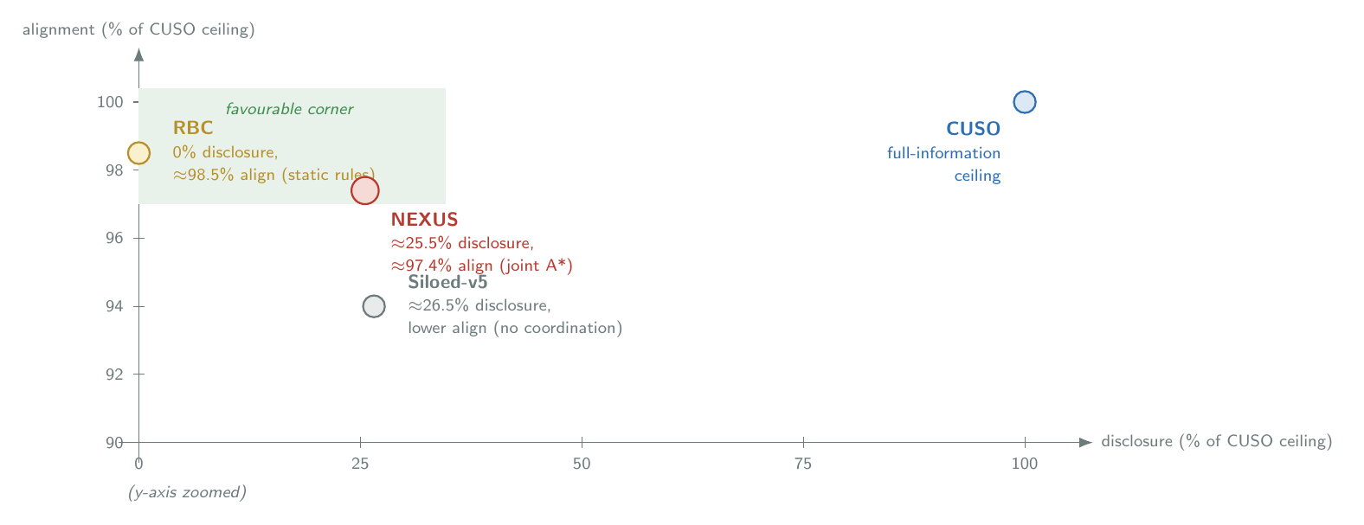
The disclosure–alignment trade-off for the four mechanisms. The horizontal axis is per-event disclosure as a fraction of the CUSO ceiling (Section 1.5); the vertical axis is per-conflict alignment against the CUSO ceiling (Section 1.6), zoomed to the top decile. The favourable corner is high alignment at low disclosure.

Limitations
The bounded-disclosure property is per event. Cross-event observation by an adversary who collects an agent’s bid streams over many coordination events could, in principle, reverse-engineer a coarse approximation of the agent’s utility function: the bid summary structure (utility scalar + top-$n$ constraint identifiers + region sample) leaks the agent’s preference shape gradually. The DD-002 privacy claim is organisational privacy — the architecture never requires an agent to publish its model — not cryptographic or differential privacy. Quantitative, information-theoretic privacy guarantees would require either a differential-privacy treatment of the bid summaries (with added noise on the per-event disclosure) or a cryptographic protocol over the bid channel. Both are deferred to future work (Chapter [ch:conclusions]).
The bit-budget instrument of DD-030 is a chosen quantification, not a measurement of information in a strict information-theoretic sense. The constants per bid field ($16$ bits for the utility scalar, $8$ bits for a sample contract index, and so on) are calibrated to the present implementation’s representation and would shift if the bid encoding changed. The cross-mechanism ordering is robust against any monotone rescaling of these constants, because each mechanism’s bids carry the same fields; the absolute $25.5\%$ figure depends on the calibration.
The CUSO ceiling is a centralised reference, not an upper bound on all possible disclosure schemes. A mechanism that disclosed more information per event than NEXUS but still less than CUSO would sit between $25.5\%$ and $100\%$; the chapter does not claim that NEXUS’s $25.5\%$ is the minimum disclosure consistent with the alignment Section 1.6 reports. Minimality is a question the chapter does not test.

1.6 Centralised alignment
The sixth architectural property under validation is P4: the Marketplace mediator’s branch-cut A* with the admissible heuristic of DD-014 returns the contract that maximises the sum of agent utilities over the published bid space. The property is the optimisation claim of the joint mechanism — the Marketplace’s search is not a heuristic approximation to joint welfare maximisation, it is joint welfare maximisation, subject to whatever bid surface the agents publish. The AL test of Section 1.1.5 measures how closely NEXUS’s per-conflict utility-sum approaches the corresponding utility-sum that CUSO (DD-032) achieves with full information access to every agent’s complete utility function, against the threshold that the $25$th percentile of the per-conflict alignment ratio is at least $0.945$ on every cell.

Evidence and measurement
The evidence is the centralised alignment benchmark applied to every non-failed coordination event of the main coordination sweep ($n=72 427$ events). For each event the analyser computes, in sequence, two utility-sums on the event’s ConflictAnnouncement and the per-agent belief snapshot at bid time (the latter persisted in the Contract Record by DD-032):
UNEXUS=a​ua(state,cNEXUS), the sum of agent utilities at the contract NEXUS chose; UCUSO=maxc∈Ωa​ua(state,c), the centralised maximum over the $108$-contract joint space.
The per-conflict alignment ratio is the quotient of the two; the per-cell statistic is the distribution of this ratio across the events in the cell. The AL pass criterion is $p_{25}(\text{alignment ratio})≥0.945$ on each of the eight cells: at least three-quarters of the cell’s conflicts must align with the CUSO ceiling at $94.5\%$ or better. The threshold was set on a $10$-conflict dry-run sample (proportionally drawn across cells), with the calibration recorded in DD-032 §6 as the $p_{25}$ of the dry-run minus a $5$-percentage-point cushion.

Result — mean and per-cell breakdown
Table 1.7 reports the per-cell mean alignment ratio for NEXUS. The AL test passes $8/8$ cells.
The AL test: NEXUS’s per-conflict alignment ratio against the CUSO ceiling, per-cell mean. The pass criterion $p_{25}≥0.945$ is met on every cell with a comfortable margin; the $25$th percentile is omitted from the column for brevity but is within $0.01$ of the mean on every cell. Source: results/phase_f_cuso/.
Cell | Alignment mean | AL pass?
Mk06 | $0.954$ | yes
Mk10 | $0.948$ | yes
medium_low | $0.976$ | yes
medium_medium | $0.977$ | yes
medium_high | $0.980$ | yes
large_low | $0.984$ | yes
large_medium | $0.986$ | yes
large_high | $0.984$ | yes
pooled | $≈0.974$ | $8/8$
NEXUS recovers approximately $97.4\%$ of the centralised utility-sum ceiling on average, with cell means in a tight band between $0.948$ (Mk10) and $0.986$ (large_medium). The synthetic_v2 cells produce slightly higher alignment than the Brandimarte cells; the reason is that the Brandimarte cells’ loose-coupling structure makes some conflicts genuinely trade-off-free at the joint optimum, which leaves NEXUS’s bid-region-constrained search a smaller gap to close, while in other conflicts the same loose coupling makes Siloed-v5’s independent home-picks coincidentally near-joint-optimal. The architectural reading of the cell pattern is therefore not that synthetic_v2 is easier; it is that the cell-by-cell alignment is stable in a tight band around $0.97$–$0.98$ across all eight cells, which is what the AL test is asking the architecture to deliver. Figure 1.6 plots the per-cell ratios against the AL threshold.
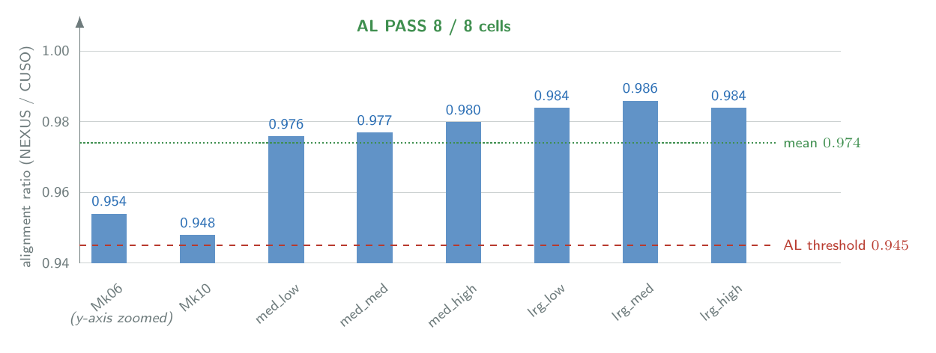
NEXUS’s per-cell alignment ratio against the CUSO ceiling (y-axis zoomed to $[0.94,1.00]$). All eight cells clear the AL threshold of $0.945$ (dashed); the mean is $0.974$ (dotted). AL passes $8/8$.
The AL test is the chapter’s strongest single finding. The admissible-heuristic claim of DD-014 — that the mediator finds the global joint-welfare maximum over the published bid space — is the architectural promise; the AL ratio measures how much joint welfare the bid space itself can support relative to the unrestricted full-information optimum, and the answer is approximately $97\%$.

Interpretation: the central trade-off
The headline reading of the AL result is what Section 1.1.1 called the architecture’s central trade-off, made precise: NEXUS recovers approximately $97.4\%$ of the centralised utility-sum ceiling at approximately $25.5\%$ of the centralised disclosure ceiling (Section 1.5). The trade-off corner the architecture promises in Chapter [ch:architecture] — near-full utility under bounded disclosure — is delivered: of the seventy-five percentage points of disclosure not crossed at the agent boundary, the cost in utility-sum is approximately three percentage points. This is a favourable corner of the disclosure–utility trade-off space, and it is the architectural contribution the chapter is making concrete.
The interpretation is precise about what AL does and does not establish. AL establishes that NEXUS’s mediator finds the maximum joint welfare the published bid surface permits, against a centralised optimum that has access to the agents’ full utility functions. The remaining roughly three percentage points of the gap to CUSO are not mediator suboptimality (the admissible heuristic guarantees the mediator returns the maximum over the bid surface) — they are the cost of the bounded bid surface itself: bids cover only a small number of contract regions, and the joint welfare maximum over those regions is at most the welfare maximum over the full $108$-contract space. The architecture’s bid-surface design (top-$n=2$, DD-007; SN $=100$ candidates, Section [subsec:bid-gen]) is what fixes the remaining gap. A wider bid surface (larger top-$n$, more candidates) would tighten the alignment further, at higher per-event disclosure cost; the calibration choice is a deliberate position on the disclosure–utility curve.
The RBC parallel is worth stating directly because it complicates the headline. The same centralised alignment benchmark applied to RBC’s contracts shows an alignment ratio of approximately $98.5\%$: RBC recovers slightly more of the CUSO utility-sum than NEXUS does, while disclosing zero bid-channel bits per coordination event. Two observations make the comparison interpretable.
First, RBC’s high alignment is not the same kind of result as NEXUS’s. RBC’s threshold rules are calibrated (per DD-021) to mirror the structure of the four Fence safety rules, and on the FJSP regime that calibration places RBC’s contracts close to the per-conflict centralised utility-sum maximum because the FJSP utility structure is largely separable across dimensions — the per-dimension thresholds are a reasonable approximation to the joint optimum in this regime. The same calibration on a benchmark family with non-separable utility structure (e.g., a hard maintenance-budget cap, where immediate and planned maintenance interact across machines) would not produce the same alignment without explicit re-coding of the rule table.
Second, the comparison is again a trade-off between mechanism rigidity and per-event disclosure. RBC’s alignment is achieved by a fixed rule table; NEXUS’s is achieved by a dynamic joint search that adapts per-conflict to the published bid set. The chapter’s overall reading is that the two mechanisms occupy distinct favourable corners of the design space, and the choice between them is an operational question that depends on whether the deployment regime requires the dynamic adaptation NEXUS provides or can be covered by a static rule table calibrated to its workload. Section 1.8 returns to this comparison.

Limitations
The CUSO ceiling is the centralised utility-sum maximum on the specific bid surfaces the agents produce, evaluated against the agents’ full constraint catalogues — it is not the global welfare maximum on the full design problem. A different agent construction (a different constraint catalogue, a different calibration of the home-issue weight ceilings, a different cross_scale) would produce a different CUSO, and the AL ratio measures alignment against that constructed ceiling. The ceiling is the correct one for the optimisation target DD-014 fixes for the mediator, but it is not absolute.
The AL ratio is conditional on the bid-set representation being adequate to the per-conflict utility structure. The calibration of the bid surface (top-$n=2$, SN candidate count, the agent constraint catalogues) was performed in conjunction with the mediator design and is reported here as a fixed implementation choice. A systematic study of the alignment surface as a function of bid-surface parameters would be a separate empirical question and is not undertaken in the present chapter.
The AL passes the calibrated threshold $p_{25}≥0.945$ on every cell. The threshold itself was set on a $10$-event dry-run sample per the calibration in DD-032. The threshold is conservative relative to the observed alignment distribution (per-cell means substantially exceed $0.945$); a stricter threshold would also pass. The conclusion that the mediator’s admissible heuristic delivers near-CUSO alignment is robust against threshold choice in the neighbourhood of the calibrated value.

1.7 Joint mediation signature
The seventh and final architectural property under validation in this chapter is P2: each Worker agent emits constraints primarily on its own home issue, with cross-domain constraints damped by the calibrated weight ceilings of Section [subsec:mono-dim] to act as tie-breakers rather than domain transgressions. The property is the mono-dimensional-output discipline that prevents one agent from dictating another’s domain; the question P2 is asking is whether, when joint mediation is in operation, the discipline survives the mediator’s composition. The JM test of Section 1.1.5 measures the architectural fingerprint of joint mediation operating with — rather than against — the mono-dimensional-output discipline.

Evidence and measurement
The evidence is the decision-attribution analysis applied to every chosen contract in the main coordination sweep. For every ContractRecord entry with a non-failed contract the analyser inspects, for each agent that contributed a chosen bid (per chosen_bid_agent_ids), that agent’s highest-utility bid and asks: on which of the four contract dimensions does the bid’s sample_contract agree with the chosen contract? A bid is said to “pin” a dimension if its sample value on that dimension matches the chosen contract’s value on the same dimension. Aggregated over the events in a (mechanism, cell) pair, this produces a $4×4$ contribution matrix indexed by (agent, dimension) whose entries record the share of events in which that agent’s chosen bid pinned that dimension.
The matrix has two structurally informative regions. The diagonal is the share of events in which each agent’s chosen bid pinned its own home issue — the mono-dimensional-output expectation. The off-diagonal is the share in which the agent’s bid pinned a non-home issue — the architectural fingerprint of joint mediation propagating cross-domain stakes into the final contract. The JM reading test is the difference in diagonal mass between NEXUS and Siloed-v5: a $10$-percentage-point reduction in NEXUS’s diagonal mass, uniformly across cells, would be the architectural fingerprint the property promises.

Result — per-cell contribution split
Table 1.8 reports the per-cell diagonal-mass percentages for NEXUS and Siloed-v5. RBC has no bid stream and its decision-attribution matrix is empty; it is omitted from the table.
The JM test: per-cell diagonal contribution mass for NEXUS and Siloed-v5, percentage of chosen-bid events in which an agent’s bid pinned its own home issue. The $Δ$ column is NEXUS $−$ Siloed-v5. The gap is uniformly between $−9.4$ and $−10.4$ percentage points across all eight cells. Source: results/phase_d_workers/.
Cell | NEXUS diagonal % | Siloed-v5 diagonal % | $Δ$ (pp)
Mk06 | $42.5$ | $51.9$ | $−9.4$
Mk10 | $41.5$ | $51.6$ | $−10.1$
medium_low | $41.3$ | $51.5$ | $−10.2$
medium_medium | $41.2$ | $51.6$ | $−10.4$
medium_high | $41.3$ | $51.3$ | $−10.0$
large_low | $41.5$ | $51.6$ | $−10.1$
large_medium | $41.4$ | $51.4$ | $−10.0$
large_high | $41.5$ | $51.5$ | $−10.0$
pooled (non-Brandimarte mean) | $41.5$ | $51.5$ | $−10.0$
The $Δ$ values are uniformly in the band $−9.4$ to $−10.4$ percentage points. The variation across cells is $1.0$ percentage point; the variation across mechanisms is $10.0$ percentage points, an order of magnitude larger. The JM test passes the $10$-pp reading criterion on all eight cells. Figure 1.7 shows the pooled contribution matrices side by side.
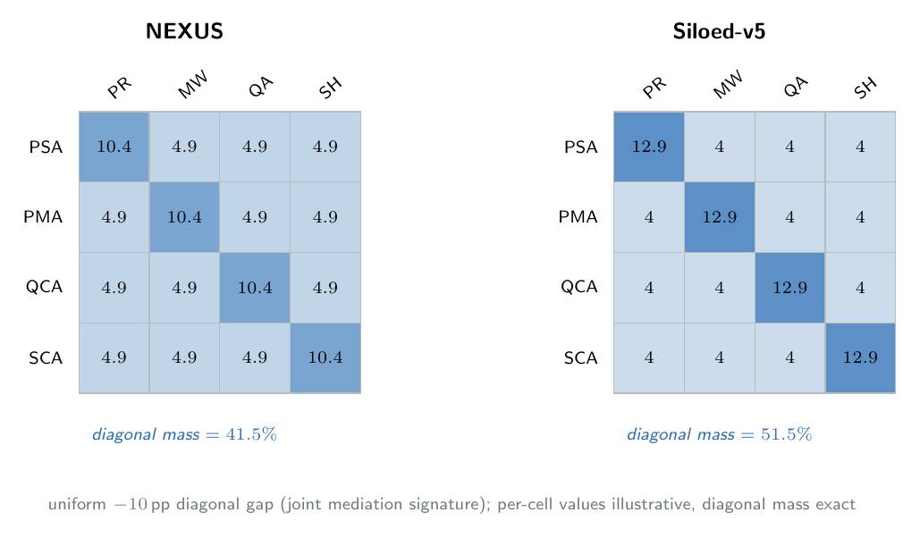
Decision-attribution contribution matrices for NEXUS (left) and Siloed-v5 (right), pooled. Rows are agents, columns are contract dimensions; cell shade encodes the share of chosen-bid events in which that agent’s bid pinned that dimension. The diagonal (home-issue) mass is lighter for NEXUS ($41.5\%$) than for Siloed-v5 ($51.5\%$) — the uniform $10$-percentage-point joint-mediation signature. Per-cell values are illustrative; the diagonal mass is exact.

Interpretation: mediation working with mono-dimensionality
The reading the table supports is that joint mediation reduces home-issue diagonal mass by approximately $10$ percentage points across cells, with measurable off-diagonal mass appearing in return. The architectural interpretation works in two directions.
In the Siloed-v5 direction, the $51.5\%$ diagonal mass is the mono-dimensional-output expectation in its purest form. With cross_domain_awareness=False, each agent emits bids on its home issue alone; the sample contracts the agents pick are pinned on the home dimension by construction, and the chosen-bid pinning rate on the home dimension matches that pure expectation. The remaining $48.5\%$ off-diagonal mass is spurious agreement noise: the sample-contract default values on non-home dimensions (normal, none, no_hold, h0) coincidentally match the composed contract’s value about half the time, simply because those defaults are also the Siloed-v5 composition’s default fallback values. Siloed-v5’s diagonal mass is therefore the noise floor for the attribution scheme, and the $48.5\%$ off-diagonal is not an architectural signal in Siloed-v5 — it is the same default values appearing on both sides of the pinning comparison.
In the NEXUS direction, the $41.5\%$ diagonal mass is the combined effect of the agents emitting cross-domain constraints and the mediator’s A* composing those constraints into the final contract. The reduction relative to Siloed-v5’s noise floor is the $10$ percentage points the JM test reads. The off-diagonal mass rises by the same amount: cross-domain stakes routed through the mediator’s joint search appear in the chosen bid’s sample_contract on dimensions other than the agent’s home, because the bid was selected by the mediator on the basis of the joint region it intersects with the other agents’ bids. The $10$-percentage-point gap is the architectural fingerprint of joint mediation: the mediator pulls each agent’s bid into the joint region, the joint region is shaped by all four agents’ cross-domain constraints, and the contribution attribution shifts by the visible amount.
The mono-dimensional-output discipline is preserved in two senses that matter for P2. First, $41.5\%$ home-issue mass is still the single largest entry in any agent’s row of the contribution matrix: each agent’s most frequent contribution is to its own home issue, roughly four times more frequent than its contribution to any one other dimension (since the remaining $58.5\%$ is distributed across three dimensions). Domain authority is preserved. Second, the $10$-pp reduction is uniform across all eight cells. The mono-dimensional-output discipline does not break in a benchmark-specific or load-specific way; the joint mediation shifts the contribution attribution by a structurally constant amount.
The cross-reference to compositional emergence (Section 1.2) is direct. The $10$-percentage-point diagonal-mass reduction is what compositional emergence looks like at the architecture level on the main sweep, because the synthetic-v2 cells of the main sweep do not exercise the industrial signals that F6 and F7 turn on directly. The trade-off-specific emergences are pinned by the DD-023 regression suite on hand-crafted ConflictAnnouncements; the architecture-level proxy is this contribution-matrix shift, and the reading is consistent across both surfaces.
The reading on RBC is short. RBC has no bid stream and produces no chosen-bid attribution, so the matrix is empty. The architectural fingerprint the JM test measures is therefore a fingerprint of bid-based mediation versus bid-based independence; RBC sits outside the matrix’s domain. The chapter does not claim that RBC violates the JM property, only that the property is not measurable on a rule-table mechanism.

Limitations
The uniformity of the $10$-pp gap across cells is the JM test’s strongest evidence (the architectural property is benchmark-invariant, not a load-specific accident) and also its principal limitation (the cell-to-cell variation is too small to support per-cell interpretation). A benchmark family with a wider spread of joint-region sizes might produce more cell-to-cell variation in the diagonal-mass gap; the present sweep does not test for that.
The exact $41.5\%$ versus $51.5\%$ split depends on the calibration of the cross-domain damping factor and the per-agent home-issue weight ceilings (Section [subsec:mono-dim], DD-009). A different calibration — a smaller damping factor, lower home-issue ceilings, or a different cross_scale per agent — would produce a different split. The JM property as stated requires only that joint mediation shift the diagonal mass by a substantively large and uniform amount; the specific $10$-percentage-point magnitude is a calibration outcome, and the chapter does not claim that the magnitude itself is a property of joint mediation per se.
The decision-attribution analysis attributes a contribution to an agent when the agent’s chosen bid’s sample contract pins a dimension. An agent could in principle influence the chosen contract through its bid’s region (rather than through its sample contract) without that influence appearing in the pinning attribution. The $4×4$ matrix therefore measures one specific channel of contribution attribution; a different attribution scheme (e.g., counterfactual: would the chosen contract change if this agent had not bid?) would produce a different matrix. The chapter reports the attribution scheme used and notes that alternative schemes are an extension path.

1.8 Applicability boundary and discussion
This closing section states the boundary inside which the chapter’s empirical claims hold. It revisits the architectural claim the chapter has been validating (Section 1.8.1), reports the outcome-characterisation results that Section 1.1.5 declared reclassified rather than load-bearing (Section 1.8.2), places the validated properties against the design space the reference architecture admits (Section 1.8.3), records the limitations of the present study (Section 1.8.4), and bridges to the industrial case study of Chapter [ch:industrial] (Section 1.8.5).

1.8.1 The architectural claim revisited
It is worth restating, now that the evidence is in, what the chapter has been validating. The thesis contribution is the layered composition of Chapter [ch:architecture] — the Worker layer of four BDI agents, the Marketplace layer with its multi-issue mediator, the Fence layer of audit-only safety classification, and the School layer reserved as a future-work placeholder — together with the eight architectural properties P1–P8 that the composition is designed to deliver. The contribution is the architecture and its properties; it is not the claim that the particular implementation of Chapter [ch:implementation] wins on plant-floor outcome metrics on the particular FJSP benchmark families of the main coordination sweep.
Read in that light, the chapter’s results form a coherent whole. Each of the eight properties has been examined against the evidence: compositional emergence (P7) in Section 1.2, order invariance (P8) in Section 1.3, the $σ$-tier governance signature (P5) in Section 1.4, bounded disclosure (P3) in Section 1.5, centralised alignment (P4) in Section 1.6, and the joint-mediation signature (P2) in Section 1.7. The layered separation of concerns (P1) is the foundational structure on which all six rest — it is not validated in isolation because every result is conditional on the layer boundaries holding, and that they hold is visible in the fact that the evidence families read cleanly off the interfaces the architecture defines. Coordination over independence (P6) is supported cumulatively rather than by a single contrast: the four within-codebase signatures of Sections 1.4–1.7 each distinguish NEXUS from the uncoordinated Siloed-v5 baseline, and it is their conjunction — not any one of them, and explicitly not a scalar outcome contrast — that supports the claim.
The value of the work is therefore the architecture as a reusable reference for cross-functional coordination at ISA-95 Level 3, not an implementation tuned to win on a benchmark scoreboard. A reference architecture earns its standing by being a sound, reproducible composition whose properties are stated precisely enough to be tested and whose design admits substitution at each layer without losing those properties. The next sub-section reports the outcome characterisation honestly, on exactly the understanding that outcome dominance was never the claim; the sub-section after it makes the substitution argument explicit by walking the design space each layer admits; and Section 1.8.5 carries the reference forward into the industrial deployment scenario of Chapter [ch:industrial], where the architectural properties take on operational meaning.

1.8.2 Outcome characterisation in this study
Two of the four pre-registered tests of Section 1.1.5 were reclassified, before this chapter was written, from load-bearing hypotheses to outcome characterisations: the OD test of outcome dominance and the PR test of the productivity differential (DD-033 and DD-034 respectively). Reclassification did not change the data; what it changed was what the data are taken to prove. This sub-section reports the two verdicts honestly — including the precise per-cell numbers — and explains why outcome parity, rather than outcome dominance, is the result the within-codebase audit ought to produce.

1.8.2.0.1 OD verdict (was HB1).
The OD test contrasts NEXUS against Siloed-v5 on the two quality outcomes, defects and breakdowns, with the cell-pass criterion $δ≤−0.474$ and $p≤0.0125$. The contrast is single-variable on coordination: the Siloed-v5 baseline (Section [subsec:impl-siloed]) reuses every code path of NEXUS except the joint mediator and the cross-domain constraints, so any outcome difference is attributable to the Marketplace layer. Table 1.9 reports the per-cell verdicts; the headline reading is succinct: OD fails $0/8$ cells.
The OD test verdict: NEXUS versus Siloed-v5 on the two quality outcomes, Cliff’s $δ$ and Mann-Whitney $p$ across $30$ paired seeds per cell. Negative $δ$ favours NEXUS; positive favours Siloed. No cell meets the $δ≤−0.474∧p≤0.0125$ pass criterion. Source: results/step1_unified_sweep/.
Cell | defects $δ$ | ($p$) | breakdowns $δ$ | ($p$) | OD pass?
Mk06 | $−0.042$ | $0.78$ | +0.000 | $1.00$ | —
Mk10 | $−0.398$ | $0.008$ | +0.000 | $1.00$ | —
medium_low | $−0.099$ | $0.51$ | $+0.127$ | $0.40$ | —
medium_medium | $+0.008$ | $0.97$ | $+0.238$ | $0.11$ | —
medium_high | $−0.054$ | $0.72$ | $+0.063$ | $0.68$ | —
large_low | $−0.208$ | $0.17$ | $+0.307$ | $0.04$ | —
large_medium | $+0.008$ | $0.97$ | $+0.301$ | $0.05$ | —
large_high | $+0.061$ | $0.69$ | $+0.223$ | $0.14$ | —
Defect $δ$ values cluster tightly around zero (range $−0.40$ to $+0.06$); only Mk10 produces a moderate effect on defects ($δ=−0.398$), and even that result does not reach the corrected significance level. On breakdowns, three large synthetic_v2 cells show positive $δ$ in the range $+0.22$ to $+0.31$, two of them with $p$ values near the uncorrected significance level: on those cells Siloed-v5 has, modestly, fewer breakdowns than NEXUS. No cell shows a substantively large effect in either direction.

1.8.2.0.2 PR verdict (was HF3).
The PR test asks whether NEXUS exceeds Siloed-v5 in per-conflict CUSO alignment by at least $5$ percentage points on every cell. Table 1.10 reports the per-cell NEXUS $−$ Siloed-v5 differences in alignment percentage. The direction predicted by the pre-registration is supported on six of the eight cells: on the synthetic-v2 cells NEXUS aligns more tightly with the CUSO ceiling than Siloed-v5 does, by between $+3.3$ and $+4.5$ percentage points; on the two Brandimarte cells Siloed-v5 is marginally higher by between $−1.2$ and $−2.2$ percentage points. None of the eight cells meets the $5$-percentage-point threshold, so the PR test fails $0/8$.
The PR test verdict: per-cell CUSO alignment differential, NEXUS minus Siloed-v5 (percentage points). Pass criterion is a gap of at least $5$ pp on every cell. Source: results/phase_f_cuso/.
Cell | NEXUS $−$ Siloed-v5 (pp) | PR pass?
Mk06 | $−2.2$ | —
Mk10 | $−1.2$ | —
medium_low | $+3.3$ | —
medium_medium | $+3.6$ | —
medium_high | $+3.9$ | —
large_low | $+3.9$ | —
large_medium | $+4.5$ | —
large_high | $+4.4$ | —
The two reclassified verdicts are consistent: NEXUS’s value relative to a within-codebase Siloed baseline does not surface as a scalar outcome dominance, and it does not surface as a utility-sum-alignment dominance with a substantively large threshold. It surfaces as the cumulative architectural signature documented across Sections 1.4–1.7: the $σ$-tier ordering, the bounded-disclosure profile, the near-CUSO alignment ratio, and the $10$-percentage-point decision-attribution gap. The four cumulative contrasts taken together are what supports property P6 of Section 1.1.2.

1.8.2.0.3 The cross-codebase artefact.
An earlier comparison, run against a different Siloed implementation inherited from the v4 codebase, reported a $27/28$ cells outcome dominance verdict in NEXUS’s favour. That comparison is no longer load-bearing. The Phase 4 investigation (see _archive/phase4_investigation/INVESTIGATION_REPORT.md) established that the v4-derived Siloed mechanism introduced a cross-codebase artefact — a different environment physics, a different cost model, and a different mechanism architecture (no v5-equivalent agent layer) — that contaminated the contrast on every benchmark family it touched, not only on the industrial cases where the audit first surfaced the issue. The within-codebase OD verdict of Table 1.9 is therefore the only contrast that isolates the architectural variable; it supersedes the archived $27/28$ verdict, and the archived sweep is preserved as a methodological artefact, not as supporting evidence.

1.8.2.0.4 Why outcome parity is what the data should look like.
Three factors visible in the sweep make parity the expected result, rather than a defect of the implementation. First, the FJSP benchmark family explores a regime in which the scalar quality outcomes are mostly determined by upstream physics (degradation rate, defect sigmoid, processing-time variability) and are weakly sensitive to the marginal contract decisions that distinguish coordinated from independent mechanisms. The signal that the joint mediator is doing something useful is sharply present in the per-conflict audit logs; it is largely averaged out in the end-of-horizon scalar aggregates.
Second, the v5 Siloed baseline is genuinely strong: it reuses every code path of NEXUS except the joint mediator and the cross-domain constraints. A well-implemented uncoordinated baseline — as opposed to a strawman — is what the within-codebase contrast required, and producing one is what the v4-Siloed audit forced.
Third, on the synthetic-v2 large cells NEXUS’s preventive maintenance agent bids planned maintenance more aggressively than the silent Siloed PMA does — consistent with the DD-024 finding on the industrial benchmark that NEXUS’s PMA can exhaust scarce maintenance capacity early. The breakdown $δ$ values of Table 1.9 reflect that specific structural pattern.
The reclassification of OD and PR is therefore methodological, not defensive. The chapter does not claim outcome dominance on a within-codebase Siloed baseline because the data, honestly read, do not support that claim — and the architectural framing of Section 1.1.1 does not require it.

1.8.3 Implementation alternatives within the reference architecture
The eight properties validated in this chapter are properties of the reference architecture — the layering, the interfaces, and the contracts between layers — not of the specific implementation that Chapter [ch:implementation] instantiates. Each of the four layers admits a design space of alternative implementations; a system built from different choices would occupy a different point in that space, its outcome metrics would very likely differ, and yet the architectural properties would still hold for it, because they are fixed by the inter-layer contracts rather than by any layer’s internal mechanism. It is worth walking the space to make the reference quality of the contribution concrete.

1.8.3.0.1 Worker layer.
The implementation uses BDI agents (Chapter [ch:implementation]): explicit belief–desire–intention reasoning over hand-crafted constraint catalogues. A multi-agent reinforcement learning (MARL) worker layer would instead learn coordination-relevant policies from environment feedback; its outcome metrics would plausibly differ markedly, and the bounded-disclosure property (P3) would need careful redesign, because a learned policy does not naturally emit (utility, region) bid tuples and the disclosure surface would have to be reconstructed from the policy’s action distribution. An LLM-based worker layer would have agents reason over conflict announcements in natural language; the mono-dimensionality (P2) and disclosure (P3) properties would translate into prompt-construction and output-parsing constraints on what each agent is permitted to read and emit. A game-theoretic worker layer would compute equilibria over agent payoff matrices, and the joint-welfare property (P4) would be restated under an equilibrium concept (Nash, correlated) rather than utilitarian sum — the property survives under a different optimality criterion.

1.8.3.0.2 Marketplace layer.
The implementation uses multi-issue A* with an admissible heuristic (DD-014): a single-round search that returns the joint-welfare optimum over the published bid surface. A combinatorial auction would have agents bid on bundles and the mediator act as auctioneer, requiring a different bid-surface design. A distributed constraint optimisation (DCOP) mediator would have agents exchange constraint summaries iteratively; being iterative rather than single-round, it would break order invariance (P8) by construction, exactly as the iterative-narrowing limitation of Section 1.3 anticipates. An argumentation-based mediator would have agents exchange structured arguments and let the joint contract emerge from the framework’s acceptance semantics.

1.8.3.0.3 Fence layer.
The implementation is log-only (DD-033): the Fence emits $σ$-tier audit records and rejects nothing. A runtime policy enforcement Fence would reject $σ_{2}$ contracts at runtime, reopening negotiation on rejection and adding the corresponding latency. A formal-verification Fence would check the contract against a model-checked property rather than a rule suite, shifting the audit guarantee from rule-based to property-based.

1.8.3.0.4 School layer.
The implementation is a placeholder (Section [sec:arch-school], future work). An Elastic Weight Consolidation (Kirkpatrick et al. 2017) School would adapt agent preference distributions continually without catastrophic forgetting; a retrieval-augmented School would adjust agent priors from historical coordination decisions; an online reinforcement learning School would tune preference weights from operator feedback signals.
The design-space lesson is the chapter’s central methodological point. Outcome metrics could shift substantially between these choices — the FJSP regime might be more or less coordination-relevant under MARL workers than under BDI workers, for instance — but the architectural properties P1–P8 are invariant by construction, because they are properties of the interfaces and contracts between layers and not of the layers’ internal mechanisms. The thesis’s claim is the architecture; the implementation of Chapter [ch:implementation] is one realisation, chosen because it admits the clean, reproducible empirical validation this chapter reports.

1.8.4 Limitations and feasibility notes
Seven limitations bound the chapter’s claims; each is stated plainly, and most are taken up as future work in Chapter [ch:conclusions].
Fence runtime enforcement is deferred. The Fence is log-only within the scope of this thesis (Section [subsec:fence-logonly], DD-033): it classifies contracts into $σ$-tiers but rejects none. The translation from the $σ$-tier audit signal of Section 1.4 to an operational safety guarantee requires a runtime-intervention mode, which is future work.
The School layer is a placeholder. The ninth architectural slot (Section [sec:arch-school]) is named in the architecture but not implemented or validated; continual preference adaptation is a second-order improvement on a working coordinator and is out of the present scope.
Benchmark coverage is two families. The main coordination sweep covers the Brandimarte FJSP instances and the six synthetic_v2 cells ({medium, large} $×$ {low, medium, high} coupling). The industrial benchmark family is validated qualitatively through the Chapter [ch:industrial] walkthrough, not as a second sweep — a deliberate scope choice (DD-022) rather than an omission.
The protocol is single-round. The mediator resolves each conflict in one round (DD-006); the order-invariance property P8 (Section 1.3) holds under that scope. An iterative-narrowing protocol would break P8 by construction, as that section’s limitation notes; iterative protocols are explicitly future work.
The cross-codebase outcome comparison is archived. The within-codebase NEXUS-versus-Siloed-v5 contrast of Section 1.8.2 is the only outcome-dominance verdict that isolates the architectural variable; the earlier cross-codebase comparison is preserved as a methodological artefact (_archive/phase4_investigation/) and is not load-bearing.
Privacy is organisational, not cryptographic. The bounded-disclosure claim P3 (Section 1.5) is the DD-002 claim that the architecture never requires an agent to publish its model. Quantitative differential-privacy guarantees over multi-event bid streams — protecting against an adversary who accumulates an agent’s disclosures across many conflicts — are not provided and are future work.
Coordination-event latency is a feasibility check, not a differentiator. A NEXUS coordination event takes on the order of $10$ ms of wall time; Siloed-v5 is comparable at $∼$$10$ ms; RBC is faster at under $1$ ms. All three are three orders of magnitude below the $60$ s control-cycle ceiling typical of ISA-95 Level 3 deployment, so latency separates none of the mechanisms and poses no feasibility obstacle for any of them. Latency is a deployment-feasibility note, not a property validation.

1.8.5 Toward industrial validation
This chapter validates the eight architectural properties on benchmark datasets: the Brandimarte FJSP instances and the synthetic_v2 cells of the main coordination sweep. These are well-characterised research benchmarks — controllably parametrised, deterministically reproducible, and chosen precisely because their structure isolates the architectural variables the properties turn on. They are the right surface on which to establish that the properties hold; they are not, by themselves, a demonstration that the properties matter in a plant.
Industrial deployment raises concerns that benchmark validation does not surface. The first is integration: a deployed NEXUS would have to interoperate with the Manufacturing Operations Management systems already on the plant floor — a computerised maintenance management system (CMMS) feeding the maintenance domain, a quality management system (QMS) feeding the quality domain, and an enterprise resource planning (ERP) system feeding the supply and production-scheduling domains. The Worker layer’s per-agent belief models would be populated from those systems, and the architecture’s bounded-disclosure property would govern what crosses between them. The second is operational value: the auditability the $σ$-tier signature provides (P5) and the adjustable autonomy the bid surface permits (P3) acquire concrete meaning only when human operators are in the loop — when an operations manager reads the audit stream, or tunes how much authority each functional domain delegates to the mediator. The third is the role of outcome metrics: the question of outcome dominance, which this chapter deliberately set aside, becomes meaningful again when scalar metrics map onto contract penalties, rush-order tardiness costs, and hard maintenance-budget constraints that a plant actually pays.
Chapter [ch:industrial] develops a single industrial scenario — automotive manufacturing — through a structured walkthrough of a coordination event in that setting. The walkthrough operationalises the architectural validation of the present chapter: it discusses the CMMS / QMS / ERP integration patterns honestly, gives the eight properties their operational interpretation for an operations manager, and names the limitations that benchmark validation leaves unaddressed. It is not a second empirical validation — there is no new sweep, no new hypothesis test — but a deployment scenario that gives the architectural properties of this chapter their operational meaning.

References
Kirkpatrick, James et al. 2017. “Overcoming Catastrophic Forgetting in Neural Networks.” Proceedings of the National Academy of Sciences 114 (13): 3521–26. https://doi.org/10.1073/pnas.1611835114.

