Chapter 4: Implementation

1 Implementation

1.1 Overview
Chapter [ch:architecture] described NEXUS as a four-layer reference architecture — four BDI Worker agents, a multi-issue Marketplace mediator, a three-tier Fence audit layer, and a deferred School layer for continual adaptation — and laid out the information-flow and bounded-disclosure properties the composition is designed to deliver. This chapter turns from architecture to implementation: it documents the runnable software system that realises the architecture, names the design decisions taken in code, and gives the engineering substrate against which the empirical characterisation of Chapter [ch:results] is performed.
The chapter is deliberately narrow. It is not a literature review — those discussions belong in Chapter [ch:literature] — and it is not a defence of the architectural choices, which Chapter [ch:architecture] already covered. Its task is to show how the architecture is realised: which packages exist, what each one is responsible for, which implementation decisions are non-obvious and why, and what evidence exists that the implementation behaves as claimed. Where a decision is documented in the repository’s append-only design-decision ledger, the chapter cites it as DD-NNN; a reader who wants the full rationale can read the corresponding entry in DESIGN_DECISIONS.md.

1.1.1 Codebase organisation
The implementation is a single Python package, src/, of about five thousand lines and three thousand lines of automated tests. Its package layout maps one-to-one onto the four-layer decomposition of Chapter [ch:architecture]: each architectural layer occupies one top-level subpackage, and the shared data structures live in a fifth core/ package that no layer is allowed to bypass. Figure 1.1 shows the mapping.
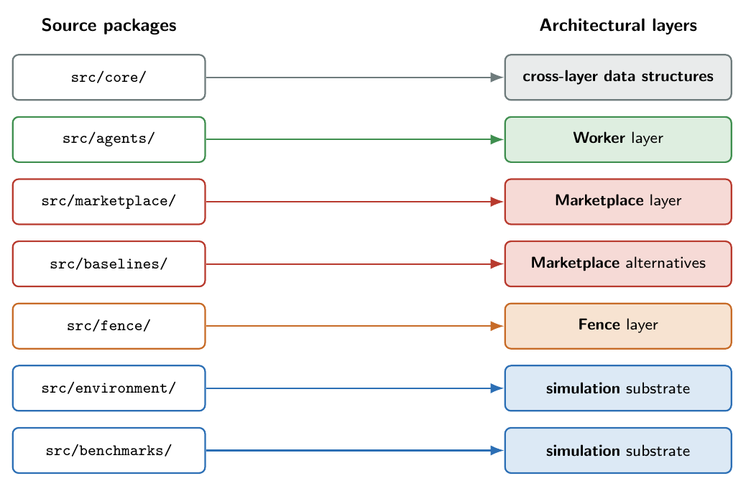
Mapping from NEXUS source packages to the four architectural layers of Chapter [ch:architecture]. Each layer is implemented by exactly one subpackage; the core/ package holds the data structures that cross layer boundaries; the environment/ package provides the discrete-event simulation against which the architecture is evaluated.
Table 1.1 records the package-to-layer mapping in text. The correspondence is not merely presentational: it is enforced by the import graph. The marketplace/ package imports agents.base.AgentV5 (the Worker abstract class) only as a type hint and never reaches into agent internals; the fence/ package imports only the audit-log data structures of marketplace.contract_record and never the mediator or the agents; the baselines/ package implements alternative mechanisms that are drop-in replacements for the Marketplace facade. This discipline makes the layer boundaries falsifiable: a layer that imported across the boundary would fail an architectural test (Section 1.8).
Source packages and the architectural layer each one realises.
Package | Layer | Responsibility
src/core/ | cross-layer | Composite contract, weighted constraint, bid summary (Ito 2007 §2 data structures).
src/agents/ | Worker | BDI agent base class plus four home agents (PSA, PMA, QCA, SCA); benchmark-specific agent subclasses.
src/marketplace/ | Marketplace | Marketplace facade (orchestrator), bid bus, mediator (branch-cut A*), contract record.
src/fence/ | Fence | Three-tier classifier, pre-declared safety rules, audit-record stream.
src/baselines/ | Marketplace (alternatives) | Siloed, Rule-Based Coordination, Sequential cascade, Contract Net, and the post-hoc CUSO centralised baseline.
src/environment/ | simulation substrate | Discrete-event plant model (SimPy); Weibull degradation, defect sigmoid, resource-capacity model.
src/benchmarks/ | simulation substrate | Brandimarte FJSP parser; synthetic-v1 and synthetic-v2 generators; industrial automotive generator (Chapter [ch:industrial]).

1.1.2 Dependencies
The runtime dependencies are deliberately minimal. numpy and simpy provide the numerical and discrete-event-simulation substrates; pytest drives the automated regression suite. Nothing else is on the runtime path. There is no machine-learning framework, no constraint-solver package, and no negotiation library: the mediator’s branch-cut A* (Section 1.3) and the agents’ constraint derivation are written from scratch against the data structures of core/. This is a deliberate decision and is recorded in DD-006: the Ito (Ito et al. 2007) protocol admits a clean direct implementation at the scale of the problem (four agents, a 108-contract joint space), and a hand-written implementation keeps the architectural claims of Chapter [ch:architecture] verifiable against the code without an opaque library in between.

1.1.3 Determinism and reproducibility
A NEXUS coordination event is deterministic given a fixed random-number-generator seed. The agent-side sampling that produces bids is keyed by a stable hash of (agent_id, conflict_id, seed) rather than by a process-dependent global RNG, which is how the implementation achieves cross-process reproducibility: the same experiment configuration on two different machines produces byte-identical audit logs. The implementation defaults to deterministic greedy search inside the bid-generation pipeline, having found in calibration that the simulated-annealing alternative makes no measurable difference at the scale of the joint contract space (DD-008). Determinism is the substrate on which simulation-model verification rests (Sargent 2013): reproducible runs make it possible to verify each component’s behaviour against expected outputs, which is what lets the test suite of Section 1.8 operate by byte-for-byte regression rather than by statistical inspection.
The remainder of the chapter walks through the layers in the order they participate in a coordination event: the Worker layer in Section 1.2; the Marketplace layer in Section 1.3; the Fence layer in Section 1.4; the alternative-mechanism baselines in Section 1.5; the benchmark instances in Section 1.6; the simulation framework in Section 1.7; and the testing strategy in Section 1.8.

1.2 The Worker Layer
The Worker layer is the implementation of the four BDI agents of Section [sec:arch-worker]. It lives in src/agents/ and is organised around a single abstract base class, AgentV5, that encapsulates the parts of the BDI deliberation pipeline that are identical for every agent — belief storage, the bid-generation protocol, the cross-domain-damping discipline — and leaves the parts that are specific to each agent — belief update and constraint derivation — as abstract methods.

1.2.1 The abstract agent
AgentV5 (in src/agents/base.py, about 450 lines) is the sole interface the Marketplace layer sees. It exposes a small public surface:
class AgentV5:
agent_id: str
HOME_ISSUE: int # 0..3; one per agent
cross_domain_awareness: bool = True # false for Siloed (DD-033)
def update_beliefs(self, obs): # specialised per agent
...
def derive_constraints(self, announcement): # specialised per agent
... # returns list[Constraint]
def propose_bids(self, announcement, # shared 4-step protocol
top_n: int = 2,
use_sa: bool = False,
**kwargs) -> list[Bid]:
...
def utility_for_contract(self, announcement, # used by CUSO (Sec. 4.5)
contract) -> float:
...
def record_contract(self, announcement, contract): # bookkeeping
...
The abstract methods are exactly update_beliefs and derive_constraints: every other behaviour is shared, which is the practical realisation of the architectural claim that the protocol is uniform across the four agents. A new agent — a fifth ISA-95 function, or a benchmark-specific specialisation (Section 1.6) — inherits from AgentV5, overrides the two abstract methods, and is interoperable with the Marketplace without further work.
Figure 1.2 shows the agent class hierarchy and the deliberation pipeline that turns a ConflictAnnouncement into a set of bids.
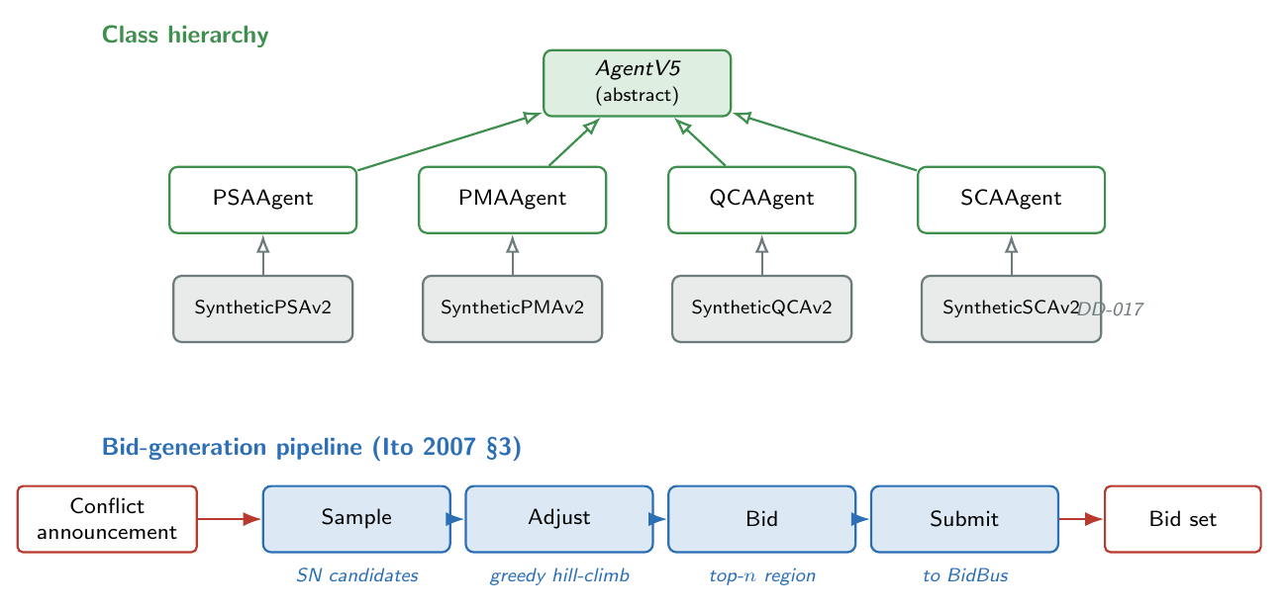
The Worker-layer class hierarchy and the bid-generation pipeline. The four home agents (PSA, PMA, QCA, SCA) specialise the abstract AgentV5 by overriding update_beliefs and derive_constraints; benchmark-specific subclasses (Section 1.6, DD-017) layer extra domain awareness on top.

1.2.2 Beliefs and desires
Each agent’s beliefs are stored in a per-agent Python dictionary that the abstract class neither inspects nor schemas: any agent can store any beliefs, and the abstract pipeline never reaches in. PMA stores machine-health histories and time since last service; QCA stores defect-rate tallies and severity tracking; SCA stores per-spare lead times; PSA stores per-machine deferral counters. update_beliefs is the method through which the environment delivers observations, and the per-agent implementation decides what to retain.
The agent’s desires are encoded in a small vector of calibrated weights that multiply the agent’s constraint weights at derivation time. The weights inherit the v4 calibration verbatim where applicable; the threshold parameters pm_threshold and shortage_lead_threshold were recalibrated in DD-010 once the sensitivity sweep showed that the v4 defaults left PMA and SCA effectively dormant on the Brandimarte benchmark. The recalibrated values — pm_threshold $=0.55$ and shortage_lead_threshold $=24 \text{h}$ — bring the activation rate of each agent into the regime where the multi-issue mechanism is actually exercised.

1.2.3 Constraints and bids
The data structures of the Worker layer are exactly the Ito (Ito et al. 2007) §2 primitives, lifted into Python dataclasses in src/core/.
A Constraint is a weighted predicate over the joint contract space. It is uniquely determined by a tuple of issue indices $(i_{1},…,i_{k})$ with $k∈\{1,2\}$ — one for unary home-issue constraints, two for cross-domain constraints — a frozenset of allowed value combinations on those issues, and a non-negative weight. At construction the constraint’s region — the set of contract indices that satisfy it — is pre-computed once and cached as a frozen set, so the mediator’s region-intersection search is a sequence of cheap set and’s rather than per-contract predicate evaluations.
@dataclass(frozen=True)
class Constraint:
name: str # human-readable, used in audit
issues: Tuple[int, ...] # unary (1) or binary (2)
allowed: FrozenSet[Tuple[int, ...]] # allowed projections on `issues`
weight: float # non-negative
region: FrozenSet[int] # pre-computed at construction
def is_satisfied(self, contract_indices) -> bool:
proj = tuple(contract_indices[i] for i in self.issues)
return proj in self.allowed
A Bid is the public, privacy-bearing summary of an agent’s position on the current conflict. It is the tuple expected by the mediator: a scalar utility, the top-$n$ constraints whose intersection defines the bid region, and a sample contract inside the region from which the utility was measured.
@dataclass(frozen=True)
class Bid:
agent_id: str
utility: float # sum of weights of ALL
# satisfied constraints
constraint_set: Tuple[Constraint, ...] # top-n by weight
sample_contract: Tuple[int, ...]
top_n_used: int
def region(self) -> FrozenSet[int]:
if not self.constraint_set: return frozenset(range(NUM_CONTRACTS))
r = self.constraint_set[0].region
for c in self.constraint_set[1:]:
r = r & c.region
return r
The asymmetry between the bid utility (sum of all satisfied constraint weights) and the bid region (intersection of the top-$n$ constraint regions) is the soft-bid relaxation of Ito (Ito et al. 2007) §3 Step 3. Its calibration is documented in DD-007: top_n is set to $2$ in the default AgentV5 configuration, which captures the single most important inter-issue trade-off each agent holds while keeping the empirical negotiation-failure rate to about one per cent on the Brandimarte benchmark family. The rationale and the failure-rate-vs-expressiveness curve are reported in Chapter [ch:results]; the implementation treats top_n as a parameter the calibration sweep can override via propose_kwargs.

1.2.4 Bid generation
AgentV5.propose_bids implements the four-step protocol of Ito (Ito et al. 2007) §3, shared by every agent:
- Sample. Draw SN candidate contracts from the joint contract space; the agent-side RNG is seeded with a stable hash of (agent_id, conflict_id, global_seed) so the samples are reproducible across processes.
- Adjust. For each sampled contract, perform a local search. The implementation defaults to greedy hill-climbing (use_sa=False, DD-008); a simulated-annealing variant with a calibrated temperature schedule is retained as a selectable option for sensitivity work but is not the default.
- Bid. For each adjusted contract whose utility exceeds a reservation threshold, build a Bid: utility is the sum over all satisfied constraint weights; region is the intersection of the top-$n$ constraints; sample_contract records the contract at which utility was measured.
- Submit. The agent returns the bid list to the Marketplace, which publishes them to the BidBus. Bids never leave the process before this step — the constraint set that produced them is discarded once the bids are formed.

1.2.5 Domain authority via home-issue weight ceilings
The mono-dimensional authority discipline of Section [subsec:mono-dim] is implemented by giving each agent a ceiling on the weights of its home-issue constraints and damping the weights of its cross-domain constraints by a fixed factor. The calibrated ceilings are recorded in Table [tab:ceilings] of Chapter [ch:architecture] and are repeated in code as named constants in src/agents/agent.py. The cross-domain damping factor is the same scalar applied across all four agents (about $0.20$ on the v4-inherited calibration, $0.30$ for PSA’s cross-domain stake on quality and shortage events).
The empirical consequence — that the cross-domain damping factor is a low-sensitivity parameter on the benchmark family, because the order-of-magnitude separation between home-issue and damped-cross-issue weights makes it a tie-breaker rather than a decision driver — is documented in DD-009. In code the discipline is expressed by keeping the per-agent home-issue weight ceiling and the cross-domain damper as named constants, never inline; calibration sweeps then override them via AgentV5 subclass attributes.
The discipline interacts with the cross_domain_awareness flag on AgentV5. By default the flag is True and the agent emits both home and (damped) cross-domain constraints; setting it to False causes derive_constraints to drop every cross-domain constraint at emission, leaving the agent strictly home-domain. This flag is the implementation seam for the Siloed baseline of Section 1.5 (DD-033); inside NEXUS proper the flag is True for all four agents.

1.2.6 The four home agents
Each home agent is a thin subclass of AgentV5 that overrides update_beliefs and derive_constraints. The implementations live in src/agents/{psa, pma, qca, sca}.py; each is about 200–300 lines and its core is a constraint-derivation function that takes a ConflictAnnouncement and the agent’s beliefs and returns a list of Constraint instances. The constraint catalogue per agent is documented in detail in the repository’s docs/AGENT_CONSTRAINT_DERIVATION.md note; this chapter cites it rather than reproducing it. The four catalogues share three disciplines:
- Always-on baselines. Each agent always emits at least one constraint, so no agent ever submits an empty bid set on a conflict it is asked to participate in. An empty bid set is a negotiation failure (Section 1.3); the always-on baselines turn that into a measurable rate rather than a silent gap.
- Conditional gates. A constraint is emitted only when the announcement triggers its gate (for example, PMA’s force_IMMEDIATE_when_critical fires only when machine_health crosses pm_threshold). The catalogue is therefore announcement-dependent: different conflicts elicit different constraint sets from the same agent.
- Binary cross-domain constraints. Each agent emits at least one binary constraint over its home issue and a second issue — for example, PSA’s psa_slow_when_breakdown_imminent couples production_rate and maint_window. These binaries are what makes the negotiation genuinely multi-issue rather than four parallel single-issue negotiations.
A new agent — whether a fifth ISA-95 function or a benchmark-specific subclass — inherits these disciplines for free by inheriting from AgentV5.

1.3 The Marketplace Layer
The Marketplace layer is the implementation of the Mediator, BidBus and ContractRecord of Section [sec:arch-marketplace]. It lives in src/marketplace/ and is the only layer with a non-trivial algorithmic core: every coordination event runs an A* search over the combinatorial space of bid combinations.

1.3.1 The Marketplace facade
Marketplace (in src/marketplace/marketplace.py) is the env-facing surface. It is a single Python class whose entry point Marketplace.__call__(conflict, env) returns either a composite Contract or the sentinel string NEGOTIATION_FAILED. The environment swaps mechanisms by calling env.set_mechanism(...); every alternative mechanism in src/baselines/ exposes the same call signature, so the mechanism choice is a single line in the experiment driver (Section 1.7).
Internally, each call runs the four phases of the protocol:
- Announce. Build a ConflictAnnouncement from the conflict event and the current environment state; the announcement carries the conflict type, the machine identifier, the timestamp, and the small set of shared plant signals each agent is permitted to read (machine_health, defect_rate, spare_lead_time). No agent’s private beliefs are read.
- Bid. For each of the four agents, call agent.propose_bids(announcement, **kwargs); collect the resulting bid lists into a list-of-lists indexed by agent.
- Mediate. Pass the bid lists to the Mediator together with a list of per-agent utility callbacks (closures over the agent’s constraint set, used by the mediator as in-region tie-breakers).
- Record. Append a ContractRecordEntry to the audit log: the announcement, every published bid, the chosen bids, the resulting contract (or the failure reason), and per-event counters from the mediator search. The Marketplace also stashes the bid lists and utility functions for an optional remediation call (Section 1.3.3).
Per DD-005, the Mediator is a logical component inside the Marketplace layer, not a fifth agent: it has no beliefs, no desires, and no view of the plant. Its entire information set is the union of the published bids.

1.3.2 The mediator algorithm
The mediator’s task, from Section [subsec:mediator], is to find the welfare-maximising feasible combination of bids — one per agent — and return a single composite contract from the joint region of that combination. The implementation lives in src/marketplace/mediator.py (about 300 lines) and is an A* search over partial bid assignments. The optimisation problem and the admissible-heuristic priority key are stated formally in Section [subsec:mediator]; this section gives the implementation.

1.3.2.0.1 Search state and expansion.
The search state is a partial combination: a tuple of $d$ bids, one for each of the first $d$ agents, paired with the intersection of their bid regions (the joint region so far). The root is the empty partial. Expansion at a state of depth $d$ tries each bid in the $(d+1)$-th agent’s bid list: the new joint region is the intersection of the current joint region with the candidate bid’s region; if the intersection is empty, the new state is branch-cut and never queued; otherwise the new state is pushed onto the priority queue. A state of depth $4$ is complete, and the first complete state popped from the queue is the answer.

1.3.2.0.2 The priority key.
The priority key on each partial $p$ at depth $d$ is the negative of the admissible upper bound on the total utility reachable from $p$:
f(p) = i≤d​ui(bi)⏟g(p) : utility committed + j>d​maxb∈Bju(b)⏟h(p) : optimistic remainder,
where $u_{i}(b_{i})$ is the utility of the bid chosen for agent $i$ on the partial, and the suffix-maximum $h(p)$ is the largest utility each not-yet-chosen agent could contribute if its best bid happened to be jointly feasible. The implementation stores the suffix maximum as a pre-computed array suffix_max[] (length $n+1$, populated once at search start) and the running $g(p)$ as an explicit field on each heap entry, so the priority is computed at push time in $O(1)$. Because branch-cutting can only remove feasible completions, the suffix maximum is an admissible (never-underestimating) upper bound on the true remainder, and the first complete pop is the global maximiser of Equation [eq:impl-astar]’s objective. This is DD-014 — the design decision that took the mediator from locally-greedy-with-branch-cuts to globally optimal in the sense of Hart, Nilsson and Raphael’s A* (Hart et al. 1968).
Listing [lst:impl-astar] sketches the priority computation.
# Pre-compute the suffix-max upper bound, once per select_contract call.
max_per_agent = [max(b.utility for b in bs) if bs else 0.0
for bs in bid_lists]
suffix_max = [0.0] * (n_agents + 1)
for j in range(n_agents - 1, -1, -1):
suffix_max[j] = suffix_max[j + 1] + max_per_agent[j]
# At push time, priority = -(g(p) + h(p)).
priority = -(sum_partial + suffix_max[depth])
heapq.heappush(heap, (priority, counter, sum_partial, partial_bids,
joint_region))

1.3.2.0.3 Joint-region tie-break.
When a complete combination is popped, its joint region typically still contains more than one contract. The implementation chooses one by maximising the sum of agent utilities — not bid utilities — over the region: each agent supplies a closure u(contract) that re-derives its full constraint set and sums the satisfied weights. The mediator iterates over the joint region and picks the contract that maximises the summed u; ties are broken by the canonical enumeration order of the joint contract space, so the tie-break is deterministic. The closures are constructed by the Marketplace facade once per call (Section 1.3.2); the mediator never sees the agents themselves, preserving DD-005’s separation.

1.3.2.0.4 Empty bid set as a failure mode.
If any agent submits an empty bid list, the mediator returns FAILED with a diagnostic reason naming the empty-bid agent; this is the structural failure mode introduced in Section [subsec:mediator]. The empty-bid case is the only way mediation can fail at top_n$=2$ in practice, because the always-on baselines of Section 1.2.3 guarantee every agent emits at least one constraint. The failure rate observed in the calibration sweeps (Chapter [ch:results]) reflects exactly the expressiveness–feasibility trade-off of DD-007.
Figure 1.3 illustrates the search on a small example, this time annotating the priority key for each state.
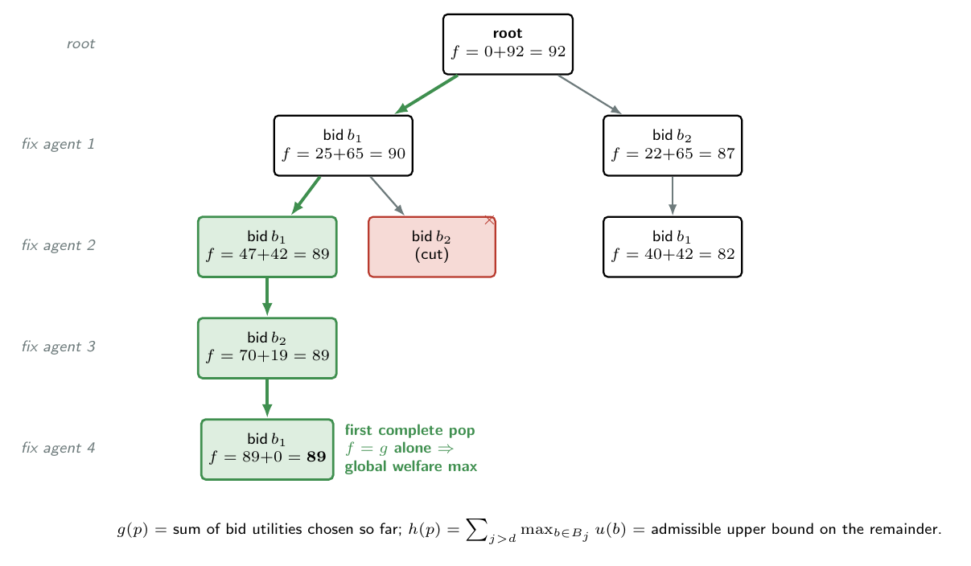
A* search over partial bid combinations, annotated with the admissible priority key $f(p)=g(p)+h(p)$ (Eq. 3.6 / Eq. 4.1). The expansion order is governed by $f$; branch-cut nodes have an empty joint region and are never queued; the first complete pop is the global welfare maximiser (DD-014).

1.3.3 Remediation under env-side capacity failure
The Marketplace alone produces contracts that maximise joint welfare over the agents’ published bids; it does not consult the environment’s resource state. When the environment subsequently applies the contract — the maint_window, supply_horizon and so on (Section 1.7) — it may find that the resource the contract calls for is exhausted: the maintenance crew is fully booked, the supplier order quota is gone. The earlier implementation handled this by silently rewriting the offending contract dimension to its do-nothing default (DD-026 surfaced that the silent rewrites were hiding a material part of the env-side cost structure from the audit stream that the Fence layer’s claims are anchored on).
DD-026 replaced the silent path with an explicit failure record and a remediation hook on the mechanism interface (DD-027). When the environment detects a capacity failure, it calls mechanism.remediate(env, forbidden_dims, original_contract), passing the set of dimensions that are forbidden to a non-default value on this conflict. The Marketplace’s implementation builds an allowed_region — the subset of the contract space where every forbidden dimension is pinned to its do-nothing default — and re-invokes the mediator with the original bid lists and utility closures, plus an optional region_filter keyword that pre-intersects every bid region with the allowed region before the A* expansion runs. If the mediator finds a contract in the constrained region the Marketplace returns it; otherwise it returns None and the environment falls back to its conservative default. Either way, the environment appends an explicit-failure record to its audit log, so the rate and shape of capacity-induced rewrites is visible to the Fence audit stream.
The Siloed and Rule-Based Coordination (RBC) baselines (Section 1.5) implement remediate by returning None unconditionally. This is the documented architectural asymmetry of DD-027: only a joint, search-based mediator can usefully remediate, because only the joint mediator has anywhere to search. A static threshold rule already produced the only contract it was going to produce given the current plant signals; an independent home-issue picker cannot re-coordinate without the cross-agent visibility it does not have.

1.3.4 Contract record and audit instrumentation
The Contract Record (src/marketplace/contract_record.py) is the audit log of every coordination event. Each entry — a ContractRecordEntry dataclass — carries the ConflictAnnouncement verbatim, every bid that was published (serialised through Bid.to_dict), the bids the mediator chose, the resulting contract (or the failure reason), the joint-region size at termination, the bid utility sum, and per-event counters for branches expanded and branches cut. The record is the single source of truth for downstream analytics: the Fence layer (Section 1.4) consumes it as an audit stream; the CUSO baseline (Section 1.5) consumes the persisted agent-belief snapshots to compute its full-information ceiling post-hoc.
Two persistence shapes are supported: in-memory, for the test suite and for the per-event analytics of Chapter [ch:results]; and JSON, for cross-process reproducibility checks. Per DD-032, the entries also serialise the per-agent belief snapshot taken at bid time, so the CUSO post-processor can be invoked against an old audit log without re-running the simulation.

1.4 The Fence Layer
The Fence layer is the implementation of the three-tier safety classifier of Section [sec:arch-fence]. It lives in src/fence/ and is the smallest of the four layers — about 370 lines including the default rule suite. Its smallness is the point: the layer’s job is to read the Marketplace’s audit log and emit a parallel stream of safety classifications, without reaching into any other layer.

1.4.1 Rule structure
A safety rule (SafetyRule in src/fence/classifier.py) is a frozen dataclass with two predicates over a contract record entry:
@dataclass(frozen=True)
class SafetyRule:
name: str
description: str
check_violation: Callable[[ContractRecordEntry, Thresholds], bool]
check_boundary: Callable[[ContractRecordEntry, Thresholds], bool]
The classifier evaluates every rule against every entry, assigning the highest tier any rule triggers:
- $σ_{0}$ (Normal) — no rule’s violation predicate fires, no rule’s boundary predicate fires;
- $σ_{1}$ (Warning) — at least one boundary predicate fires; no violation predicate does;
- $σ_{2}$ (Critical) — at least one violation predicate fires, or the entry is a NEGOTIATION_FAILED entry (a coordination event that produced no contract is $σ_{2}$ by convention).
The threshold band for the boundary predicate is a single number — ten per cent of the safe range — shared across rules.

1.4.2 The default rule suite
The default rule suite installs four rules, one per contract issue, each encoding a domain safety invariant inherited from the v4 lineage:
- no_fast_when_breakdown_imminent — production_rate is fast while machine_health is below the breakdown threshold.
- maintain_when_health_critical — maint_window is none while machine_health is below the preventive-maintenance threshold.
- hold_quality_when_severe — quality_action is no_hold while defect_rate is at or above twice the quality control limit.
- preorder_when_long_lead — supply_horizon is h0 while spare_lead_time exceeds the shortage horizon.
These four rules are not the only possible suite. The rule list is a Classifier constructor argument; new rules can be installed without touching any other layer, and the classifier is unit-tested against rule sets the regression suite supplies directly. This is the practical realisation of the architectural claim of Section [subsec:fence-rationale]: safety governance is replaceable because it is informationally limited to the audit stream.

1.4.3 Audit instrumentation and the explicit-failure log
The Fence reads the Contract Record post-hoc and produces a parallel stream of FenceRecord entries. Each FenceRecord carries the conflict identifier, the assigned tier, the list of rule names whose violation or boundary predicate fired, and the small set of plant signals (machine_health, defect_rate, spare_lead_time) the rule predicates evaluated against. The implementation supports two analytics surfaces: Classifier.tier_distribution() — the proportion of $σ_{0}$, $σ_{1}$ and $σ_{2}$ entries on a run, the headline number Chapter [ch:results] reports — and Classifier.violations_by_rule() — per-rule tallies, used for diagnostics when a sigma tier shifts unexpectedly.
DD-026 adds a second audit stream alongside the Contract Record: the explicit-failure log. When the environment’s resource capacity is exhausted, the failure — and any remediation attempt (Section 1.3.3) — is recorded in env._env_failure_log with a structured entry naming the exhausted resource, the original contract, the remediated contract (if any), and the timestamp. The Fence layer consumes this log alongside the Contract Record so that capacity-induced contract rewrites are visible to the safety-audit pipeline rather than silently rewriting recorded contracts. The result, on the post-DD-026 implementation, is that the audit stream is a complete reconstruction of what the plant actually did, not what the mechanism asked for.
Figure 1.4 consolidates the layout: the Marketplace appends to the Contract Record on every event; the environment appends to its failure log on every capacity-induced rewrite; the Fence consumes both and emits the tier-classified FenceRecord stream.
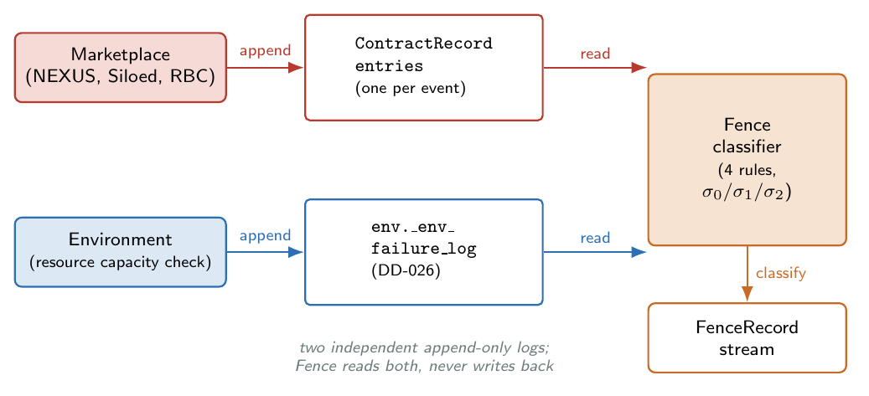
Audit-stream topology. The Marketplace appends one ContractRecordEntry per coordination event (DD-005); the environment appends one entry to env._env_failure_log per capacity-induced rewrite (DD-026); the Fence classifier reads both streams and emits a parallel FenceRecord stream with the three-tier label.

1.5 Baselines
The Marketplace facade of Section 1.3 is the NEXUS mechanism. The empirical work of Chapter [ch:results] compares NEXUS against alternative mechanisms that are architectural baselines in the sense of DD-033: each isolates a single architectural axis on which NEXUS can be characterised. They are not stalking-horses against which NEXUS is expected to dominate on plant outcomes; the methodological reframing of DD-033 and DD-034 says explicitly that Chapter [ch:results] validates architectural properties — safety audit tier distribution, max-sum-utility alignment, bounded disclosure — not throughput or makespan dominance over the baselines. This section documents the implementations.

1.5.1 Siloed: no coordination
The Siloed baseline (src/baselines/siloed.py) models a multi-vendor MOM deployment in which each ISA-95 Level 3 function runs its own scheduler with no cross-domain data sharing. There is no mediator, no joint search, and no negotiation; each agent picks its home issue from its own constraints, and the mechanism composes the four picks into a contract.
The implementation is intentionally small: each agent is constructed with cross_domain_awareness=False (the flag of Section 1.2.5), so its derive_constraints call drops every cross-domain constraint at emission. The Siloed mechanism then calls each agent’s propose_bids and selects, for each home issue, the contract value that the highest-utility home-issue bid prefers; the four home picks are composed into a single Contract. When an agent emits no bids the corresponding issue defaults to its do-nothing value (normal, none, no_hold, h0).
Two properties make Siloed a clean architectural baseline. First, the mechanism reuses the AgentV5 class hierarchy verbatim, so the contrast with NEXUS is exactly the contrast between the joint search and its absence — no other variable changes. Second, the mechanism cannot remediate: SiloedMechanism.remediate(...) returns None unconditionally, which is the documented asymmetry of DD-027. The contrast is what makes the audit stream of Section 1.4 more than a tautology: NEXUS and Siloed apply the same Fence rules to comparable contracts, and the difference in tier distribution is a measurement of what the joint search delivers in safety terms.

1.5.2 Rule-Based Coordination
The Rule-Based Coordination (RBC) baseline (src/baselines/rbc.py) implements the static-threshold-rule design of DD-021. It is the second baseline of the Coordination Comparison: it issues coordinated decisions across all four contract issues, but its coordination is by independent threshold rule rather than by joint search. The threshold table is reproduced in Listing [lst:impl-rbc].
def decide(announcement):
# maintenance dimension (PMA domain)
if announcement.machine_health < 0.5: mw = IMMEDIATE
elif announcement.machine_health < 0.7: mw = PLANNED
else: mw = NONE
# quality dimension (QCA domain)
if announcement.defect_rate > 0.15: qa = HOLD_FULL
elif announcement.defect_rate > 0.08: qa = HOLD_LIGHT
else: qa = NO_HOLD
# supply dimension (SCA domain)
if announcement.spare_lead_time > 48: sh = H72
elif announcement.spare_lead_time > 24: sh = H48
else: sh = H24
# production dimension (PSA domain): no dynamic adjustment
return Contract(production_rate=NORMAL, maint_window=mw,
quality_action=qa, supply_horizon=sh)
RBC has three properties worth noting. First, it is deterministic: identical announcements always yield the identical contract, with no sampling and no search; there is therefore no failure-fallback path of the kind Section 1.3.2 described for the joint mediator. Second, it reads only the shared plant signals every mechanism sees — it does not inspect agent beliefs and has no inter-agent visibility, so the privacy comparison of Section [sec:arch-privacy] is well-defined. Third, like Siloed, RBC cannot remediate: its threshold rules have already produced the only contract they were going to produce given the current plant signals. RBC contrasts with NEXUS along exactly one axis — dynamic joint mediation versus static per-dimension rule — and that single-axis contrast is what makes the architectural comparison interpretable.

1.5.3 The centralised utility-sum optimiser (CUSO)
The third baseline is the Centralised Utility-Sum Optimiser, CUSO (src/baselines/centralized_utility.py, DD-032). It replaces the NSGA-III front-style centralised baseline used in earlier iterations of the empirical plan (DD-028, DD-029, both superseded) with a baseline that is target-aligned to the NEXUS mediator: CUSO maximises the same objective as NEXUS — the sum of agent utilities — but under full information access to every agent’s utility function.
The implementation is a single function: given a ConflictAnnouncement and the four agents, enumerate the entire 108-contract joint space and return argmaxc∈Ωa​ua(state,c). The maximum-utility-sum it returns is the ceiling that NEXUS could attain under its bounded-disclosure constraint: NEXUS sees only bid summaries, CUSO sees every agent’s full utility function, and the alignment ratio $\text{NEXUS}/\text{CUSO}$ is a direct measurement of how much joint utility NEXUS recovers under the bounded-disclosure constraint that makes it a distributed mechanism in the first place.
def cuso_select(announcement, agents):
contracts = all_contract_indices() # |Omega| = 108
best = None; best_sum = -inf
for c in contracts:
total = sum(a.utility_for_contract(announcement, c) for a in agents)
if total > best_sum:
best, best_sum = c, total
return CUSOResult(optimal_contract=best, max_utility_sum=best_sum)
CUSO is a post-processing baseline, not a runtime mechanism. It is not installed into the environment via env.set_mechanism; it is invoked, per conflict, by the Phase F post-processor experiments/analyze_phase_f_cuso.py against the recorded audit log (Marketplace.contract_record persists the ConflictAnnouncement and per-agent belief snapshot for exactly this purpose, per DD-032). The post-processor reports the alignment ratio over a sweep and the bits-of-disclosure model that DD-030’s information-theoretic ceiling reframes for CUSO.

1.5.4 Other mechanisms in the codebase
Two further mechanisms are present in src/baselines/ but are not used as primary baselines in Chapter [ch:results]. The Sequential cascade (src/baselines/sequential.py, DD-012) implements the domain-authority cascade PSA $→$ PMA $→$ QCA $→$ SCA in which each stage commits a contract dimension conditioned on upstream picks. It was dropped from the primary comparison after DD-019’s investigation showed a 41% mediator-failure rate on the resource-constrained synthetic-v2 environment — a structural commitment-asymmetry property that makes the comparison incomparable on the outcomes the thesis cares about. The Contract Net mechanism (src/baselines/cnp.py, DD-001) implements single-winner contract-net bidding; it was dropped after the diagnostic that the mechanism collapses to fixed-priority routing on the Brandimarte benchmark family. Both implementations are preserved in code so the historical comparisons remain reproducible, but neither is loaded by the canonical experiment driver.
Figure 1.5 consolidates the four mechanisms used in the empirical chapter, on the two architectural axes that matter for Chapter [ch:results]: joint search (yes/no) and full information access (yes/no).
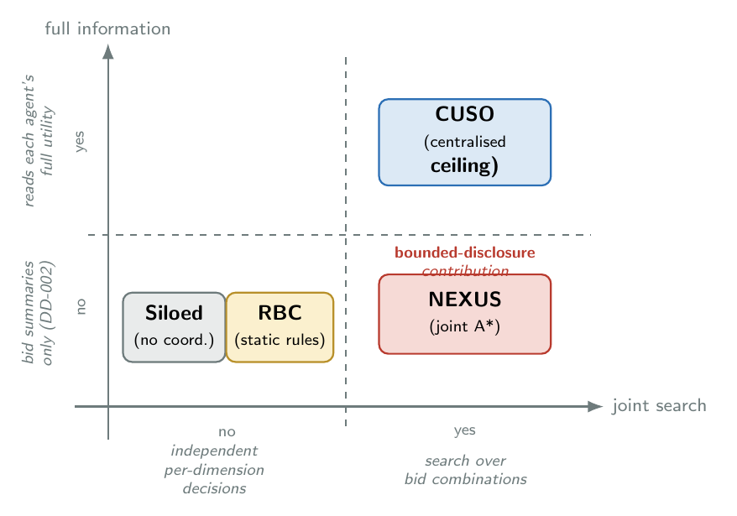
The four mechanism implementations used in Chapter [ch:results], placed on the axes joint search (whether a search over contract combinations is performed) and full information access (whether the mechanism reads private agent state). NEXUS is the only mechanism that combines joint search with bounded disclosure.

1.6 Benchmark Instances
The src/benchmarks/ package implements two families of benchmark instance generators. The first is the classical Brandimarte (Brandimarte 1993) FJSP family, parsed from the SchedulingLab instance files; the second is a pair of synthetic generators (synthetic_v1, synthetic_v2) that produce FJSP-like instances with controlled stress on specific architectural properties. Each family lives in its own subpackage and exposes the same FJSPInstance dataclass to the environment, so swapping benchmark families is a one-line change in the experiment driver.

1.6.1 Brandimarte parser
The Brandimarte parser (src/parsers.py, about 80 lines) is the implementation of the SchedulingLab instance format: a header line giving the number of jobs and machines, then one line per job giving the operation count followed by a list of (machine_id, processing_time) options per operation. The parser auto-detects 0-based versus 1-based machine indexing (Mk06 uses the former; Mk07–Mk10 use the latter) and normalises to 0-based; the resulting FJSPInstance is the dataclass the environment consumes verbatim.
The Brandimarte family has been the canonical FJSP benchmark since 1993; NEXUS inherits it as the canonical architectural stress test for the multi-issue mediator. The empirical observation that the Brandimarte family produces a particular pattern of cross-functional trade-offs — thesis-relevant for the Coordination Comparison — motivates the second benchmark family.

1.6.2 Synthetic generators and the subclass architectural pivot
The Brandimarte family is rich on the scheduling axis but does not expose every architectural property the thesis cares about. The synthetic generators were introduced (DD-015) to produce FJSP-like instances with explicit, calibrated stress on multi-issue coordination dimensions: coupling density across the four issues, cross-domain conflict balance, breakdown intensity, and disruption clustering.
A non-obvious implementation decision arose at the agent-integration stage. The synthetic generators expose state variables (cascade amplifiers, resource capacities, critical-machine flags) that the agents’ constraint derivations should be able to read — but those state variables are not in the standard ConflictAnnouncement contract and adding them globally would pollute the home agents that run on Brandimarte. The alternative considered was to modify the abstract agent in-place; the alternative selected, in DD-017, was to introduce a synthetic-aware subclass of each home agent that reads the synthetic-specific state through a controlled extension interface. The repository tree shows the result: src/agents/synthetic_v2/ mirrors src/agents/ with one subclass per home agent (synthetic_pma_v2, etc.) inheriting from the corresponding base.
The pivot has two consequences worth naming. First, the home agents remain benchmark-agnostic: nothing in src/agents/{psa,pma,qca,sca}.py mentions synthetic_v2, and the Brandimarte regression remains byte-identical to the pre-pivot baseline. Second, the synthetic-aware subclasses are a clean target for further extension: the same pattern is used for the industrial automotive extensions of DD-023 that become the Chapter [ch:industrial] case-study material. The architectural pivot is therefore not a one-off fix; it is the mechanism by which the architecture is extensible to benchmark-specific domains without weakening the home-agent contract.

1.6.3 Synthetic-v2: resource contention, critical machines, cascade
The synthetic_v2 generator (DD-019) is the version used by Chapter [ch:results]. It produces FJSP-like instances with three pre-registered features the Brandimarte family does not express:
- Resource contention. A finite pool of maintenance crews and a finite supplier-order quota per simulation period; capacity can be exhausted, which is what triggers the explicit-failure path of Section 1.3.3. Scaled per shop size: one crew and one supplier on the small preset, two crews and one supplier on medium and large (Molenaers et al. ABC criticality framework, Xia 2021 dual-sourcing adapted to a single shared supplier).
- Critical machines. Twenty per cent of machines are flagged critical, in line with the Pareto criticality fraction documented by Molenaers et al.; missed preventive maintenance on a critical machine triggers cascade effects on downstream defect rates.
- Cascade consequences. Missed PM on a critical machine amplifies the downstream defect rate by a per-level factor (low $0.18$, medium $0.26$, high $0.35$), matching the bounds reported by Nourelfath et al. 2016.
Figure 1.6 shows the data flow from instance generator to environment to mechanism: the same end-to-end pipeline is used for Brandimarte and for the synthetic generators; the only difference is which generator populates FJSPInstance and which environment subclass picks up the synthetic-specific state.
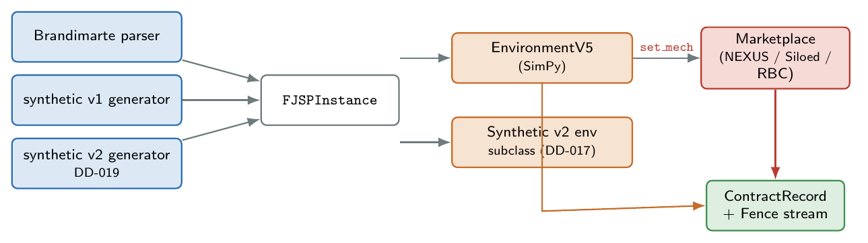
Benchmark and simulation pipeline. The Brandimarte and synthetic generators both produce FJSPInstance; the environment (and, for the synthetic-v2 family, its subclass) loads the instance, registers the mechanism, and runs the discrete-event loop of Section 1.7. The synthetic-aware agent subclasses (DD-017) reach into the synthetic state through a controlled interface.

1.7 Simulation Framework
The simulation framework is the discrete-event substrate against which the architecture is evaluated. It lives in src/environment/ and is implemented on top of simpy, a standard Python discrete-event simulation library, following the discrete-event modelling methodology of Law and Kelton (Law and Kelton 2000). The framework is independent of the choice of mechanism: NEXUS, Siloed, RBC and CUSO all run on the same environment, and the environment never inspects which mechanism is installed beyond the protocol surface (env.set_mechanism(mech)).

1.7.1 Plant physics
The environment models a flexible job shop in which jobs arrive as a Poisson stream, each job is a sequence of operations, and each operation has a set of machine options with per-machine processing times. Three physical mechanisms drive the cross-functional dynamics:
- Weibull machine degradation. Each machine’s machine_health is given by $exp(−(\text{effective_age}/\text{scale})^{\text{shape}})$ with shape $2$ and scale $120$ hours; effective age is total processing hours minus the maintenance offset, so apply_maintenance resets effective age to zero and total processing hours continues to climb monotonically.
- Defect sigmoid. The instantaneous defect probability is $σ((0.6−\text{health})⋅20)$, a sigmoid centred at $\text{health}=0.6$ with steepness $20$ (the v4 D1=B calibration). The quality hold contract dimension modulates this probability via a multiplicative factor per action level.
- Shortage triggers. Each spare part has a per-instance spare_lead_time; the shortage_threshold of $24$ hours (DD-010) gates whether a low-stock event is raised as a shortage conflict.
These mechanisms are inherited from the v4 lineage verbatim (DD-003 treats the environment as a preserved asset); the v5 changes are confined to the conflict-resolution and contract-application paths.

1.7.2 Event lifecycle
A simulation run is a SimPy main loop that interleaves three event families: job arrivals, operation start/end events, and conflict events. Figure 1.7 shows the loop. On each conflict the environment hands control to the installed mechanism (Marketplace, SiloedMechanism, RuleBasedCoordination, etc.) via the mechanism’s __call__(conflict, env) entry point; the mechanism returns either a composite Contract or the NEGOTIATION_FAILED sentinel; the environment then projects each contract dimension onto the plant state.
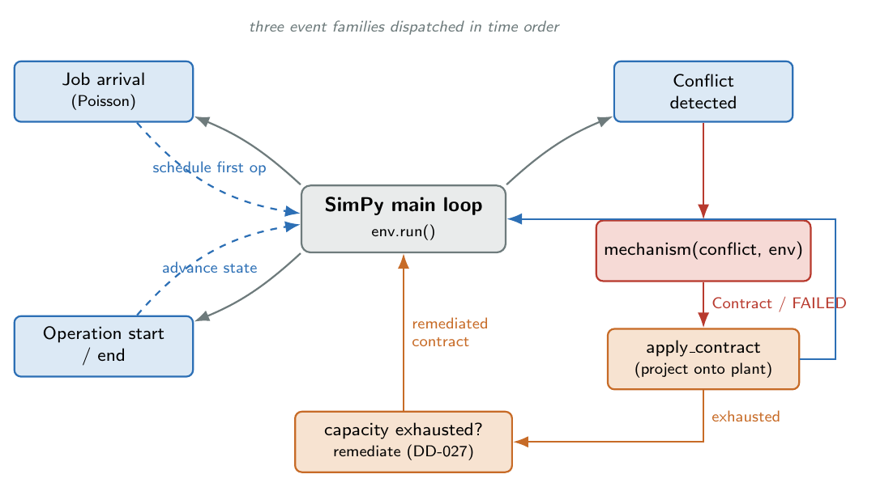
The simulation event loop. The SimPy main loop dispatches job-arrival, operation start/end, and conflict events. On each conflict the installed mechanism returns a composite Contract, which the environment projects onto plant state. Capacity exhaustion triggers the explicit-failure path of DD-026.
Contract application is straightforward: maint_window drives ms.apply_maintenance() for planned and immediate; quality_action sets a quality-hold window during which defects are scaled by the action’s hold factor; supply_horizon sets a preorder window during which shortage risk is suppressed; production_rate adjusts the per-job processing rate multiplier. On a NEGOTIATION_FAILED return the environment falls back to a conservative default — apply maintenance for maintenance and shortage conflicts; no action for quality — and the Fence layer classifies the event as $σ_{2}$ by the convention of Section [subsec:fence-tiers].

1.7.3 Resource capacity and the explicit-failure path
The synthetic_v2 environment subclass adds a per-conflict resource-capacity check on the maintenance crew and the supplier quota. When the requested maintenance window is planned or immediate but no crew slot is free, or when the supply horizon is non-zero but the supplier quota is exhausted, the environment used to silently rewrite the offending dimension to its do-nothing default — the cost-hiding pattern that DD-026 replaced. The current implementation calls mechanism.remediate(env, forbidden_dims, original_contract) (Section 1.3.3), accepts the remediated contract if it is itself capacity-applicable, and otherwise falls back to the conservative default — but, crucially, appends an explicit-failure record to env._env_failure_log in either case.
The result, for the Fence audit pipeline of Section 1.4, is that the audit stream is now a faithful reconstruction of what the plant actually did and why, not what the mechanism hoped would happen. For the joint mediator (NEXUS) the remediation hook recovers a non-trivial fraction of capacity-induced rewrites; for Siloed and RBC the remediation hook returns None, by the architectural asymmetry of DD-027, and the conservative default is applied.

1.8 Testing Strategy
The implementation is accompanied by an automated regression suite of approximately 350 tests at the time of writing, organised into 29 pytest modules under tests/. The suite is what lets the architecture be modified with confidence: every design decision named in this chapter was developed under the test suite as both regression scaffold and acceptance gate, and the admissible-heuristic correction of DD-014, for instance, was made and verified against it without breaking any test that pre-dated the correction.

1.8.1 Test categories
The suite is organised around the four-layer architecture, not around test types. Figure 1.8 shows the layout: each top-level module addresses one component of one layer.
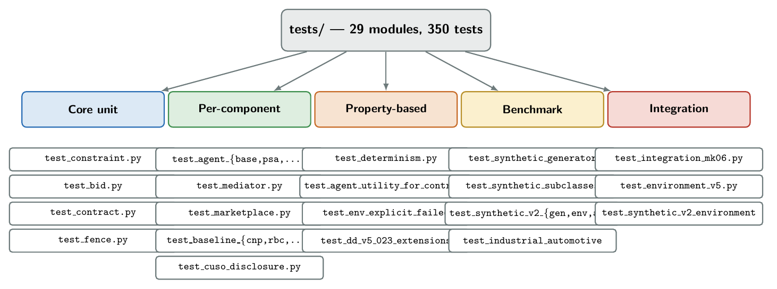
Test-suite organisation. The 29 pytest modules cover every component of every layer plus the baseline mechanisms, the benchmark generators, the simulation framework, and the cross-cutting determinism and integration tests.
Five categories of test are exercised across the suite, in roughly descending share of the test budget:
- Unit tests on the core data structures (test_constraint.py, test_bid.py, test_contract.py, test_fence.py) — pure structural assertions on the dataclasses and the rule predicates.
- Per-component logic tests on every agent (test_agent_{base,psa,pma,qca,sca}.py), on the mediator (test_mediator.py), on the Marketplace orchestrator (test_marketplace.py), on every baseline (test_baseline_{cnp,rbc,sequential,siloed}.py), and on the CUSO disclosure model (test_cuso_disclosure.py).
- Property-based tests on cross-cutting invariants: test_agent_utility_for_contract.py checks that the agent’s utility function is consistent with its constraint set; test_determinism.py checks that two independent runs of the same configuration produce byte-identical audit logs; test_env_explicit_failed.py checks that every capacity-induced rewrite is logged.
- Benchmark and generator tests (test_synthetic_{generator,subclasses}.py, test_synthetic_v2_{generator,environment,agents}.py) — structural and statistical assertions on the synthetic instance distributions.
- Integration tests: test_integration_mk06.py runs an end-to-end simulation on Brandimarte Mk06 with each mechanism, asserts shape invariants on the resulting audit log, and compares headline counts against a checked-in reference. This is the test that catches cross-cutting regressions the unit tests miss.

1.8.2 A representative test pattern
The flavour of the suite is captured by the typical regression-test shape: construct a small, hand-built configuration that targets one property of one component, run the component, and assert structural properties of the result.
def test_mediator_global_optimum_under_branch_cut():
# Two agents, three bids each: by construction the locally-greedy
# mediator would pick a sub-optimal completion.
bid_lists = build_two_agent_branch_cut_scenario()
mediator = Mediator()
result = mediator.select_contract(bid_lists, ANNOUNCEMENT, utility_fns=None)
# Globally optimal sum-utility = 5.0; locally-greedy would yield 3.0.
assert result.status == "OK"
assert result.bid_utility_sum == pytest.approx(5.0)

1.8.3 Determinism as a test substrate
The single most powerful test in the suite is test_determinism.py: it runs each mechanism on each benchmark across a configurable number of seeds and asserts that the resulting audit logs are byte-identical to a checked-in reference. Determinism is the test substrate: when a refactor changes some intermediate detail, the determinism test catches it before any property-level test does. The empirical claim of Chapter [ch:results] that every result rests on a byte-identical recomputation is the consequence of this discipline, not a separate claim — the test suite is what makes the reproducibility property structural rather than aspirational.

Summary
This chapter has documented the implementation of NEXUS. The codebase mirrors the four-layer decomposition of Chapter [ch:architecture] as five Python subpackages with a strict import graph (Section 1.1); the Worker layer implements the BDI agents over a shared AgentV5 base class with mono-dimensional authority enforced by per-agent home-issue weight ceilings (Section 1.2); the Marketplace layer realises the multi-issue mediator as a branch-cut A* search with an admissible priority key, plus a remediation hook for env-side capacity failures (Section 1.3); the Fence layer is a small post-hoc rule classifier reading the Contract Record and the explicit-failure log (Section 1.4); three architectural baselines — Siloed, RBC, and the post-hoc CUSO centralised ceiling — are implemented as drop-in mechanism alternatives that isolate single architectural axes (Section 1.5); two benchmark families are supported through a controlled subclass-extension pattern that keeps the home agents benchmark-agnostic (Section 1.6); the simulation framework is a SimPy discrete-event environment with an explicit-failure path for resource exhaustion (Section 1.7); and the whole assembly is held in place by a deterministic, layer-organised test suite (approximately 350 tests at the time of writing; Section 1.8). The next chapter turns from how the system is built to what it does.

References
Brandimarte, Paolo. 1993. “Routing and Scheduling in a Flexible Job Shop by Tabu Search.” Annals of Operations Research 41 (3): 157–83. https://doi.org/10.1007/BF02023073.
Hart, Peter E., Nils J. Nilsson, and Bertram Raphael. 1968. “A Formal Basis for the Heuristic Determination of Minimum Cost Paths.” IEEE Transactions on Systems Science and Cybernetics 4 (2): 100–107. https://doi.org/10.1109/TSSC.1968.300136.
Ito, Takayuki, Hiromitsu Hattori, and Mark Klein. 2007. “Multi-Issue Negotiation Protocol for Agents: Exploring Nonlinear Utility Spaces.” Proceedings of the 20th International Joint Conference on Artificial Intelligence (IJCAI-07), 1347–52. https://doi.org/N/A.
Law, Averill M., and W. David Kelton. 2000. Simulation Modeling and Analysis. 3rd ed. McGraw-Hill.
Sargent, Robert G. 2013. “Verification and Validation of Simulation Models.” Journal of Simulation 7 (1): 12–24. https://doi.org/10.1057/jos.2012.20.

