**SE-Assignment-5 Response**

Questions:

1. Installation of VS Code:
   * Describe the steps to download and install Visual Studio Code on Windows 11 operating system. Include any prerequisites that might be needed.

**Response**

***Prerequisites***

**System Requirements**:

* + Windows 7, 8, 10, or 11 (64-bit is recommended).
  + At least 1 GB of RAM (though more is recommended for better performance).

***Steps to Download and Install Visual Studio Code***

1. **Download Visual Studio Code**:

* Open your web browser and go to the [Visual Studio Code website](https://code.visualstudio.com/).
* Click on the "Download" button, and it should automatically detect your operating system. Make sure to download the correct version for Windows (usually a 64-bit installer).

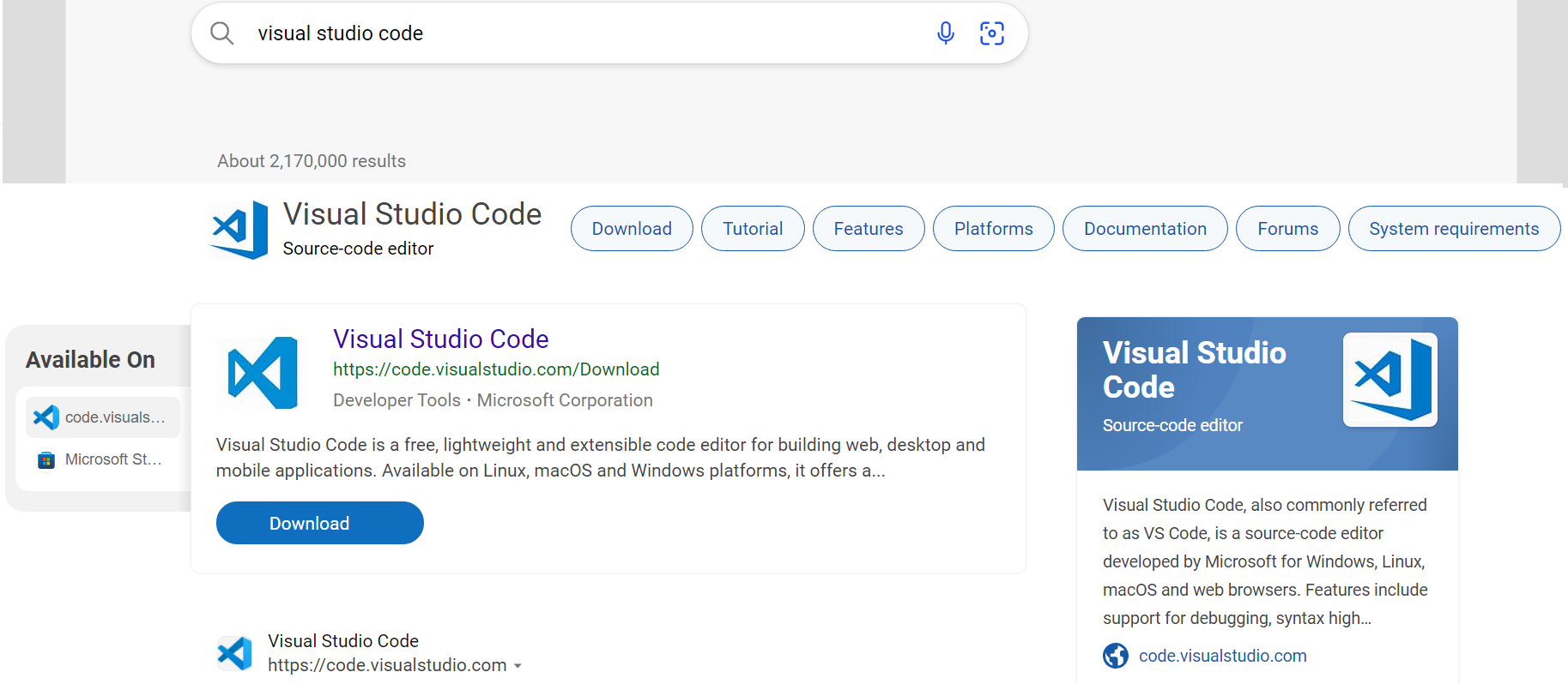

1. **Run the Installer**:

* Once the download is complete, navigate to the downloaded file (typically in your "Downloads" folder) and double-click on it to run the installer.

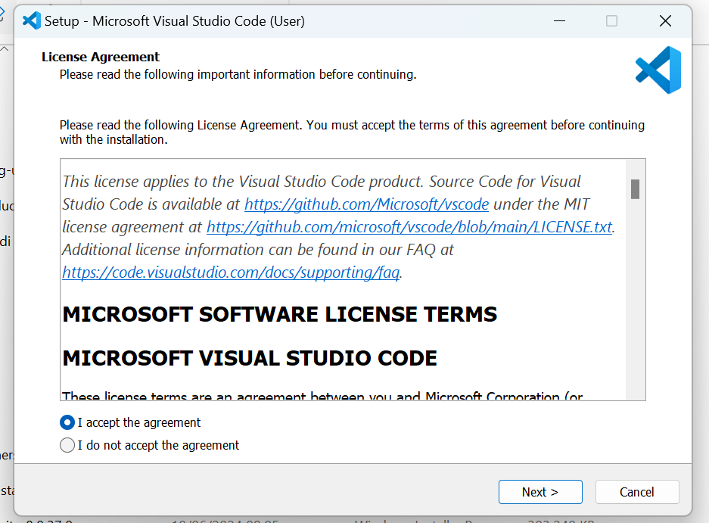

1. **Install Visual Studio Code**:

* In the Visual Studio Code Setup window, read the License Agreement and check the box to accept the terms.
* Click "Next".
* Choose the destination folder where you want to install Visual Studio Code. Click "Next".
* Choose additional tasks you want to perform while installing, such as:
* Creating a desktop icon.
* Adding "Open with Code" actions to the context menu for Windows Explorer.
* Adding to PATH (this is useful for accessing code command in the terminal).
* Click "Next" and then "Install" to begin the installation process.

1. **Complete Installation**:

* Wait for the installation to complete. This may take a few minutes.
* Once the installation is complete, you can choose to launch Visual Studio Code immediately by checking the "Launch Visual Studio Code" box.
* Click "Finish" to exit the installer.

1. **Launch Visual Studio Code**

**Additional Configuration**

1. **Install Extensions**:

* Open Visual Studio Code.
* Click on the Extensions icon in the Activity Bar on the side of the window or press Ctrl+Shift+X.
* Search for and install any extensions you need, such as language support, themes, linters, and debuggers.

1. **Configure Settings**:

* Open the settings by clicking on the gear icon in the lower left corner and selecting "Settings", or press Ctrl+,
* Customize the settings to suit your development needs.

1. First-time Setup:

After installing VS Code, what initial configurations and settings should be adjusted for an optimal coding environment? Mention any important settings or extensions.

**Response**

After installing Visual Studio Code, there are several initial configurations and settings you can adjust to optimize your coding environment. Here are some important settings and extensions to consider:

Initial Configurations

1. **Theme and Appearance**:

Go to File > Preferences > Color Theme and choose a theme that suits your preference. Popular themes include "Dark+", "Light+", "Monokai", and "Dracula".

1. **Auto Save**:

In the file tab, select Auto Save to automatically save files after a short delay.

1. **Extensions**:

Click on the Extensions icon in the Activity Bar on the side of the window

Search for and install the following recommended extensions based on your needs. Recommended Extensions

* **Programming Language Support**:
* Python: Python by Microsoft.
* JavaScript/TypeScript: ESLint, Prettier - Code formatter.
* C/C++: C/C++ by Microsoft.
* **Productivity Tools**:
* Live Server: Launch a local development server with live reload feature for static and dynamic pages.
* Path Intellisense: Autocompletes filenames.

1. User Interface Overview:
   * Explain the main components of the VS Code user interface. Identify and describe the purpose of the Activity Bar, Side Bar, Editor Group, and Status Bar.

**Response**

The main components of the Visual Studio Code user interface are designed to facilitate easy navigation and efficient coding. Here are the key components:

1. **Activity Bar**

* **Location**: Left edge of the window.
* **Purpose**: Provides quick access to different views and functions, such as Explorer, Search, Source Control, Run and Debug, Extensions, and more. Icons represent these views, and clicking them changes the content displayed in the Side Bar.

1. **Side Bar**

* **Location**: Left side of the window, next to the Activity Bar.
* **Purpose**: Displays contextual information and tools depending on the selected view from the Activity Bar. For example, it shows the file explorer, search results, version control information, or installed extensions.

1. **Editor Group**

* **Location**: Central part of the window.
* **Purpose**: The main area where you edit your files. You can open multiple files in tabs, split the editor into multiple groups (columns or rows), and view different files side by side.

1. **Status Bar**

* **Location**: Bottom of the window.
* **Purpose**: Displays information about the current state of the editor and workspace, such as line and column number, selected language mode, encoding, Git branch, errors and warnings, and various other notifications. It also provides quick access to settings and commands.

1. Command Palette:

What is the Command Palette in VS Code, and how can it be accessed? Provide examples of common tasks that can be performed using the Command Palette.

**Response**

The **Command Palette** in VS Code is a feature that provides easy access to all of the editor’s functionality, including keyboard shortcuts for the most common tasks. You can access it by pressing Ctrl+Shift+P

**Accessing the Command Palette**

* **Shortcut**: Press Ctrl+Shift+P (or F1).
* **Menu**: You can also access it via the menu by going to View > Command Palette.

Here are some common tasks you can perform using the Command Palette:

**Examples of Common Tasks Performed Using the Command Palette**

1. **Open a File**:
   * Type Open File or use the shortcut Ctrl+P to quickly open files by name.
2. **Search for a Command**:
   * Start typing the name of a command, such as Toggle Sidebar Visibility or Open Settings. This can help you find and execute commands without knowing the exact menu location.
3. **Change Language Mode**:
   * Type Change Language Mode to change the syntax highlighting and behavior to a different programming language.
4. **Run Tasks**:
   * Type Run Task to execute predefined tasks such as build scripts, test runners, or other automation scripts.
5. **Git Commands**:
   * Type Git: ... to access Git commands like Git: Clone, Git: Commit, or Git: Pull.
6. **Extensions Management**:
   * Type Extensions: Install Extensions to open the Extensions view and search for new extensions to install.
7. **Keyboard Shortcuts**:
   * Type Preferences: Open Keyboard Shortcuts to view and edit the keyboard shortcuts.
8. **Snippet Management**:
   * Type Preferences: Configure User Snippets to create or edit code snippets for different languages.
9. **Debugging**:
   * Type Debug: Start Debugging or Debug: Open Configurations to start a debugging session or configure debug settings.
10. **View Management**:
    * Type View: Toggle Terminal to open or close the integrated terminal.
    * Type View: Split Editor to split the editor into multiple views.
11. Integrated Terminal:

Describe how to open and use the integrated terminal in VS Code. What are the advantages of using the integrated terminal compared to an external terminal?

Response

**Opening and Using the Integrated Terminal in VS Code**

1. **Open the Integrated Terminal**:
   * *Menu*: Go to View > Terminal.
2. **Using the Integrated Terminal**:
   * *New Terminal*: Click the + icon in the terminal panel to open a new terminal instance. You can have multiple terminals open simultaneously.
   * *Switch Between Terminals*: Use the dropdown menu in the terminal panel to switch between different terminal instances.
   * *Run Commands*: Type your commands as you would in any standard terminal. This includes navigating directories, running scripts, and executing version control commands.

**Advantages of Using the Integrated Terminal Compared to an External Terminal**

1. **Context Awareness**:
   * **Automatic Directory**: The integrated terminal opens in the workspace directory by default, saving time and effort in navigating to the correct directory manually.
   * **File and Project Context**: Easily switch between terminal and code editor without losing context, making it more efficient for tasks like debugging and running scripts.
2. **Seamless Integration**:
   * **Unified Interface**: Everything is within the same window, reducing the need to switch between different applications.
   * **Editor Integration**: Outputs and errors can be directly related to files in the editor, with clickable paths and errors that take you directly to the relevant part of your code.
3. **Multiple Terminals**:
   * **Multiple Instances**: You can open multiple terminal instances in different tabs and switch between them easily. This is useful for running multiple processes simultaneously.
4. **Customization**:
   * **Shell Customization**: Configure the terminal to use your preferred shell (e.g., Bash, PowerShell, Command Prompt) by setting it in the user settings (Terminal > Integrated > Shell).
5. **Task Automation**:
   * **Integrated Tasks**: Run pre-configured tasks directly from the terminal. Tasks can be defined in tasks.json and executed with ease.
6. **Environment Consistency**:
   * **Consistent Environment**: Using the integrated terminal ensures that the terminal environment is consistent with the editor, avoiding potential discrepancies between external terminals and the editor.
7. **Extension Support**:
   * **Extensions**: Some VS Code extensions add functionality to the terminal, providing additional tools and enhancements specific to your workflow.
8. File and Folder Management:

Explain how to create, open, and manage files and folders in VS Code. How can users navigate between different files and directories efficiently?

**Response**

Creating, Opening, and Managing Files and Folders in VS Code

**Creating Files and Folders**

1. **Creating a New File**:
   * **Menu**: Go to File > New File.
2. **Creating a New Folder**:
   * **Explorer Panel**: Right-click in the Explorer panel (side bar) and select New Folder. Name the folder and press Enter.
3. **Saving Files**:
   * **Save**: Press Ctrl+S to save the current file. If it is a new file, you will be prompted to provide a file name and location.
   * **Save As**: Press Ctrl+Shift+S to save the current file with a new name or to a different location.

**Opening Files and Folders**

1. **Opening a File**:
   * **Menu**: Go to File > Open File.
2. **Opening a Folder**:
   * **Shortcut**: Press Ctrl+K Ctrl+O to open the folder dialog and select a folder to open.
   * **Menu**: Go to File > Open Folder.
3. **Opening a Workspace**:
   * **Workspace**: Go to File > Open Workspace to open a previously saved workspace configuration.

**Managing Files and Folders**

1. **Explorer Panel**:
   * **View**: Click the Explorer icon in the Activity Bar to view the file and folder structure of the open folder/workspace.
   * **Actions**: Right-click files or folders in the Explorer panel to access actions such as Rename, Delete, Copy, Cut, and Paste.
2. **Dragging and Dropping**:
   * **Move Items**: Drag files and folders within the Explorer panel to move them to a new location.
3. **Renaming Files and Folders**:
   * **Explorer Panel**: Right-click the file or folder and select Rename, or click the file/folder and press F2.
4. **Deleting Files and Folders**:
   * **Explorer Panel**: Right-click the file or folder and select Delete, or select the item and press Delete.

**Efficient Navigation Between Files and Directories**

1. **Quick Open**:
   * **Shortcut**: Press Ctrl+P to quickly open any file by typing part of its name. Use arrow keys to navigate the results and press Enter to open the selected file.
2. **Go to File**:
   * **Shortcut**: Use Ctrl+T as an alternative to Ctrl+P for quick file navigation.
3. **Go to Symbol**:
   * **Shortcut**: Press Ctrl+Shift+O to navigate to a symbol within the current file. Start typing the name of the symbol and select it from the list.
4. **Go to Definition/Declaration**:
   * **Shortcut**: Right-click on a symbol and select Go to Definition or Go to Declaration, or use F12.
5. **Breadcrumb Navigation**:
   * **Breadcrumbs**: Enable breadcrumbs to show the file path at the top of the editor. Click on parts of the breadcrumb to navigate the file hierarchy.
6. **Split Editor**:
   * **Split View**: Click the Split Editor button in the upper right corner of the editor or press Ctrl+\ to view multiple files side by side.
7. **Editor History**:
   * **Navigate Back/Forward**: Use Alt+Left Arrow to navigate back and Alt+Right Arrow to navigate forward through recently viewed files.
8. **Explorer Panel Search**:
   * **Search**: Press Ctrl+Shift+F to open the search panel within the Explorer, allowing you to search for files and content within files.
9. Settings and Preferences:

Where can users find and customize settings in VS Code? Provide examples of how to change the theme, font size, and keybindings.

**Response**

Users can find and customize settings in Visual Studio Code through the Settings interface, which allows for extensive personalization to suit individual preferences. Here’s how to access and modify these settings:

**Accessing Settings**

1. **Settings Interface**:
   * **Shortcut**: Press Ctrl+,.
   * **Menu**: Go to File > Preferences > Settings (or Code > Preferences > Settings on macOS).

**Changing the Theme**

1. **Open Settings**:
   * Press Ctrl+, to open the Settings.
2. **Change Theme**:
   * **Command Palette**: Press Ctrl+Shift+P, type Color Theme, and select Preferences: Color Theme.
   * **Settings**: In the Settings panel, type Theme in the search bar. Under Workbench: Color Theme, select a theme from the dropdown list.

**Changing the Font Size**

1. **Open Settings**:
   * Press Ctrl+, to open the Settings.
2. **Adjust Font Size**:
   * In the Settings panel, type Font Size in the search bar.
   * Locate Editor: Font Size and adjust the value to your desired font size (e.g., change from 14 to 16).

**Customizing Keybindings**

1. **Open Keyboard Shortcuts**:
   * **Shortcut**: Press Ctrl+K Ctrl+S.
   * **Menu**: Go to File > Preferences > Keyboard Shortcuts.
2. **Modify Keybindings**:
   * In the Keyboard Shortcuts editor, search for the command you want to change (e.g., Copy, Paste, Save).
   * Click on the existing keybinding or the pencil icon next to the command.
   * Press the new key combination you want to assign and press Enter.

**Example of Customizing Keybindings**

**Change Save Shortcut**:

* + In the Keyboard Shortcuts editor, search for File: Save.
  + Click on the existing keybinding Ctrl+S.
  + Press the new key combination (e.g., Ctrl+Alt+S) and press Enter.

1. Debugging in VS Code:

Outline the steps to set up and start debugging a simple program in VS Code. What are some key debugging features available in VS Code?

**Response**

**Setting Up and Starting Debugging in VS Code**

1. **Install Required Extensions**:
   * Ensure you have the appropriate language extension installed for your programming language (e.g., Python, JavaScript).
2. **Open Your Project in VS Code**:
   * Open VS Code and navigate to File > Open Folder... to open the folder containing your project.
3. **Create or Open the Debug Configuration**:
   * Click on the Debugging icon in the Activity Bar on the side of the window (or press Ctrl+Shift+D).
   * Click on the gear icon (Configure or Fix 'launch.json') and select your environment (e.g., Node.js, Python, Java).
   * If launch.json does not exist, VS Code will prompt you to create a new one for your selected environment. Otherwise, edit the existing launch.json.
4. **Configure Launch Settings**:
   * Modify launch.json to specify how VS Code should run and debug your program.
5. **Set Breakpoints**:
   * Click in the gutter next to the line number where you want to set a breakpoint. A red circle will appear, indicating the breakpoint.
6. **Start Debugging**:
   * Press F5 or click the green play button next to the configuration dropdown in the Debug view to start debugging. Alternatively, use Ctrl+F5 to start debugging without attaching a debugger.
7. **Interact with the Debugger**:
   * Once debugging starts, VS Code will switch to the Debug view. You can see variable values, step through code (using F10 for stepping over, F11 for stepping into), and inspect call stacks and watch variables.

**Key Debugging Features in VS Code**

1. **Variable Inspection**:
   * Hover over variables to see their current values, or view them in the Variables panel.
2. **Call Stack Navigation**:
   * View the call stack to understand the hierarchy of function calls leading to the current point in the program.
3. **Watch Expressions**:
   * Add expressions to monitor their values continuously while debugging.
4. **Breakpoints**:
   * Set breakpoints to pause the program execution at specific points to examine the program state.
5. **Debug Console**:
   * Use the integrated debug console (Ctrl+Shift+Y) to directly execute commands and evaluate expressions during debugging.
6. **Conditional Breakpoints**:
   * Set breakpoints that trigger only when a specified condition is met.
7. **Step Controls**:
   * Control program execution with step-in (F11), step-over (F10), step-out (Shift+F11), and continue (F5) commands.
8. **Exception Handling**:
   * Configure how VS Code handles exceptions, such as breaking on unhandled exceptions or ignoring specific exception types.
9. Using Source Control:

How can users integrate Git with VS Code for version control? Describe the process of initializing a repository, making commits, and pushing changes to GitHub.

Response

**Initializing a Repository**

1. **Open Your Project in VS Code**:
   * Navigate to File > Open Folder... and select the folder containing your project.
2. **Open the Source Control View**:
   * Click on the Source Control icon in the Activity Bar on the side of the window (or press Ctrl+Shift+G).
3. **Initialize Git Repository**:
   * Click on Initialize Repository or Initialize Git Repository... if it's the first time setting up Git for this project.
   * Alternatively, open a terminal in VS Code (Ctrl+`) and run:

**Making Commits**

1. **Stage Changes**:
   * In the Source Control view, review the changes under Changes (unstaged changes) and Staged Changes.
   * Click + next to each file or use Stage All Changes (Ctrl+Enter) to stage all changes.
2. **Commit Changes**:
   * Enter a commit message in the textbox labeled Message (press Ctrl+Enter to commit).
   * Click the check mark (✔) or press Ctrl+Enter to commit the changes.

**Pushing Changes to GitHub**

1. **Link to GitHub Repository (if not already done)**:
   * If your repository is not yet linked to GitHub, click on the ... (more actions) button in the Source Control view and select Publish to GitHub....
   * Follow the prompts to sign in to GitHub and select/create a repository to link to.
2. **Push Commits to GitHub**:
   * After committing your changes, click on the ... (more actions) button in the Source Control view and select Push.
   * Replace main with the branch name you are pushing from.