1. Python Basics:

What is Python, and what are some of its key features that make it popular among developers? Provide examples of use cases where Python is particularly effective.

**Python** is a high-level, interpreted programming language known for its readability, simplicity, and versatility. Developed by Guido van Rossum and first released in 1991, Python has become one of the most popular programming languages in the world. Here are some of the key features that contribute to its popularity among developers:

**Key Features of Python**

1. **Easy to learn and use:** Python's syntax is known for being clear and readable, resembling plain English more than some other languages. This makes it a good starting point for new programmers and allows experienced developers to code quickly.
2. **Versatility:** Python can be used for a wide range of applications, including web development, data analysis, machine learning, automation, and scientific computing. This makes it a valuable tool for developers who work on various projects.
3. **Large standard library and extensive third-party libraries:** Python has a rich set of built-in libraries and frameworks that provide functionality for many common tasks. Additionally, there's a vast collection of third-party libraries that developers can leverage to save time and effort.
4. **Interpreted language:** Unlike compiled languages, Python code doesn't need to be translated into machine code before running. This allows for faster development cycles and easier debugging.
5. **Free and open-source:** Python is free to use and modify, with a large and active community that contributes to its development and provides support.

Here are some areas where Python is effective:

* **Data Science and Machine Learning:** Due to its powerful libraries like NumPy, Pandas, and Scikit-learn, Python excels at data analysis, manipulation, and building machine learning models. From stock price prediction to medical diagnosis, Python is a go-to language for data-driven tasks.
* **Web Development:** Frameworks like Django and Flask make Python a strong contender for web development. Python's clean syntax and focus on readability help developers build complex web applications efficiently.
* **Automation:** Python's ability to interact with systems and files makes it perfect for automating repetitive tasks. Whether it's web scraping, data processing, or system administration, Python scripts can save developers and non-programmers alike a significant amount of time.
* **Scientific Computing:** Libraries like SciPy and Matplotlib provide powerful tools for numerical computation, data visualization, and scientific simulations. Python is widely used in fields like physics, engineering, and astronomy.
* **Game Development:** While not the primary language for high-performance graphics, Python can be effectively used for building simpler games or prototypes. Libraries like Pygame offer a user-friendly environment for game development.

1. Installing Python:

Describe the steps to install Python on your operating system (Windows, macOS, or Linux). Include how to verify the installation and set up a virtual environment.

Here's how to install Python on Windows and set up a virtual environment:

**Downloading and Installing Python:**

1. **Download the installer:** Head to the official Python download page (<https://www.python.org/downloads/>). Choose the latest stable version of Python that matches your system architecture (64-bit).

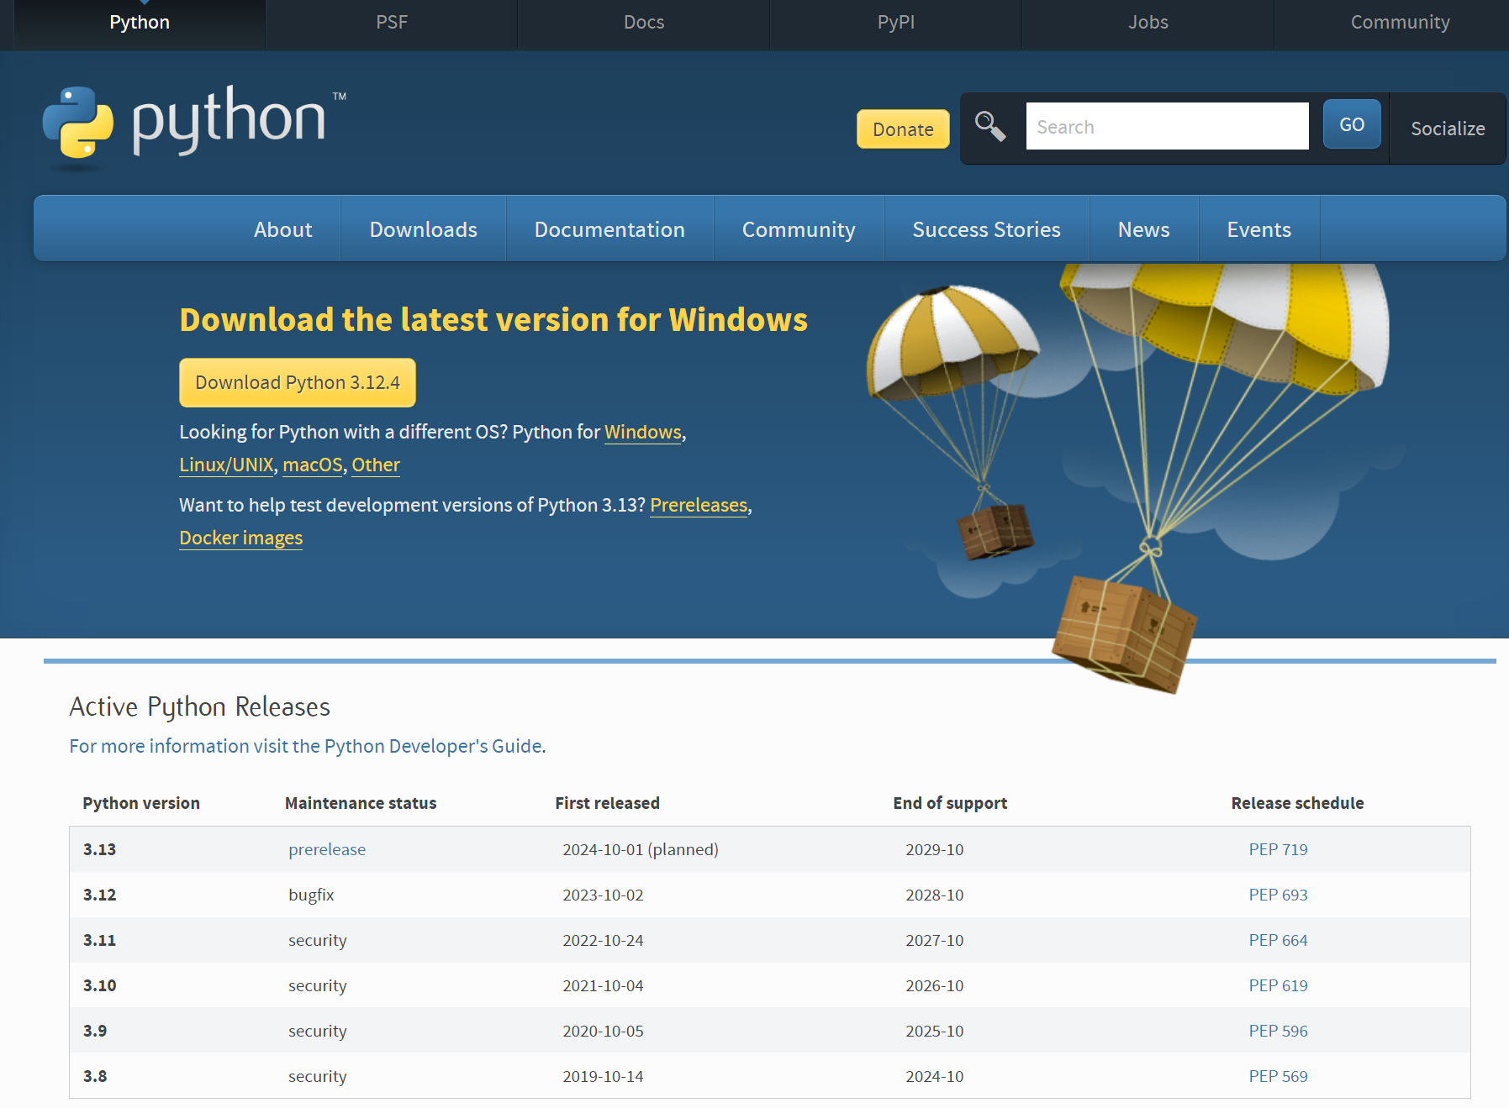

1. **Run the installer:** Double-click the downloaded installer (.exe file). During installation, make sure to check the box "Add Python to PATH. This allows you to run Python commands from the command prompt.

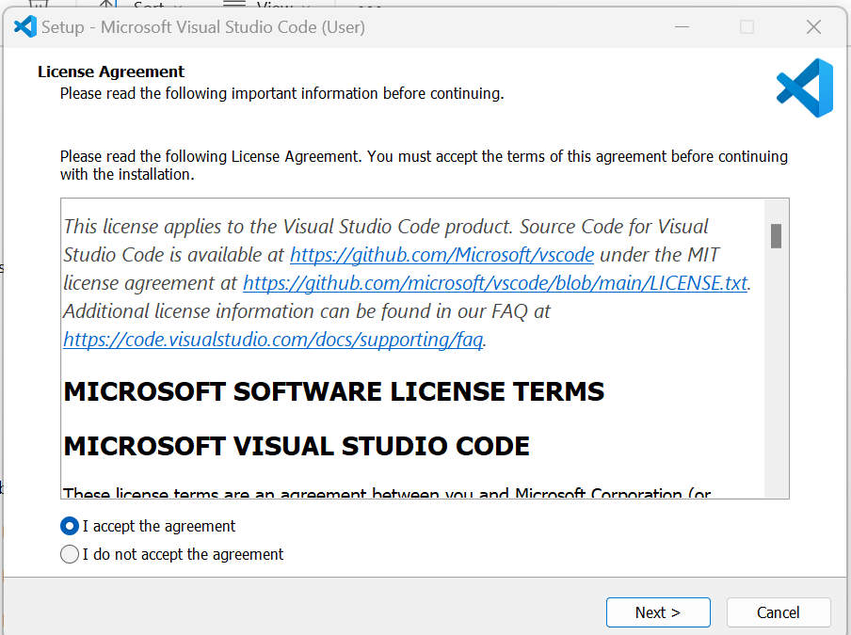

1. **Verifying Installation:**

* **Open Command Prompt:** Search for "Command Prompt" in the Start menu and launch it.
* **Type** python --version Press Enter. If the installation was successful, you should see the installed Python version displayed.

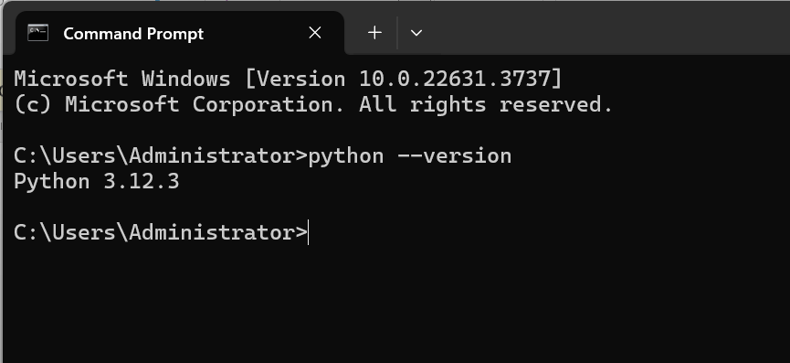

1. Setting Up a Virtual Environment

Virtual environments help isolate project dependencies and avoid conflicts between different projects. Here's how to create one using venv:

* **Open Command Prompt:** Navigate to the directory where you want to create your virtual environment using the cd command.
* **Create the environment:** Type the command python -m venv, followed by your desired environment name.
* **Activate the environment:** On Windows, type

my_env\Scripts\activate

* **Deactivate the environment:** When you're done working in the environment, type

deactivate

This deactivates the virtual environment and returns you to your system's default Python installation.

Python Syntax and Semantics:

1. Write a simple Python program that prints "Hello, World!" to the console. Explain the basic syntax elements used in the program.

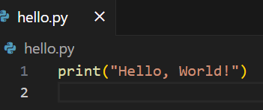

**Explanation of Syntax Elements:**

1. **print () function:** This built-in function displays the message passed within its parentheses on the console.
2. **String:** "Hello, World!" is a string enclosed in double quotes. Strings represent text data in Python.
3. **Parentheses:** The parentheses around the string tell the print () function what to display.
4. Data Types and Variables:

List and describe the basic data types in Python. Write a short script that demonstrates how to create and use variables of different data types.

Here are the basic data types in Python:

1. **Numeric Types:**

* **int:** Represents whole numbers (positive, negative, or zero). No limit on size by default.
* **float:** Represents numbers with decimal points. Limited.
* **complex:** Represents complex numbers (combination of real and imaginary parts).

1. **String Type:**

* **str:** Represents textual data enclosed in single or double quotes. Supports Unicode characters for internationalization.

1. **Sequence Types:**

* **list:** An ordered, mutable collection of elements enclosed in square brackets []. Elements can be of different data types.
* **tuple:** An ordered, immutable collection of elements enclosed in parentheses (). Elements can be of different data types. Once created, the elements cannot be changed.

1. **Boolean Type:**

* **bool:** Represents logical values: True or False. Used for conditional statements and comparisons.

1. **Dictionary Type:**

* **dict:** An unordered collection of key-value pairs enclosed in curly braces {}. Keys must be unique and immutable, while values can be of any data type. Used for storing data with associations.

You can use the type () function to check the data type of a variable in your code.

script demonstrating variables of different data types:

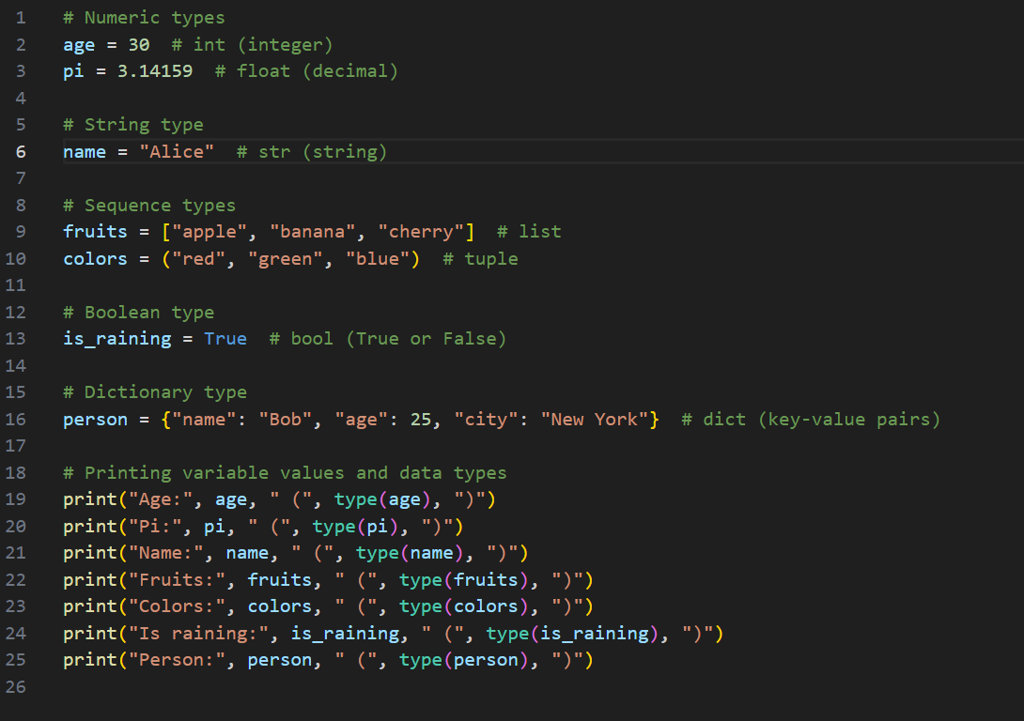

Control Structures:

1. Explain the use of conditional statements and loops in Python. Provide examples of an if-else statement and a for loop.

Conditional statements and loops allow you to execute code based on certain conditions and repeat code blocks a specific number of times or until a condition is met.

**Conditional Statements:**

* **if statement:** This statement allows you to check a condition and execute a block of code only if the condition is True. Here's the basic syntax:
* **if-else statement:** This extends the if statement by providing an alternative block of code to execute if the condition is False.
* **elif statement:** This allows you to check multiple conditions sequentially. You can have multiple elif (else if) blocks to handle different scenarios, followed by an optional else block if none of the conditions match.

**Loops:**

* **for loop:** This loop iterates over a sequence of elements (like a list, tuple, or string). It executes a block of code for each element in the sequence.
* **while loop:** This loop continues to execute a block of code as long as a certain condition remains True. It's important to include a way for the condition to eventually become False to avoid infinite loops.

**How they work together:**

Conditional statements and loops are often used together. For example, you can use a loop to iterate through data and use conditional statements within the loop to make decisions based on the data.

Functions in Python:

1. What are functions in Python, and why are they useful? Write a Python function that takes two arguments and returns their sum. Include an example of how to call this function.

Functions in Python are reusable blocks of code that perform specific tasks. They are essential for code modularity, readability, and maintainability.

**Why functions are useful**

* **Reusability:** Once you define a function, you can call it multiple times throughout your program with different inputs (arguments) if applicable. This saves you from writing the same code repeatedly.
* **Modularity:** Functions break down complex programs into smaller, manageable parts. This improves code organization and readability.
* **Maintainability:** If you need to modify a specific functionality, you only need to change the code within the function definition, instead of searching through the entire codebase.
* **Readability:** Functions with descriptive names make code easier to understand for yourself and others. You can focus on the overall program flow by calling functions with clear purposes.

Example of a function

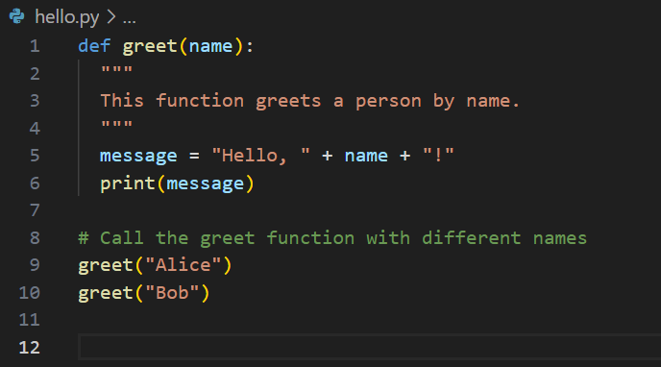

In this example, the greet function is defined to take a name as input and print a personalized greeting. The code is more concise and easier to understand compared to writing the greeting message multiple times.

Here's a Python function that takes two arguments and returns their sum, along with an example of how to call it:

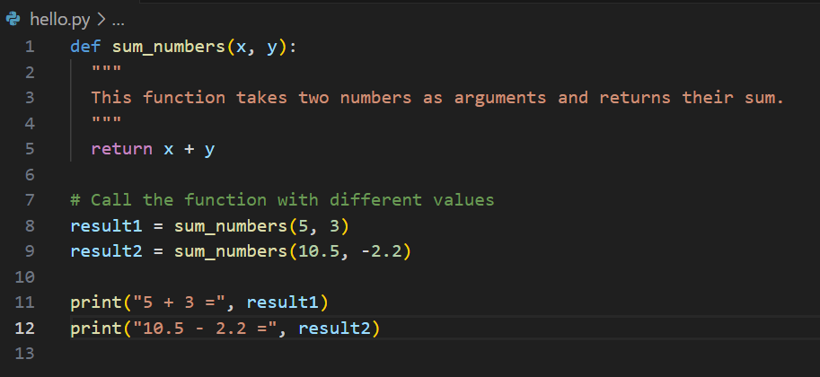



Key differences between lists and dictionaries in Python:

1. **Structure:**

* **List:** An ordered collection of elements enclosed in square brackets []. Elements can be of different data types. You can access elements by their index (position) in the list, starting from 0.
* **Dictionary:** An unordered collection of key-value pairs enclosed in curly braces {}. Keys must be unique and immutable (like strings or numbers), while values can be of any data type. You access elements using their associated keys.

1. **Ordering:**

* **List:** Maintains the order in which elements are added. This allows you to iterate through elements in the same order they were inserted.
* **Dictionary:** Does not guarantee any specific order for key-value pairs. The order you see when printing a dictionary might not be the same order in which elements were added.

1. **Duplicates:**

* **List:** Can contain duplicate elements. You can have multiple instances of the same value at different positions in the list.
* **Dictionary:** Cannot contain duplicate keys. Each key must be unique within a dictionary. However, you can have multiple key-value pairs with the same value.

1. **Use Cases:**

* **List:** Ideal for storing sequences of data where order matters. For example, a shopping list, a list of student grades, or chronological events.
* **Dictionary:** Suited for storing data where you need to associate information with unique identifiers. Examples include phone numbers with names (phonebook), word definitions (dictionary), or student information with ID numbers.

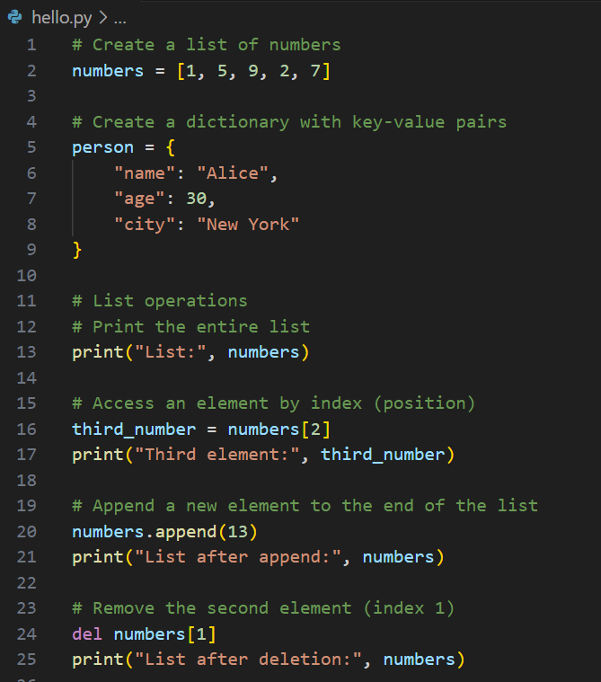 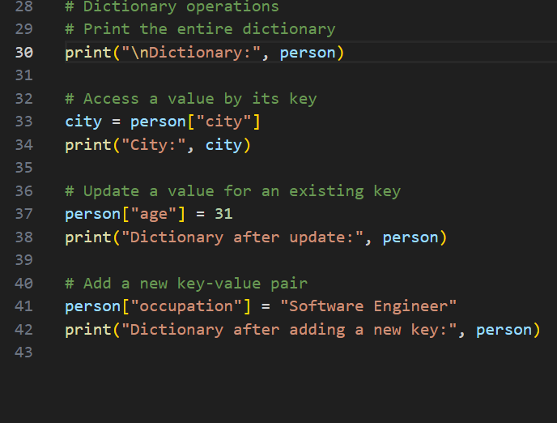

Exception Handling:

1. What is exception handling in Python? Provide an example of how to use ***try***, ***except***, and ***finally*** blocks to handle errors in a Python script.

Exception handling in Python is a mechanism for managing errors that occur during program execution. It allows you to write robust code that can gracefully handle unexpected situations and prevent your program from crashing.

an example of a Python script that demonstrates using try, except, and finally blocks to handle errors:

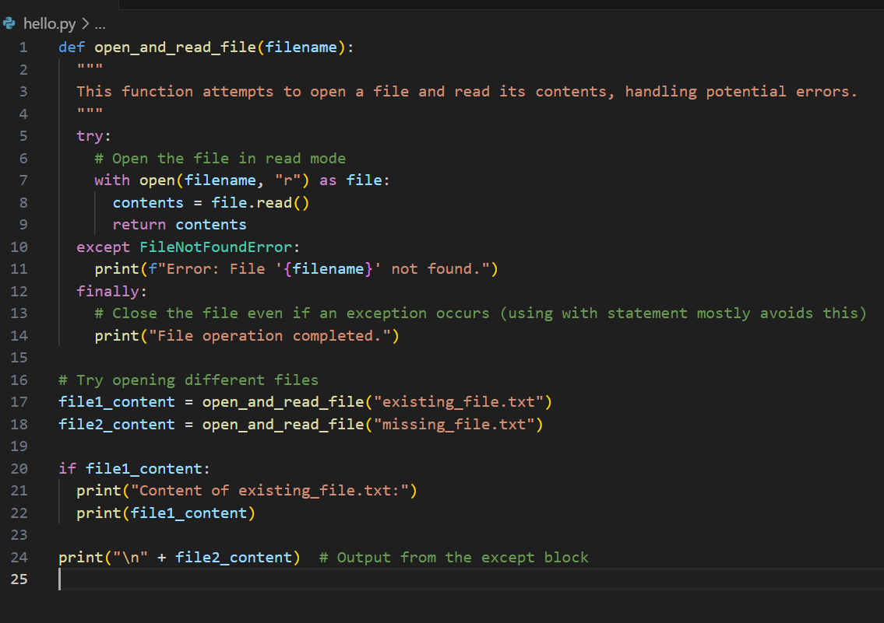

Modules and Packages:

1. Explain the concepts of modules and packages in Python. How can you import and use a module in your script? Provide an example using the ***math*** module.

**Modules:**

A module is a single Python file (.py) containing functions, classes, variables, and executable statements. It defines a unit of code that can be imported and reused in other Python programs.

You use the import statement to bring functionalities from a module into your program. This allows you to access the defined elements within the module.

There are two main ways to import modules:

* **Importing the entire module:**

This gives you access to all functions, classes, etc. defined in module.

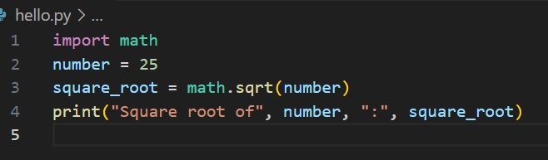

* Use elements from the module:

If you only need a few functions from a module, you can import them directly without the module prefix. Here's how:

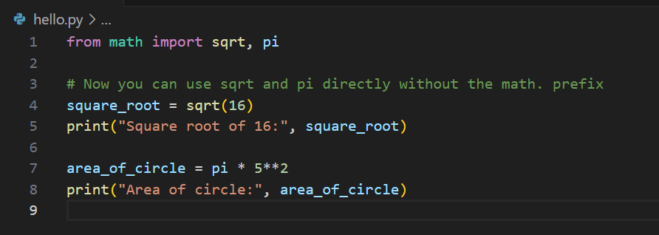

File I/O:

1. How do you read from and write to files in Python? Write a script that reads the content of a file and prints it to the console, and another script that writes a list of strings to a file.
2. **Reading from a File:**

Use the open () function to open the file in read mode ("r"). This returns a file object you can use to interact with the file's content.

* Read the Content:
* Read the entire file:
* Read a specific number of characters:
* Read line by line:

Example: Reading a File:

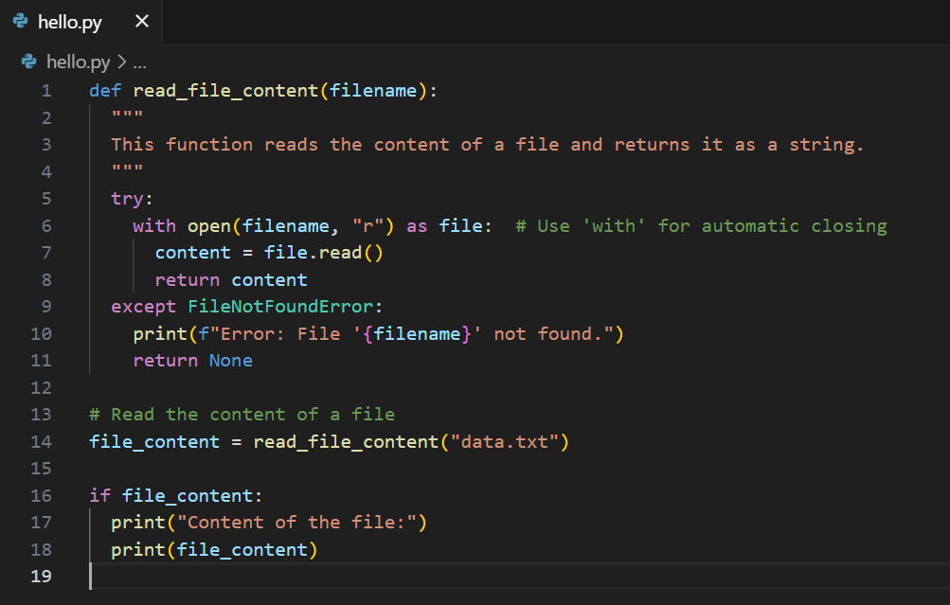

* Writing to a File:

Use the open () function to open the file in write mode ("w") or append mode ("a").

* Write Content
* Close the File:

**Example: Writing to a File:**

