**Customer Requirements Specification**

**(Lastenheft)**

(TINF19C, SWE I Praxisprojekt 2020/2021)

Project: PLCopen-Editor

Customer: Rentschler & Holder

Rotebühlplatz 41

70178 Stuttgart

Supplier: Team 1 (Elian Yildirim, Franziska Kopp, Leonie de Santis, Mouaz Tabboush)

Rotebühlplatz 41

70178 Stuttgart

|  |  |  |  |
| --- | --- | --- | --- |
| **Version** | **Date** | **Author** | **Comment** |
| 0.1 | 16.10.2020 | Leonie de Santis | Created |
| 0.2 | 18.10.2020 | Leonie de Santis | Added the goal and product environment |
| 0.3 | 21.10.2020 | Leonie de Santis | Use Cases created and completed with diagrams |
| 0.4 | 24.10.2020 | Leonie de Santis | Added Features and Business processes |
| 0.5 | 28.10.2020 | Leonie de Santis | Added Product Data and Other Product Characteristics |
|  |  |  |  |
|  |  |  |  |
|  |  |  |  |

CONTENTS

*1.* Goal 3

2. Product Environment 4

*3.* Product Usage 5

*3.1.* Business Processes 5

3.1.1. <BP.001>: PLC programming 5

3.1.2. <BP.002>: File conversion 5

3.1.3. <BP.003>: PLC program storage 5

3.1.4. <BP.004>: Programming languages 6

3.2. Use Cases 6

3.2.1. <UC.001> Create PLC program 7

3.2.2. <UC.002> Import File 7

3.2.3. <UC.003> Export File 8

*3.3.* Features 9

3.3.1. /LF10/ File format analysis 9

3.3.2. /LF20/ File validation 9

3.3.3. /LF30/ Importer 9

3.3.4. /LF40/ Plausibility check 9

3.3.5. /LF50/ Exporter 9

3.3.2. /LF60/ Error handling 9

*4.* Product Data 10

4.1. /LD10/ PLC 10

4.2. /LD20/ FB 10

4.2. /LD30/ File types 10

*5.* Other Product Characteristics 11

5.1. /NF10/ Usability 11

5.2. /NF20/ License 11

5.3. System Environment 11

6. References 12

# Goal

The goal of this project is to develop a web application which supports the commonly used programming languages of Programmable Logic Controllers (PLC) according to IEC 61131-3 [1]:

* Ladder Logic (LD)
* Function Block Diagram (FBD)
* Instruction List (IL)
* Structured Text (ST)
* Sequential Function Chart (SFC)

The editor of the open source project OpenPLC [2] can be used as a reference. The GUI shall be implemented as a browser based application based on ANGULAR. The editor shall enable the graphical creation of PLC programs and support at least FBD and SFC. All common logic blocks should be provided as graphical library elements which can be dragged into the editing window and linked with each other via their inputs/outputs. The programs should be able to be saved and loaded in the XML-format PLCopen[3] and AutomationML[4].

Optionally, a functional verification of a sample program on a runtime system and an interactive SCADA HMI on a suitable system without hardware I/O, can be performed.

# Product Environment

The software is mainly used in automation technology for control and regulation tasks. The programmable logic controller (PLC) represents an open and universal automation solution for almost all industries and applications. The programming languages LD, FBD, IL, ST and SFC are to be supported. Initially, priority is given to the programming languages FBD and SFC.

SFC is a graphical representation for the description of sequential processes. It is often used in a superordinate way to break down a process into manageable units and to describe the control flow between these parts. The steps contained therein can be formulated independently of each other in another language defined in IEC 61131-3. FBD is another graphically oriented programming language for PLC. It works with a list of networks. Each network contains a structure that can contain logical and arithmetic expressions, function block calls, a jump or a return statement.

To exchange programs between development environments, the PLCopen XML and AutomationML formats are used. AutomationML (AML, Automation Markup Language) developed a neutral, XML-based and free standard for representing automation systems as objects. It enables a transfer of technical data. For this purpose already existing formats were adapted and merged in a suitable way. The representation of plant-specific data is possible in general and in particular the plant structure, geometry, kinematics and logical description. PLCopen XML is used for the logical description. PLCopen XML contains all important information about the different PLC programming languages, as well as the program organization units (POU) created by the user, such as functions and function blocks. It also includes graphical information such as the position and the connections.

.

# Product Usage

The following business processes, use cases and features shall be supported by the system.

## Business Processes

### <BP.001>: PLC programming

|  |  |
| --- | --- |
| **Triggering Event:** | The user wants to create a PLC program |
| **Result:** | The user creates a graphical PLC program. This can be created as FBD or SFC. |
| **Involved Roles:** | User and Editor |

### <BP.002>: File import

|  |  |
| --- | --- |
| **Triggering Event:** | The user has a PLCopen XML or AML file and wants to convert it into a graphical PLC program. |
| **Result:** | The system converts the imported file and creates the graphical program in the editor window. |
| **Involved Roles:** | User and Importer |

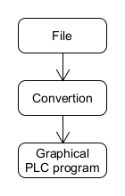

Figure 1: <BP.002> File import

### <BP.003>: PLC program storage

|  |  |
| --- | --- |
| **Triggering Event:** | The user wants to save the created PLC program. |
| **Result:** | The PLC program which is illustrated in the editor window will be saved as PLCopen XML or AML file. |
| **Involved Roles:** | PLC program and Exporter |

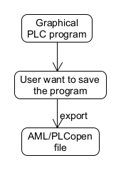

Figure 2: <BP.003> PLC program storage

### <BP.004>: Programming languages

|  |  |
| --- | --- |
| **Triggering Event:** | The developer wants to implement new function blocks or another PLC programming language in his project. |
| **Result:** | The developer implements the new elements into the project. |
| **Involved Roles:** | Developer and Editor |

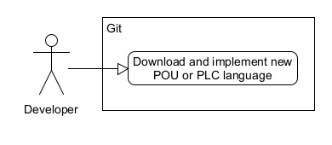

Figure 3: <BP.004> Programming languages

## Use cases

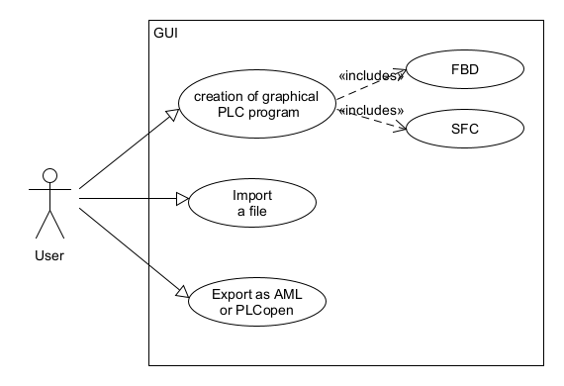

Figure 4: Use Case Overview Diagram

### <UC.001> Create PLC program

|  |  |
| --- | --- |
| **Related Business Process:** | <BP.001>: PLC programming |
| **Use Cases Objective:** | User wants to create a graphical PLC program. The User can choose between the programming languages FBD and SFC |
| **System Boundary:** | Program itself is the system boundary. |
| **Precondition:** | The GUI has to run without errors. |
| **Postcondition on success:** | If an error occurs, an easily understandable error message should be communicated. |
| **Involved Roles:** | User, Editor |
| **Triggering Event:** | User opens the GUI |

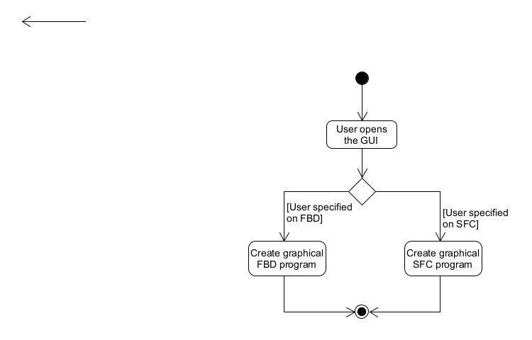

Figure 5: <UC.001> Create PLC program

### <UC.002> Import file

|  |  |
| --- | --- |
| **Related Business Process:** | <BP.002>: File conversion |
| **Use Cases Objective:** | User wants to import an OpenPLC or AutomationML file to load the PLC-program |
| **System Boundary:** | Program itself is the system boundary. |
| **Precondition:** | Imported file must be valid and without errors. |
| **Postcondition on success:** | The PLC program was loaded completely |
| **Involved Roles:** | User, PLCopen/AML file, Importer |
| **Triggering Event:** | User opens the GUI and want to import a file |

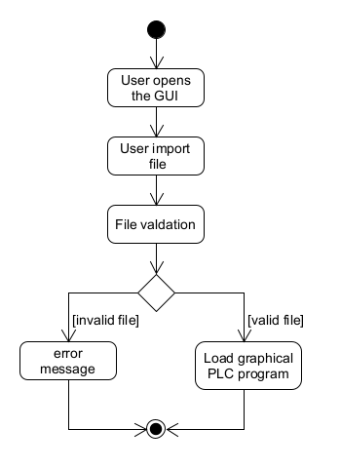

Figure 6: <UC.002> Import file

### <UC.003> Export as PLCopen or AML

|  |  |
| --- | --- |
| **Related Business Process:** | <BP.003>: Data storage |
| **Use Cases Objective:** | User want to export the PLC program as PLCopen or AutomationML to exchange their program between development environments |
| **System Boundary:** | Program itself is the system boundary. |
| **Precondition:** | Created PLC program must be without errors. |
| **Postcondition on success:** | The browser shall not be closed until the export is completed |
| **Involved Roles:** | PLC program, Exporter |
| **Triggering Event:** | User finished the graphical PLC program and decide to save in PLCopen or AutomationML |

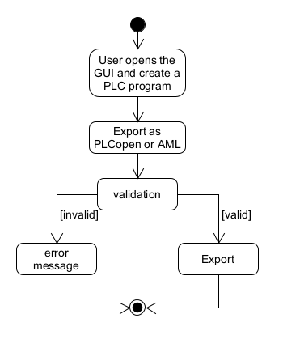

Figure 7: <UC.003> Export as PLCopen or AML

## Features

The following functionalities shall be supported by the system.

* + 1. **/LF10/ File format analysis**

The File format analysis shall check if the imported file the user wants to convert is a XML file. In case of violation, an error message is displayed and the user is asked to import a new file. Otherwise the file validation will continue.

* + 1. **/LF20/ File validation**

The File validation shall check if the imported file is convertible and corresponds to the PLCopen XML or AML schema. In case of violation, an error message is displayed and the user is asked to import a new file. If the file is valid, it can be imported.

* + 1. **/LF30/ Importer**

The importer should create a graphical PLC program from the imported file. If an error occurs, a corresponding error message should be displayed. If the file is imported completely, the user can edit the PLC program.

* + 1. **/LF40/ Plausibility check**

The plausibility check is intended to check if the PLC program has a complete and correct structure. In case of violation, the user should be informed of his fault. Otherwise, the user can continue or export the program.

* + 1. **/LF50/ Exporter**

The exporter should save the created PLC program as PLCopen XML or AML file. If an error occurs, a corresponding error message should be displayed. If the export was completed successfully, the web application can be closed or continued. The exported file can be imported into the PLCopen editor or the AutomationML editor.

* + 1. **/LF60/ Error handling**

The Software shall check if an error has occurred. If an error occurs, the user should receive an appropriate and understandable error message so that the error can be easily corrected.

# Product Data

## /LD10/ PLC

The editor shall support at least the PLC programming languages FBD and SFC.

## /LD20/ FB

The editor shall provide all current logic blocks as graphical library elements. These can be dragged into the editor window and connected to each other at the inputs and outputs.

## /LD30/ File types

The system shall work with the file types, PLCopen XML and AML. It must transfer these files into a graphical PLC program or be able to export a PLC program in one of these file types.

# Other Product Characteristics

This section describes the already known non-functional requirements for the product.

## /NF10/ Usability

The software should support a graphical user interface. It should be clearly laid out and easy to use so that the user can achieve the objectives effectively, efficiently and satisfactorily.

## /NF20/ License

The software shall be published under the MIT license [5].

## System Environment

The PLCopen-Editor is a browser-based application and therefore only requires an Internet connection and an installed web browser on your computer to work.

# References

[1] <http://tiegelkamp.eu/Buch/IEC61131-3JohnTiegelkampDeutschV1.2.pdf>

[2] <https://www.openplcproject.com/plcopen-editor/>

[3] <https://plcopen.org/>

[4] <https://www.automationml.org/>

[5] <https://opensource.org/licenses/MIT>