

Project Manual

**Project: PLCopen-Editor**

Course: Software Engineering

Class: Tinf19C

Professor: Christian Holder, Markus Rentschler

Project manager: Mouaz Tabboush

Team members: Elian Yildirim

Franziska Kopp

Leonie de Santis

Version: PHB 1.0, November 2020

**Contents**

1 Table of revision 3

2 Project assignment 4

3 Project Objectives Plan 5

4 Project context 6

5 Project organization 7

6 Work breakdown structure (WBS) 8

7 WP-Description 9

8 Milestone plan 10

9 Gantt chart 11

10 Project risks 12

# Table of revision

|  |  |  |  |
| --- | --- | --- | --- |
| **Version** | **Date** | **Comment** | **Author** |
| 0.1 | 02.11.2020 | Created  Project assignment und Project organization | Leonie de Santis |
| 0.2 | 03.11.2020 | Work breakdown structure | Mouaz Tabboush |
| 0.3 | 03.11.2020 | Project context, Project Objectives Plan, WP-Description, Milestone plan, Gantt chart, Project risks | Leonie de Santis |
|  |  |  |  |

# Project assignment

|  |  |
| --- | --- |
| **Project assignment** | |
| Project objective (Output):  Development of an editor GUI, which supports the PLC programming languages FBD (Function Block Diagram) and SFC (Sequential Function Chart). The common logic blocks should be available as graphical library elements and should be able to be dragged into the editor window and connected with each other.  It should be possible to save and load the PLC programs as PLCopen or AML. | Non-objectives / Non-contents:   * The PLC programming languages LAD, IL and ST need not be supported * The verification of the function of an example program on a runtime system was taken from the requirements and is optional.   . |
| Project benefits (Outcome):  With the PLCopen-Editor GUI graphical PLC programs can be created. The languages FBD and SFC as well as the common logic blocks are available for this purpose. The programs can be saved or loaded as PLCopen XML or AML files.  The exported file can be imported and loaded in other development environments (e.g. AML editor). | |
| Project client: C. Holder; M. Rentschler | Project manager: Mouaz Tabboush |
| Team members:   * Elian Yildirim * Franziska Kopp * Leonie de Santis | Other defendants: |
| Main tasks:   * Documentation * Analysis * Design * Coding * Testing | Milestones:   * Analysis- / Design-Phase * Coding-Phase * Testing-Phase * Project completion |
| Start of project: Introductory lecture and project awarding | Start date: 11.09.2020 |
| End of project: Presentation of the result | End date: Mai 2021 |

# Project Objectives Plan

|  |  |
| --- | --- |
| **Objective type** | **Project objectives** |
| **Project objective (Output):** | Development of an editor GUI, which supports the PLC programming languages FBD (Function Block Diagram) and SFC (Sequential Function Chart). The common logic blocks should be available as graphical library elements and should be able to be dragged into the editor window and connected with each other.  It should be possible to save and load the PLC programs as PLCopen or AML. |
| **Sub-objectives:** | Design:   * Workflow * Editor GUI * Import/Export   Coding:   * Homepage * Editor window * Programming languages: FBD, SFC * FBs that are dragged into the editor window and connected * Import/Export   Testing:   * Error Detecting * GUI Testing * Export Testing * Side effects (Delete, Move, …) * Components (Function Blocks, Connectors, Variables) |
| **Non-objectives / Non-contents:** | * The PLC programming languages LAD, IL and ST need not be supported * The verification of the function of an example program on a runtime system was taken from the requirements and is optional. |
| **Project benefits (Outcome):** | With the PLCopen-Editor GUI graphical PLC programs can be created. The languages FBD and SFC as well as the common logic blocks are available for this purpose. The programs can be saved or loaded as PLCopen XML or AML files.  The exported file can be imported and loaded in other development environments (e.g. AML editor). |

# Project context

|  |
| --- |
| **Initial situation** |
| For the creation of PLC programs there is an editor of the open source project OpenPLC, which can be used as a reference. |

|  |  |
| --- | --- |
| **Temporal project context** | |
| **Pre-project phase** | **Post-project phase** |
| * Familiarization in PLC * Familiarization with the OpenPLC editor | * Further PLC programming languages can be added * Additional function modules can be added |

|  |  |
| --- | --- |
| **Factual project context** | |
| **Context** | **Measures required** |
| Other projects and exams in the theoretical phase | Fair distribution of tasks within the team and keeping to deadlines |
| Projects in the practical phase and the resulting time constraints | Longer periods of time for tasks to be performed |

|  |  |  |  |
| --- | --- | --- | --- |
| **Social context** | | | |
| **Stakeholder group** | **Potentials / Chances** | **Conflicts / Risks** | **Measures** |
| Client | Satisfied with the results | Changes in requirements during the project phase | Clear and regular communication between client and contractor |
| Contractor | Achieving the requirements | Difficulties within the team and time conflicts | Useful, regular meetings and keeping to deadlines |
| User | Using the PLCopen-Editor | difficulties in handling the program | Clear GUI structure and self-explanatory operation |

# Project organization

|  |  |  |
| --- | --- | --- |
| **Project role** | **Role Description** | **Name** |
| Project client | * Client | C. Holder  M. Rentschler |
| Project manager | * Project manager und Test manager | Mouaz Tabboush |
| Team members | * Developer * Technical writer * Product manager * Test manager | Elian Yildirim  Franziska Kopp  Leonie de Santis |

Mouaz Tabboush

Elian Yildirim

Franziska Kopp

C.Holder/M. Rentschler

Leonie de Santis

# Work Breakdown Structure (WBS)

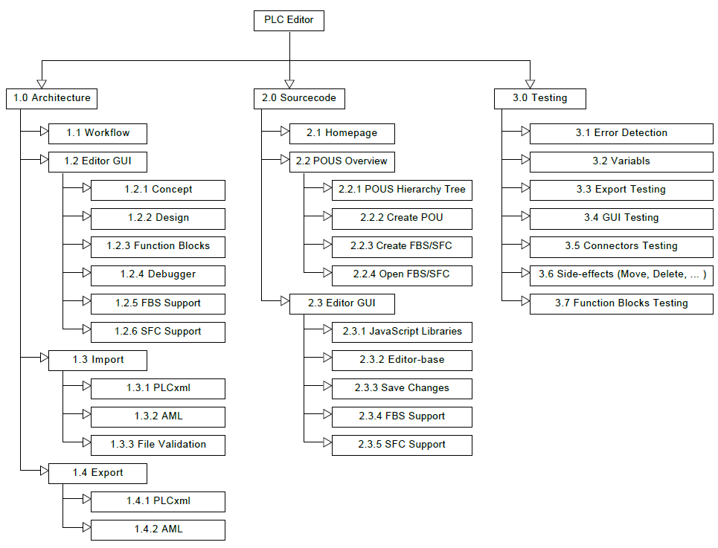

# WP-Description

|  |  |
| --- | --- |
| **Work package: 0.0 Analysis** | |
| WP content / outcome: | * CRS * SRS * BC * PM * SAS |
| Ownership: | Mouaz Tabboush, Leonie de Santis |
| Collaboration: | Elian Yildirim, Franziska Kopp |

|  |  |
| --- | --- |
| **Work package: 1.0 Architecture/Design** | |
| WP content / outcome: | * Workflow * Editor GUI * Import, Export |
| Ownership: | Elian Yildirim, Mouaz Tabboush |
| Collaboration: | Franziska Kopp, Leonie de Santis |

|  |  |
| --- | --- |
| **Work package: 2.0 Coding** | |
| WP content / outcome: | * Homepage * Project overview * Editor * FBD, SFC, FB * Import. Export |
| Ownership: | Elian Yildirim, Franziska Kopp |
| Collaboration: | Mouaz Tabboush, Leonie de Santis |

|  |  |
| --- | --- |
| **Work package: 3.0 Testing** | |
| WP content / outcome: | * Error Detecting * Variables * Export: PLCopen XML / AML testing * GUI testing * Side-effects (Delete, Move, …) * Function Blocks |
| Ownership: | Franziska Kopp, Leonie de Santis |
| Collaboration: | Elian Yildirim, Mouaz Tabboush |

# Milestone plan

|  |  |  |  |
| --- | --- | --- | --- |
| **PSP-Code** | **Milestone name** | **PLAN - Date** | **ACTUAL - Date** |
| **0.0** | **Analysis** |  |  |
| 0.1 | CRS | 06.11.2020 |  |
| 0.2 | BC | 06.11.2020 |  |
| 0.3 | SRS | 06.11.2020 |  |
| 0.4 | PM | 06.11.2020 |  |
| 0.5 | SAS | 06.11.2020 |  |
| **1.0** | **Architecture/Design** |  |  |
| 1.1 | Workflow | 27.11.2020 |  |
| 1.2 | Editor GUI | 23.10.2020 |  |
| 1.3 | Import | 19.02.2021 |  |
| 1.4 | Export | 19.02.2021 |  |
| **2.0** | **Coding** |  |  |
| 2.1 | Homepage | 30.10.2020 |  |
| 2.2 | Project overview | 12.02.2021 |  |
| 2.3 | Editor | 12.02.2021 |  |
| 2.3.4 | FBD | 05.03.2021 |  |
| 2.3.5 | SFC | 05.03.2021 |  |
|  | FB | 05.03.2021 |  |
|  | Import | 26.03.2021 |  |
|  | Export | 26.03.2021 |  |
| **3.0** | **Testing** |  |  |
| 3.1 | Error Detecting | 23.04.2021 |  |
| 3.2 | Variables | 23.04.2021 |  |
| 3.3 | Export testing | 23.04.2021 |  |
| 3.4 | GUI-Testing | 23.04.2021 |  |
| 3.5 | Connector-Testing | 23.04.2021 |  |
| 3.6 | Side effects (Delete, Move, …) | 23.04.2021 |  |
| 3.7 | Function Blocks Testing | 23.04.2021 |  |

# Gantt chart



# Project risks

|  |  |  |  |
| --- | --- | --- | --- |
| **Risk Analysis** | | | |
| **Risk** | **Annotation** | **Probability of occurrence** | **Measure** |
| Personnel risks | Member leaves project | Low | Project plan will have to be adapted, so that the working hours of the missing member distributes to the left members |
| Planning risk | Milestones are not achieved at the planned time | Medium | Project plan will have to be adapted |
| Risk in communication between the members | Tasks are done in a different way than consulted or tasks are not done in time. | Medium | Regular meetings |
| Risk in communication to client | The project is not implemented the way the client wanted it to be. | Medium | As soon as there are concerns about how the client wants something to be implemented, the product manager will ask the client. |
| Financial risk | The planning of the costs is wrong and the project is more expensive than expected. | Low | As soon as there are concerns about the costs, the members of the project will discuss about how to reduce the costs. |