Arrows_stats

Eliany Perez

4/19/2021

setwd("C:/Users/12393/Desktop/Arrows")  
roi<-read.csv("ROIs.csv")

#ttests  
  
jmv::ttestOneS(  
 data = roi,  
 vars = Parietal,  
 meanDiff = TRUE,  
 ci = TRUE,  
 effectSize = TRUE,  
 ciES = TRUE,  
 desc = TRUE)

##   
## ONE SAMPLE T-TEST  
##   
## One Sample T-Test   
## -------------------------------------------------------------------------------------------------------------------------------------------------------   
## Statistic df p Mean difference Lower Upper Cohen's d Lower Upper   
## -------------------------------------------------------------------------------------------------------------------------------------------------------   
## Parietal Student's t 0.8198949 13.00000 0.4270534 0.1849352 -0.3023568 0.6722273 0.2191261 -0.3153658 0.7454695   
## -------------------------------------------------------------------------------------------------------------------------------------------------------   
##   
##   
## Descriptives   
## ----------------------------------------------------------------------   
## N Mean Median SD SE   
## ----------------------------------------------------------------------   
## Parietal 14 0.1849352 0.1503920 0.8439670 0.2255597   
## ----------------------------------------------------------------------

jmv::ttestOneS(  
 data = roi,  
 vars = Lateral.Occipital,  
 meanDiff = TRUE,  
 ci = TRUE,  
 effectSize = TRUE,  
 ciES = TRUE,  
 desc = TRUE)

##   
## ONE SAMPLE T-TEST  
##   
## One Sample T-Test   
## ------------------------------------------------------------------------------------------------------------------------------------------------------------   
## Statistic df p Mean difference Lower Upper Cohen's d Lower Upper   
## ------------------------------------------------------------------------------------------------------------------------------------------------------------   
## Lateral.Occipital Student's t 2.765991 13.00000 0.0160400 0.9748075 0.2134372 1.736178 0.7392422 0.1337451 1.322871   
## ------------------------------------------------------------------------------------------------------------------------------------------------------------   
##   
##   
## Descriptives   
## -----------------------------------------------------------------------------   
## N Mean Median SD SE   
## -----------------------------------------------------------------------------   
## Lateral.Occipital 14 0.9748075 1.055159 1.318658 0.3524261   
## -----------------------------------------------------------------------------

Because the previous ttests were done on a large region of the brain, I extracted specific coordinates based on previous studies to conduct the following ttests and now we can see that they are statistically significant.

#Left Parietal  
jmv::ttestOneS(  
 data = roi,  
 vars = Left.Parietal,  
 meanDiff = TRUE,  
 ci = TRUE,  
 effectSize = TRUE,  
 ciES = TRUE,  
 desc = TRUE)

##   
## ONE SAMPLE T-TEST  
##   
## One Sample T-Test   
## -------------------------------------------------------------------------------------------------------------------------------------------------------   
## Statistic df p Mean difference Lower Upper Cohen's d Lower Upper   
## -------------------------------------------------------------------------------------------------------------------------------------------------------   
## Left.Parietal Student's t 5.619616 13.00000 0.0000834 5.100897 3.139941 7.061852 1.501906 0.7139535 2.263729   
## -------------------------------------------------------------------------------------------------------------------------------------------------------   
##   
##   
## Descriptives   
## ------------------------------------------------------------------------   
## N Mean Median SD SE   
## ------------------------------------------------------------------------   
## Left.Parietal 14 5.100897 5.616716 3.396283 0.9076948   
## ------------------------------------------------------------------------

#right Parietal  
jmv::ttestOneS(  
 data = roi,  
 vars = Right.Parietal,  
 meanDiff = TRUE,  
 ci = TRUE,  
 effectSize = TRUE,  
 ciES = TRUE,  
 desc = TRUE)

##   
## ONE SAMPLE T-TEST  
##   
## One Sample T-Test   
## --------------------------------------------------------------------------------------------------------------------------------------------------------   
## Statistic df p Mean difference Lower Upper Cohen's d Lower Upper   
## --------------------------------------------------------------------------------------------------------------------------------------------------------   
## Right.Parietal Student's t 6.403524 13.00000 0.0000233 4.930798 3.267285 6.594310 1.711414 0.8634110 2.533816   
## --------------------------------------------------------------------------------------------------------------------------------------------------------   
##   
##   
## Descriptives   
## -------------------------------------------------------------------------   
## N Mean Median SD SE   
## -------------------------------------------------------------------------   
## Right.Parietal 14 4.930798 5.157188 2.881126 0.7700132   
## -------------------------------------------------------------------------

So now we know that for words versus images, there is significant activation in both the left and right parietal cortex.

library(ggplot2)

## Warning: package 'ggplot2' was built under R version 4.0.3

ggplot(roi, aes(words_LP, images_LP, color= ID)) +   
 geom_point()+  
 geom_smooth(method = lm)

## `geom_smooth()` using formula 'y ~ x'

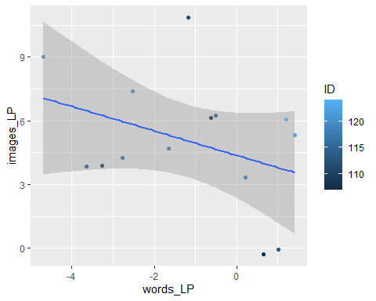

library(ggplot2)  
  
ggplot(roi, aes(words_RP, images_RP, color= ID)) +   
 geom_point()+  
 geom_smooth(method = lm)

## `geom_smooth()` using formula 'y ~ x'

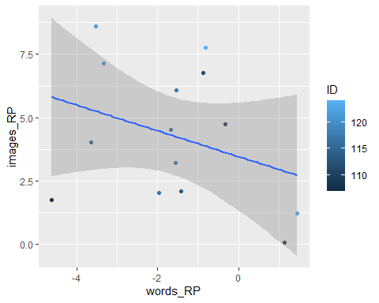 Both for the Left and Right Parietal cortex, there as activation increases for images, activation for words decreases.