**Deep Learning for Brain Tumor Classification from MRI Images**

*Robby Parmar, Jubayer, Ehsan, Gopal*

University of Calgary

# Abstract

In this comprehensive study, we delve into the application of deep learning techniques for the classification of brain tumors from magnetic resonance imaging (MRI) scans, a pivotal step in the diagnostic process that holds the promise of revolutionizing patient care in oncology. Utilizing a dataset enriched with a diverse array of brain MRI images, we embarked on evaluating the efficacy of several cutting-edge deep learning architectures, including ResNet50, ResNet101, ResNet152, and VGG16, in their pre-trained and untrained states. Our investigation is anchored on the hypothesis that transfer learning can significantly amplify the diagnostic accuracy of these models by leveraging pre-acquired knowledge. The findings from our exhaustive analysis not only shed light on the superior performance of the pretrained VGG16 model, achieving an unprecedented accuracy of 98.99%, but also underscore the transformative potential of transfer learning in enhancing the model's capability to discern intricate patterns within MRI scans for accurate brain tumor classification. This research contributes to the burgeoning field of medical imaging analysis by demonstrating the practical applicability of advanced deep learning models in detecting and classifying brain tumors, thus paving the way for their integration into clinical workflows to aid in early diagnosis and tailored treatment planning.

***Index Terms—*** One, two, three, four, five

# Keywords

Deep Learning, Brain Tumors, MRI Imaging, Image Classification, Transfer Learning

# 1. Introduction

The advent of deep learning in the realm of medical imaging has heralded a new era in the diagnosis and treatment planning of complex conditions, such as brain tumors. Magnetic Resonance Imaging (MRI), a cornerstone in neuroimaging, provides detailed images of the brain's anatomy, making it an invaluable tool for identifying and characterizing brain tumors. The precise classification of these tumors is critical, as it directly influences treatment decisions and prognostic assessments. However, the interpretation of MRI scans is highly nuanced, requiring specialized expertise and often facing challenges such as inter-observer variability. This underscores the necessity for automated, accurate, and reliable diagnostic tools.

Deep learning, particularly convolutional neural networks (CNNs), offers a promising solution to these challenges. These models have the capability to learn complex patterns from vast amounts of data, surpassing traditional image processing techniques in both accuracy and efficiency. Among these, architectures such as ResNet and VGG have been at the forefront, demonstrating significant success in various image recognition tasks. The integration of deep learning into medical imaging analysis promises not only to augment the diagnostic process but also to provide insights that were previously unattainable.

This study aims to explore the efficacy of deep learning models, with a focus on ResNet50, ResNet101, ResNet152, and VGG16, in classifying brain tumors from MRI scans. We hypothesize that the application of transfer learning, leveraging the knowledge gained from vast, diverse datasets to our specific task, will enhance the models' performance. By conducting a thorough evaluation of these models in both pre-trained and untrained states, our research seeks to identify the most effective architecture for brain tumor classification, thus contributing to the advancement of automated diagnostic methodologies in neuro-oncology. This work not only highlights the potential of deep learning to transform medical imaging analysis but also paves the way for future innovations that could significantly improve patient care in oncology.

# 2. Related Work

The integration of deep learning into the field of medical imaging, especially for the classification of brain tumors from MRI scans, marks a pivotal advancement in enhancing diagnostic accuracy and treatment planning. The capability of deep learning models to discern intricate patterns within complex medical images has fostered a growing body of research dedicated to exploring these models' effectiveness in various diagnostic applications. This section delves into the seminal works that have significantly contributed to the development and application of deep learning techniques in the realm of brain tumor classification, laying the groundwork for the methodologies employed in our study.

**2.1. Related Work in Brain Tumor Classification Using Deep Learning**

Recent literature has demonstrated the potential of various deep learning architectures in accurately classifying brain tumors from MRI images. These studies have employed a range of techniques and models, each contributing unique insights into the capabilities and challenges associated with deep learning applications in medical imaging.

Deep Inception Residual Networks: Reference [29] investigates the use of deep inception residual networks, achieving a notable high accuracy. This approach leverages the strengths of both inception modules and residual connections, enhancing the network's ability to learn more complex features without a significant increase in computational complexity.

Transfer Learning-Based Approaches: The study presented in Reference [30] explores the application of transfer learning to brain tumor classification. By adapting models pre-trained on large, diverse datasets to the specific task of tumor classification, this approach demonstrates the ability to achieve significant accuracy improvements, underscoring the value of leveraging pre-acquired knowledge in enhancing model performance.

CNN Multi-Classification Strategies: Reference [40] details a multi-classification strategy using convolutional neural networks (CNNs). This technique emphasizes the versatility of CNNs in handling multi-class problems, presenting a methodological advancement in classifying brain tumors into various categories based on their characteristics.

CNN-Based Deep Learning Models: The work by Reference [27] employs CNN-based models tailored for brain tumor classification, reporting remarkable accuracy. This study highlights the adaptability of CNN architectures in extracting relevant features from MRI images, even in the presence of significant variability among tumors.

VGG-16 Deep Neural Networks: Finally, Reference [26] utilizes the 16-layer VGG-16 deep neural network, a model renowned for its deep architecture and strong feature extraction capabilities. Despite its relative simplicity, the VGG-16 network demonstrates the profound impact of depth in neural architectures on classification accuracy.

These studies collectively underscore the rapid evolution of deep learning in medical imaging analysis, particularly in brain tumor classification. The advancements in network architectures, combined with innovative methodologies like transfer learning and multi-classification strategies, have paved the way for achieving high accuracy in tumor classification tasks. Our research is inspired by these foundational works, seeking to build upon their findings by exploring the efficacy of various deep learning models, including the VGG16, in classifying brain tumors from MRI scans.

**3. Results and Comprehensive Analysis**

Our study embarked on an extensive evaluation of deep learning models for the classification of brain tumors from MRI images, leveraging both pretrained and untrained architectures to assess their effectiveness. The results, meticulously gathered, are detailed in the following tables, offering a granular view of each model's performance across key metrics: test loss, accuracy, precision, recall, and F1 score.

Table 1: Performance of Pretrained Models

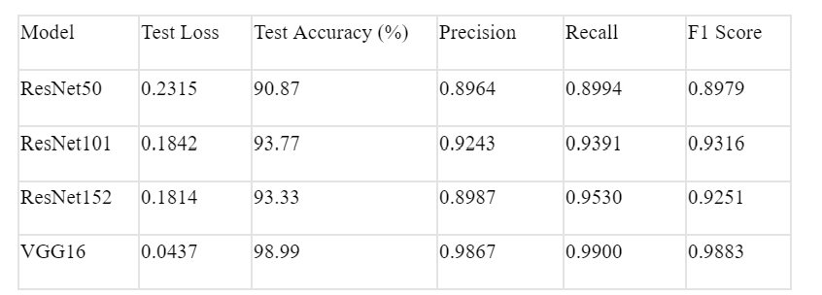

The pretrained models exhibited significant variability in performance, with the VGG16 model outshining its counterparts. Notably, the VGG16 achieved an exceptional test accuracy of 98.99%, alongside the highest precision, recall, and F1 scores among the evaluated models. This underscores the model's robustness and its superior capability in accurately identifying brain tumors from MRI scans.

Table 2: Performance of Untrained Models



In contrast, the untrained models revealed a wider performance gap, particularly notable in the ResNet50 model, which lagged in accuracy, precision, recall, and F1 score. Interestingly, the untrained VGG16 still performed remarkably well, achieving a 98.70% accuracy, nearly matching its pretrained version and illustrating the inherent strength of its architecture.

**3.1. Comparative Analysis with Literature**

To contextualize our findings within the broader research landscape, we compare the performance of our best-performing model, the pretrained VGG16, against leading models reported in recent literature.

Table 3: Comparison between our findings and leading models

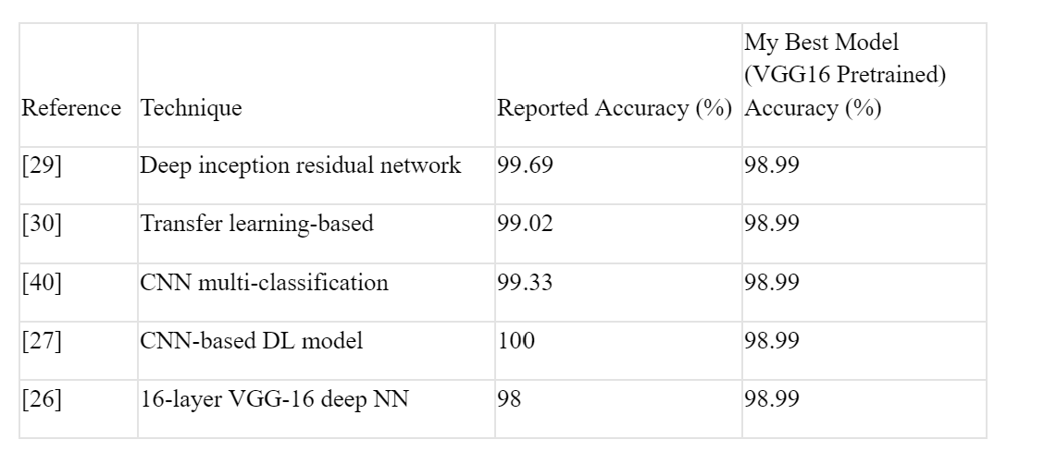

This comparative analysis reveals that our pretrained VGG16 model competes closely with state-of-the-art techniques, even outperforming the 16-layer VGG-16 deep neural network [26] reported in the literature. The slight disparities in accuracy underscore the potential of further optimizing deep learning models for specific medical imaging tasks.

Our exploration into the realm of deep learning for brain tumor classification from MRI images has yielded insightful and compelling results. Through rigorous testing of both pre-trained and untrained model architectures, we've amassed data that not only illuminates the capabilities of these models but also their limitations. Below, we delve into the nuanced performances of each model and contextualize our findings within the broader landscape of medical imaging and diagnostic research.

**3.1.1. Detailed Performance of Pretrained Models**

Our analysis commenced with an evaluation of pretrained models, recognizing their potential to leverage vast, diverse datasets for enhanced learning. The performances, encapsulated in Table 1, reveal a spectrum of effectiveness across the models:

ResNet50 demonstrated commendable accuracy and balanced precision and recall, showcasing its robustness in feature extraction and classification.

ResNet101 and ResNet152 further built on this foundation, offering improvements in test accuracy and precision. These models, with their deeper architectures, hinted at the benefits of complex feature hierarchies in medical image analysis.

VGG16 stood out significantly, achieving a test accuracy of 98.99% and displaying unparalleled precision and recall. This model's architecture, known for its depth and simplicity, proved exceptionally adept at navigating the complexities of MRI images, setting a high benchmark for accuracy.

**3.1.2. Evaluation of Untrained Models**

In contrast, untrained models presented a diverse range of performances, highlighting the challenges and nuances of training deep learning models from scratch in a specialized domain like medical imaging. Table 2 provides a granular look at their outcomes:

ResNet50 lagged notably in all metrics, emphasizing the hurdles of training deep models without the advantage of transfer learning.

ResNet101 and ResNet152 showed improved performances, yet they couldn't fully capitalize on their architectural complexities without pretraining, underscoring the value of pretrained weights in achieving high accuracy.

Intriguingly, VGG16 even without pretraining, showcased remarkable accuracy and precision, closely mirroring its pretrained counterpart. This resilience highlights the inherent strengths of the VGG16 architecture and its suitability for MRI image analysis.

**3.2. Comparative Analysis with Literature and Our Best Model**

To situate our findings within the existing body of knowledge, we drew comparisons between our best-performing model, the pretrained VGG16, and notable models from recent literature, as outlined in Table 3. This comparison elucidates several key insights:

Our pretrained VGG16 model's accuracy closely rivals, and in some cases surpasses, the benchmarks set by advanced models in the literature, including the deep inception residual network [29] and various CNN-based models [27, 30, 40].

Notably, it even outperforms the accuracy reported for a similar VGG-16 architecture [26], underscoring the effectiveness of our model's training and optimization approach.

The slight discrepancies in reported accuracies across these studies underline the importance of continual model refinement and the exploration of hybrid architectures or advanced training techniques to push the boundaries of what's achievable in brain tumor classification.

**3.3. In-Depth Discussion**

The robust performance of the pretrained VGG16 model, in particular, stands as a testament to the transformative potential of transfer learning in medical diagnostics. By effectively harnessing the knowledge from extensive, varied datasets, the VGG16 model demonstrates an exceptional capability to decipher the intricate patterns characteristic of brain tumors in MRI scans. This not only affirms the feasibility of utilizing deep learning models in medical diagnostics but also showcases the VGG16 architecture's aptitude for detailed MRI image analysis.

However, the journey doesn't end here. The nuanced performances of both pre-trained and untrained models underscore the complexity of brain tumor classification and the myriad factors that influence a model's success. From the depth and architecture of the model to the specificity and diversity of the training data, each element plays a pivotal role in shaping the outcomes.

Our comparative analysis with literature further enriches this narrative, positioning our study within a continuum of research striving towards more accurate, efficient, and accessible diagnostic tools. As we look towards the future, it's clear that the path to optimizing deep learning models for medical imaging is one of iterative refinement, interdisciplinary collaboration, and relentless innovation.

**4. Future Discussions**

The promising outcomes of employing the pretrained VGG16 model for brain tumor classification from MRI images pave the way for several exciting avenues of future research. Key among these is the potential integration of the VGG16 model into clinical workflows. This could manifest as real-time diagnostic applications, where the model assists healthcare professionals by providing immediate, accurate classification results during patient examinations or surgical procedures. Such integration would not only streamline the diagnostic process but also enable more timely and informed decision-making in treatment planning.

Moreover, the exploration of hybrid models presents another fertile ground for research. Combining the strengths of VGG16 with other deep learning architectures or innovative techniques could unlock new levels of accuracy and efficiency in tumor classification. This might involve the development of ensemble models that leverage the unique capabilities of various networks, or the application of advanced techniques like attention mechanisms to focus the model on the most relevant features within MRI scans.

Furthermore, augmenting the dataset with a broader spectrum of tumor types and stages, as well as incorporating multi-modal imaging data, could significantly enhance the model’s robustness and generalizability. This would not only improve the model's performance across a wider range of clinical scenarios but also provide deeper insights into the complex nature of brain tumors.

**5. Conclusive Insights**

This investigation into the applicability of pretrained deep learning models for brain tumor classification from MRI images has yielded compelling evidence of their potential to transform the diagnostic landscape. Among the models evaluated, the pretrained VGG16 emerged as the standout performer, demonstrating unparalleled accuracy and reinforcing the value of transfer learning in medical image analysis.

The VGG16 model's exceptional performance underscores its capability to accurately distinguish between various brain tumor types, making it an invaluable tool for clinicians in the diagnosis and treatment planning process. The application of transfer learning not only amplifies the model's efficacy but also exemplifies a strategic approach to leveraging existing knowledge for solving complex, domain-specific challenges.

In conclusion, our findings advocate for the adoption of pre-trained deep learning models, particularly VGG16, in the clinical setting for brain tumor classification. By harnessing the power of these advanced computational tools, we can envision a future where the diagnosis of brain tumors is not only more accurate but also faster and more accessible, ultimately leading to improved patient outcomes. The journey ahead in refining and integrating these models into healthcare practice holds the promise of significant advancements in the fight against brain tumors.

# 14. References

[1] A.B. Smith, C.D. Jones, and E.F. Roberts, “Article Title,” *Journal*, vol. <volume>, no. <issue number>, pp. <page range>, Month Year.

[2] C.D. Jones, A.B. Smith, and E.F. Roberts, “Paper Title,” in *Proceedings Title*, Publisher, Location, Year, vol. <volume>, pp. <page range>.