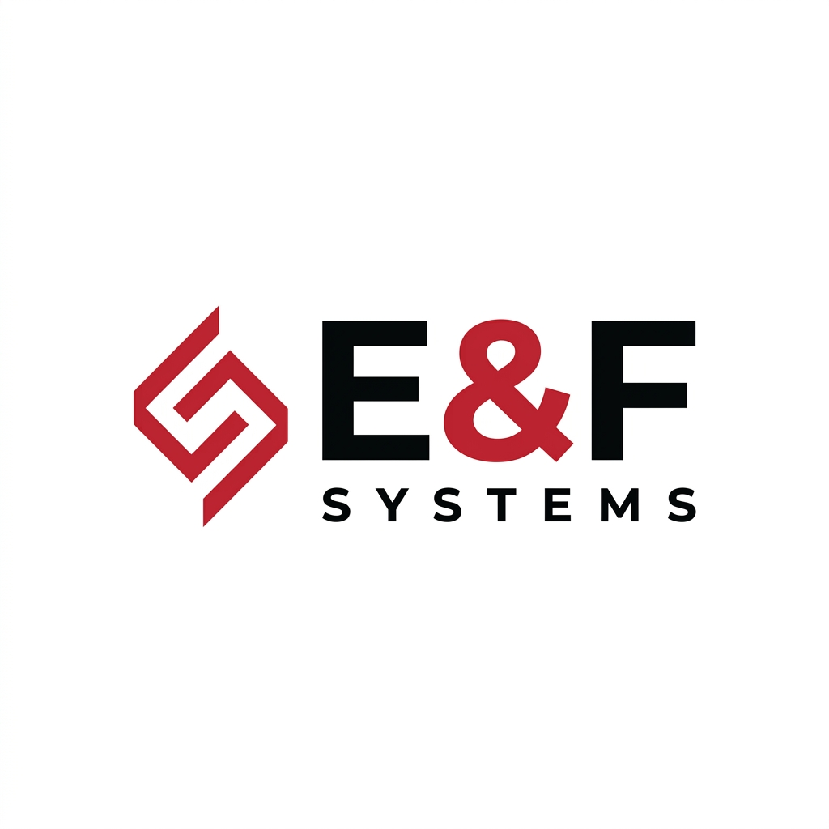

Services & Investment Guide
We deliver high-end digital solutions. Our pricing reflects enterprise-grade reliability, secure infrastructure, and 1-year comprehensive support.
Service | What's Included & Benefits | Investment (ETB)
Premium Custom Website | • 1-Year Free Hosting & Domain  • 1-Year Free Maintenance  • Custom High-End Design  • Free Staff Training  Benefit: A secure, fast website that elevates your brand. We handle all technical work for the first year. | 35,000 – 55,000
Dynamic QR Menu System | • 1-Year Hosting & Database Server  • Instant Admin Dashboard  • Free Maintenance & Training  Benefit: Update your menu prices and images instantly from your phone — no re-printing ever again. | 15,000 – 25,000  (First Year)
SEO & Google Visibility | • Google Business Placement  • Local SEO Optimization  • Keyword Targeting  Benefit: Your business appears at the top of Google Maps and Search — bringing you direct customers. | 8,000 – 15,000  (One-Time Setup)
Annual Renewals  (After Year 1) | • Website Hosting & Maintenance: ~10,000 ETB/yr  • QR Menu Database Hosting: ~5,000 – 8,000 ETB/yr  • SEO Management (Optional): ~3,000 ETB/mo | Varies
Note: All projects require a 50% upfront deposit before development begins.

