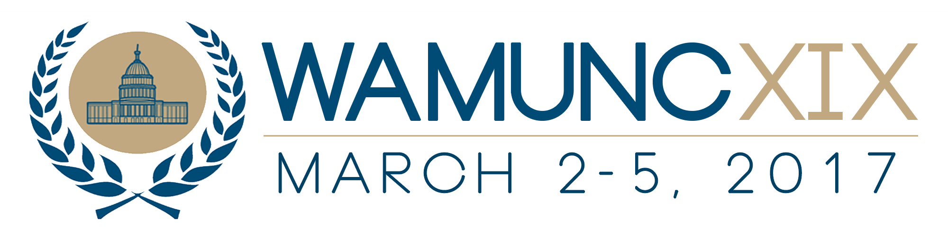

Kellie Bancalari
Director of Public Relations
Washington Area Model United Nations Conference
Email: pr@wamunc.com
Phone: (908) 442-9097
Website: WAMUNC.com

***For Immediate Release***

Over 1,200 Students From Around the World Expected to Attend WAMUNC XIX

Washington- Over a thousand high school students will gather in Washington in March for the 19th annual Washington Area Model United Nations Conference (WAMUNC). The conference is set to take place at the Washington Marriott Wardman Park Hotel on March 2 to March 5, 2017.

“This years conference will be the best WAMUNC yet, and the most diverse. We are really looking forward to students being able to gain more from the diversity of committees, delegates, and staffers,” explained Secretary General Supriya Mazumdar, the 21 year old in charge of planning and executing the conference.

Conference participants will be able to gain invaluable insight into how to interact with delegates from diverse backgrounds. As Mazumdar acknowledged, “With over 1,200 delegates from 47 states, 14 different countries, and hundreds of schools, students will be sure not to just learn during their committee session, but outside of the classroom too.”

These students are set to come from every corner of the United States and the world. The countries in which the students will travel from include South Africa, Panama, and Taiwan.

Once at the conference, students will be challenged find solutions to some of the world’s most pressing issues including the health of refugees, terrorism, and climate change. In 24 committees on a variety of topics, participants will have the opportunity to debate issues that most interest them providing them with an educational experience not found in a classroom.

WAMUNC, the biggest conference in the Greater Washington Metro Area, provides a unique opportunity for conference participants. On March 3, the participants will have the opportunity to explore the city through excursions led by George Washington University students to different embassies and multilateral organizations like the World Food Programme. This makes WAMUNC one of the most interactive and real conferences in the world.

-END-

