[Date]

SYLLA Mamadou Fanta

[nom de la société]

PROJECT WEB

A website allowing user to give the comment on a product

Table des matières

I. INTRODUCTION : 2

II. PRESENTATION 2

A. Home page 2

B. Logging form 3

C. Object view page 3

D. Comments page: 4

III. DIFFICULTIES & SOLUTIONS 5

A. Home page 5

B. Logging page 5

C. Object view page 5

D. Vuejs implementation to treat likes 5

E. Comment page 5

IV. POSSIBLE IMPROVEMENT 5

A. Graphics 5

B. Security 6

C. Vuejs implementation 6

D. Comments with a database 6

CONCLUSION 6

# INTRODUCTION :

The fourth-year international web programming course aims at improving students web programming skills. This web program is not only about improving some skills and making fun designing web pages, it’s also a friend of war in the business world. because for those who attend to run a business, the web programing becomes mandatory for them because it’s nowadays the ideal way to attract customers and value your product. The Web programming is useful to keep a product alive and to keep and increase the number of clients.

# PRESENTATION

The objective of our project is to create a website which allows users to see four best products on the market and allow them first, to like (thumb up, thumb down) the product they appreciate, and second, to leave a comment. The goal is to collect all the information given by the users in order to determine and rearrange the products from the best one to the least. It also allows users looking for information on a specific product, to see the comments of the people who have used it before.

The project is divided in four essential pages:

## Home page

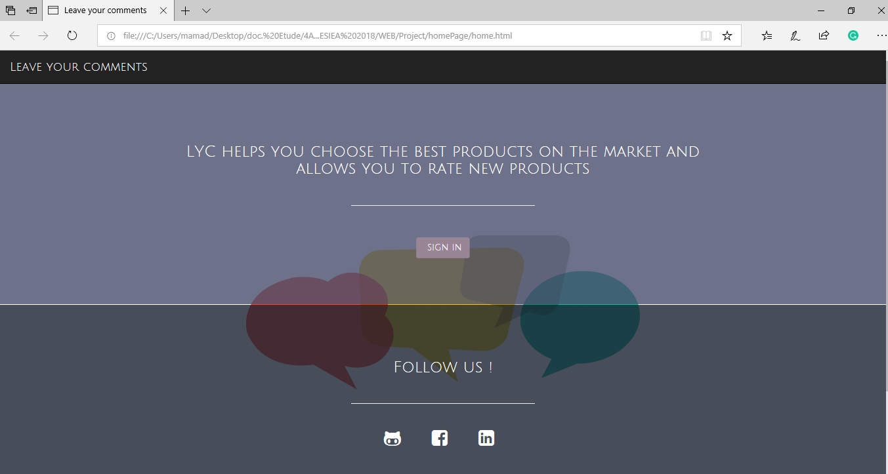

In the home page, we have some key information like, a brief description of the website. A sign in button. The home page design is quite simple, we opted for a simple design so that the users can go to the essential. User don’t have to waste time by just

We have also added some social network links (GitHub, Facebook and LinkedIn ), to spread all information about the service we give.

## Logging form

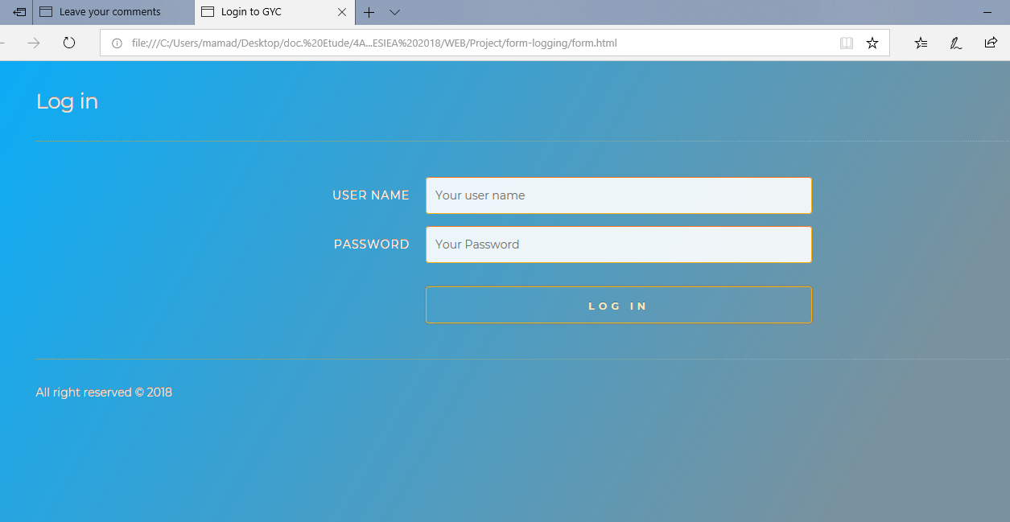

To log in, a default user was created, the default user is [esiea@esiea.fr](mailto:esiea@esiea.fr) and the password is : esiea .The next page is the object view page

## Object view page

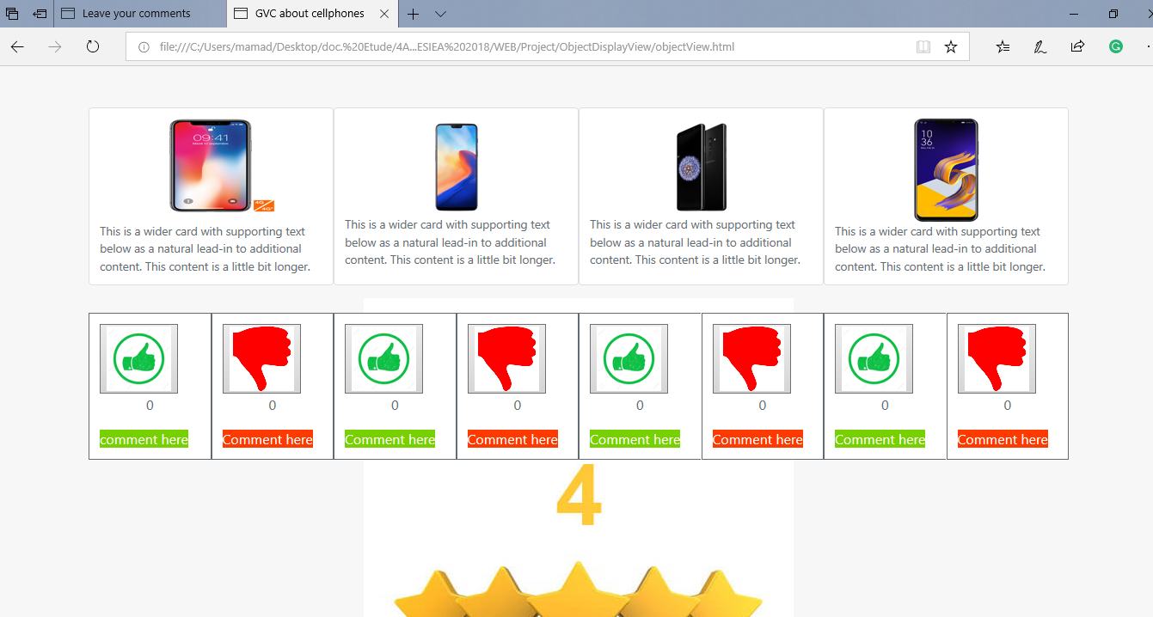

This page is the most important one. The whole app is about this one. It allow to push the button to like or dislike a picture. Under the like buttons, for those who will like to leave there comments, they just have to click on “Comment here”, the green one is to do goods comments and the red one to post bad comments.

Click on thumbs up or down as many times as you want on the cellphone that you like or dislike.

## Comments page:

This page gives the possibility to leave comments. It also shows the technical detail of the product a search bar and all the comments of other users which gave one.

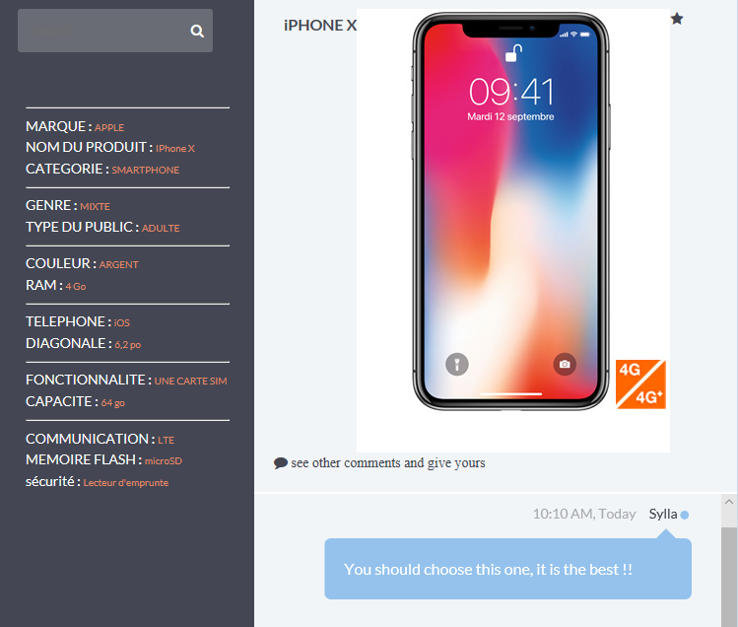

# DIFFICULTIES & SOLUTIONS

This Project was full of difficulties, barely everywhere. The project itself wasn’t tough enough, but we were beginners, so we struggled finding solutions.

The first problem we had to face was to find a subject for the project. We had two projects rejected by the teacher before validating the third one. It wasn’t that easy to set up an idea based on what we want and what the teacher expects.

We have accoutered difficulties in the following parts:

## Home page

The home page problem was not that difficult, but the importance was to make an attractive and soft design. We know that a heavy design could be

## Logging page

In this part, we had a little problem recognizing users and their passwords in order to allow them to log in, It happened when we logged in without putting an user name and a password, because we also got bugs when we implemented nodejs to check the logging. Now it works well.

## Object view page

Here the difficulty was to adapt bootstrap code to our needs, for example putting more images, comments, and implementing vuejs code, some times vuejs codes didin’t work when those were put inside bootstrap elements, so we had to learn to the good position to put those codes in.

## Vuejs implementation to treat likes

We decided to use vuejs to treat the number of likes and dislikes that cellphones receives from the users. Using vuejs was not easy for us because this is a framework that give us codes, functions and elements that are already created, and we had just to implement them, but when we tried to adapt to our needs it was a problem of understanding how to use and modify it.

## Comment page

The problem here was to post comments into the web page. When we write a comment, it has to be printed in the list comments on the page, but we couldn’t do that

At the beginning, this page was created in local, not in nodejs server, so all the js code and js files were not adapted to be treated by the server, that means that all the code had to be modified, and also we had to learn to use nodejs to treat comments as nodejs do, and not as client service do.

# POSSIBLE IMPROVEMENT

## Graphics

We could do better in the web site graphic design, but learning to adapt bootstrap, to install a server with nodejs , use vuejs, and other technical problems used most of our time. So if we continue with this project we have to improve the graphics, to make that more attractive and organized with the differences of style that each page has (same style with some variations).

## Security

Nodejs allows us to save information using a key to hide information, like password and others. We must understand and work on the security if we want to create a website for a company, so we would like to learn more about it, and implement that to our website to hide password and other information to our database, files, etc.

## Vuejs implementation

Nowaday, vuejs just increments likes and dislikes when the user is in the page of cellphones list, but we have to improve in adding functionalities like

1. Print the cellphones on the page by increasing order of number of likes.
2. Save the number of likes and dislikes in a JSON file, and read it when the user opens the page.

## Comments with a database

Honestly all comments and data from users are saved in a database in companies, we would like to use a relational database management system (RDBMS) like mongoDB to manage the user’s data and comments, it will be easier to treat data than using text files.

# CONCLUSION

This project is not fully finished as we want it to, we have successfully established a chat conversation in order to allow users to leave their comment and to like the displayed images of cellphones. The project works on the local web browser, but by using glitch server, it was not possible to leave a comment.

But in the other side, we might have some difficulties realizing the project but, we have had a full overview of the nodejs, viewjs, bootstrap and deploying on glitch. All these was was new for us, but we had the chance to practice it and it was a significant experience for us.

The course was interesting too because we learned a lot of things at the end.

We could do better, but the time was short to understand all the base of nodejs, vuejs, bootstrap, and design the website. Some nodejs tools that allows us to solve our problems were not able to use, because we had to use database, EJS files (so the order was only use HTML), vuejs functions hard to understand how to use, and others like those.

We have to improve our skills on nodejs, html,css, bootstrap, vuejs and javascript, so we will study and practice by ourself.