|  |  |
| --- | --- |
|  | Elias Beddegenoodts |
| TI reeks 2 |
| Webontwikkeling 2 |
| 20/02/2020 |

# Wireframe

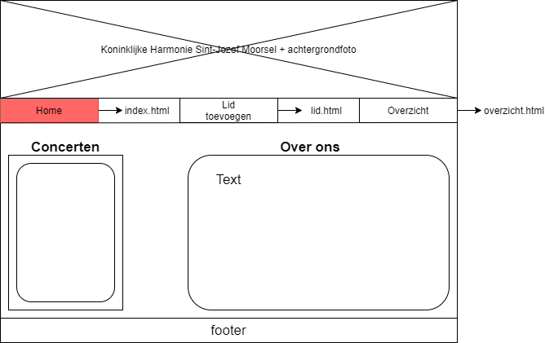

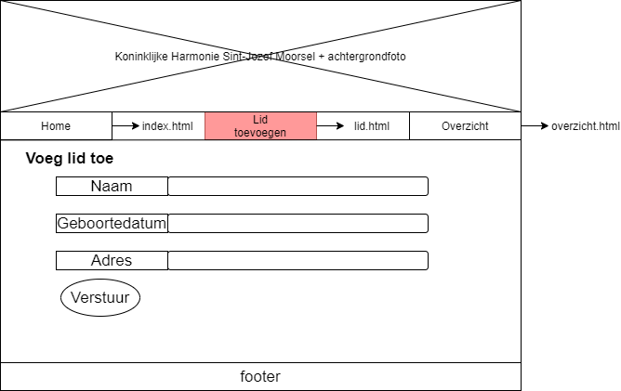

Overzicht.html

