## Impact on outpatient antimicrobial prescriptions (Paper III)

Demographic data regarding the study birth-cohorts are summarized in chapter @ref(#datasourcesresults) and Table ??. From 2005-2012, first-line penicillins were prescribed most commonly and represented between 41% and 47% of all antimicrobial prescriptions. Their use decreased suddenly in 2013 to 32%, and represented only 18% of all antimicrobial prescriptions in 2014 and 2015. During this same period, the use of second-line penicillins went from 35% to 40% 2005-2012, to 48%, 55% and 54% in 2013, 2014 and 2015. Use of cephalosporins followed a simmilar trend – it was between 5.2% and 7.8% 2005–2012, and increased to 10–15% between 2013–2016. Antimicrobial prescriptions by calendar year are shown in Table 1.

Table 1 Incidence rate and number of outpatient antimicrobial prescriptions by birth-cohort and gender

|  |  |  |  |  |  |  |  |  |
| --- | --- | --- | --- | --- | --- | --- | --- | --- |
| Calendar year | No. prescriptions | Incidence per 100 person-years | First-line penecillin | Second-line penecillin | First-generation macrolide | Second-generation macrolide | Cephalosporin | Other |
| 2005 | 25,649 | 204.0493 | 41.41 | 37.92 | 1.48 | 6.55 | 5.37 | 7.26 |
| 2006 | 26,396 | 205.5123 | 40.34 | 39.57 | 1.27 | 6.22 | 5.36 | 7.24 |
| 2007 | 25,179 | 192.0448 | 44.97 | 36.80 | 1.60 | 6.39 | 5.16 | 5.08 |
| 2008 | 24,046 | 178.4622 | 46.74 | 35.22 | 0.20 | 6.37 | 5.91 | 5.57 |
| 2009 | 22,409 | 159.3586 | 46.41 | 37.16 | 0.05 | 5.51 | 6.33 | 4.55 |
| 2010 | 24,007 | 166.9239 | 43.71 | 38.55 | 0.02 | 5.54 | 7.02 | 5.17 |
| 2011 | 23,866 | 163.6002 | 44.70 | 37.92 | 0.03 | 5.91 | 7.47 | 3.98 |
| 2012 | 22,703 | 159.5993 | 43.45 | 39.01 | 0.01 | 6.92 | 7.77 | 2.83 |
| 2013 | 21,113 | 151.9686 | 32.10 | 48.08 | 0.02 | 6.56 | 10.03 | 3.20 |
| 2014 | 20,325 | 151.7924 | 18.48 | 55.46 | 0.01 | 6.60 | 14.53 | 4.92 |
| 2015 | 19,873 | 149.6010 | 18.49 | 53.91 | 0.06 | 7.25 | 14.95 | 5.34 |
| 2016 | 20,543 | 160.3294 | 35.28 | 41.68 | 0.04 | 5.52 | 12.91 | 4.57 |

The proportion of visits resulting in antimicrobial prescription and the incidence of antimicrobial prescriptions linked to each of the study’s diagnostic groups are shown in Figure 1. The proportion of otitis media visits resulting in a antimicrobial prescription remained stable between 57% and 64% of visits. The incidence of otitis media associated prescriptions decreased from a high of 54.9 prescriptions per 100 person-years in 2008 to 39.8 prescriptions per 100 person-years in 2015.

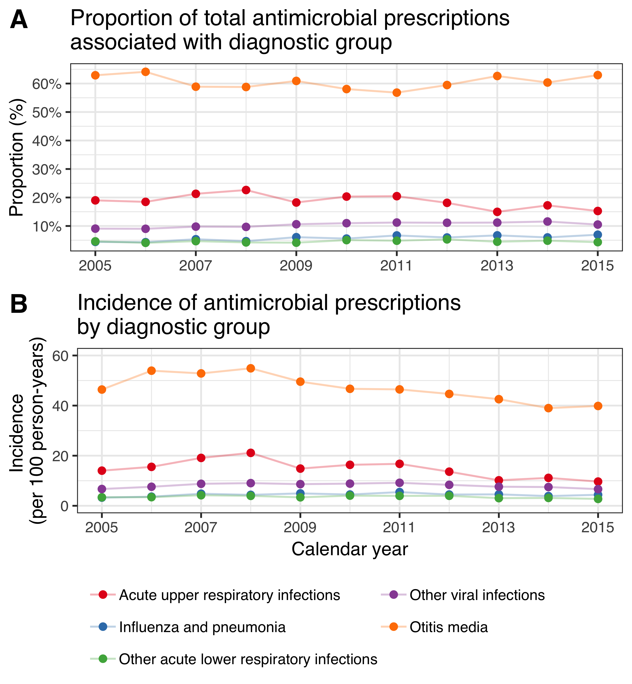

Figure 1 Proportion of visits due to each diagnostic group resulting in antimicrobial prescription and incidence of associated antimicrobial prescriptions

A total of 226,084 outpatient antimicrobial prescriptions were recorded among birth-cohorts 2005-2015 during the study period. The crude incidence rate of outpatient antimicrobial prescriptions per 100 person-years in the VNEC and VEC was 164.6 and 150.2 respectively. The incidence rate and number of outpatient antimicrobial prescriptions by birth-cohort, and gender is shown in Table 2.

Table 2 Incidence rate and number of outpatient antimicrobial prescriptions by birth-cohort and gender

|  |  |  |
| --- | --- | --- |
| Birth-cohort | Females | Males |
| 2005 | 176.0 (11,178) | 200.0 (13,423) |
| 2006 | 167.0 (10,843) | 190.0 (13,109) |
| 2007 | 153.0 (10,140) | 174.0 (12,339) |
| 2008 | 153.0 (10,543) | 171.0 (12,492) |
| 2009 | 151.0 (10,699) | 169.0 (12,775) |
| 2010 | 150.0 (10,366) | 161.0 (11,854) |
| 2011 | 142.0 ( 9,230) | 156.0 (10,906) |
| 2012 | 142.0 ( 9,447) | 158.0 (11,058) |
| 2013 | 138.0 ( 9,015) | 158.0 (10,180) |
| 2014 | 145.0 (7,726) | 167.0 (9,234) |
| 2015 | 138.0 (4,075) | 173.0 (5,452) |

The lowest incidence was observed in children zero to five months of age. The incidence increased sharply thereafter and peaked in children six to eleven and twelve to seventeen months of age, after which it decreased again. The crude IR decreased significantly in all age-groups, with incidence rate ratios ranging from 0.82-0.94. The largest and visually most consistent decrease in incidence was noted among children zero to five months of age, IRR 0.82 (95%CI 0.79-0.85), Figure 2

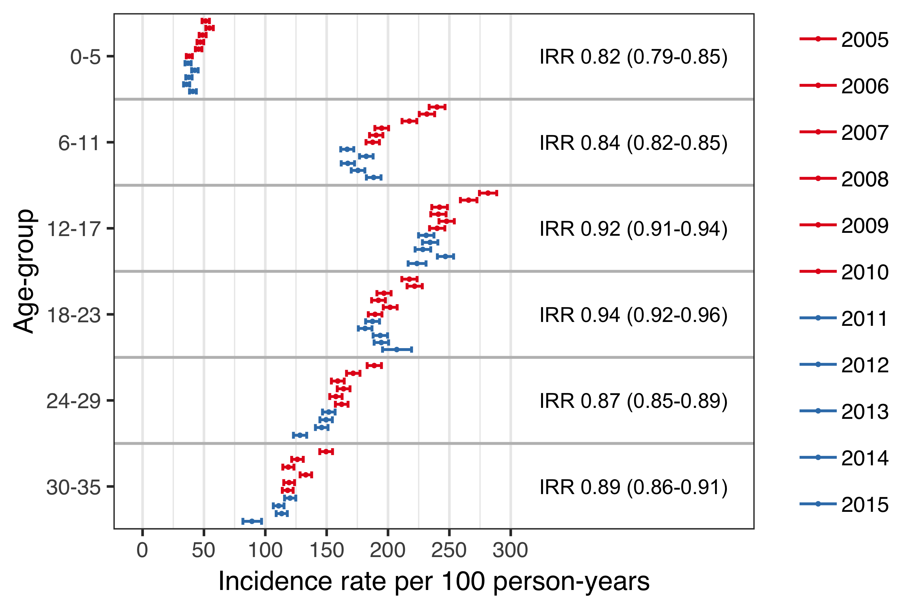

Figure 2 Incidence of outpatient antimicrobial prescriptions by age-group and birth-cohort

The proportion of children in the VNEC and VEC who filled at least one antimicrobial prescription by three years of age was 88.6% and 86.8 respectively. Children in the VEC were significantly more likely than children in the VNEC to have not filled an antimicrobial prescription (incidence risk ratio 1.16, 95%CI 1.10-1.23) or filled only between one and four antimicrobial prescriptions (incidence risk ratio 1.08, 95%CI 1.06–1.11). The cumulative number of prescriptions by vaccine eligibility cohort in shown in Table 3.

Table 3 The proportion of children in the vaccine non-eligible cohorts (VNEC, born: 2005–2010) and vaccine eligible cohorts (VEC, born 2011–2013) that had filled 0, 1–4, 5–9, 10–14 and ≥ 15 prescriptions at 36 months of age.

|  |  |  |  |
| --- | --- | --- | --- |
| No. prescriptions | VNEC (%) | VEC (%) | Incidence risk (95%CI) |
| 0 | 11.4 | 13.2 | 1.16 (1.10-1.23) |
| 1-4 | 43.7 | 47.3 | 1.08 (1.06-1.11) |
| 5-9 | 31.6 | 29.0 | 0.918 (0.889-0.947) |
| 10-14 | 9.79 | 7.52 | 0.768 (0.716-0.823) |
| ≥15 | 3.51 | 2.91 | 0.831 (0.74-0.934) |

Discrimination indices for the Andersen-Gill multiple event model were adequate, Nagelkerke’s = 0.212 and Somer’s = 0.295. A diagnostic plot of Schoenfeld residuals was used to visually assess the proportional hazard assumption for each covariate and no systematic deviations were detected. The model was used to estimate the hazard ratio of outpatient antimicrobial prescriptions between each of the study’s birth-cohorts and the last vaccine non-eligible cohort, 2010. Visually, there seemed to be a decreasing trend in hazard among the vaccine non-eligible birth-cohorts (Figure 3). The hazard did not change significantly between the last vaccine non-eligible birth-cohort and the preceeding two cohorts, but decreased significantly thereafter, with each vaccine eligible cohort having a significantly lower hazard of outpatient antimicrobial prescription. The estimated impact of PHiD-CV10 on outpatient antimicrobial prescriptions among children under three years of age was 8% (95%CI 4%-12%).

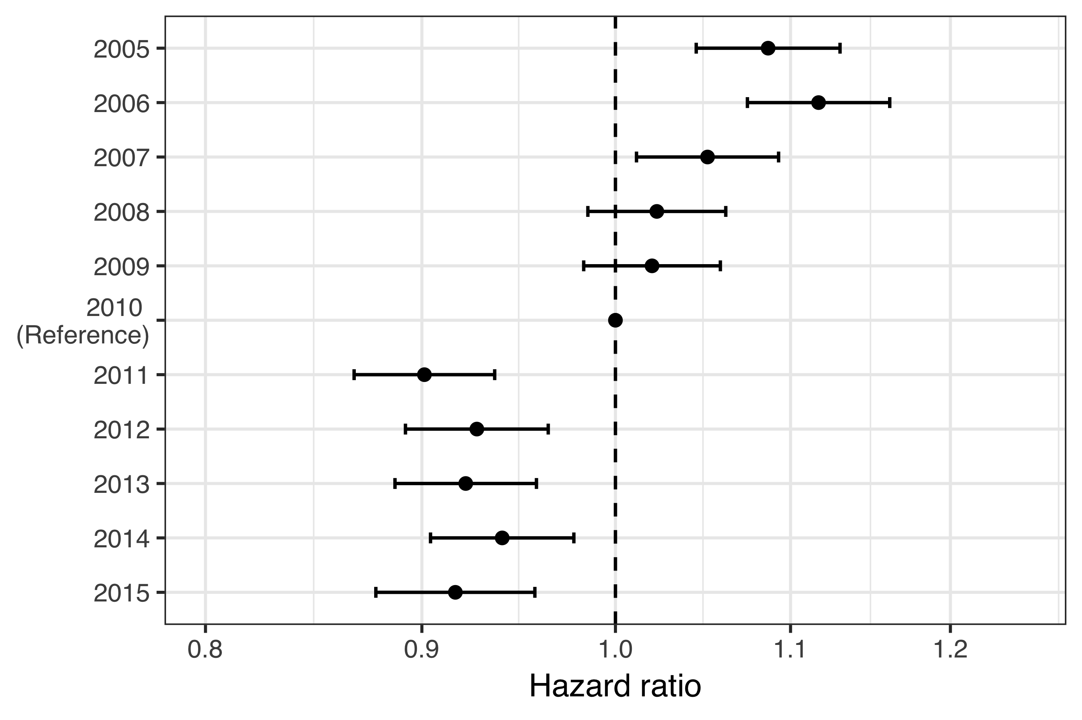

Figure 3 Estimated hazard ratio between each of the study’s birth-cohorts and the last vaccine non-eligible birth-cohort

When the hazard ratio of outpatient antimicrobial prescriptions between the VEC and VNEC was stratified by the number of previous prescriptions, the vaccine impact was descernable for children who had up to three prior antimicrobial prescriptions, after which no effect was found (Figure 4).

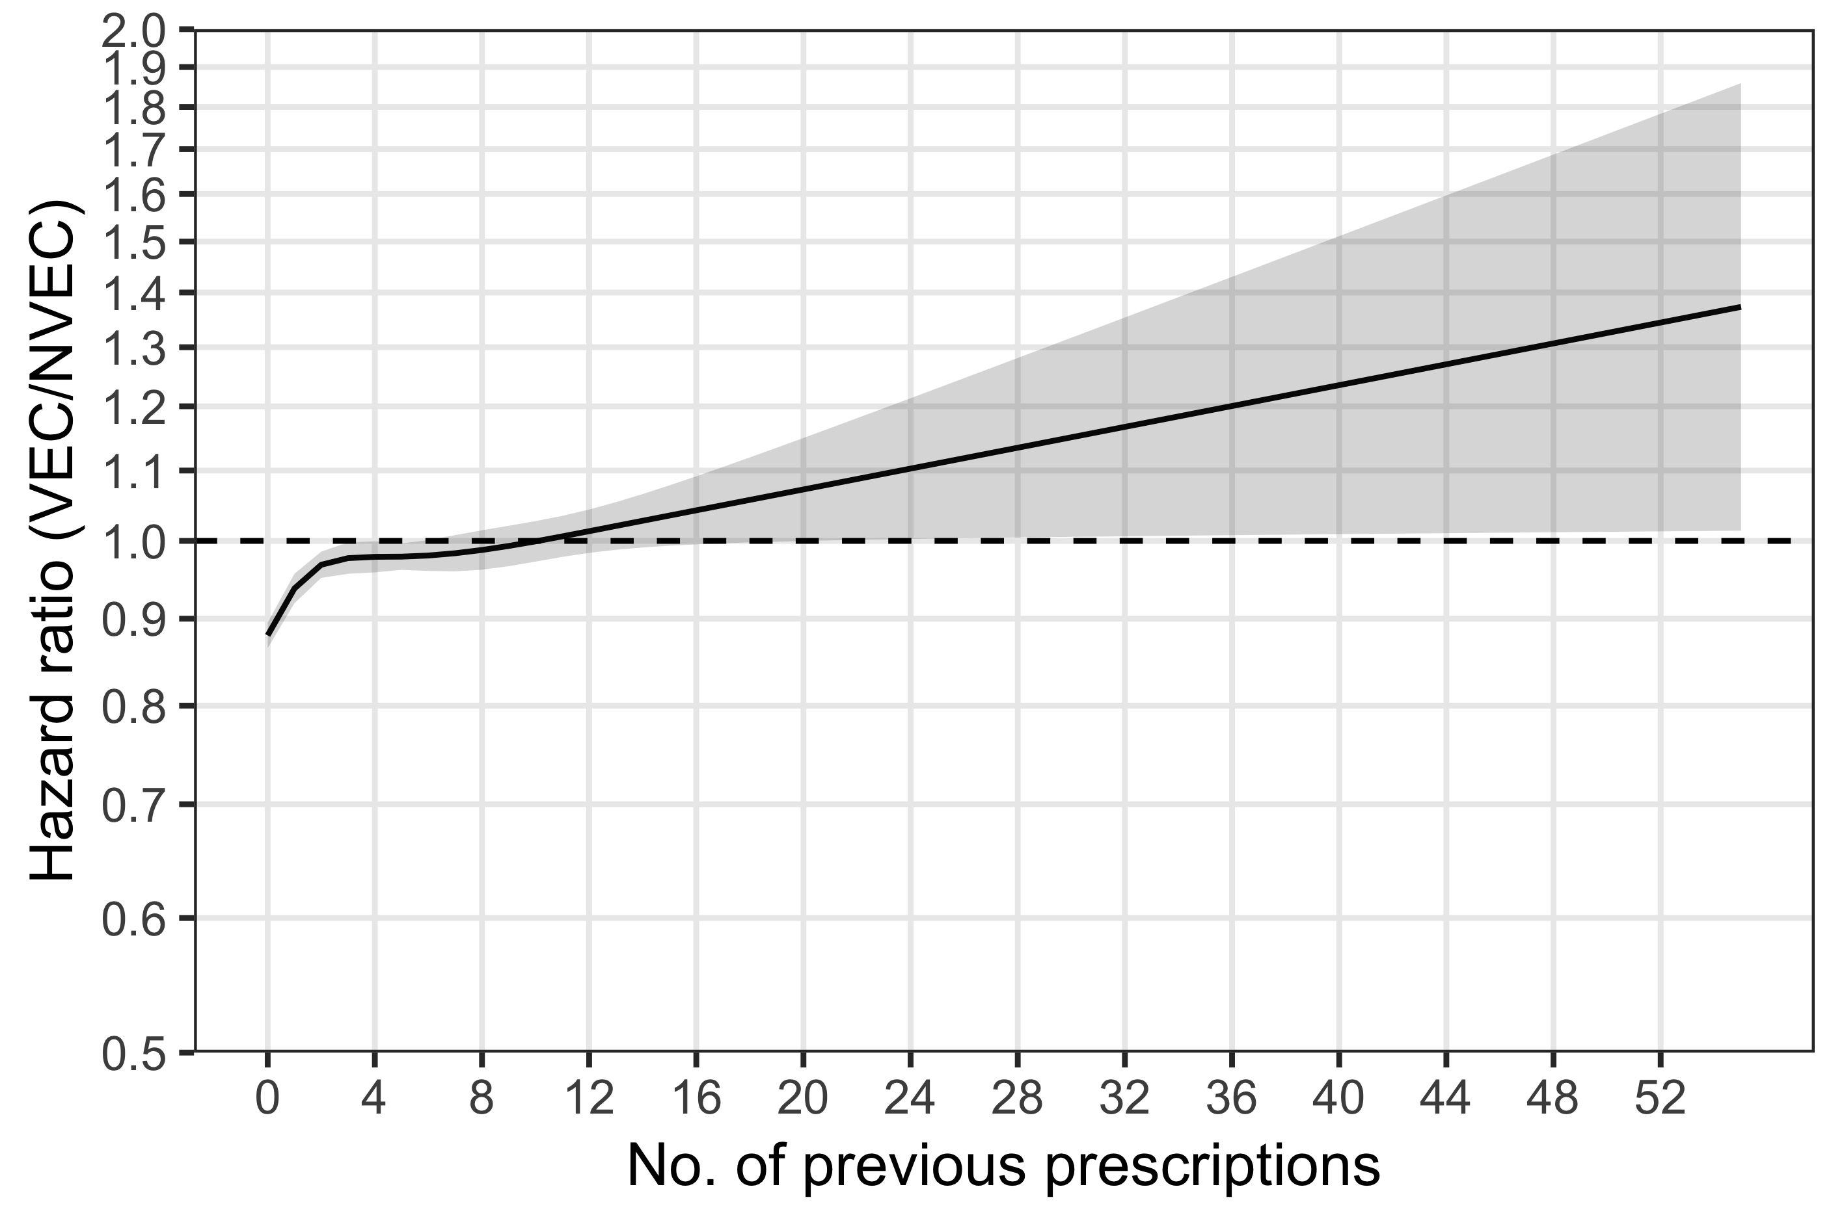

Figure 4 Estimated hazard ratio of AOM between VEC and VNEC stratified by the number of previous visits

The mean number of outpatient antimicrobial prescriptions as a function of age was caclulated using the generalized Nelson-Aalen estimate on the underlying Andersen-Gill model. By their fourth birthday, the average male child in the VNEC had filled 6.48 antimicrobial prescriptions and the average female had filled 6.07. The average male and female in the VEC had filled 5.84 and 5.46 prescriptions respectively. The mean number of antimicrobial prescriptions by age and gender is shown in Figure 5.

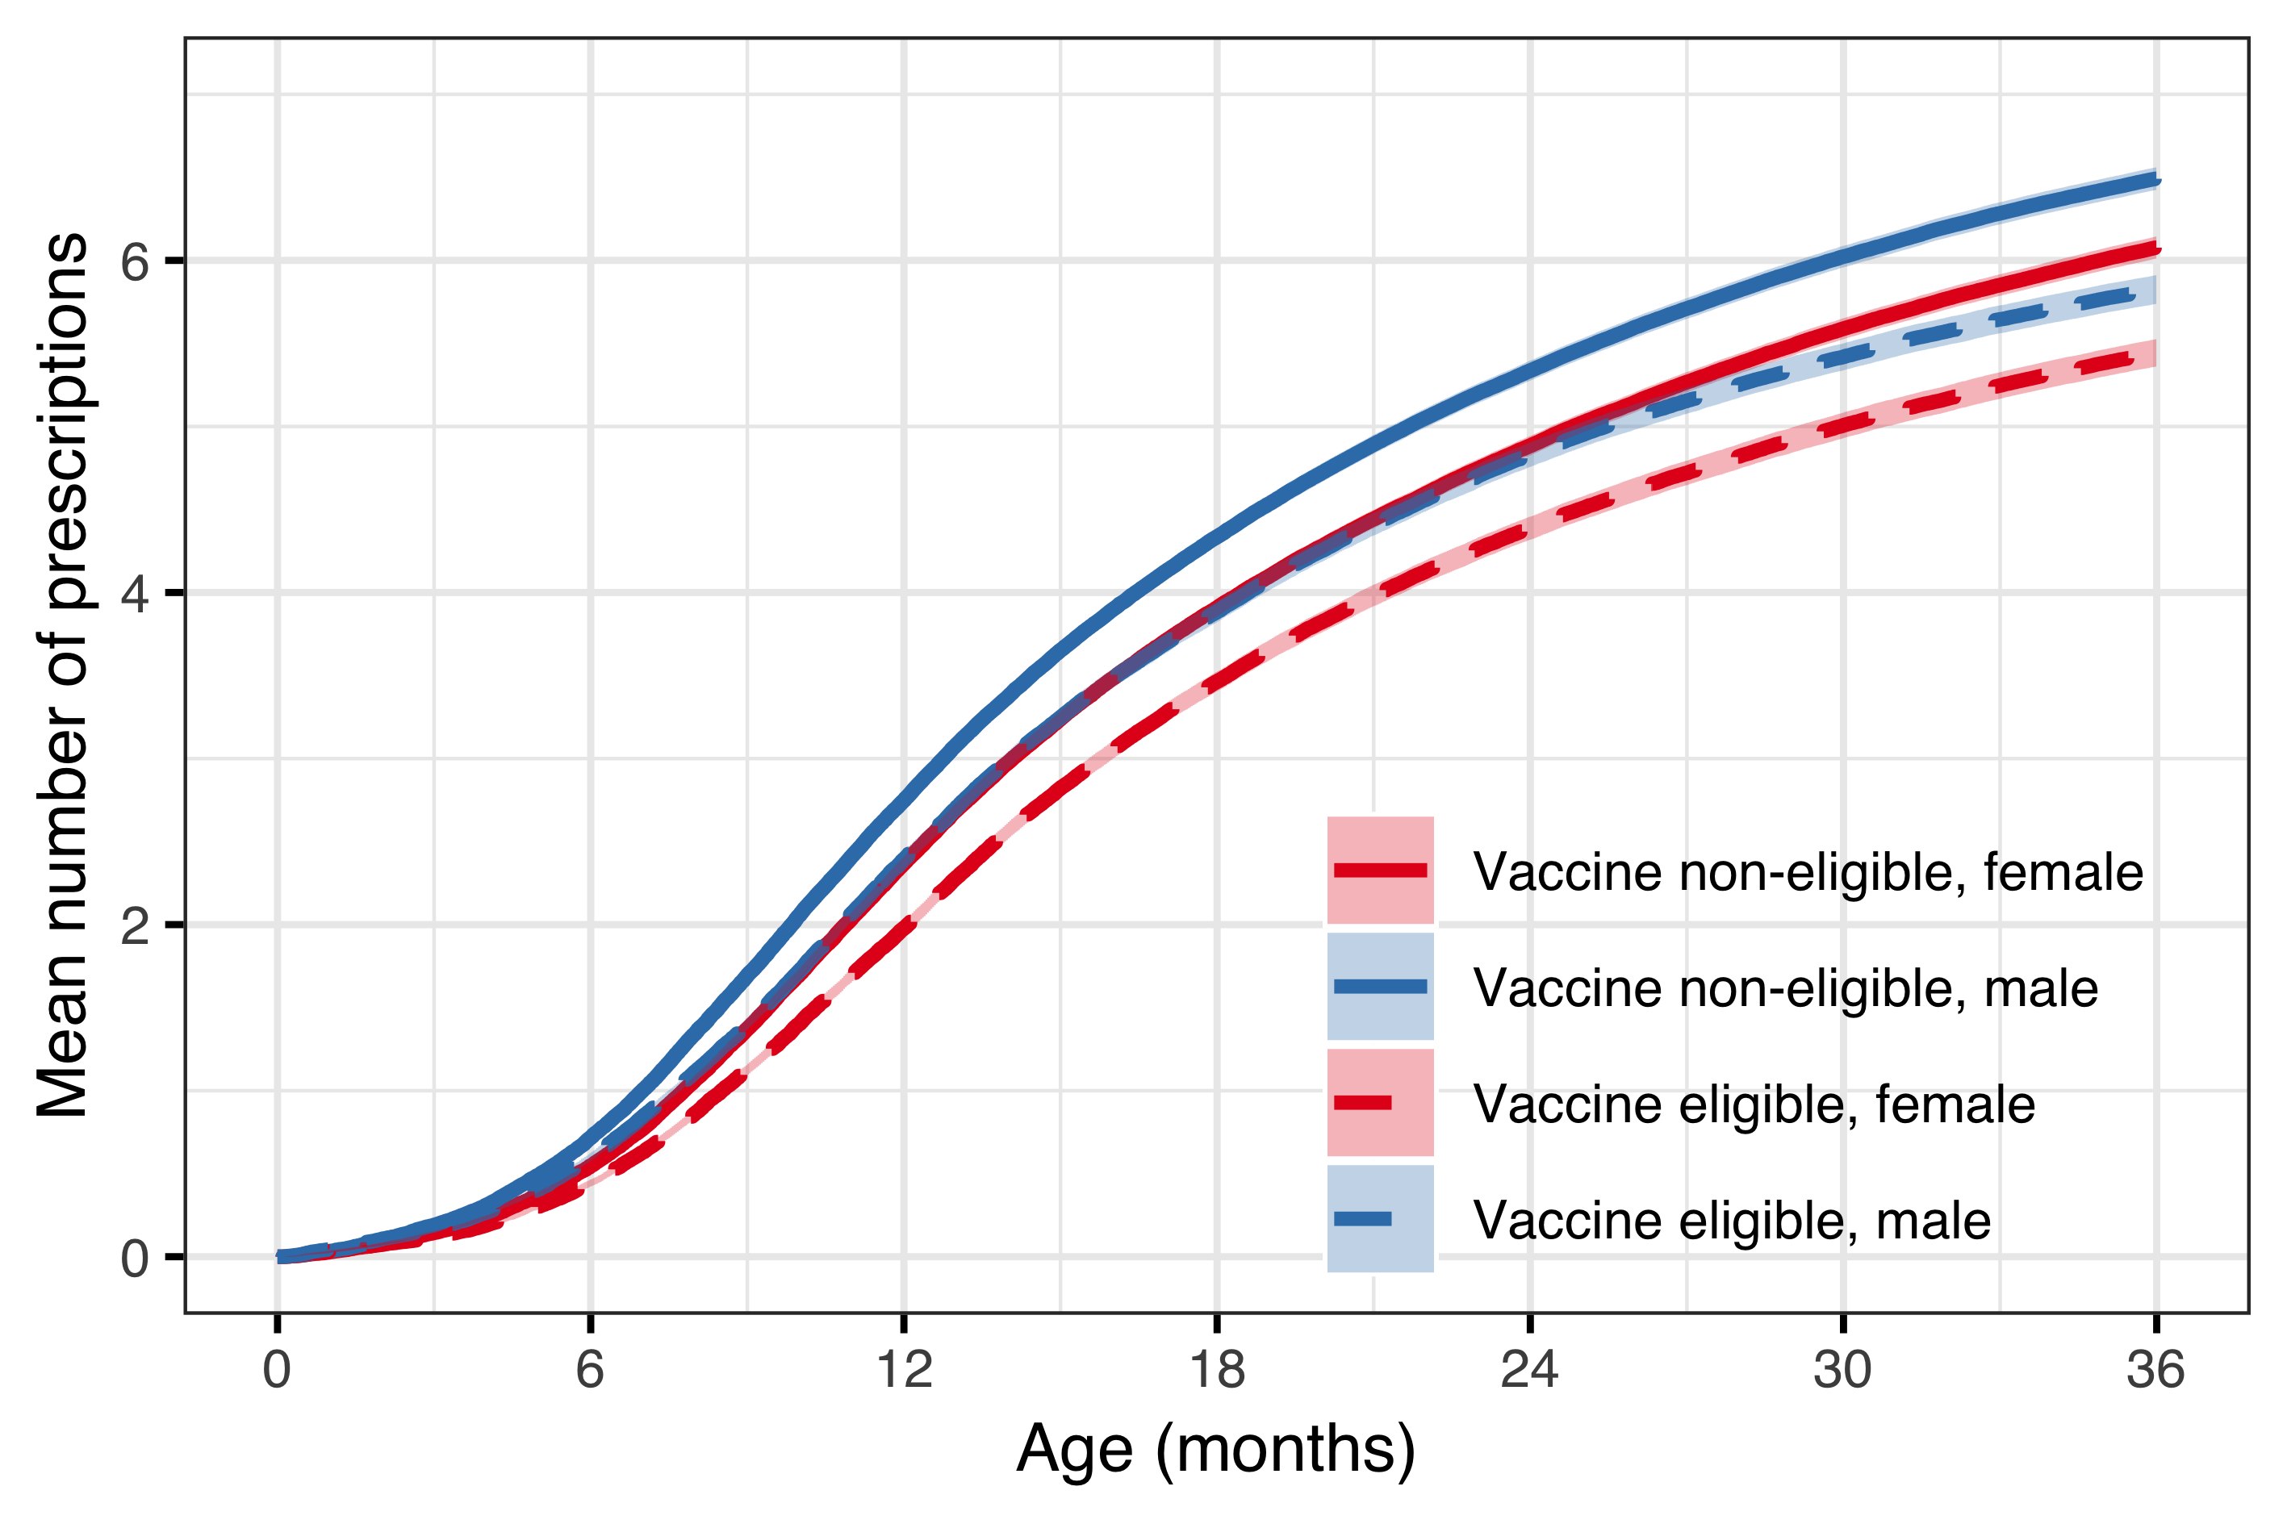

Figure 5 Mean number of AOM episodes by age in the vaccine eligible and vaccine non-eligible cohorts