PhD thesis

Elías Sæbjörn Eyþórsson

2018-12-27

Table of Contents

# Preamble

Placeholder

# Introduction

Placeholder

## Clinical manifestations of *Streptococcus pneumoniae*

### Acute otitis media

#### Pathogens implicated in acute otitis media

#### Healthcare burden of otitis media

#### Tympanostomy tube procedures

#### Acute otitis media in Iceland

### Pneumonia

#### Pathogens causing pneumonia

#### Healthcare burden of pneumonia

### Invasive pneumococcal disease

## Pneumococcal vaccines

### A brief history of pneumococcal vaccination

### The impact of pneumococcal conjugate vaccines on otitis media

#### Randomized controlled trials evaluting the efficacy of pneumococcal conjugate vaccines for otitis media

#### Observational studies evaluting the impact of pneumococcal conjugate vaccines for otitis media.

### The impact of pneumococcal conjugate vaccines on pneumonia

### The impact of pneumococcal conjugate vaccines on invasive pneumococcal disease

## Cost-effectiveness in the context of pneumococcal conjugate vaccination

### Vaccine efficacy assumptions in economic analyses of pneumococcal conjugate vaccines

### Assumptions regarding costs and utilities in economic analyses of pneumococcal vaccines

# Aims

The aims of the thesis were to estimate the impact of PHiD-CV10 on various facets of pneumococcal disease, associated healthcare burden, and cost:

1. The incidence of paediatric emergency department visits for otitis media with treatment failure (Paper I)
2. The incidence of otitis media visits to primary care (Paper II)
3. The incidence of outpatient antimicrobial prescriptions (Paper III)
4. The incidence of tymapnostomy tube procedures (Paper IV)
5. The incidence of hospitalizations for respiratory and invasive infections commonly associated with *Streptococcus pneumoniae* (Paper V)
6. Incidence of pneumococcal disease in all age-groups and cost-effectiveness analysis (Paper VI)

# Materials and methods

Placeholder

## Data collection and sources

### Statistics Iceland

### Landspitali University Hospital patient registry

### The Primary Care Registry

### The National Vaccine Registry

### The National Drug Prescription Registry

### Reimbursement database of Icelandic Health Insurance

## Impact on otitis media with treatment failure (Paper I)

## Impact on primary care visits for acute otitis media (Paper II)

## Impact on outpatient antimicrobial prescriptions (Paper III)

## Impact on tympanostomy tube procedures (Paper IV)

## Impact on respiratory associated hospitalizations (Paper V)

## Impact and cost-effectiveness analysis (Paper VI)

### Data sources

### Statistical analysis

# Results

Placeholder

## Data collection and sources

### Statistics Iceland

### Landspitali University Hospital patient registry

### The Primary Care Registry

### The National Vaccine Registry

### The National Drug Prescription Registry

### Reimbursement database of Icelandic Health Insurance

## Impact on otitis media with treatment failure (Paper I)

The total number of children under 18 years of age who lived within Children’s Hospital Iceland’s referral region remained stable during the study period, decreasing from 62,067 in 2008 to 61,798 in 2015. The variation in the number of children under four years of age in the same region was more pronounced, increasing from 13,562 in 2008 to 14,644 in 2011, and then decreasing again to 13,272 in 2015.

During the period 1 January 2008 to 31 December 2015, 103,220 visits were recorded to the emergency department of Children’s Hospital Iceland. The visits varied over the calendar year, spiking in the winter months and troughing in the summer months. The total number of visits increased steadily during the study period, from 12,229 in 2008 to 14,502 in 2015 (Figure 1).

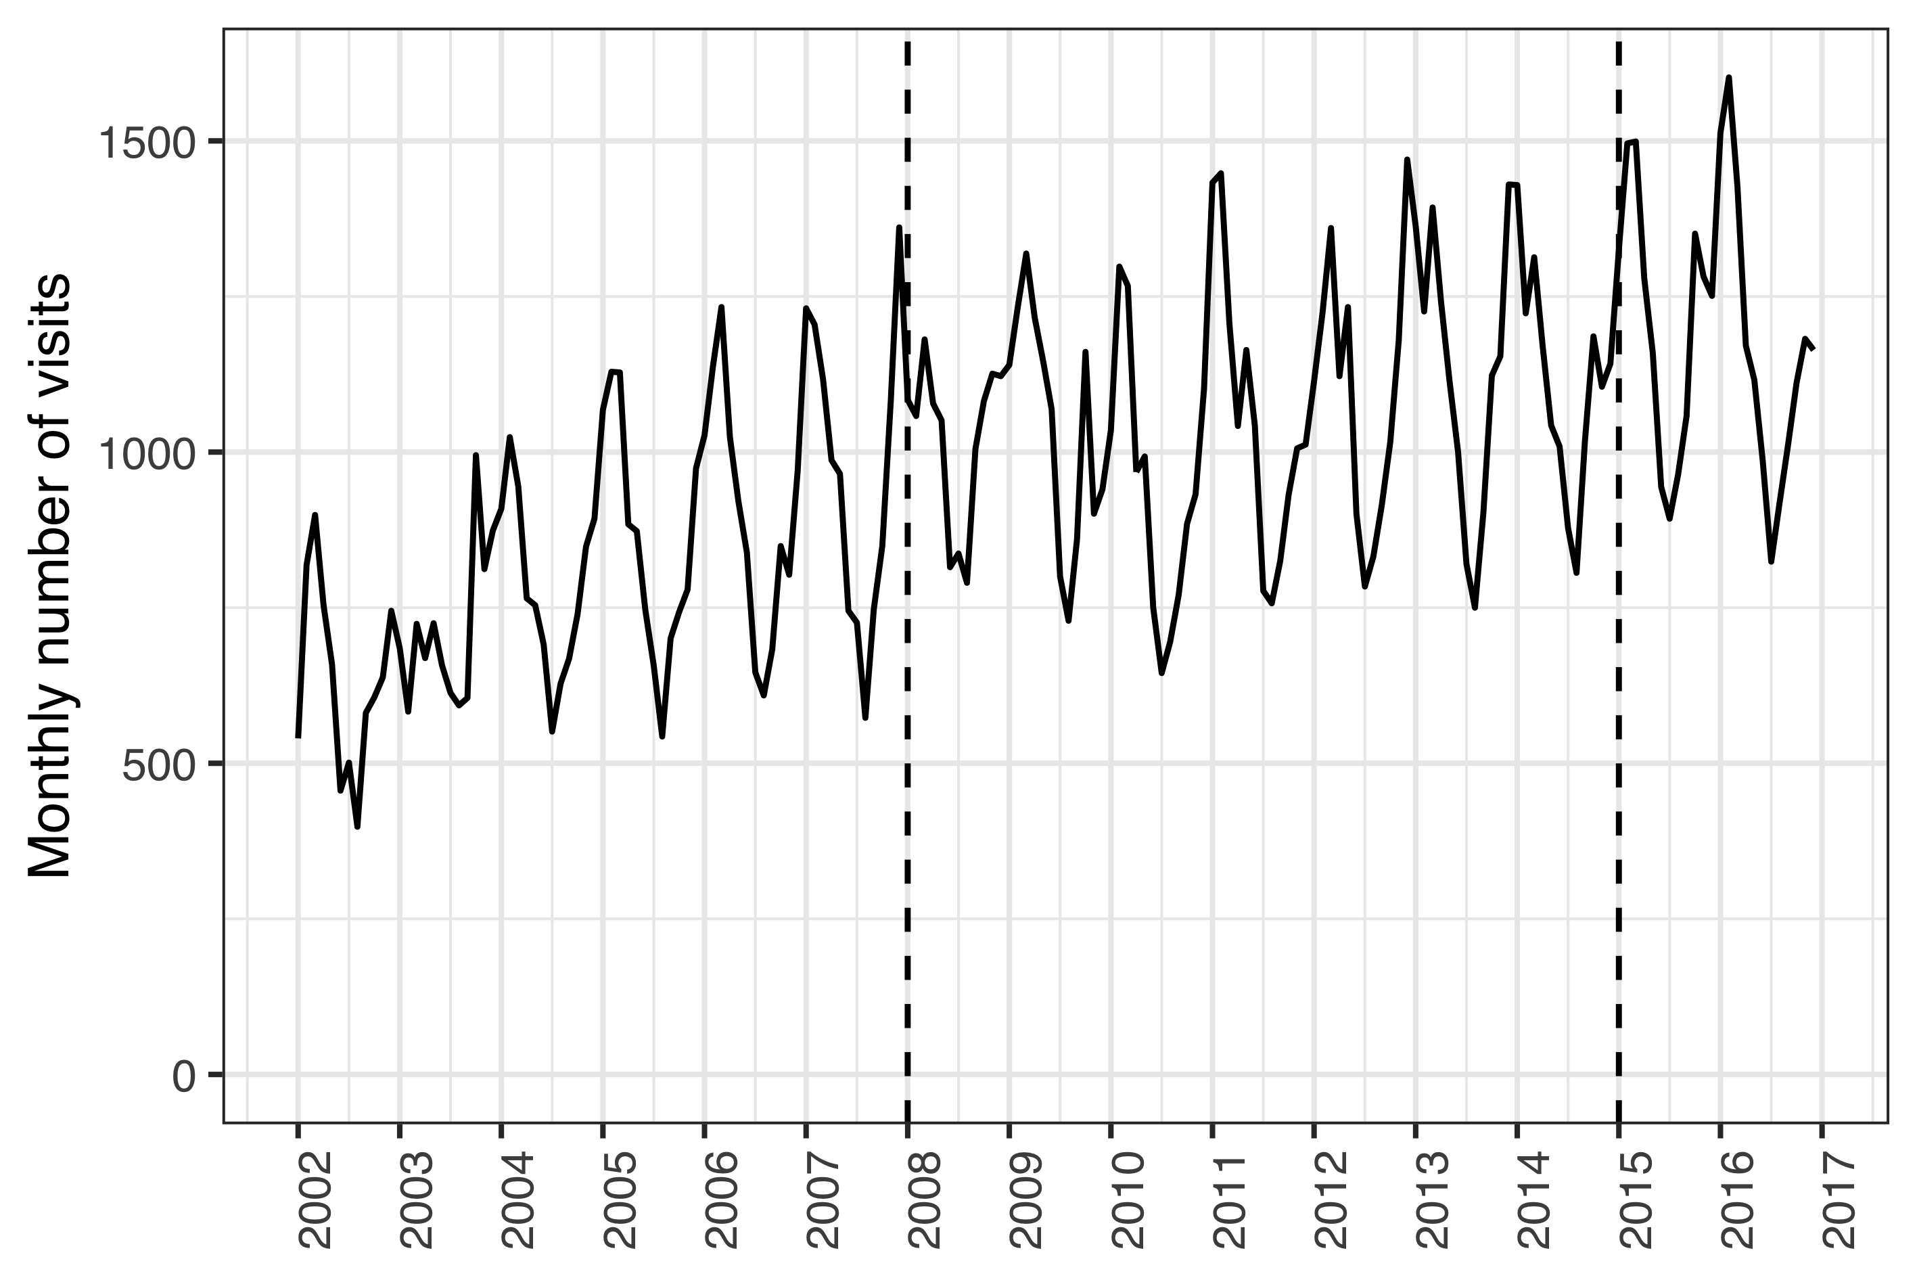

Figure 1 The monthly number of visits of children zero to 18 years of age to Children’s Hospital Iceland’s emergency department for the period from January 2002 to December 2016. All visits are included regardless of International Classification of Diseases, 10th revision (ICD-10) diagnostic codes. The study period was from January 2008 to December 2015, and is delineated with two vertical dashed lines.

During the same period, 6,232 visits to the Children’s Hospital Iceland for acute otitis media were recorded for 4,624 individual children under four years of age, representing 4,994 distinct episodes. Of those episodes, 531 were treated with one or more doses of ceftriaxone. The total number of visits, visits for AOM and ceftriaxone treatment episodes are shown in Table 1,

Table 1 The incidence of visits and parenteral ceftriaxone administrations at Children’s Hospital Iceland by calendar-year. The incidence is both presented for all visits regardless of diagnosis (Total) and visits associated with acute otitis media (AOM). When presented for total visits or administrations, the denominator is children 18 and younger who live within Children’s Hospital Iceland’s referral region and is expressed per 1,000 visits or person-years. The denominator of AOM associated visits are children younger than four years of age in the same region. The incidence rate and incidence risk are shown with the number of events within parentheses

|  |  |  |  |  |  |  |
| --- | --- | --- | --- | --- | --- | --- |
| Year | Total (n) | AOM (n) | Total (n) | AOM (n) | Total (n) | AOM (n) |
| 2008 | 197 (12,229) | 69 (936) | 80.8 (988) | 186 (174) | 15.9 (988) | 72.9 (174) |
| 2009 | 199 (12,514) | 72 (1,012) | 74.8 (936) | 192 (194) | 14.9 (936) | 66.5 (194) |
| 2010 | 181 (11,339) | 64.2 (925) | 81 (918) | 253 (234) | 14.6 (918) | 63.7 (234) |
| 2011 | 201 (12,645) | 60.8 (890) | 63.8 (807) | 178 (158) | 12.8 (807) | 55.1 (158) |
| 2012 | 215 (13,150) | 58.4 (830) | 52.5 (691) | 163 (135) | 11.3 (691) | 48.6 (135) |
| 2013 | 221 (13,518) | 55.2 (772) | 54.7 (739) | 105 (81) | 12.1 (739) | 52.8 (81) |
| 2014 | 216 (13,323) | 52 (708) | 48.9 (652) | 76.3 (54) | 10.6 (652) | 47.9 (54) |
| 2015 | 235 (14,502) | 55.1 (731) | 56.7 (822) | 88.9 (65) | 13.3 (822) | 61.9 (65) |

The incidence rate of AOM visits to Children’s Hospital Iceland decreased significantly in the post-vaccine period as compared to the pre-vaccine period; from 47.4 visits to 41.8 per 1,000 person-years. The crude IRR was 0.88 (95% CI 0.83 to 0.93). Mantel-Haenszel adjustment was not appropriate due to effect heterogeneity ( = 15.2, *P*<0.001). When each age-group was examined separately, a significant decrease in AOM visits was observed among children between one and two years of age (IRR 0.89) and between two and three years of age (IRR 0.79) as shown in Table 2. Children younger than one year of age and children between three and four years of age, visited the Children’s Hospital Iceland because of AOM 471 times and 379 times, respectively.

Table 2 The incidence rate ratios (IRR) of acute otitis media (AOM) associated visits between the pre- and post-vaccine periods are presented for each age with 95% confidence intervals within parentheses. The chi-squared statistic and P-value are also presented.

|  |  |  |  |
| --- | --- | --- | --- |
| Age (years) | IRR (95% CI) | Chi-squared | P-value |
| <1 | 1.10 (0.90-1.30) | 0.80 | 0.370 |
| 1-2 | 0.89 (0.83-0.96) | 8.60 | 0.003 |
| 2-3 | 0.79 (0.71-0.88) | 17.00 | <0.001 |
| 3-4 | 1.00 (0.85-1.30) | 0.22 | 0.639 |

Independent of the decrease in AOM associated visits to the Children’s Hospital, the incidence of ceftriaxone treatment episodes for AOM was also found to decrease significantly in the post-vaccine period compared to the pre-vaccine period. The effect was heterogeneous across age-strata ( = 57, *P*<0.001) and the crude overall IRR was 0.48 (95% CI 0.40 to 0.58). The stratum specific results are shown in Table 3. During the study period, only 17 episodes of AOM were treated with ceftriaxone among children zero to one years of age and 19 episodes were treated among children three to four years of age.

Table 3 The incidence rate ratios (IRR) of ceftriaxone treatment episodes of acute otitis media (AOM) between the pre- and post-vaccine periods are presented for each age with 95% confidence intervals within parentheses. The chi-squared statistic and P-value are also presented.

|  |  |  |  |
| --- | --- | --- | --- |
| Age (years) | IRR (95% CI) | Chi-squared | P-value |
| <1 | 0.61 (0.19-1.80) | 0.96 | 0.326 |
| 1-2 | 0.47 (0.37-0.60) | 41.00 | <0.001 |
| 2-3 | 0.47 (0.32-0.68) | 18.00 | <0.001 |
| 3-4 | 0.85 (0.31-2.30) | 0.12 | 0.732 |

The risk of receiving ceftriaxone treatment if presenting to Children’s Hospital Iceland with AOM was calculated to correct for the possibility that observed decreases in ceftriaxone treatment episodes were due only to a decrease in the number of AOM associated visits. The risk decrease was not homogeneous across age-strata ( = 33.8, *P*<0.001) and the overall relative risk ratio was 0.58 (95% CI 0.48 to 0.69). The stratum specific effects are shown in Table 4.

Table 4 The incidence risk ratio (IRR) of receiving ceftriaxone treatment if presenting to Children’s Hospital Iceland with acute otitis media (AOM) between the pre- and post-vaccine periods is shown along with 95% confidence intervals. The corresponding Chi-squared statistic and P-value are also presented.

|  |  |  |  |
| --- | --- | --- | --- |
| Age (years) | IRR (95% CI) | Chi-squared | P-value |
| <1 | 0.56 (0.17-1.70) | 1.30 | 0.258 |
| 1-2 | 0.53 (0.42-0.67) | 26.00 | <0.001 |
| 2-3 | 0.59 (0.40-0.86) | 7.50 | 0.006 |
| 3-4 | 0.81 (0.29-2.20) | 0.19 | 0.662 |

Thus the study found significant decreases in the incidence of AOM visits, ceftriaxone treatment episodes of AOM and risk of ceftriaxone treatment if presenting to the Children’s Hospital Iceland with AOM. Similar decreases were established in the ceftriaxone treatment episodes for pneumonia. In the pre-vaccine period, 251 treatment episodes were recorded, compared to only 90 in the post-vaccine period. The effect was not consistent across age-strata ( = 72, *P*<0.001). The overall IRR was 0.37 (95% CI 0.29 to 0.47). The stratum specific effects are shown in Table 5.

Table 5 The incidence rate ratio (IRR) of ceftriaxone treatment episodes of pneumonia between the pre- and post-vaccine periods are presented along with 95% confidence intervals. The Chi-squared statistic and P-value are also shown.

|  |  |  |  |
| --- | --- | --- | --- |
| Age (years) | IRR (95% CI) | Chi-squared | P-value |
| <1 | 0.15 (0.017-0.64) | 8.6 | 0.003 |
| 1-2 | 0.34 (0.220-0.51) | 33.0 | <0.001 |
| 2-3 | 0.36 (0.230-0.54) | 28.0 | <0.001 |
| 3-4 | 0.51 (0.290-0.89) | 6.4 | 0.012 |

To ascertain whether a decrease in ceftriaxone use occurred in vaccinated children for non-vaccine related indications, the incidence of ceftriaxone treatment episodes for all other indications was examined. No heterogeneity across age-strata was detected ( = 0.56, *P*=0.455). The Mantel-Haenszel adjusted IRR was 0.96 (95% CI 0.87 to 1.06), and the null hypothesis of no difference in the incidence rate of treatment episodes could not be rejected. The number of treatment episodes by age and vaccine period ranged from 117 to 295. The stratum specific IRR are shown in Table 6.

Table 6 The incidence rate ratios (IRR) of ceftriaxone treatment episodes for indications other than acute otitis media and pneumonia between the pre- and post-vaccine periods are presented for each age with 95% confidence intervals within parentheses. The chi-squared statistic and P-value are also presented.

|  |  |  |  |
| --- | --- | --- | --- |
| Age (years) | IRR (95% CI) | Chi-squared | P-value |
| <1 | 1.30 (1.10-1.50) | 7.60 | 0.006 |
| 1-2 | 0.86 (0.70-1.00) | 2.40 | 0.121 |
| 2-3 | 0.73 (0.58-0.91) | 8.00 | 0.005 |
| 3-4 | 0.90 (0.70-1.20) | 0.62 | 0.432 |

The quarterly incidence of ceftriaxone treatment episodes by indication are shown in Figure 2.

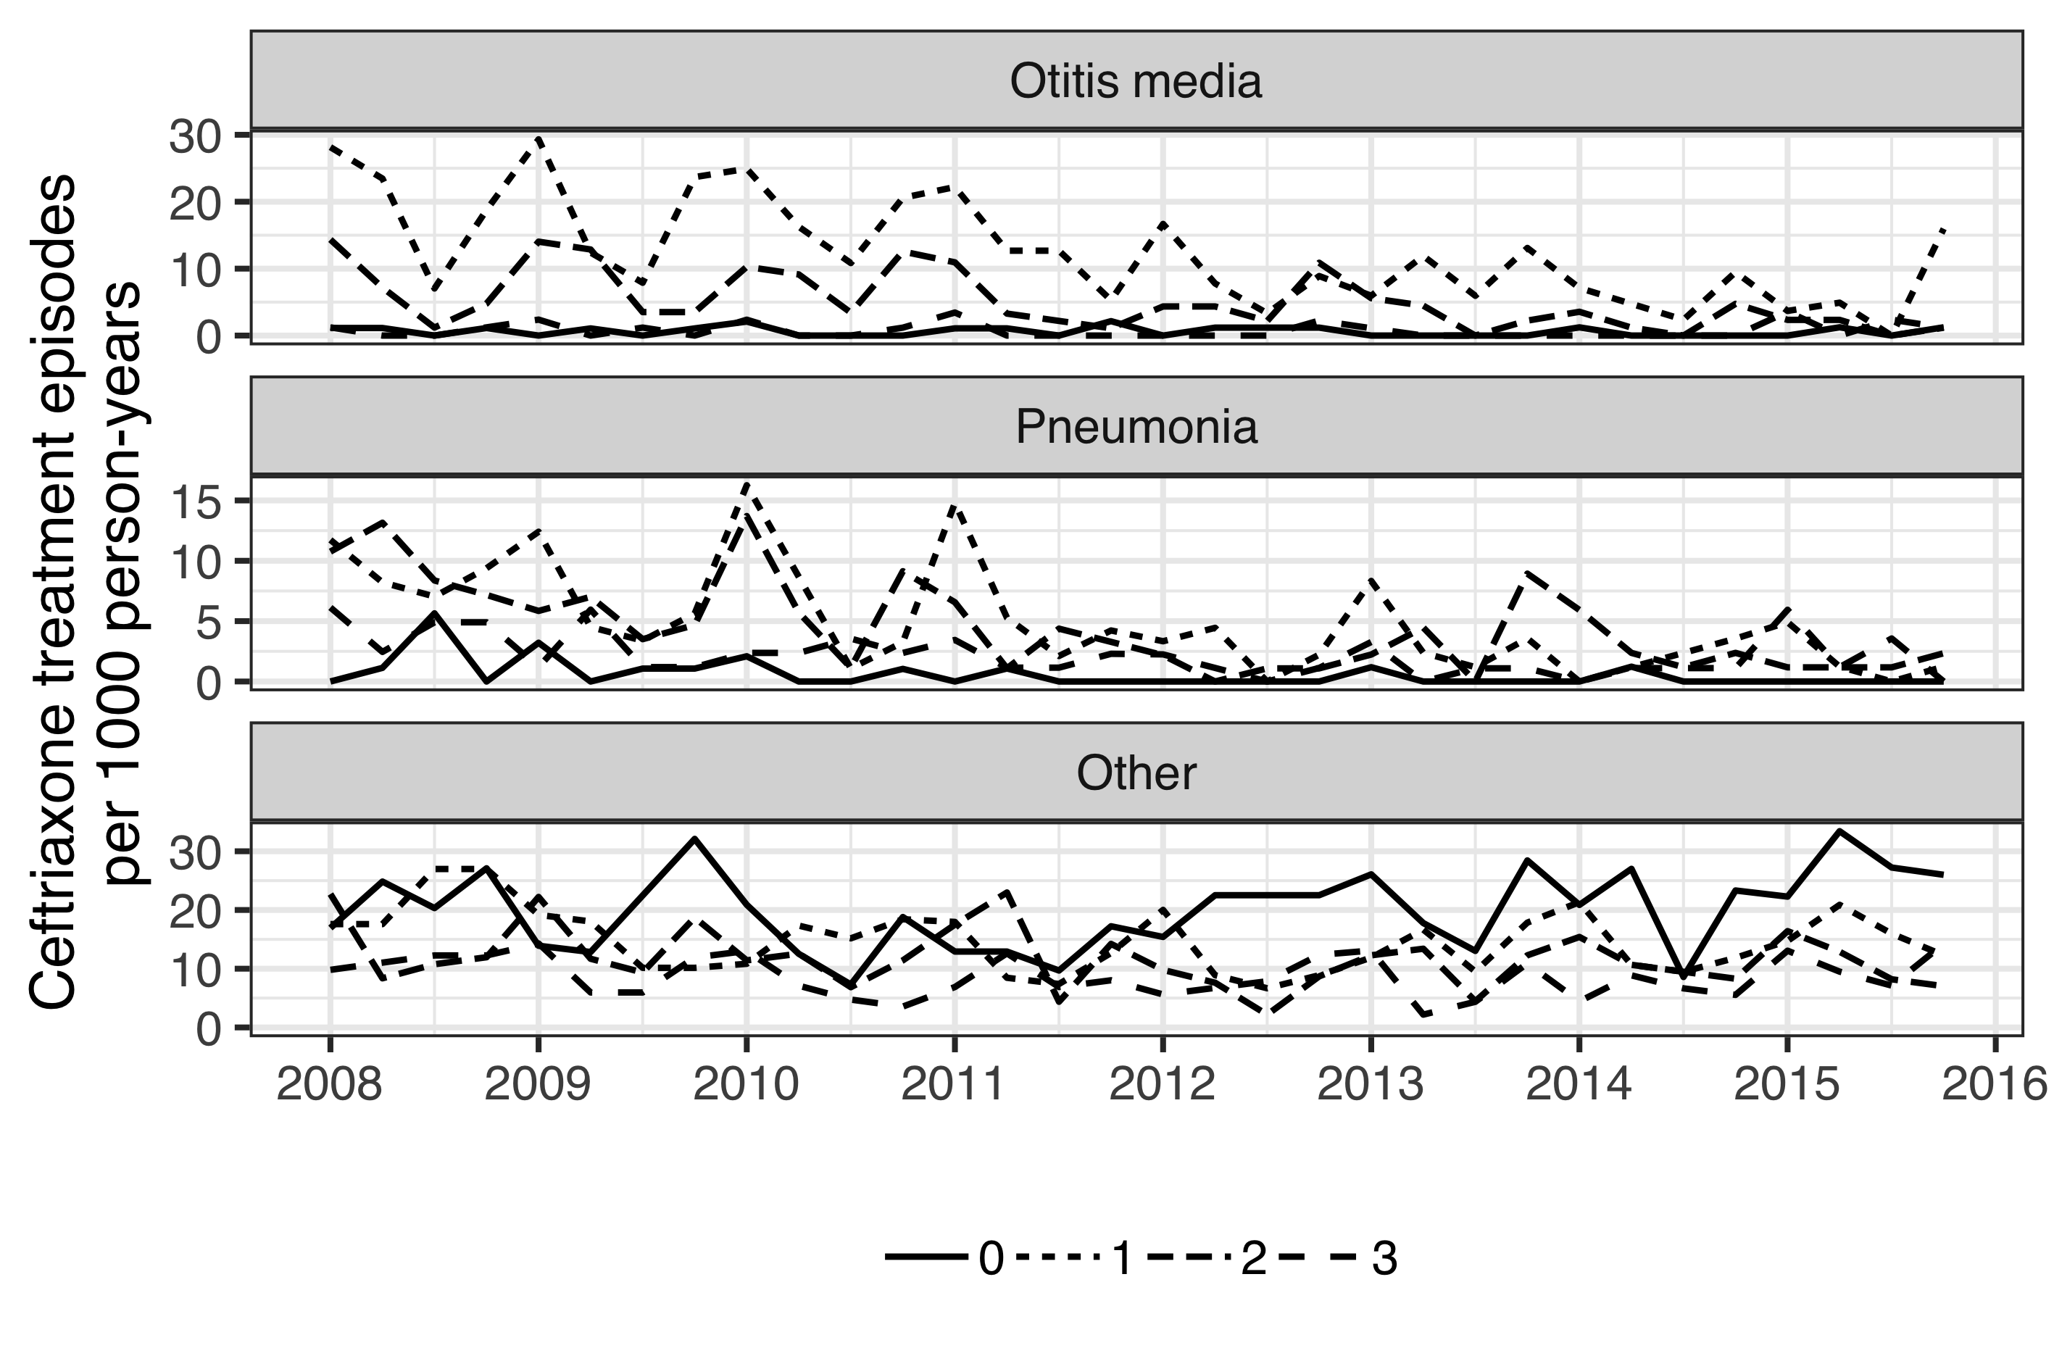

Figure 2 The quarterly incidence rate (IR) of ceftriaxone treatment episodes are shown stratified by age and indication for the period from January 2008 to December 2015. The IR per 1,000 person-years is presented for children one, two, three and four years of age using different line-types. The figure is stratified by indication, and demonstrates a decrease in the IR of ceftriaxone treatment episodes for acute otitis media and pneumonia in the post-vaccine period January 2012 to December 2016. No such decrease is visible for ceftriaxone treatment episodes for all other indications.

To further test whether a general decrease was occurring in the overall use of ceftriaxone, rather than a specific decrease for vaccine-related indications in vaccinated children, an examination of ceftriaxone treatment episodes in all children regardless of age and indication was undertaken. An overall decrease in the IR of ceftriaxone treatment episodes was found among children under 18 years of age regardless of indication. The IR declined from 11.1 to 9.55 treatment episodes per 1,000 person-years, IRR 0.86 (95% CI 0.81-0.91). The effect was not consistent across age-groups ( = 23.6, *P*<0.001). When examined by age-group, the overall decrease proved to be driven by the youngest age-group – i.e the children who were protected by the vaccination. The incidence of ceftriaxone treatment episodes did not decrease significantly in other age groups (Figure 3).

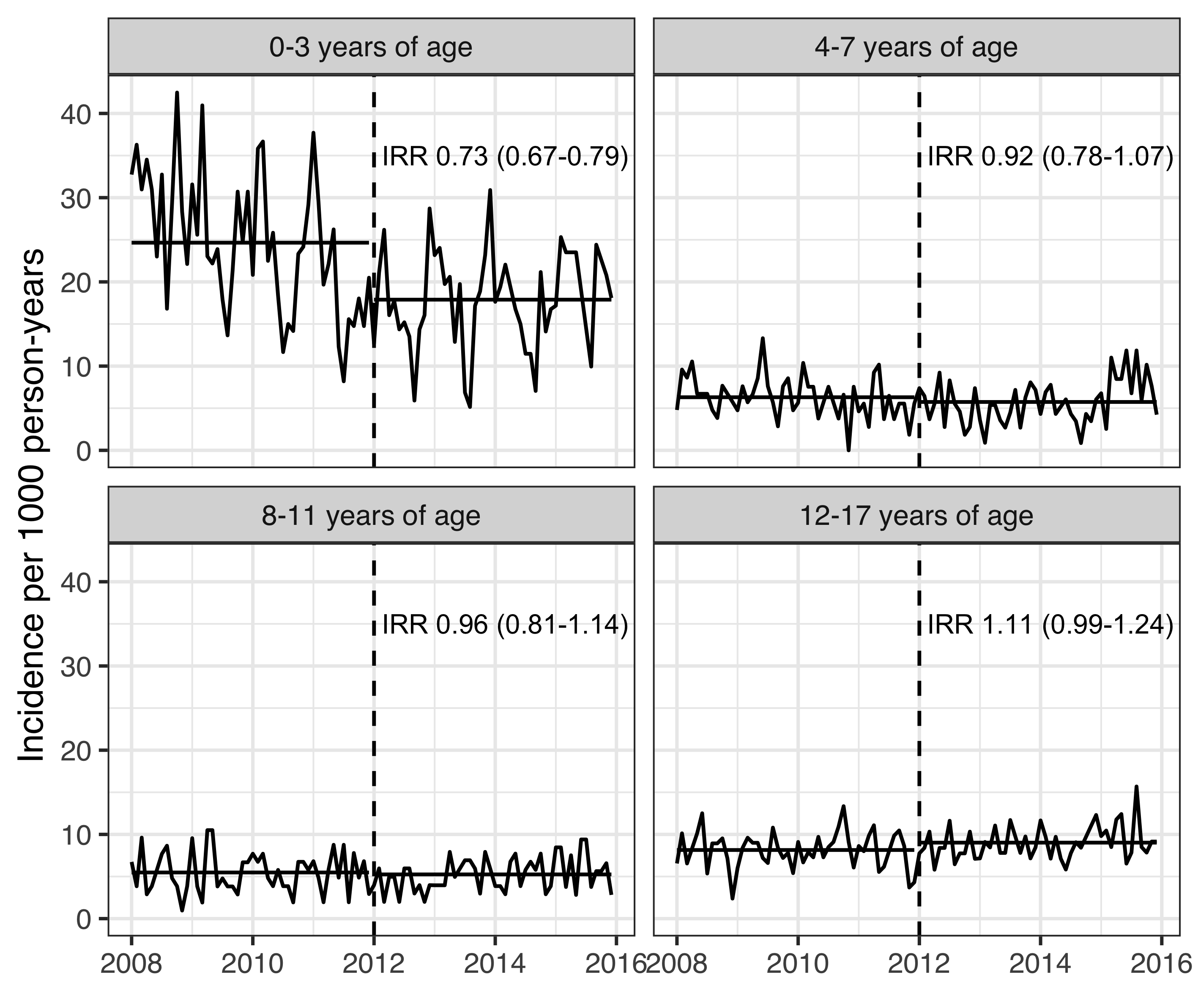

Figure 3 The monthly incidence rates (IR) of ceftriaxone treatment episodes per 1,000 person-years regardless of indication are shown stratified by age-groups for the period from January 2005 to December 2016. The delineation between the pre- and post-vaccine periods on January 2012 is illustrated with a dashed vertical line. For each age-group, the mean IR in the pre- and post-vaccine periods are depicted with a solid horizontal line. The incidence rate ratio (IR) between the two vaccine periods is shown for each age-group along with 95% confidence intervals within parentheses. The figure demonstrates a significant decrease in the IR of ceftriaxone treatment episodes for children zero to three years of age. No change is detectable in other age-groups.

## Impact on primary care visits for acute otitis media (Paper II)

## Impact on outpatient antimicrobial prescriptions (Paper III)

## Impact on tympanostomy tube procedures (Paper IV)

## Impact on respiratory associated hospitalizations (Paper V)

# Discussion

Placeholder

## Main findings

## Data collection and sources

## Epidemiology and impact of PHiD-CV10 on otitis media in Iceland (Papers I, II, III, V and VI)

### Epidemiology of acute otitis media in Iceland (Papers II and V)

### Impact on primary care visits for otitis media (Papers II and VI)

### Impact on pediatric emergency department visits for acute otitis media (Paper I)

### Impact on outpatient antimicrobial prescriptions for otitis media (Paper III)

### Evidence of herd-effect of PHiD-CV10 on the incidence of otitis media in the unvaccinated population (Papers II and VI)

### Impact on acute otitis media with treatment failure (Paper I)

## Impact of PHiD-CV10 on tympanostomy tube placements (Paper IV)

### Impact on hospital admissions for otitis media (Paper V)

## Impact of PHiD-CV10 on pneumonia hospitalizations in Iceland (Papers V and VI)

### Evidence of herd-effect of PHiD-CV10 on pneumonia hospitalization in the unvaccinated population (Papers V and VI)

## Impact of PHiD-CV10 on invasive pneumococcal disease (Papers V and VI)

## Cost-effectiveness of introduction of PHiD-CV10 into the Icelandic pediatric vaccination program (Paper VI)

# Conclusions

* Study the herd-effect of PHiD-CV10 introduction.