Lab 8: Docker Containers and Images
EECE 435L Software Tools Lab, Fall 2026-2027
Elias Ghanem | AUB username: esg07
Code repository: https://github.com/eliasghan/Lab8-Elias-Ghanem

1. Tutorial: first container (hello world Flask app)
I created a small Flask app (hello_flask/app.py), generated requirements.txt with pip freeze, and wrote the Dockerfile from the handout. I then built the image and ran it with port 5000 published:
docker image build -t flask_docker .
docker run -p 5000:5000 -d --name flask_docker flask_docker
One change was needed for the port binding to work: the app calls app.run(host="0.0.0.0", port=5000). By default Flask listens on 127.0.0.1, which inside a container accepts only connections from the container itself, so requests forwarded by -p 5000:5000 would never reach it.
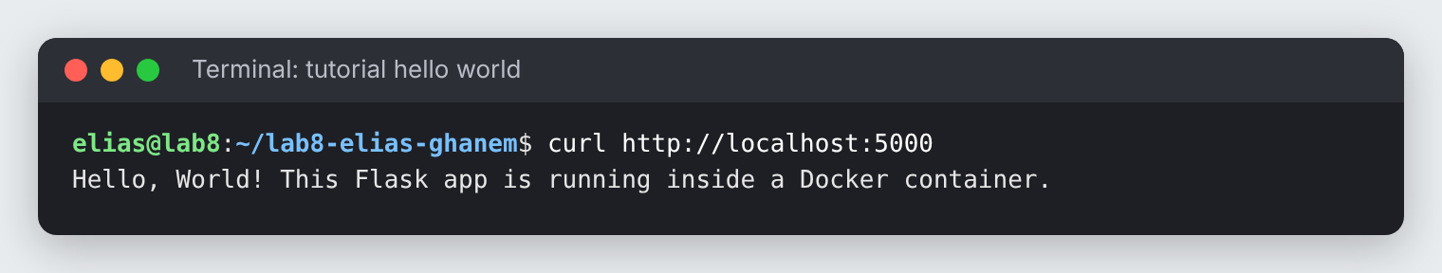
Figure 1: the hello world app answering on port 5000 from inside its container

2. Activity 1: docker ps -a, docker stop, docker logs
Note: docker stop and docker logs act on a container (given by its name or ID), not on an image. I named the containers with --name when running them, so the commands below use the container name lab8-user-api.

2.1 docker ps -a
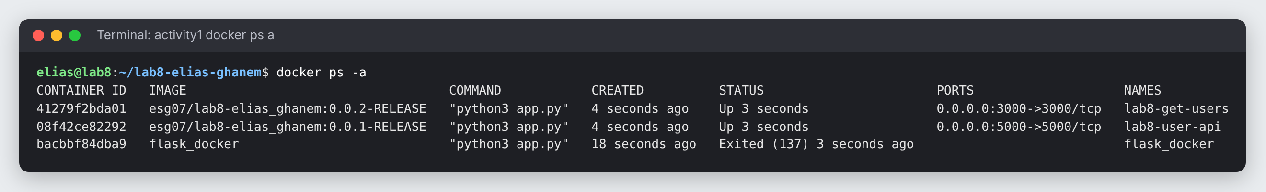
Figure 2: docker ps -a
What it does: docker ps lists the running containers; the -a (all) flag also includes stopped ones. For each container it shows its ID, the image it was created from, the command it runs, when it was created, its status (Up, or Exited with the exit code), the published ports, and its name. Here the two Activity 2 containers are running on ports 5000 and 3000, and the tutorial container flask_docker is stopped.

2.2 docker stop <container>
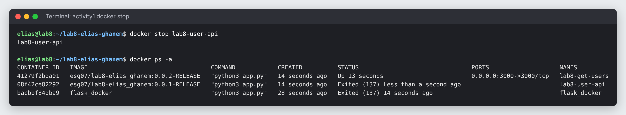
Figure 3: docker stop lab8-user-api, then docker ps -a to confirm
What it does: docker stop stops a running container. Docker sends the main process a SIGTERM so it can shut down cleanly, and if the process has not exited after a 10 second grace period it sends SIGKILL. The container is not deleted: it stays in the list with status Exited and can be restarted with docker start. Exit code 137 (128 + 9, SIGKILL) shows the Flask development server did not exit on SIGTERM, so Docker killed it after the grace period.

2.3 docker logs <container>
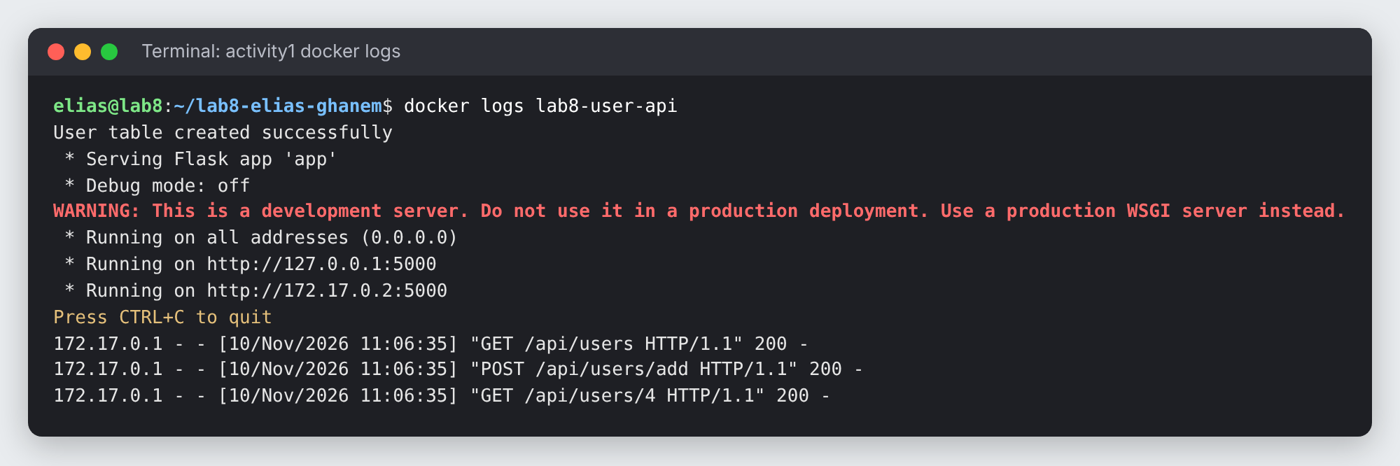
Figure 4: docker logs lab8-user-api
What it does: docker logs prints everything the container has written to standard output and standard error since it started. Here it shows the database table being created, Flask starting on 0.0.0.0:5000, and one line for each HTTP request the API received (GET all users, POST add user, GET user 4). It works on stopped containers too, and -f follows the log live.

3. Activity 2: two container images
Both images use the same repository name with different tags. Docker does not accept the name exactly as written in the handout, so I adjusted it in two ways:
- Repository names must be lowercase: lab8-Elias_Ghanem becomes lab8-elias_ghanem.
- A tag cannot contain a colon (the colon separates the repository from the tag): 0.0.1:RELEASE becomes 0.0.1-RELEASE.

Image | Port | Contents
esg07/lab8-elias_ghanem:0.0.1-RELEASE | 5000 | Lab 5 user management REST API (Postman and APIs)
esg07/lab8-elias_ghanem:0.0.2-RELEASE | 3000 | get_users API (GET): names of all users in the database

Each image uses the handout's Dockerfile structure with python:3.12-alpine as the base instead of 3.8 (Python 3.8 is end-of-life and Flask 3.1 needs Python 3.9 or newer). Each Dockerfile also adds EXPOSE for its port. A .dockerignore keeps venv, caches and any local database.db out of the image.
cd image1_user_api
docker image build -t esg07/lab8-elias_ghanem:0.0.1-RELEASE .
cd ../image2_get_users
docker image build -t esg07/lab8-elias_ghanem:0.0.2-RELEASE .
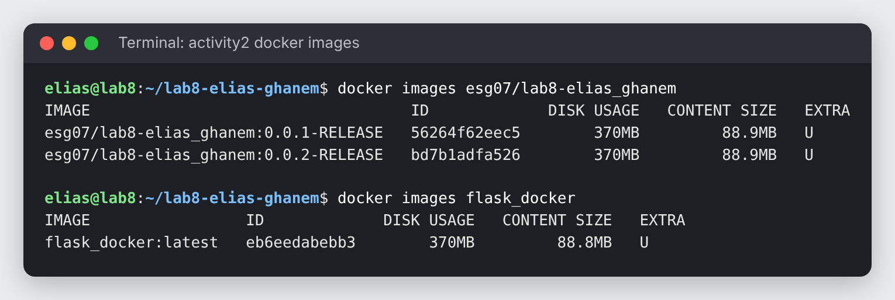
Figure 5: the two Activity 2 images (and the tutorial image)
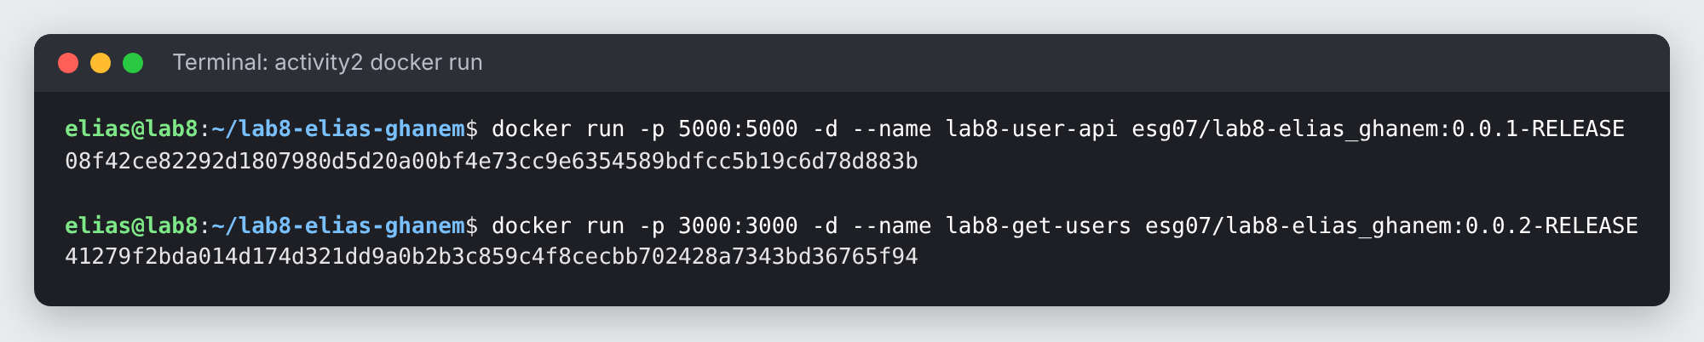
Figure 6: running both images, publishing ports 5000 and 3000

3.1 Docker Desktop
Insert Docker Desktop screenshot here (Images tab showing both esg07/lab8-elias_ghanem tags)

3.2 Image 1: Lab 5 user API on port 5000 (tag 0.0.1-RELEASE)
This is the Lab 5 Flask API with its SQLite database. On first start it creates the users table and inserts three default users. Endpoints:
Endpoint | Method | Description
/api/users | GET | List all users
/api/users/<id> | GET | Get one user
/api/users/add | POST | Add a user (JSON body)
/api/users/update | PUT | Update a user (JSON body with user_id)
/api/users/delete/<id> | DELETE | Delete a user

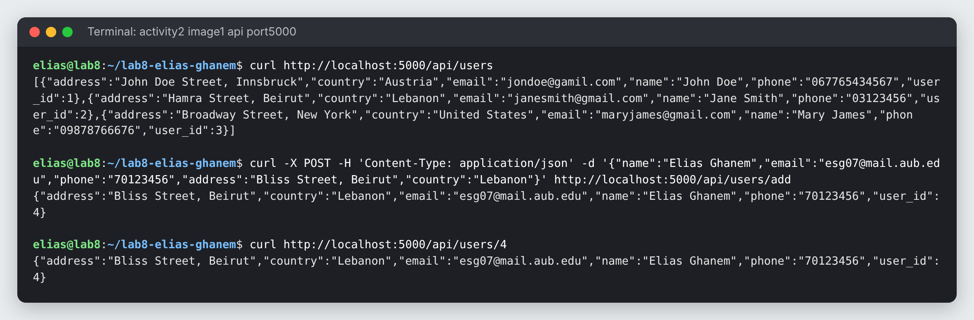
Figure 7: calling the containerised Lab 5 API on port 5000
I also ran the Lab 5 Postman collection against the container with newman (the Postman command-line runner). All six requests returned 200 OK:
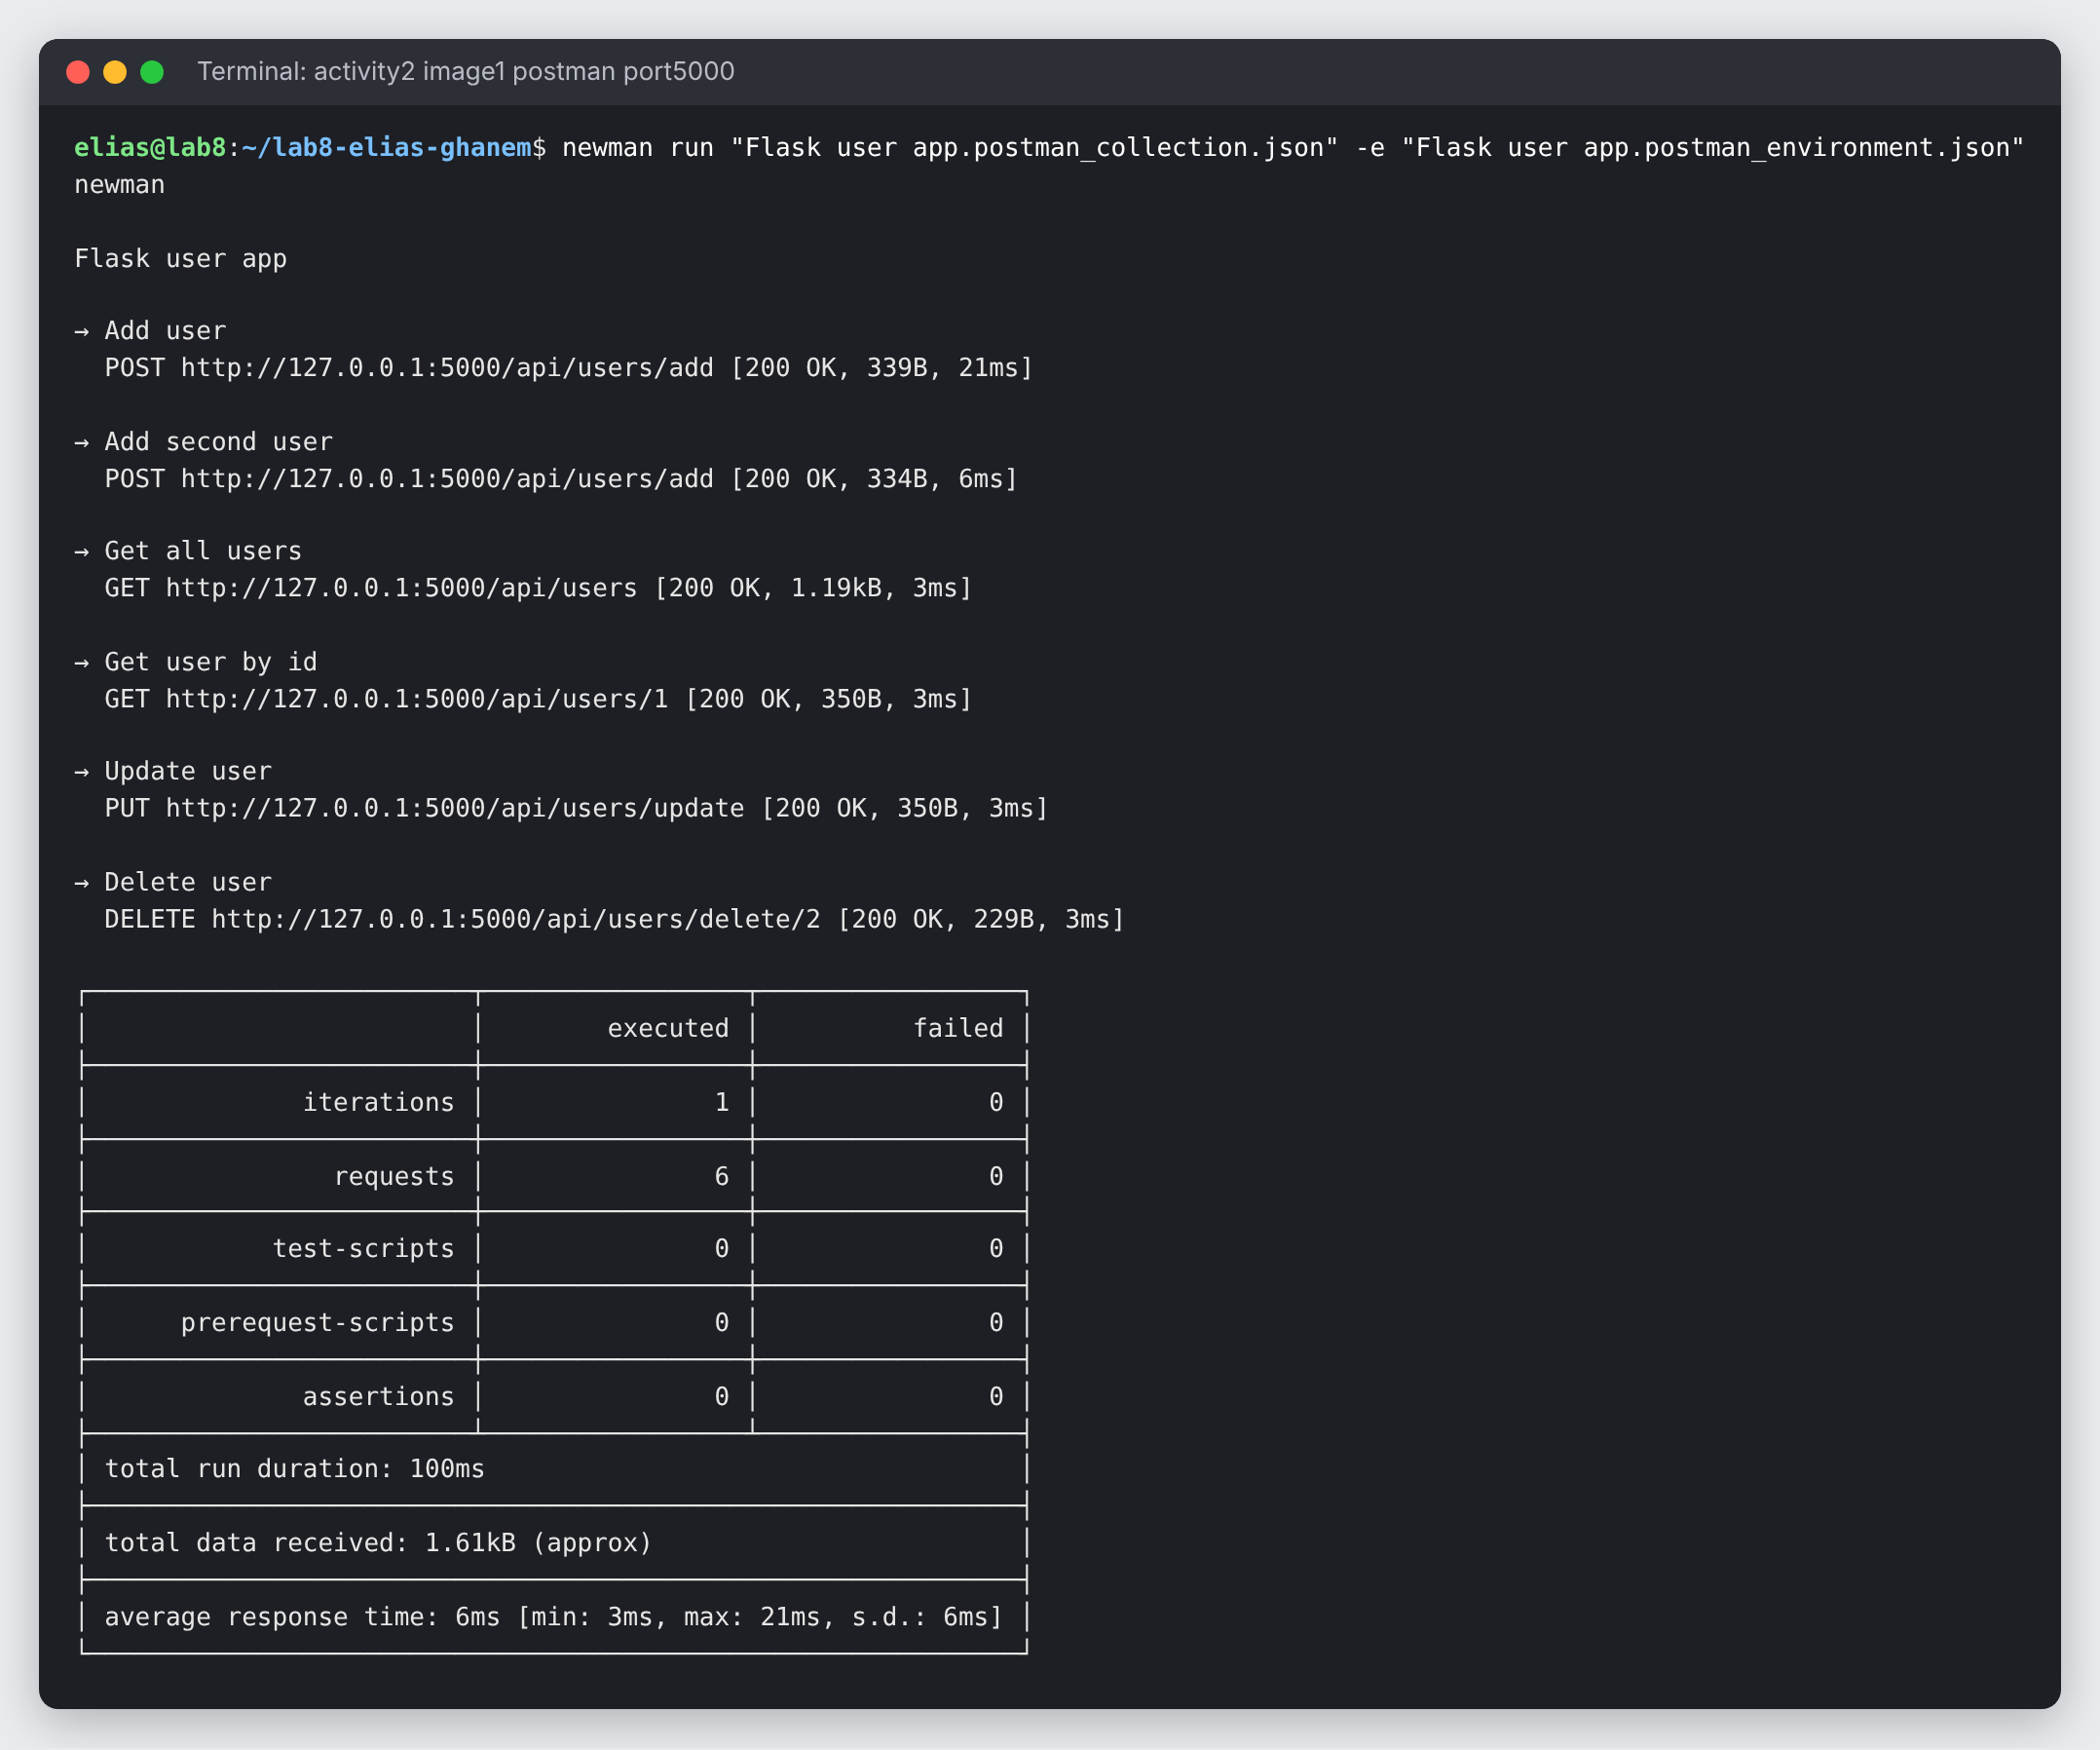
Figure 8: Lab 5 Postman collection run against port 5000

3.3 Image 2: get_users API on port 3000 (tag 0.0.2-RELEASE)
This image runs a Flask app on port 3000 with the same users table. Its GET /get_users endpoint (also available as /api/get_users) reads every row of the users table and returns only the names, as a JSON list.
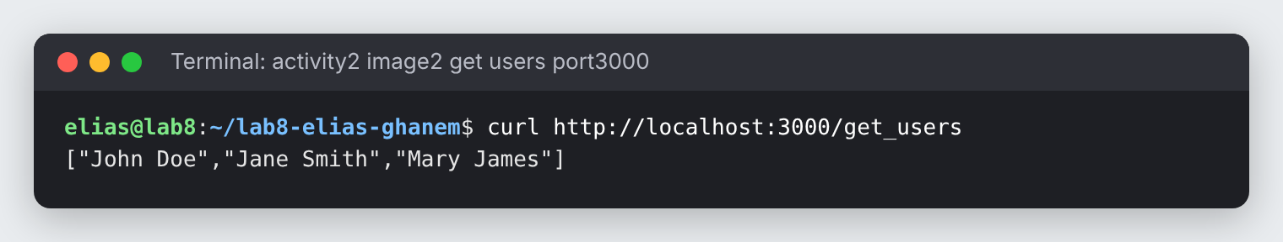
Figure 9: GET /get_users on port 3000 returns the list of user names
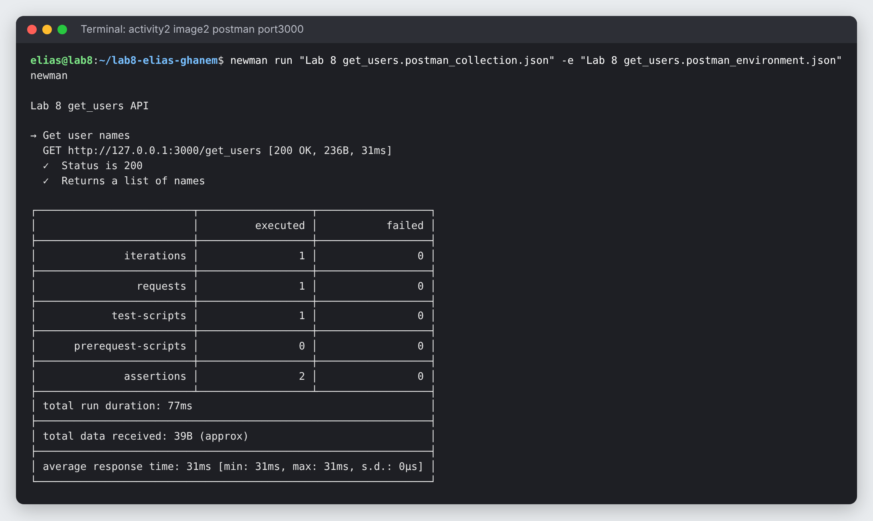
Figure 10: Postman request with tests (status 200, response is a list of strings)

