LAB 12 – Hello Cliche

1. **Launch Eclipse**
   1. Run **eclipse.exe** from the eclipse directory.
   2. 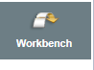Accept the default workspace location (or specify an alternate location) and click OK.
   3. Click the Workbench icon to close out the welcome screen.
2. **Create a Project**
   1. *File > New > Dynamic Web Project*
   2. **Project Name**: ClicheMessage
   3. Click “New Runtime”
   4. Select “Apache Tomcat v7.0” (make sure “Create new local server” is checked) and click **Finish.**

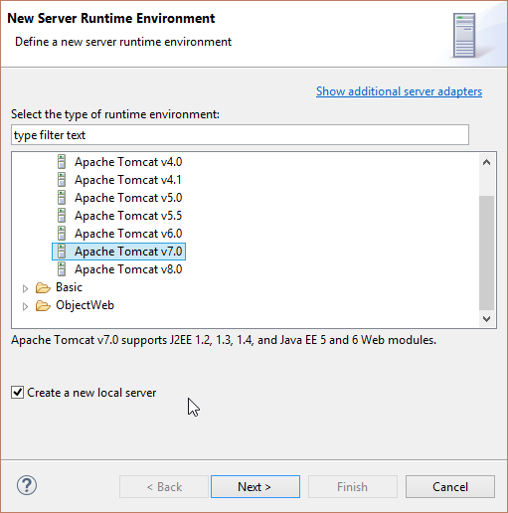

* 1. Click **Next**.
  2. Point to the location of the Tomcat directory.

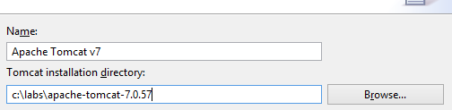

* 1. Click **Finish**

1. **Convert project into a Maven project**
   1. Right-click on the project. *Configure > Convert to Maven Project*
   2. Accept defaults and click **Finish**.
2. **Set Maven dependencies to include required libraries**
   1. Expand project in the Project Explorer view
   2. Double-click **pom.xml** (this is the Maven config file)
   3. Click on the “Dependencies” tab

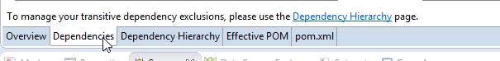

* 1. Add each dependency by clicking the “Add” button on the left.

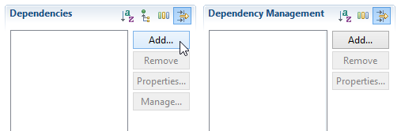

* 1. Add the following dependencies:

|  |  |  |
| --- | --- | --- |
| Group Id | Artifact Id | Version |
| asm | asm | 3.3.1 |
| org.json | json | 20140107 |
| com.sun.jersey | jersey-bundle | 1.19 |
| com.sun.jersey | jersey-core | 1.19 |
| com.sun.jersey | Jersey-server | 1.19 |

* 1. Save pom.xml (*File > Save* or *Ctrl + S*).

1. **Create a service implementation class**
   1. Right-click on the project. *New > Class*
   2. **Package:** com.labs.rest
   3. **Name:** HelloCliche
   4. Click **Finish**.
2. **Complete the source code for the service**

**package** com.labs.rest;

**import** javax.ws.rs.GET;

**import** javax.ws.rs.POST;

**import** javax.ws.rs.Path;

@Path("/hello")

**public** **class** HelloCliche {

@GET

**public** String getSomething() {

**return** "Hello GET!";

}

@POST

**public** String postSomething() {

**return** "Hello POST!";

}

}

* 1. Save HelloCliche.java (*File > Save* or *Ctrl + S*).

1. **Configure the service container**
   1. Right-click the project. *Java EE Tools > Generate Deployment Descriptor Stub*
   2. Open the project’s Deployment Descriptor. 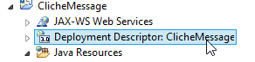
   3. Add a Servlet and ServletMapping definitions below the welcome-file-list element.

<servlet>

<servlet-name>Cliche Rest Service</servlet-name>

<servlet-class>  
 com.sun.jersey.spi.container.servlet.ServletContainer  
 </servlet-class>

<load-on-startup>1</load-on-startup>

</servlet>

<servlet-mapping>

<servlet-name>Cliche Rest Service</servlet-name>

<url-pattern>/cliche/*</url-pattern>  
</servlet-mapping>

1. **Deploy project to server**
   1. 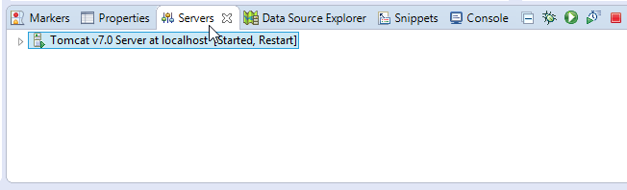Click the *Servers* tab directly below the editor.
   2. Right-click on the Tomcat server. Select *“Add and Remove…”*
   3. Click the project name on the left, click the “Add” button, and click **Finish**.
2. **Test the service**
   1. Click the green play button on the right side of the *Servers* tab.
   2. Test the service using your browser.
      1. Launch browser of your choice.
      2. Navigate to: http://localhost:8080/ClicheMessage/cliche/hello/
      3. Result should be: Hello GET!
   3. Test the service using a simple form.
      1. Right-click on *WebContent* folder and select “Import…”
      2. *General > File System*
      3. Click “Browse” and select the *Lab12* folder.
      4. Select the RestTester.html file.
      5. Click **Finish**.
      6. Navigate your browser to:  
         http://localhost:8080/ClicheMessage/RestTester.html
      7. Experiment with GET and POST requests