LAB 14 – Client Application

1. **Launch Eclipse**
   1. Accept the default workspace
2. **Create a Project**
   1. *File > New > Maven Project*
   2. **Project Name**: Calculator
   3. Click **Finish**.
3. **Convert project into a Maven project**
   1. Right-click on the project. *Configure > Convert to Maven Project*
   2. Check the first two checkboxes.
   3. Click **Next**.
   4. **Group Id**: com.rest.labs
   5. **Artifact Id**: JaxrsClient

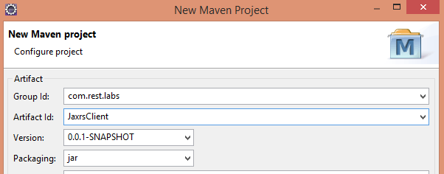

* 1. Click **Finish**.

1. **Set Maven dependency to include required library**
   1. Expand project in the Project Explorer view
   2. Double-click **pom.xml** (this is the Maven config file)
   3. Click on the “Dependencies” tab
   4. Add dependency by clicking the “Add” button on the left.
   5. Add one dependency:

|  |  |  |
| --- | --- | --- |
| Group Id | Artifact Id | Version |
| com.sun.jersey | jersey-client | 1.19 |

* 1. Save pom.xml (*File > Save* or *Ctrl + S*).

1. **Create a service client class**
   1. Right-click on the project. *New > Class*
   2. **Package:** com.labs.rest
   3. **Name:** RestClient
   4. Click **Finish**.
2. **Complete the source code for the client**

**package** com.rest.labs;

**import** com.sun.jersey.api.client.Client;

**import** com.sun.jersey.api.client.ClientResponse;

**import** com.sun.jersey.api.client.WebResource;

**public** **class** RestClient {

**static** Client *client* = Client.*create*();

**static** String *getUrl* = “”; //TODO: Set URL

**public** **static** **void** main(String[] args){

*getRequest*();

}

**public** **static** **void** getRequest(){

WebResource webResource = *client*.resource(*getUrl*);

//TODO: Set MIME type inside the accept() method call

ClientResponse response =

webResource.accept("").get(ClientResponse.**class**);

**if**( response.getStatus() != 200 ) {

**throw** **new** RuntimeException("HTTP Error: "+ response.getStatus());

}

//TODO: Display response data

}  
}

1. Update the class by following the instructions in the TODO comments.
2. Save RestClient.java (*File > Save* or *Ctrl + S*).
3. 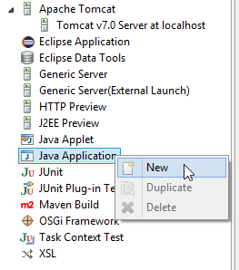**Setup the Run Configuration to launch the client application**
   1. Right-click the project. *Run As > Run Configurations…*
   2. Right-click *Java Application* on the left and select *New*.
   3. Complete the fields in this window
      1. **Name**: *Java Run Config*
      2. **Project**: *JaxrsClient*
      3. **Main class**: *com.rest.labs.RestClient*
   4. Click **Apply**.
   5. Click **Close**.
4. **Test the client app**
   1. If you are accessing a local service, be sure the server is running.
   2. Right-click the project. *Run As > Java Application*
   3. Check the *Console* view for output from the service call.