ElderCare Backend Setup Guide (MySQL + Spring Boot)

1. Install MySQL
Download and install MySQL Community Server (8.x).
During installation, note your:
- Username (default: root)
- Password
- Port (default: 3306)
You will use these in the backend configuration.

2. Install MySQL Workbench
Install MySQL Workbench so you can:
- Connect to your MySQL server
- Create the database
- Run SQL scripts
- View/edit tables

3. Clone or Download the GitHub Repository
Download or clone the project, then open the backend in IntelliJ or your preferred IDE.
Navigate to:
eldercare-backend/src/main/resources/application.properties

4. Configure application.properties
Each team member MUST update database credentials with their own MySQL username and password.
Use the following template:
spring.application.name=eldercare-backend
spring.datasource.url=jdbc:mysql://localhost:3306/eldercare
spring.datasource.username=YOUR_USERNAME
spring.datasource.password=YOUR_PASSWORD
spring.datasource.driverClassName=com.mysql.cj.jdbc.Driver
spring.jpa.hibernate.ddl-auto=update
spring.jpa.show-sql=true
spring.jpa.properties.hibernate.dialect=org.hibernate.dialect.MySQLDialect

5. Create the Database
Open MySQL Workbench and run:
CREATE DATABASE IF NOT EXISTS eldercare;
USE eldercare;

6. Insert Demo Data
The SQL file has been added to the project:
eldercare-backend/sql/init_data.sql
Open this file, copy all SQL statements, and run them in MySQL Workbench.
This will insert sample users and care_posts for demo purposes.

7. Run the Backend
In IntelliJ, run the Spring Boot main file:
EldercareBackendApplication.java

8. Test the API
Use browser or Postman to verify backend is working.
Get all users:
http://localhost:8080/api/users/6
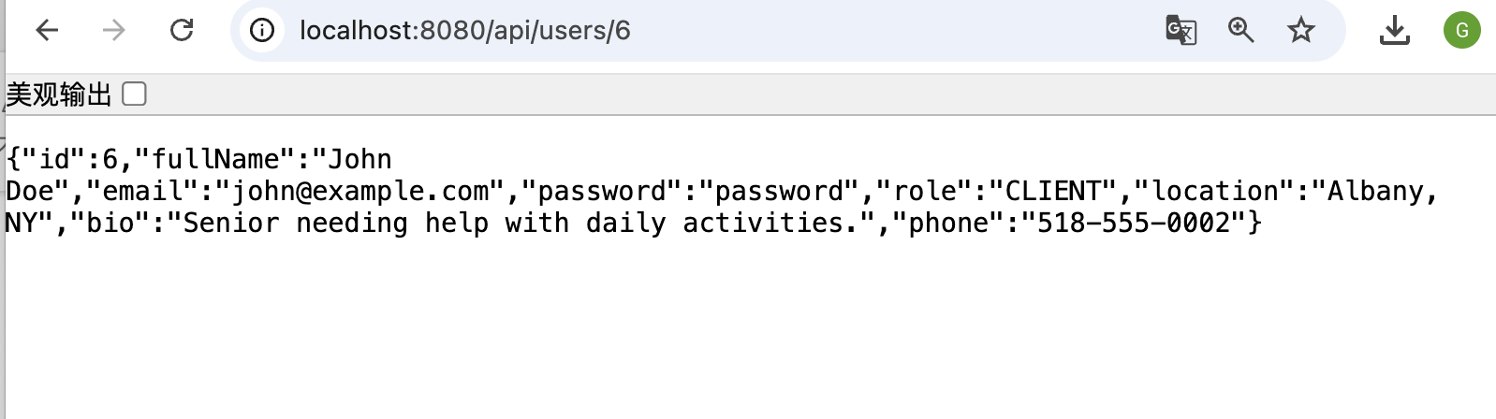

Get all care posts:
http://localhost:8080/api/posts
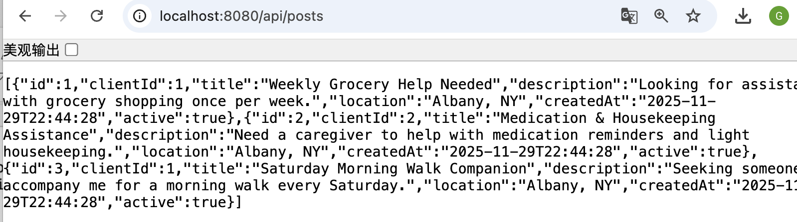

If you see JSON output, everything is set up correctly

