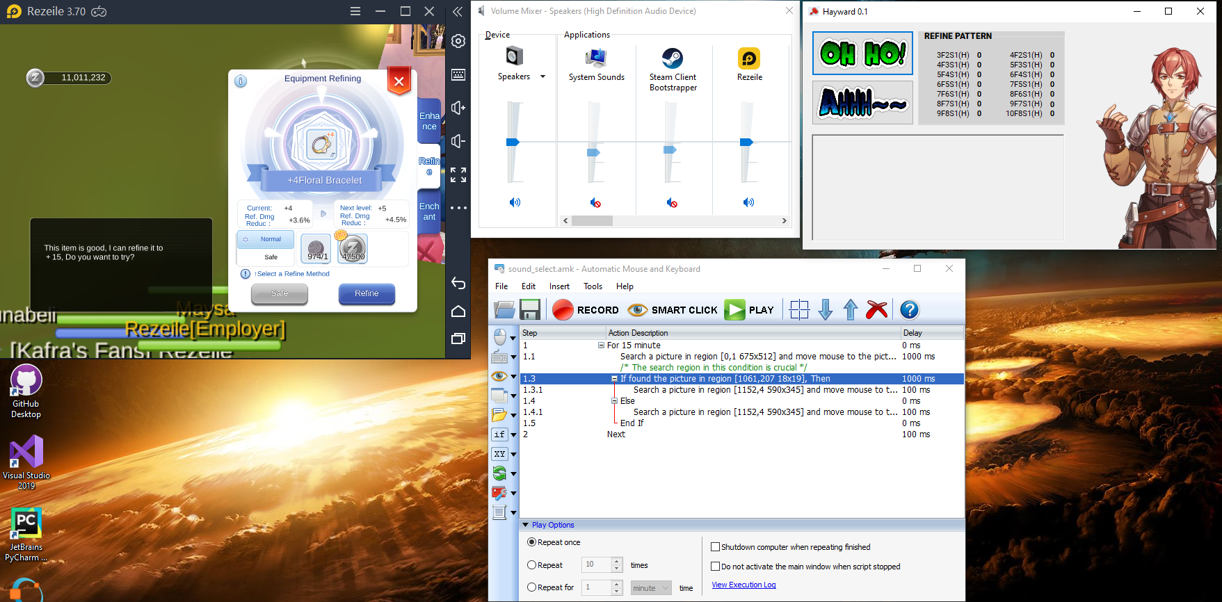

4

3

2

1

Setup:

1. Character Window: Usual setting 640x480, 160 dpi upper left.

Start at refine page with bag full and item already in place.

1. Windows Sound Volume Mixer: Set the level of the LD player to 50%
2. AMK: Short script that Loops for 15mins
   1. Click Refine
   2. Checks the volume mixer level (The setting of the search region is very important) so it can classify between Ahhh and Ohho. (Ohho is slightly louder)

Try to place the search rect around the upper 70% of the volume

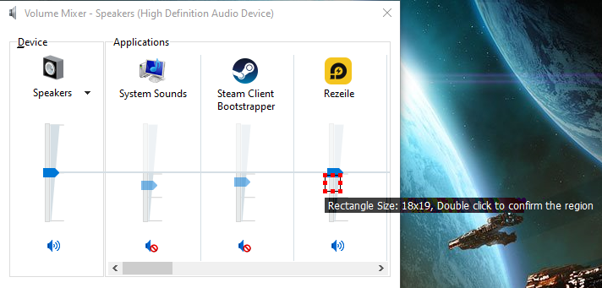

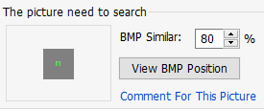

1. Hayward Module: This is a simple UI that allows you to record the sequence of Ahhh’s and Ohho’s and automatically searches for the 14 (fail-success) patterns. The pattern with the most number of occurrences will be highlighted. (You can also just use this manually without setting up the AMK)

*