PROJECT ENGLISH Pepe’s pizza restaurant

Would you like to visit a very fresh and pleasant restaurant? Then try this place. One of my favorite restaurants is Pepe's Pizza for many good things related to the service, the food, the facilities and the great fame it has in the city. It is located at Avenida Central Oriente 1736, Zocotumbak, Tuxtla Gutiérrez, Chis.

They recommended it to me and I thank the person who did it, since it is an excellent restaurant in my opinion and in the opinion of many people I know, and in that of other people. It has a nice atmosphere, has a beautiful view and at night it looks much better by the lamps that the restaurant has that give it a really beautiful and unique style as you can see in the photos. It is a wonderful restaurant. I loved it. It is famous for its pizzas, especially for the cheese pizzas, they are a delight. Very good place to taste a good pizza 🍕 at a good price, if you like pizza and pasta this place is right for you. The pizzas come with delicious cheese toppings accompanied by a rich sauce and muffins that make an exquisite dish. The drinks are also the best, you can order refreshments of different brands, coffee and some drinks from the region.

The service in general is excellent, fast, adequate, is the best and the servers are really friendly and treat you with respect and are always available, the food is cheap and different prices according to what you order. The restaurant is great, so there is enough space for you to go with your whole family to enjoy the delicious food, the music they sometimes play and have a good time while you decide to place an order.

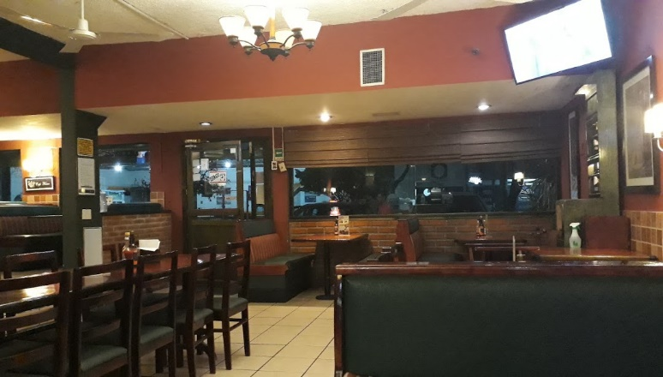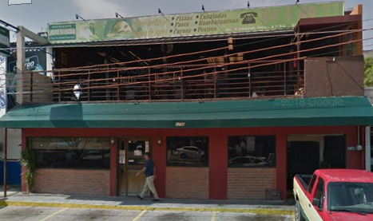 I recommend this restaurant, one of the best in the city.

**Elías Roblero Pérez 4°A IDS**