- What are two of the most important protocols? P31
- What is a protocol? P35
- Why the computers connected to the Internet are called as end systems? P36
- What are the ways for end systems to access networks? P38-----
- Explain physical media. P47
- Explain circuit switching and packet switching. P51
There are two fundamental approaches to moving data through a network of links and switches: circuit switching and packet switching.
In circuit-switched networks, the resources needed along a path (buffers, link transmission rate) to provide for communication between the end systems are reserved for the duration of the communication session between the end systems. In packet-switched networks, these resources are not reserved; a session’s messages use the resources on demand, and as a consequence, may have to wait (that is, queue) for access to a communication link.

- Explain the total nodal delay. P66
- What is the five layer internet protocol stack? P77
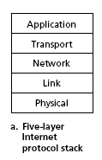
When taken together, the protocols of the various layers are called the protocol stack. The Internet protocol stack consists of five layers: the physical, link, network, transport, and application layers, as shown in Figure

- Explain C/S and P2P P114
In a client-server architecture, there is an always-on host, called the server, which services requests from many other hosts, called clients.
In a P2P architecture, there is minimal (or no) reliance on dedicated servers in data centers. Instead the application exploits direct communication between pairs of intermittently connected hosts, called peers.

- What are TCP service and UDP service? P120
The TCP service model includes a connection-oriented service and a reliable data transfer service. When an application invokes TCP as its transport protocol, the application receives both of these services from TCP.

UDP is a no-frills, lightweight transport protocol, providing minimal services. UDP is connectionless, so there is no handshaking before the two processes start to communicate. UDP provides an unreliable data transfer service—that is, when a process sends a message into a UDP socket, UDP provides no guarantee that the message will ever reach the receiving process. Furthermore, messages that do arrive at the receiving process may arrive out of order.

- Explain HTTP, P126 FTP P144, SMTP P148
- Explain DNS P159 and the hieracky of DNS servers P163
DNS： We have just seen that there are two ways to identify a host—by a hostname and by an IP address. People prefer the more mnemonic hostname identifier, while routers prefer fixed-length, hierarchically structured IP addresses. In order to reconcile these preferences, we need a directory service that translates hostnames to IP addresses. This is the main task of the Internet’s domain name system (DNS).

Hieracky of DNS servers：
there are three classes of DNS servers:
1).Root DNS servers. In the Internet there are 13 root DNS servers.
2).Top-level domain (TLD) servers. These servers are responsible for top-level
domains such as com, org, net, edu, and gov.
3).Authoritative DNS servers. Every organization with publicly accessible hosts on the Internet must provide publicly accessible DNS records that map the names of those hosts to IP addresses.

- Explain GBN P256
- Translate the paragraph from at the bottom of P374 to the middle of 375.

最长前缀匹配http://www.voidcn.com/article/p-segvivzi-btq.html
- Suppose a router has built up the routing table shown in Table-1 .The router can deliver packets directly over interface-0 and interface-1 ，or it can forward packets to router R2,R3,or R4. Assume the route does the longest prefix match. Describe what the router does with a packet addressed to each of the following destinations:
(a)128.96.171.92 1000 0000. 0110 0000 . 1010 1011 . 0101 1100
(b)128.96.167.151 1000 0000. 0110 0000 . 1010 0111 . 1001 0111
(c)128.96.163.151 1000 0000. 0110 0000 . 1010 0011 . 1001 0111
(d)128.96.169.192 1000 0000. 0110 0000 . 1010 1001 . 1100 0000
(e)128.96.165.121 1000 0000. 0110 0000 . 1010 0101 . 0111 1001

Table-1
SubnetNumber | SubnetMask | NextHop
128.96.170.0/23  1000 0000. 0110 0000 . 1010 1010 . 0000 0000  1000 0000. 0110 0000 . 1010 101 | 255.255.254.0 | Interface-0
128.96.168.0/23  1000 0000. 0110 0000 . 1010 1000 . 0000 0000  1000 0000. 0110 0000 . 1010 100 | 255.255.254.0 | Interface-1
128.96.166.0/23  1000 0000. 0110 0000 . 1010 0110 . 0000 0000  1000 0000. 0110 0000 . 1010 011 | 255.255.254.0 | R2
128.96.164.0/22  1000 0000. 0110 0000 . 1010 0100 . 0000 0000  1000 0000. 0110 0000 . 1010 01 | 255.255.252.0 | R3
Default |  | R4

Answer:
- Interface-0
- R2
- R4
- Interface-1
- R3
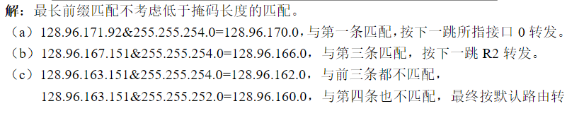
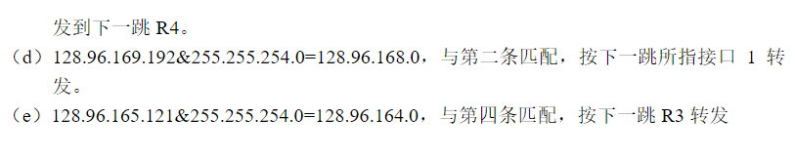

Table-2 is the routing table using CIDR. Address bytes are in hexadecimal. The notation “/23”in C4.5E.2.0 means a netmask with 23 leading 1 bits ，that is FF.FF.FE.0,what next hop the following will be delivered：
- C4.4B.31.2E 1100 0100 . 0100 1011 . 0011 0001 . 0010 1110
- C4.5E.05.09 1100 0100. 0101 1110 . 0000 0101 . 0000 1001
- C4.4D.31.2E 1100 0100 . 0100 1101 .0011 0001. 0010 1110
- C4.5E.03.87 1100 0100 . 0101 1110 . 0000 0011 . 1000 0111
- C4.5E.7E.12 1100 0100 . 0101 1110 . 0111 1110 . 0001 0010
- C4.5E.D1.02 1100 0100 . 0101 1110 . 1101 0001 . 0000 0010

Table-2
Netmask Length | NextHop
C4.5E.2.0/23 1100 0100 . 0101 1110 . 0000 0010 . 0000 0000  1100 0100 . 0101 1110 . 0000 001 | A
C4.5E.4.0/22 1100 0100 . 0101 1110 . 0000 0100 . 0000 0000  1100 0100 . 0101 1110 . 0000 01 | B
C4.5E.C0.0/19 1100 0100 . 0101 1110 . 1100 0000 . 0000 0000  1100 0100 . 0101 1110 . 110 | C
C4.5E.40.0/18 1100 0100 . 0101 1110 . 0100 0000 . 0000 0000  1100 0100 . 0101 1110 . 01 | D
C4.4C.0.0/14 1100 0100 . 0100 1100 . 0000 0000 . 0000 0000  1100 0100 . 0100 11 | E
C0.0.0.0/2 1100 0000 . 0000 0000 . 0000 0000 . 0000 0000  11 | F
80.0.0.0/1 1000 0000 . 0000 0000 . 0000 0000 . 0000 0000  1 | G

ANSWER
- F (b)B (c)E (d)A (e)D (f)C
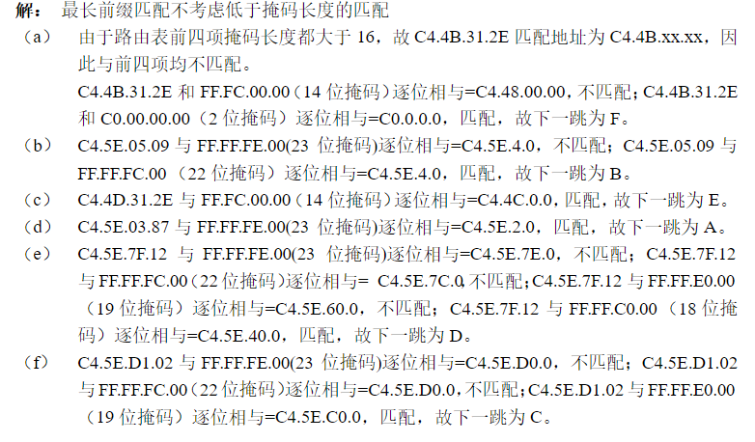

3、calculate the latency （from first bit sent to last bit received）for the following：
(a) 1G bps Ethernet with a single store-and-forward switch in the path，and a packet size of 5000bits，assume that each link introduces a propagation delay of 10μs and that the switch begins transmitting immediately after it has finished receiving that packet;
(b) Same as (a) but with three switches;
(c)Same as (b) but assume switchesbegin to transmit packets after the first 128bits have been received.
ANSWER
- Delay= (5000bits/1 G bps + 10μs)*2 = (5μs+10μs)*2=30μs
- Delay = (5μs+10μs)*4=60μs
- Delay=(4*10μs + 1*5μs + 3*128bits/1Gbps)=(40μs + 5μs+ 0.384μs) =45.384μs
CRC校验
4、suppose we want to transmit the message1011 0010 0100 1011 and protect it from errors using the CRC-8 polynomial x⁸+x²+x+1
(a)use polynomial long division to determine the message that should be transmitted.
(b)suppose the leftmost bit of the message is inverted due to noise on the transmission link. What is the result of the receiver’s CRC calculation? How does the receiver know that an error has occurred?
ANSWER
- ①D(x)=1011 0010 0100 1011
②D(x)^0000 0000 (^ denotes append)
③polynomial long division
④the remainder is R(x)=1001 0011
⑤so we transmit S(x)=D(x)^R(x)=1011 0010 0100 10111001 0011
- ①receives 0011 0010 0100 1011 1001 0011
②polynomial long division
③the remainder is 10110110
④the receiver knows that an error has occurred when it gets a non-zero remainder.

