

Team “Loquat”

Telerik Academy

Members:

Borislava Yosifova

Elena Kirilova

Maq Gocevska

Petko Arbov

Hristian Dimov

Recycling takes time to sort and dump items. Usually, this also means a loss of finances somewhere. Someone has to be paid for the time it takes to sort the items. Our game stimulate people to recycle by showing the process like something fun and exciting.

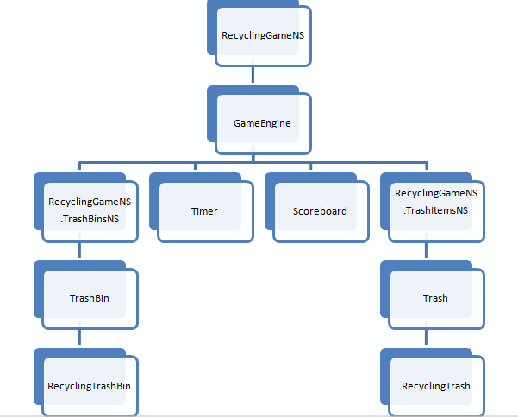

Resources used:

* jquery
* jquery ui
* jasmine
* Q
* Prototype

Repository link:

<http://loquat-team-project.googlecode.com/svn/trunk/>