Resumen 2017-oct-09

First steps with Pangolin and openGL
Drawing a Grid and a sinusoidal 3D curve on screen

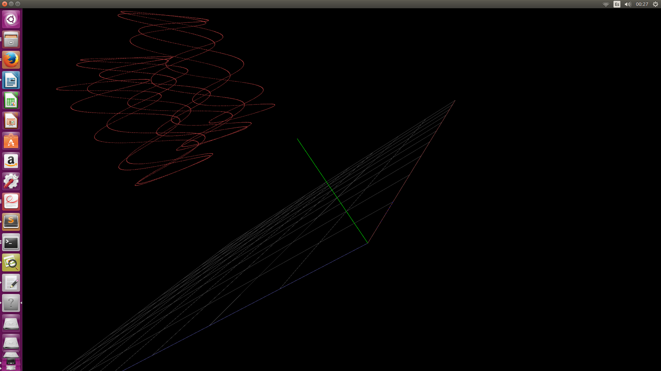

The code it is based on the Pangolin Examples

#include <pangolin/pangolin.h>
#include <pangolin/scene/axis.h>
#include <pangolin/scene/scenehandler.h>
int main( int /*argc*/, char** /*argv*/ )
{
pangolin::CreateWindowAndBind("Main Test",640,480);
glEnable(GL_DEPTH_TEST);

// Define Projection and initial ModelView matrix
pangolin::OpenGlRenderState s_cam(
pangolin::ProjectionMatrix(640,480,420,420,320,240,0.2,100),
pangolin::ModelViewLookAt(-2,2,-2, 0,0,0, pangolin::AxisY)
);

// Create Interactive View in window
pangolin::Handler3D handler(s_cam);
pangolin::Renderable tree;
tree.Add( std::make_shared<pangolin::Axis>() );
pangolin::View& d_cam = pangolin::CreateDisplay()
.SetBounds(0.0, 1.0, 0.0, 1.0, -640.0f/480.0f)
.SetHandler(&handler);
glColor3f(0.75f, 0.75f, 0.75f);
int cont=0;
while( !pangolin::ShouldQuit() )
{
cont ++;
// Clear screen and activate view to render into
glClear(GL_COLOR_BUFFER_BIT | GL_DEPTH_BUFFER_BIT);
d_cam.Activate(s_cam);

// Render OpenGL Cube
glColor3f(.3,.3,.3);
/*glBegin(GL_QUADS);
glVertex3f( 0,-0.001, 0);
glVertex3f( 0,-0.001,10);
glVertex3f(10,-0.001,10);
glVertex3f(10,-0.001, 0);
glEnd();
*/
// FRAGMENTO QUE DIBUJA UN GRID
glBegin(GL_LINES);
for(int i=0;i<=10;i++) {
if (i==0) { glColor3f(.6,.3,.3); } else { glColor3f(.25,.25,.25); };
glVertex3f(i,0,0);
glVertex3f(i,0,10);
if (i==0) { glColor3f(.3,.3,.6); } else { glColor3f(.25,.25,.25); };
glVertex3f(0,0,i);
glVertex3f(10,0,i);

};
glEnd();
// FIN GRID

// FRAGMENTO QUE DIBUJA UNA CURVA SINUSOIDAL EN TRES DIMENSIONES
glBegin(GL_POINTS);
//for(int j=0;j<=2000;j++) {
for(int j=0;j<=cont;j++) {
glColor3f(.6,.2,.2);
//glVertex3f(cos(j*0.02),cos(j*0.01),sin(j*0.05));
glVertex3f(cos(j*0.002)+3,cos(j*0.01)+3,sin(j*0.05)+3);
}
glEnd();
//pangolin::glDrawColouredCube();
tree.Render();

// Swap frames and Process Events
pangolin::FinishFrame();
}

return 0;
}

