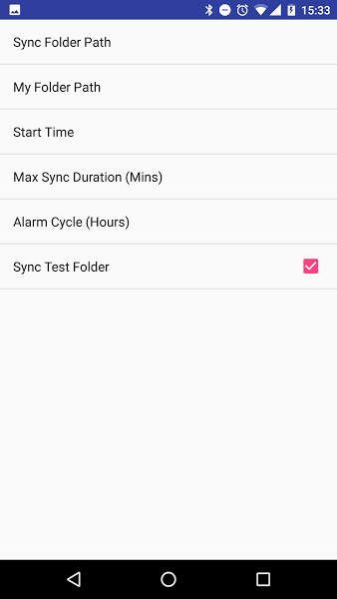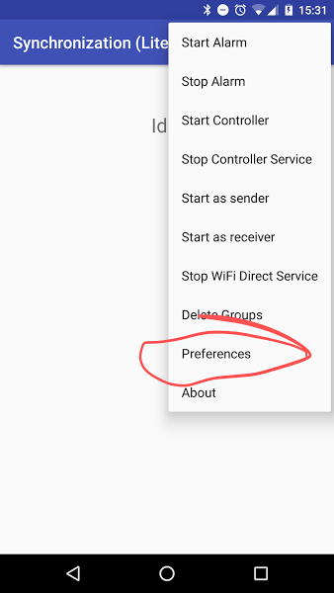

**Sync app**

1. Choose preferences.

2. Sync folder path is the place incoming folders will be stored.

3. My folder path is the folder that will be sent to other devices.

4. Start time is the time the sync will start, it should be the same on all devices in a specific location.

5. Max sync duration is the time in which the controller will abort the sync, even if not all devices synced.

6. Alarm Cycle is the cycle of the sync, which default to one day.

7. Sync test folder, if checked will sync the auto created test folder, and not the "my folder" (from 3).

8. After setting the preferences, you can select the start alarm (from the options menu), and the sync will run on the device daily (or according to the set Alam cycle).