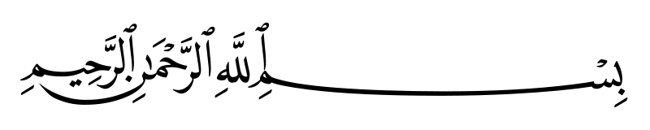

3- Queues: ************************************

**Using arrays**

**#include <stdio.h>**

**#include <stdlib.h>**

**#define SIZE 100**

**int queue[SIZE];**

**int rear = -1, front = -1;**

**void enQueue(int value)**

**{**

**if (rear == SIZE - 1)**

**printf("Overflow, queue is full\n");**

**else**

**{**

**if (front == -1)**

**front = 0;**

**rear++;**

**queue[rear] = value;**

**printf("Value %d added to the queue successful.\n", value);**

**}**

**}**

**void deQueue()**

**{**

**if (rear == front)**

**printf("Underflow, queue is already empty!\n");**

**else**

**{**

**printf("%d deleted\n", queue[front]);**

**front++;**

**if (front == rear)**

**rear = front = -1;**

**}**

**}**

**void display_array()**

**{**

**printf("\n------------------------------------------------------------\n");**

**if (rear == -1)**

**printf("Queue is empty!\n");**

**else**

**{**

**for (int i = front; i <= rear; i++)**

**printf(" %d |", queue[i]);**

**}**

**printf("\n------------------------------------------------------------\n");**

**}**

**int main()**

**{**

**while (1)**

**{**

**int value, choice;**

**printf("TYPE 01 ---> push\n");**

**printf("TYPE 02 ---> pop\n");**

**printf("\nchoice = ");**

**scanf("%d", &choice);**

**switch (choice)**

**{**

**case 1:**

**printf("\nValue = ");**

**scanf("%d", &value);**

**enQueue(value);**

**display_array();**

**break;**

**case 2:**

**deQueue();**

**display_array();**

**break;**

**default:**

**printf("no valid\n");**

**break;**

**}**

**}**

**return 0;**

**}**



**Using linked list**

**#include <stdio.h>**

**#include <stdlib.h>**

**typedef struct Queue**

**{**

**int data;**

**struct Queue *next;**

**} queue;**

**queue *head = NULL;**

**queue *create_node(int value)**

**{**

**queue *node = (queue *)malloc(sizeof(queue));**

**node->data = value;**

**node->next = NULL;**

**return node;**

**}**

**void enQueue(int value)**

**{**

**queue *element = create_node(value);**

**if (head == NULL)**

**head = element;**

**else**

**{**

**queue *temp = head;**

**while (temp->next != NULL)**

**temp = temp->next;**

**temp->next = element;**

**}**

**}**

**void deQueue()**

**{**

**if (head == NULL)**

**printf("Underflow, queue is empty!\n");**

**else**

**{**

**queue *temp = head;**

**if (temp->next == NULL)**

**{**

**head = NULL;**

**free(temp);**

**}**

**else**

**{**

**head = temp->next;**

**free(temp);**

**}**

**}**

**}**



**void display()**

**{**

**printf("\n------------------------------------------------------\n");**

**if (head == NULL)**

**printf("List is empty!\n");**

**else**

**{**

**queue *temp = head;**

**while (temp->next != NULL)**

**{**

**printf(" %d | ", temp->data);**

**temp = temp->next;**

**}**

**printf(" %d | ", temp->data);**

**}**

**printf("\n------------------------------------------------------\n");**

**}**

**int main()**

**{**

**while (1)**

**{**

**int value, choice;**

**printf("TYPE 01 ---> push\n");**

**printf("TYPE 02 ---> pop\n");**

**printf("\nchoice = ");**

**scanf("%d", &choice);**

**switch (choice)**

**{**

**case 1:**

**printf("\nValue = ");**

**scanf("%d", &value);**

**enQueue(value);**

**display();**

**break;**

**case 2:**

**deQueue();**

**display();**

**break;**

**default:**

**printf("no valid\n");**

**break;**

**}**

**}**

**return 0;**

**}**

Created by: Mohammed El Idrissi Laoukili

لااله الا الله

Instagram : __elidrissii

