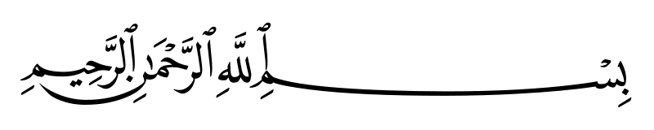

4- Stacks: ************************************

**Using arrays**

**#include <stdio.h>**

**#include <stdlib.h>**

**#define SIZE 100**

**int stack[SIZE];**

**int top = -1;**

**void push(int value)**

**{**

**if (top == SIZE - 1)**

**printf("Overflow, Stack is full.\n");**

**else**

**{**

**top++;**

**stack[top] = value;**

**printf("Insertion completed.\n");**

**}**

**}**

**void pop()**

**{**

**if (top == -1)**

**printf("Underflow, Stack is empty§\n");**

**else**

**{**

**printf("%d deleted, ", stack[top]);**

**top--;**

**}**

**}**

**void display()**

**{**

**if (top == -1)**

**printf("Underflow, Stack is already empty.\n");**

**else**

**{**

**printf("Stack's elements are:\n");**

**for (int i = top; i >= 0; i--)**

**printf("\n\t|\t%d\t|\n\t-----------------", stack[i]);**

**}**

**}**



**void display2()**

**{**

**if (top == -1)**

**printf("Underflow, Stack is already empty.\n");**

**else**

**{**

**printf("Stack's elements are:\n");**

**for (int i = top; i >= 0; i--)**

**printf("%d->", stack[i]);**

**}**

**}**

**int main()**

**{**

**int value, choice;**

**do**

**{**

**printf("1- push\n");**

**printf("2- pop\n");**

**printf("Choice = ");**

**scanf("%d", &choice);**

**switch (choice)**

**{**

**case 1:**

**printf("Enter value = ");**

**scanf("%d", &value);**

**push(value);**

**break;**

**case 2:**

**pop();**

**break;**

**default:**

**printf("Invalid chocie. Try again.\n");**

**break;**

**}**

**printf("\n------------------------------\n");**

**display();**

**printf("\n------------------------------\n");**

**} while (1);**

**return 0;**

**}**



**Using linked list**

**#include <stdio.h>**

**#include <stdlib.h>**

**typedef struct Node**

**{**

**int data;**

**struct Node *next;**

**} stack;**

**stack *head = NULL;**

**stack *createNode(stack *newElement, int value)**

**{**

**newElement = (stack *)malloc(sizeof(stack));**

**newElement->next = NULL;**

**newElement->data = value;**

**return newElement;**

**}**

**void push(int value)**

**{**

**stack *newElement;**

**newElement = createNode(newElement, value);**

**if (head == NULL)**

**head = newElement;**

**else**

**{**

**newElement->next = head;**

**head = newElement;**

**}**

**}**

**void pop()**

**{**

**if (head == NULL)**

**printf("Stack is empty!\n");**

**else**

**{**

**stack *temp = head;**

**head = temp->next;**

**free(temp);**

**}**

**}**

**void display()**

**{**

**if (head == NULL)**

**printf("List is empty!\n");**

**else**

**{**

**stack *temp = head;**

**while (temp->next != NULL)**

**{**

**printf("\n\t|\t%d\t|\n\t-----------------", temp->data);**

**temp = temp->next;**

**}**

**printf("\n\t|\t%d\t|\n\t-----------------", temp->data);**

**}**

**}**



**int main()**

**{**

**int value, choice;**

**do**

**{**

**printf("1- push\n");**

**printf("2- pop\n");**

**printf("Choice = ");**

**scanf("%d", &choice);**

**switch (choice)**

**{**

**case 1:**

**printf("Enter value = ");**

**scanf("%d", &value);**

**push(value);**

**break;**

**case 2:**

**pop();**

**break;**

**default:**

**printf("Invalid chocie. Try again.\n");**

**break;**

**}**

**printf("\n------------------------------\n");**

**display();**

**printf("\n------------------------------\n");**

**} while (1);**

**return 0;**

**}**

Created by: Mohammed El Idrissi Laoukili

لااله الا الله

Instagram : __elidrissii

